Title | Faculty & Staff
Meta Description
— Page content begins below. Please do not edit the table above. —

Faculty and Staff of the School of Education
Dr. Camille Brandt
Associate Professor
Phone: (218) 755-2934
Box #: 16
Email: camille.brandt@bemidjistate.edu

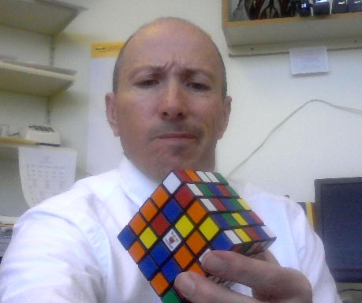
[[IMAGE REF 0000]] Image reference -- not directly editable; the original page reference is preserved automatically. Source: https://www.bemidjistate.edu/academics/professional-education/wp-content/uploads/sites/12/2024/09/portercoggins-rubiks-cube-jpeg.jpg
Professor
Bangsberg Complex 216
Phone: (218) 755-2720
Box #: 16
Email: porter.coggins@bemidjistate.edu

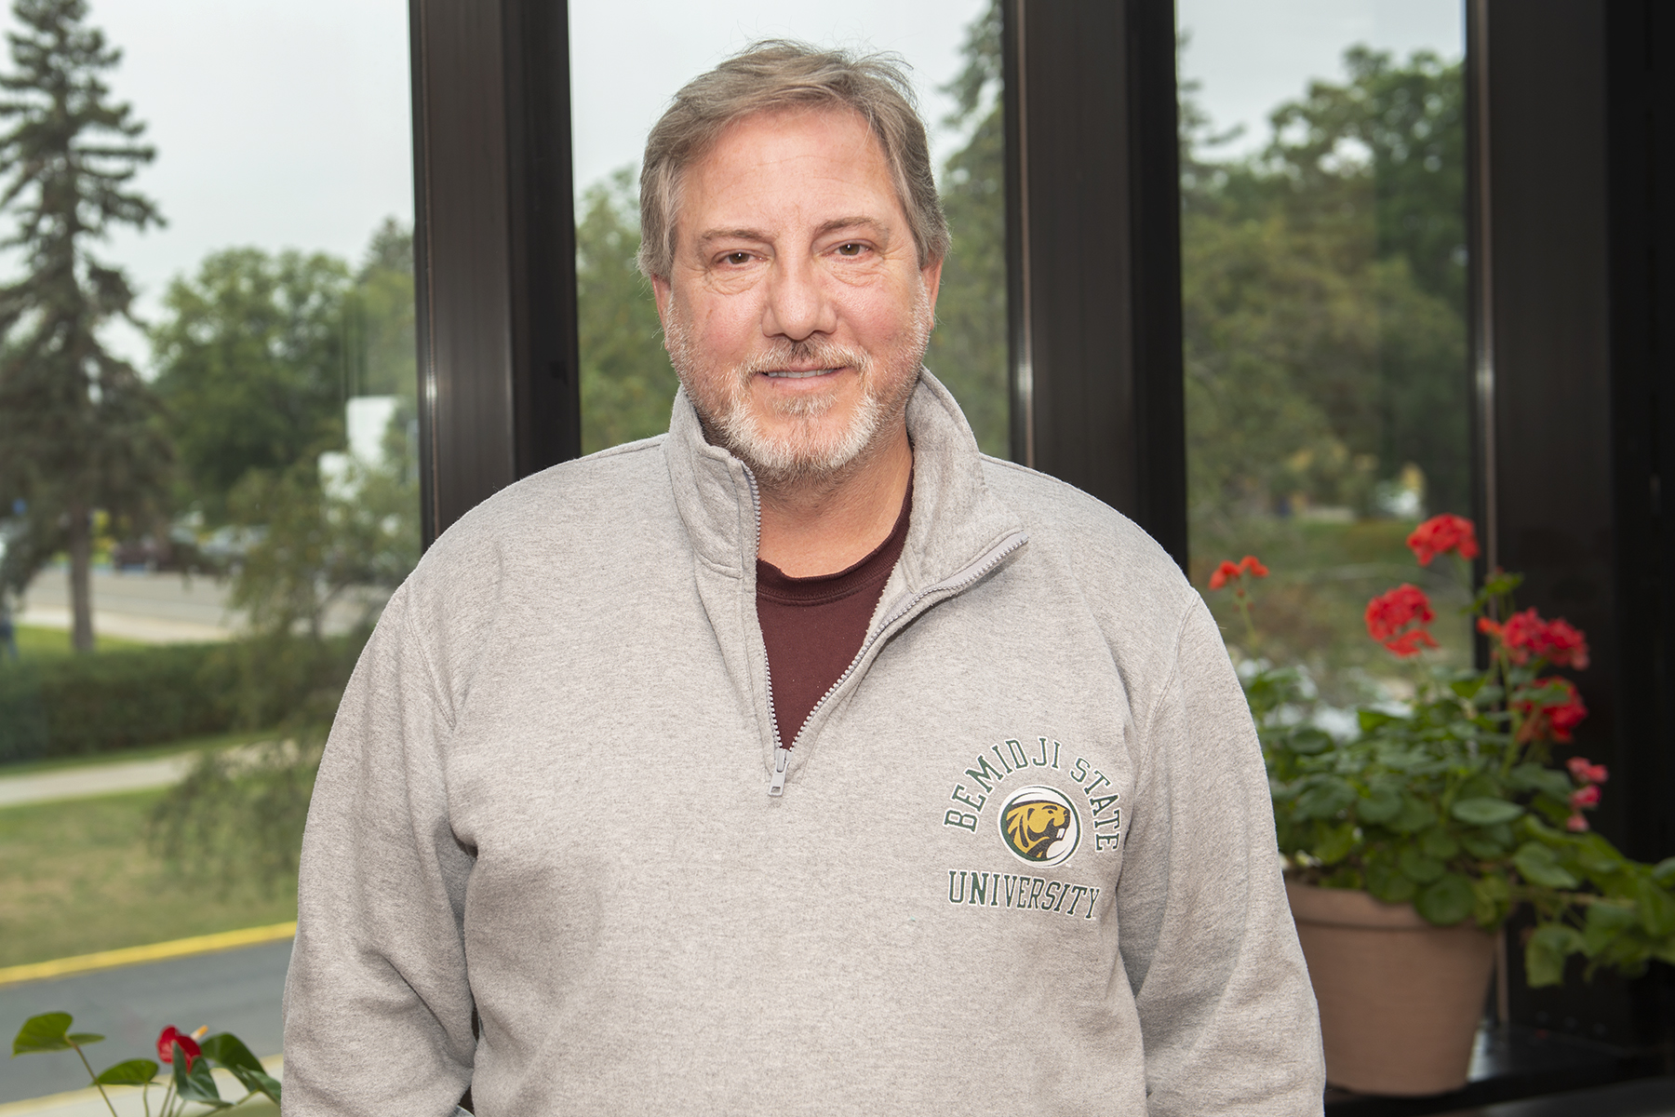
[[IMAGE REF 0001]] Image reference -- not directly editable; the original page reference is preserved automatically. Source: https://www.bemidjistate.edu/academics/professional-education/wp-content/uploads/sites/12/2022/08/23PROFED_PEDL_Tim_Goodwin_0024.jpg
Associate Professor
Phone: (218) 308-0780
Box #: 16
Email: timothy.goodwin@bemidjistate.edu

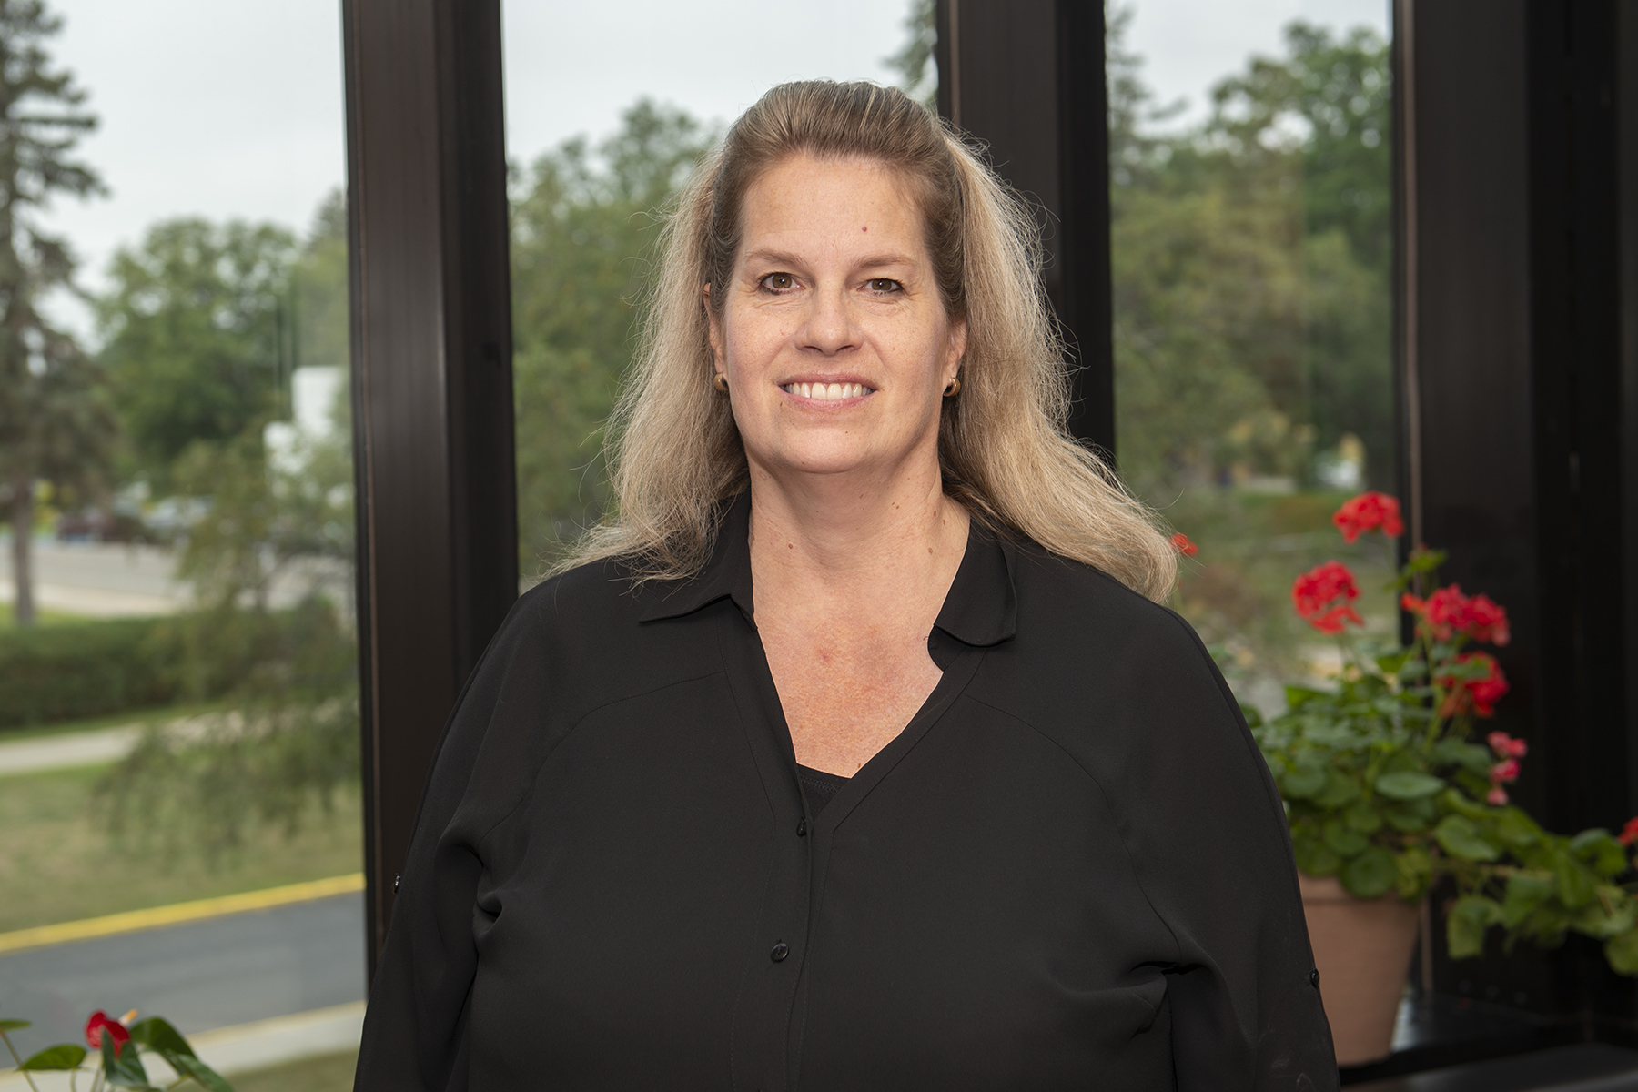
[[IMAGE REF 0002]] Image reference -- not directly editable; the original page reference is preserved automatically. Source: https://www.bemidjistate.edu/academics/professional-education/wp-content/uploads/sites/12/2022/08/23PROFED_Lisa_Krall.jpg
Assistant Professor
Box #: 16
Email: lisa.krall@bemidjistate.edu

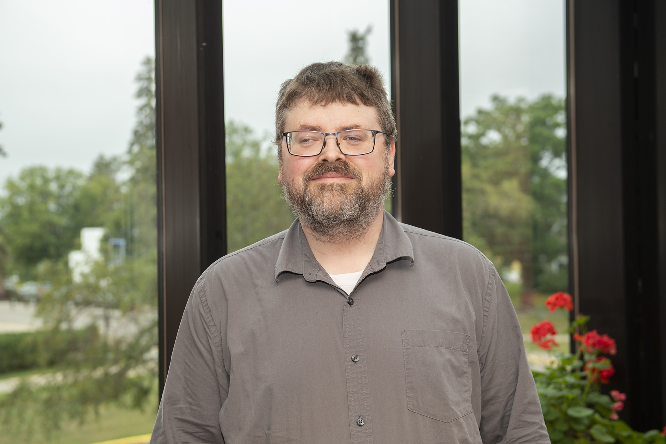
[[IMAGE REF 0003]] Image reference -- not directly editable; the original page reference is preserved automatically. Source: https://www.bemidjistate.edu/academics/professional-education/wp-content/uploads/sites/12/2022/08/23PROFED_Carl_Lund.jpg
Associate Professor
Bangsberg Complex 104
Box #: 16
Email: carl.lund@bemidjistate.edu

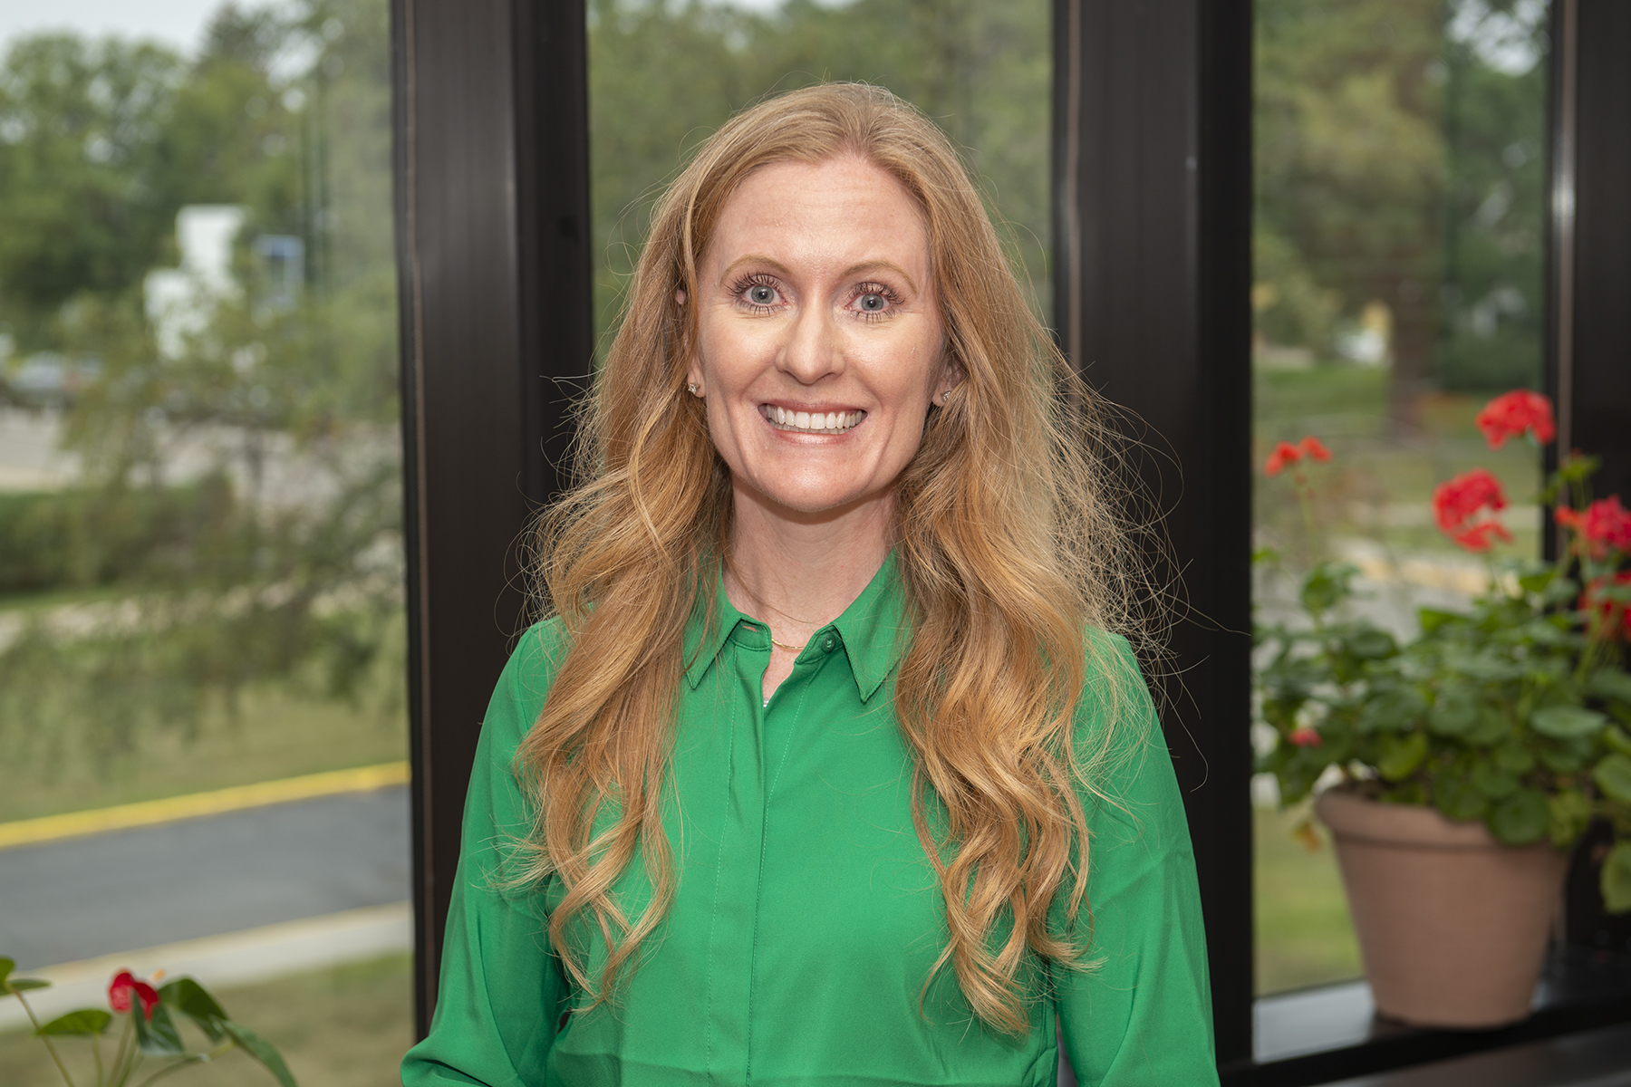
[[IMAGE REF 0004]] Image reference -- not directly editable; the original page reference is preserved automatically. Source: https://www.bemidjistate.edu/academics/professional-education/wp-content/uploads/sites/12/2022/08/23PROFED_Kathrina_OCohnell.jpg
Assistant Professor
Box #: 16
Email: kathrina.oconnell@bemidjistate.edu

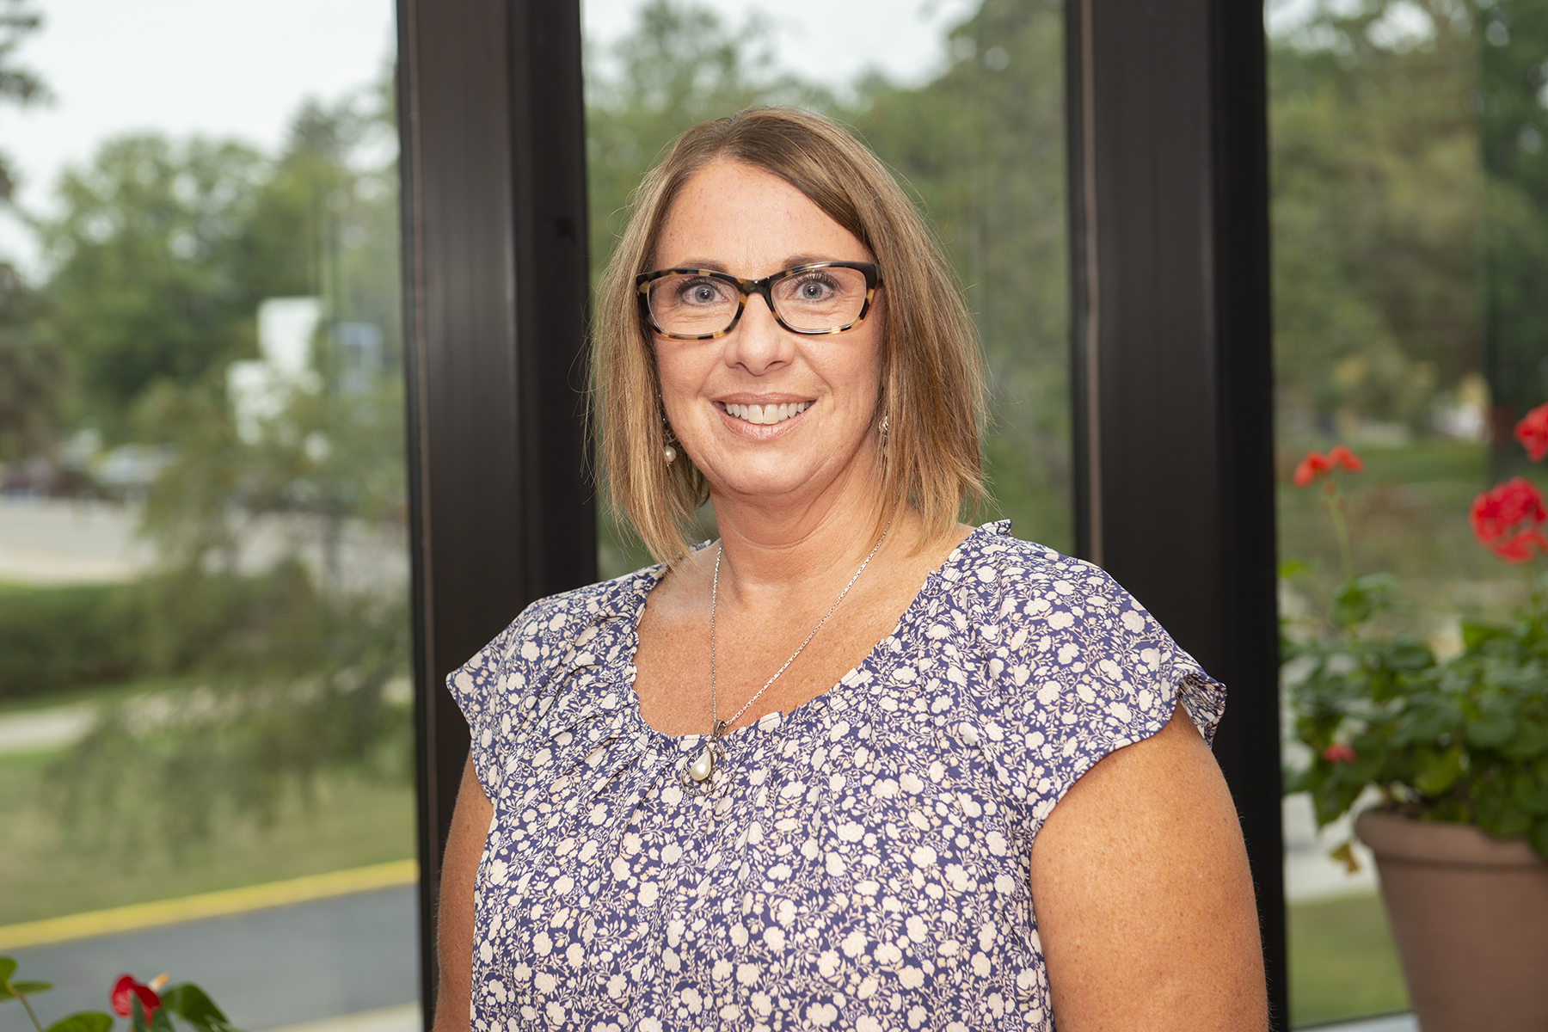
[[IMAGE REF 0005]] Image reference -- not directly editable; the original page reference is preserved automatically. Source: https://www.bemidjistate.edu/academics/professional-education/wp-content/uploads/sites/12/2022/08/23PROFED_Sonia_OBryan.jpg
Department Chair-Associate Professor
Bangsberg Complex 103
Phone: (218) 755-3774
Box #: 16
Email: sonia.obryan@bemidjistate.edu

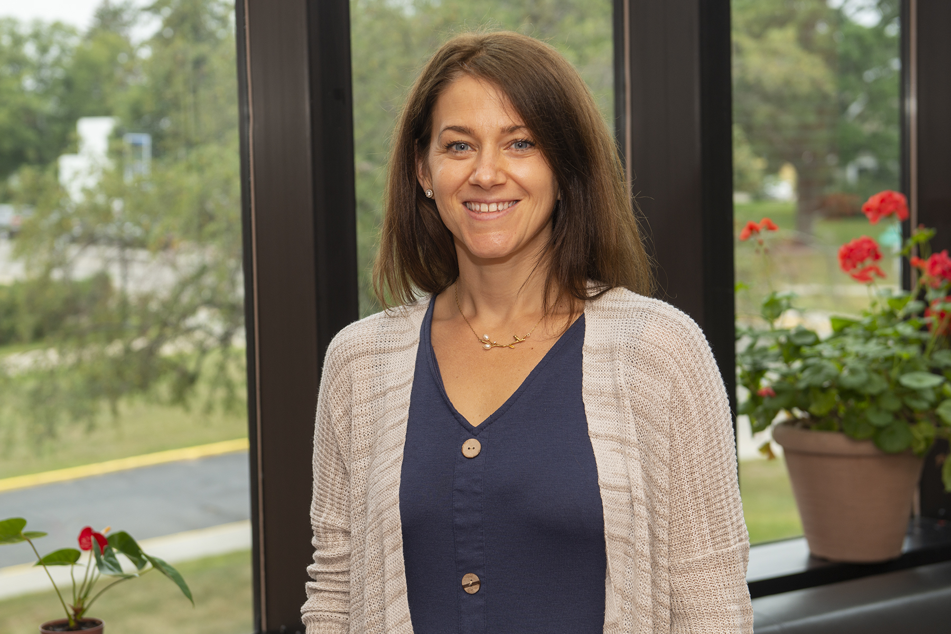
[[IMAGE REF 0006]] Image reference -- not directly editable; the original page reference is preserved automatically. Source: https://www.bemidjistate.edu/academics/professional-education/wp-content/uploads/sites/12/2022/08/23PROFED_PEDL_Jessamay_Pesek.jpg
Associate Professor
Box #: 16
Email: jessamay.pesek@bemidjistate.edu

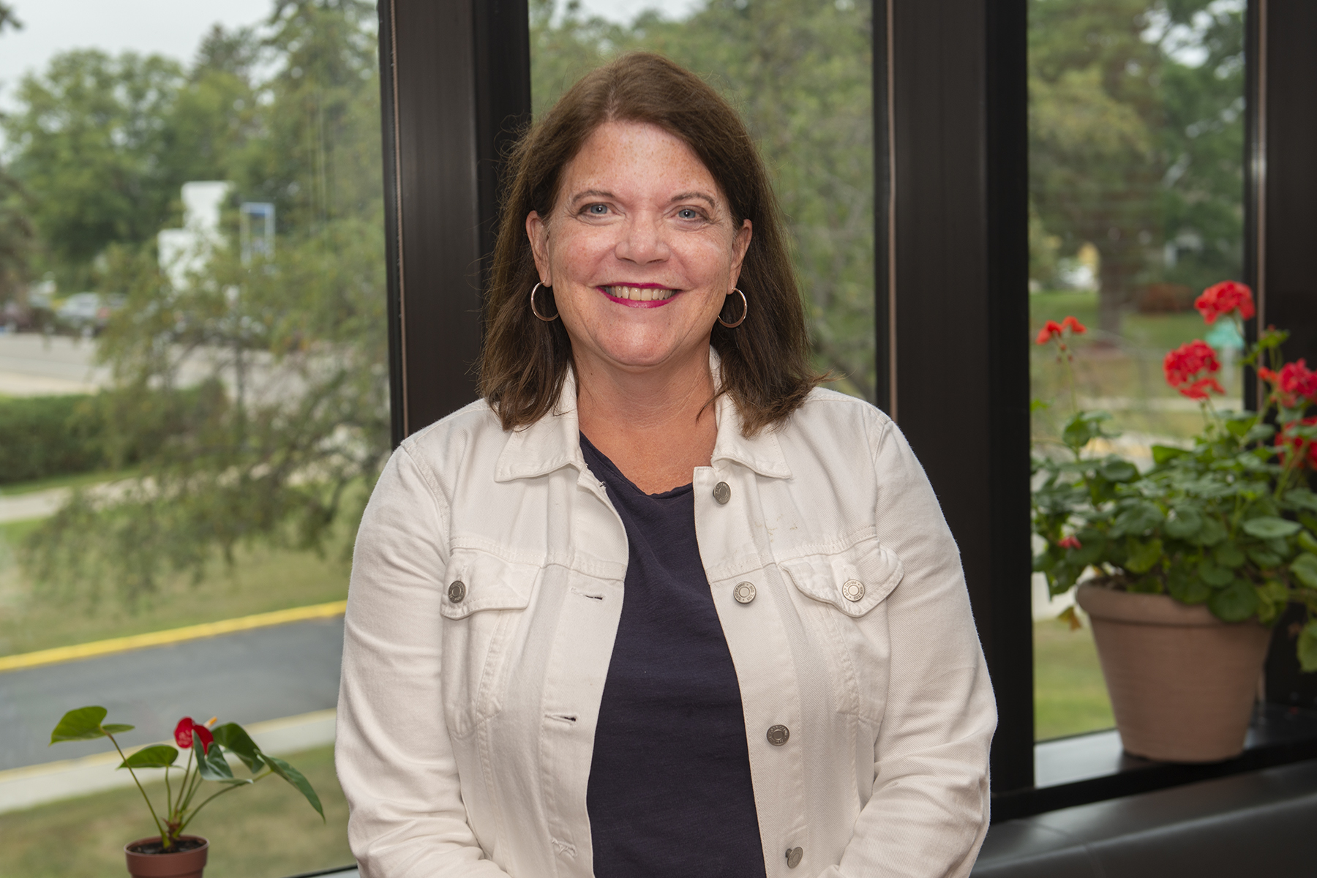
[[IMAGE REF 0007]] Image reference -- not directly editable; the original page reference is preserved automatically. Source: https://www.bemidjistate.edu/academics/professional-education/wp-content/uploads/sites/12/2022/08/23PROFED_PEDL_Lisa_Schmitz.jpg
Associate Professor
Phone: (218) 755-3734
Box #: 16
Email: lisa.schmitz@bemidjistate.edu

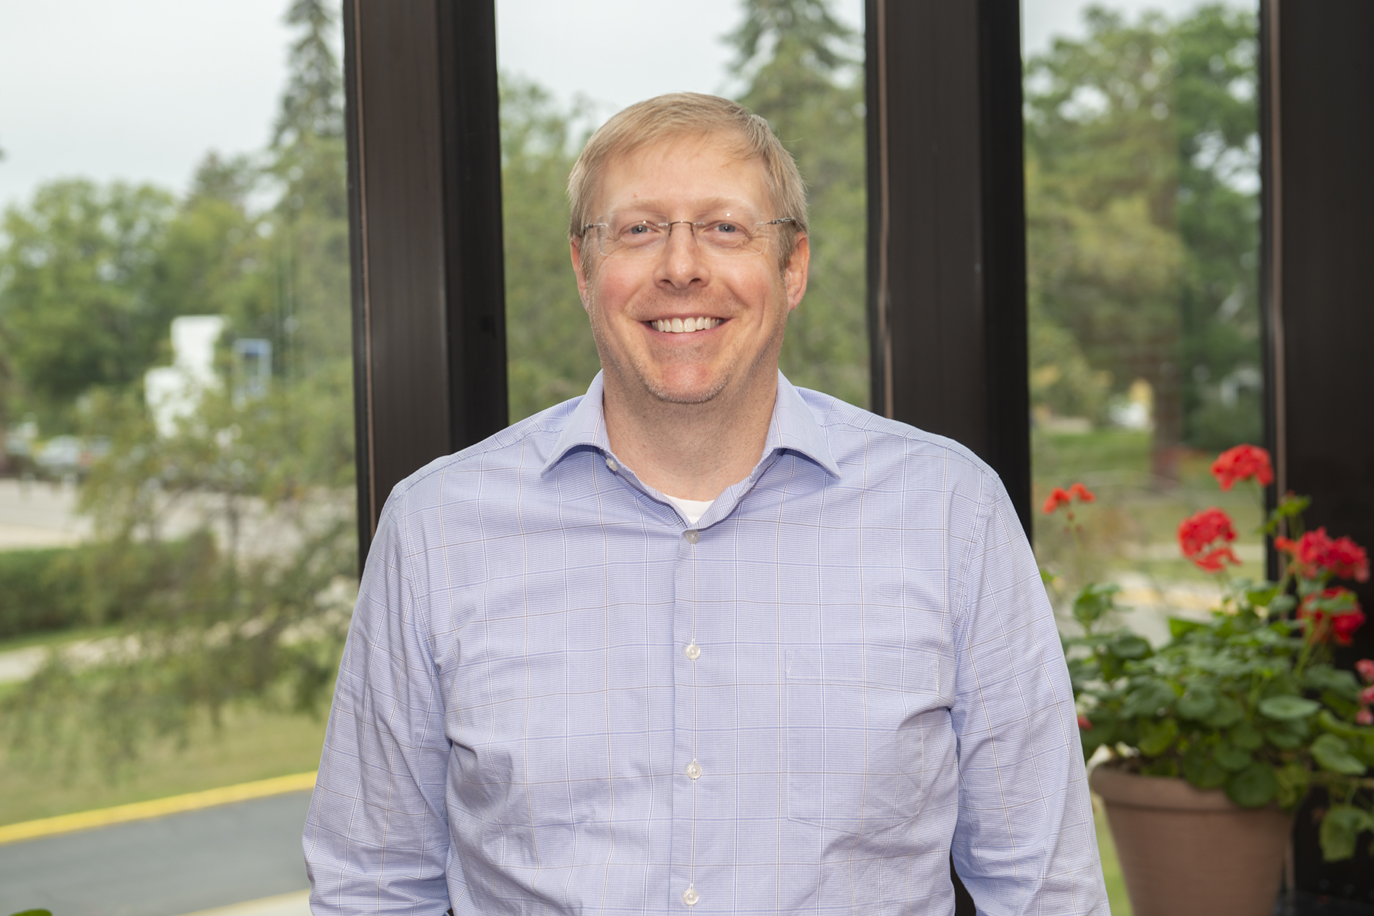
[[IMAGE REF 0008]] Image reference -- not directly editable; the original page reference is preserved automatically. Source: https://www.bemidjistate.edu/academics/professional-education/wp-content/uploads/sites/12/2022/08/23PROFED_Michael_Urban.jpg
Professor
Bangsberg Complex 106
Phone: (218) 755-3782
Box #: 16
Email: michael.urban@bemidjistate.edu

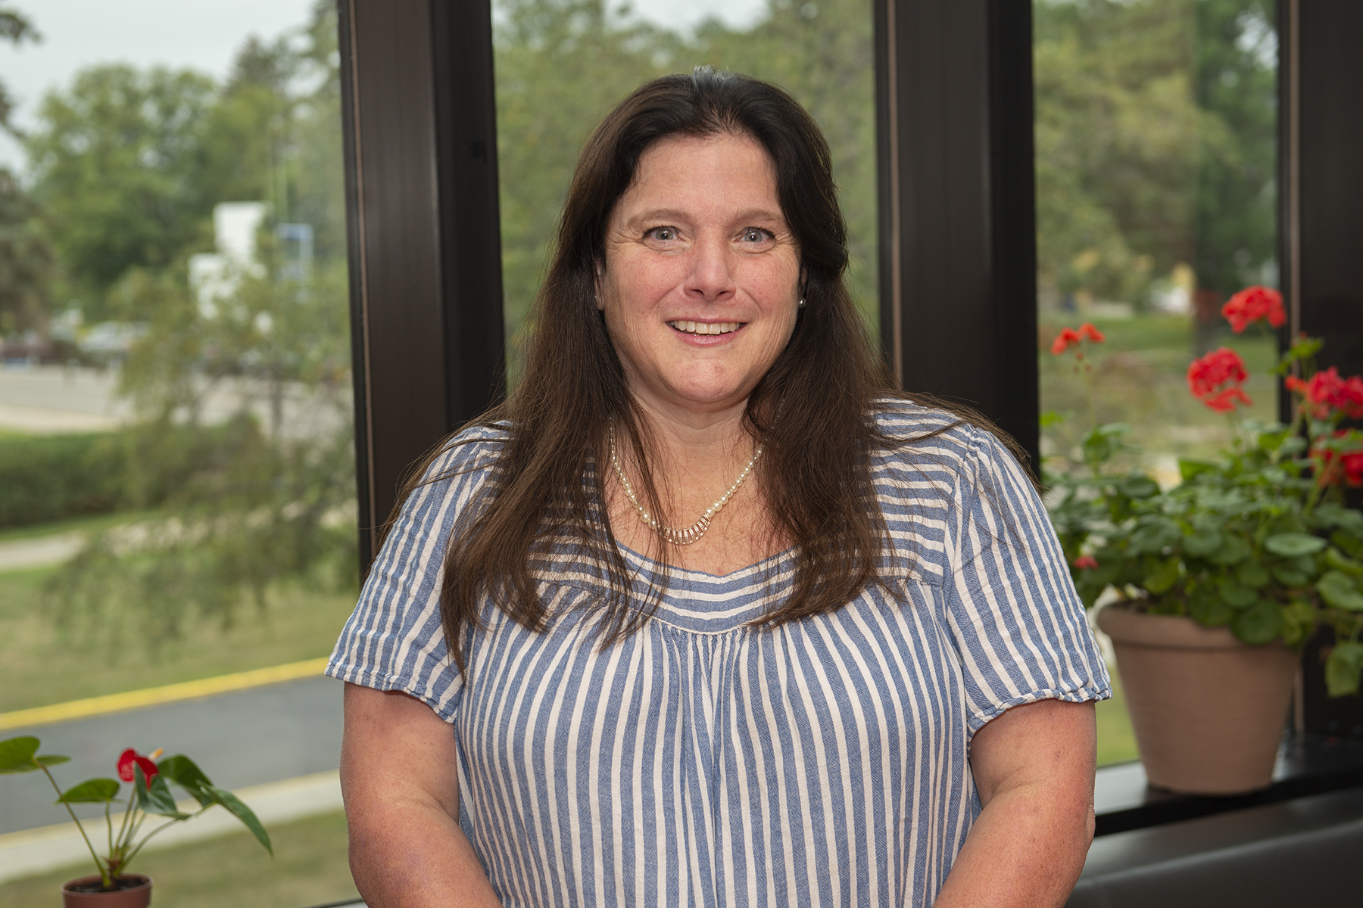
[[IMAGE REF 0009]] Image reference -- not directly editable; the original page reference is preserved automatically. Source: https://www.bemidjistate.edu/academics/professional-education/wp-content/uploads/sites/12/2022/08/23PROFED_SPED_Miriam_White.jpg
Associate Professor
Bangsberg Complex 210
Phone: (218) 755-3744
Box #: 16
Email: miriam.white@bemidjistate.edu

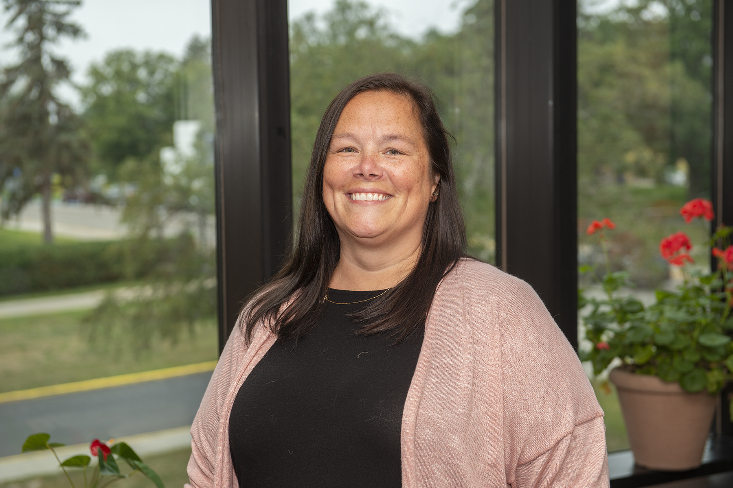
[[IMAGE REF 0010]] Image reference -- not directly editable; the original page reference is preserved automatically. Source: https://www.bemidjistate.edu/academics/professional-education/wp-content/uploads/sites/12/2022/08/23PROFED_Tammy_Erickson.jpg
Office Manager
School of Education and School of Music
Bangsberg Complex 102 & 305
Phone: (218) 755-2934 School of Education
Phone: (218) 755- 3352 School of Music
Box #: 16
Email: tammy.erickson@bemidjistate.edu

