Title | Faculty & Staff
Meta Description
— Page content begins below. Please do not edit the table above. —
Dr. Andrew Graham, Chair
Assistant Professor
Bridgeman 248
Phone: (218) 755-2953
Box #34
Email: andrew.graham@bemidjistate.edu

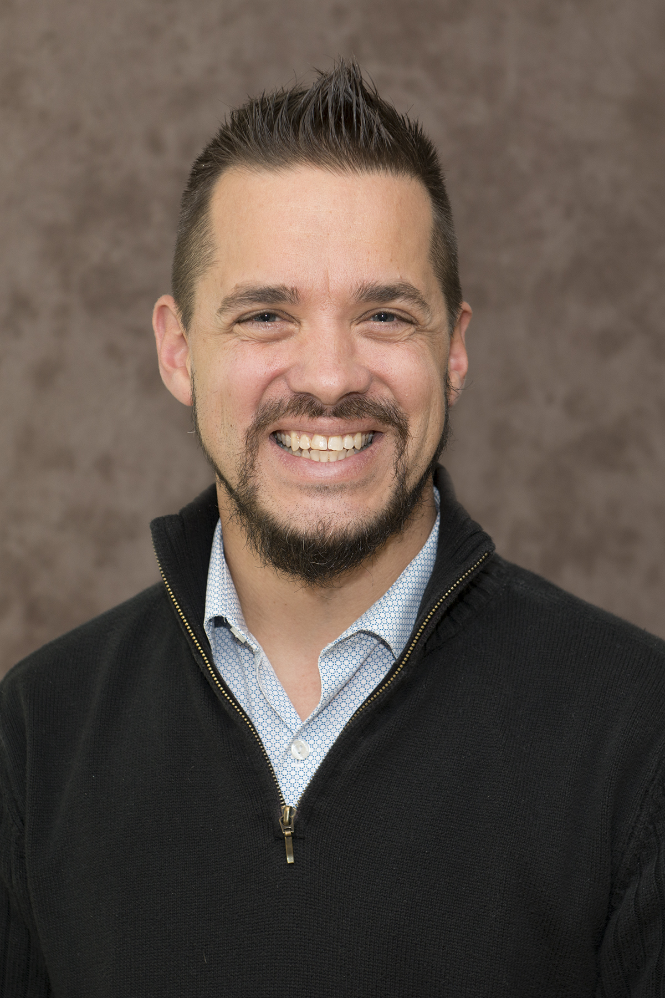
[[IMAGE REF 0001]] Image reference -- not directly editable; the original page reference is preserved automatically. Source: https://www.bemidjistate.edu/academics/technology-art-design/wp-content/uploads/sites/43/2022/05/20BSU_TAD_Mitch_Blessing.jpg
Associate Professor
Bridgeman Hall 235
Phone: (218) 755-2286
Box #34
Email: mitchell.blessing@bemidjistate.edu

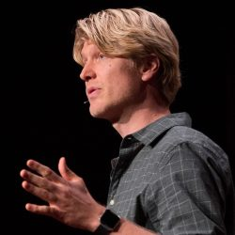
[[IMAGE REF 0000]] Image reference -- not directly editable; the original page reference is preserved automatically. Source: https://www.bemidjistate.edu/academics/technology-art-design/wp-content/uploads/sites/43/2026/04/EricCarlson-250x250.jpg
Assistant Professor
Bridgeman Hall 232
Box #34
Email: eric.carlson.2@bemidjistate.edu

Alice Blessing
Adjunct faculty / Gallery Director
Phone: (218) 755-2950
Email: alice.blessing@bemidjistate.edu

Dr. Nusrat Chowdhury
Assistant Professor
Bridgeman Hall 247
Phone: (218) 755-2954
Box #34
Email: nusrat.chowdhury@bemidjistate.edu

Tom DalyIMAGEPLACEHOLDER0002
Adjunct Faculty
Email: thomas.daly@bemidjistate.edu

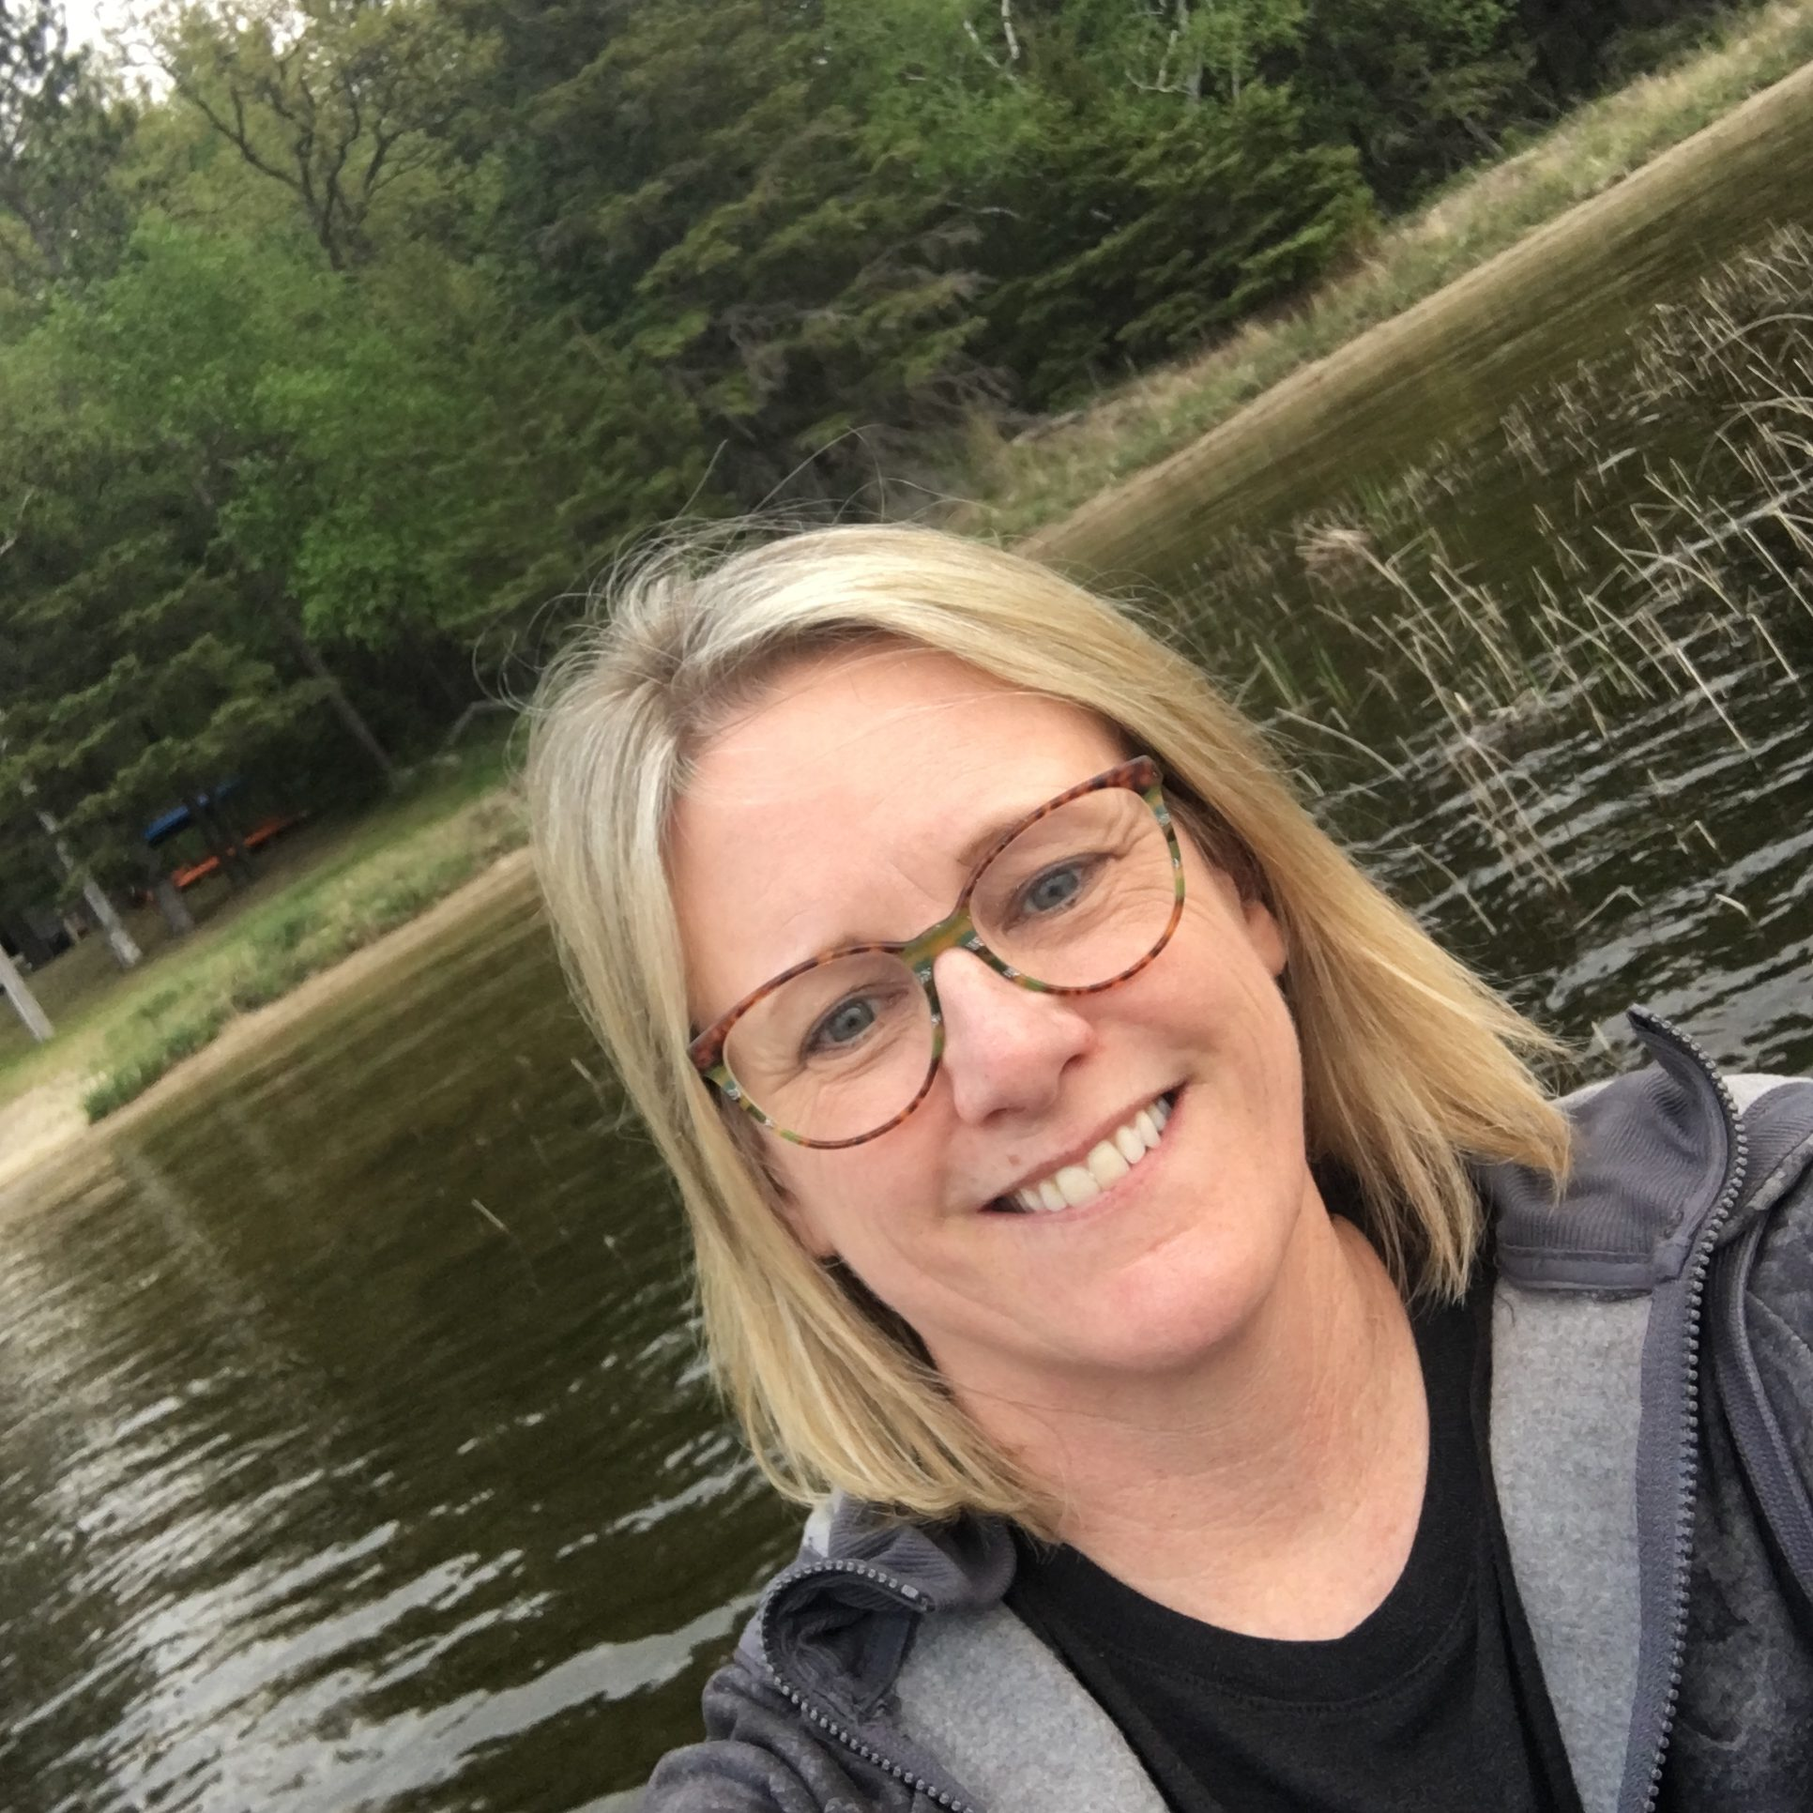
[[IMAGE REF 0003]] Image reference -- not directly editable; the original page reference is preserved automatically. Source: https://www.bemidjistate.edu/academics/technology-art-design/wp-content/uploads/sites/43/2022/05/BHiggins-rotated-1.jpg
Professor
Bridgeman 248
Phone: (218) 755-3790
Box #34
Email: bonnie.higgins@bemidjistate.edu

Sachel JosefsonIMAGEPLACEHOLDER0004
Associate Professor
Bridgeman Hall
Phone: (218) 755-2949
Box #34
Email: sachel.josefson@bemidjistate.edu


[[IMAGE REF 0005]] Image reference -- not directly editable; the original page reference is preserved automatically. Source: https://www.bemidjistate.edu/academics/technology-art-design/wp-content/uploads/sites/43/2022/05/BSU_14CBTC_Michael_Lund.jpg
Associate Professor
Bridgeman 228
Phone: (218) 755-2951
Email: michael.lund@bemidjistate.edu

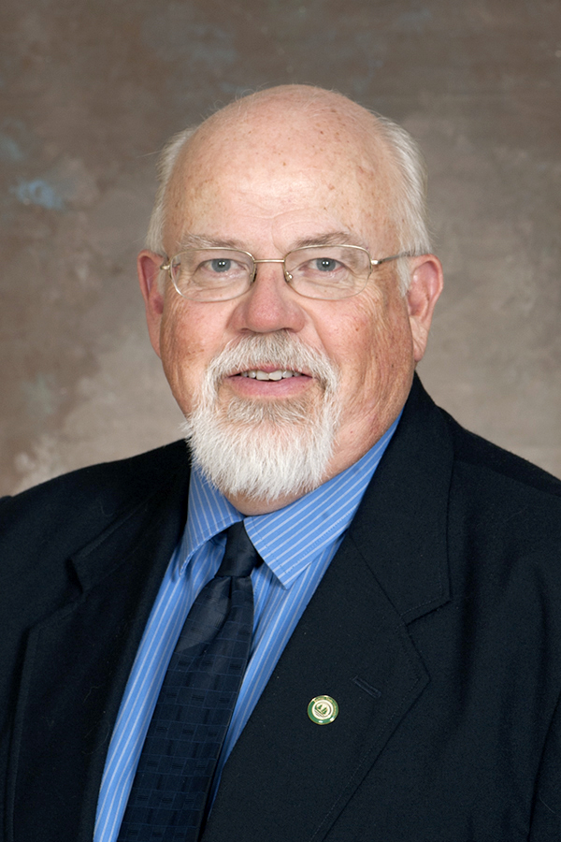
[[IMAGE REF 0006]] Image reference -- not directly editable; the original page reference is preserved automatically. Source: https://www.bemidjistate.edu/academics/technology-art-design/wp-content/uploads/sites/43/2022/05/BSU_14CBTC_David_Towley.jpg
Associate Professor
Bridgeman 230
Phone: (218) 755-2205
Box #34
Email: dave.towley@bemidjistate.edu

