Title | Applied Engineering
Meta Description
— Page content begins below. Please do not edit the table above. —
If you have a two-year technical degree or diploma, you can earn a bachelor’s degree in applied engineering in as little as two years. Your technical education has provided you the foundation for your bachelor’s in applied engineering.

Why Earn a Bachelor’s in Applied Engineering
- Earn a Promotion: 56% of our graduates received a job promotion within three years of graduation.
- Job Growth: Jobs requiring a bachelor’s degree are projected to grow by 8.2% from 2014-2024.
- More Money: Income with a bachelor’s degree is 40% higher than those with just an associates degree.
- Job Opportunities: The Bureau of Labor Statistics recognizes 166 careers requiring a bachelor’s degree, and only 49 requiring an associates degree.
- Affordable: Bemidji State University’s Applied Engineering degree was recognized as one of 20 most affordable online engineering degrees in the United States.

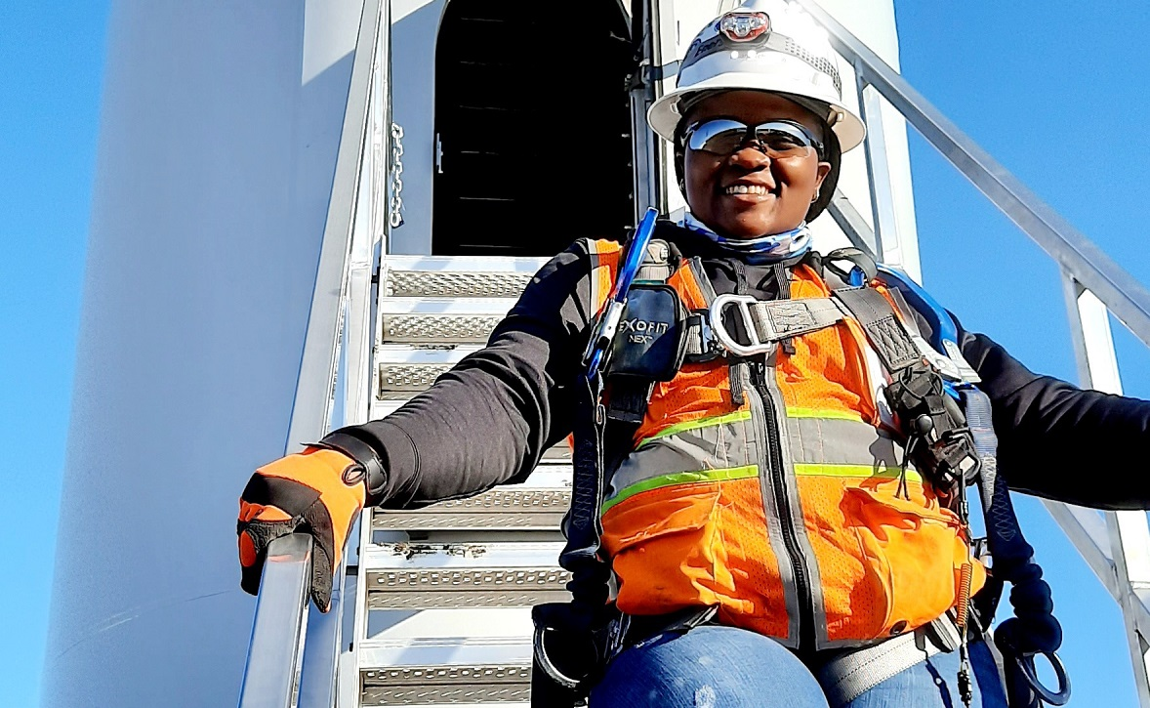
[[IMAGE REF 0000]] Image reference -- not directly editable; the original page reference is preserved automatically. Source: https://www.bemidjistate.edu/academics/technology-art-design/wp-content/uploads/sites/43/2022/08/Lyliane.jpg
“The applied engineering program prepared me for most entry-level engineering jobs, not just a specific type. I already had a job [as a design engineer] secured by graduation, and a few months later I was offered a position within a different company.”
— Lyliane Tchuamo ’20Applied Engineering B.A.S.

Flexible Applied Engineering Degree Options for Every Learner
In today’s fast-paced and ever-changing world, we understand the need for flexible and adaptable degree options that cater to a variety of lifestyles and career goals. Our applied engineering program offers two distinct paths for you to achieve your educational aspirations: an online program designed for working professionals and a comprehensive on-campus experience for those seeking a traditional learning environment. No matter your preference, our expert faculty and cutting-edge resources will ensure that you receive a top-notch education, tailored to your unique needs.

Applied Engineering Online Program
Embrace the convenience and flexibility of our applied engineering online program, perfect for busy individuals with families and careers. The online delivery option allows you to continue working while you finish your applied engineering degree completely online. Our innovative digital platform delivers high-quality content through diverse formats, promoting engagement with both fellow students and our experienced faculty. Benefit from the additional support offered by our Extended Learning Center, designed to enhance your online learning experience.

Applied Engineering On-Campus Program
Immerse yourself in the hands-on, interactive world of our applied engineering bachelor’s on-campus. Situated within the School of Technology, Art & Design, you’ll work collaboratively on real-world projects in our state-of-the-art labs. Enjoy the personalized attention of small class sizes and a low student-to-teacher ratio, fostering an optimal learning environment.
For more information on the courses in this program, visit the course catalog.

