Title | Environmental Communication
Meta Description
— Page content begins below. Please do not edit the table above. —
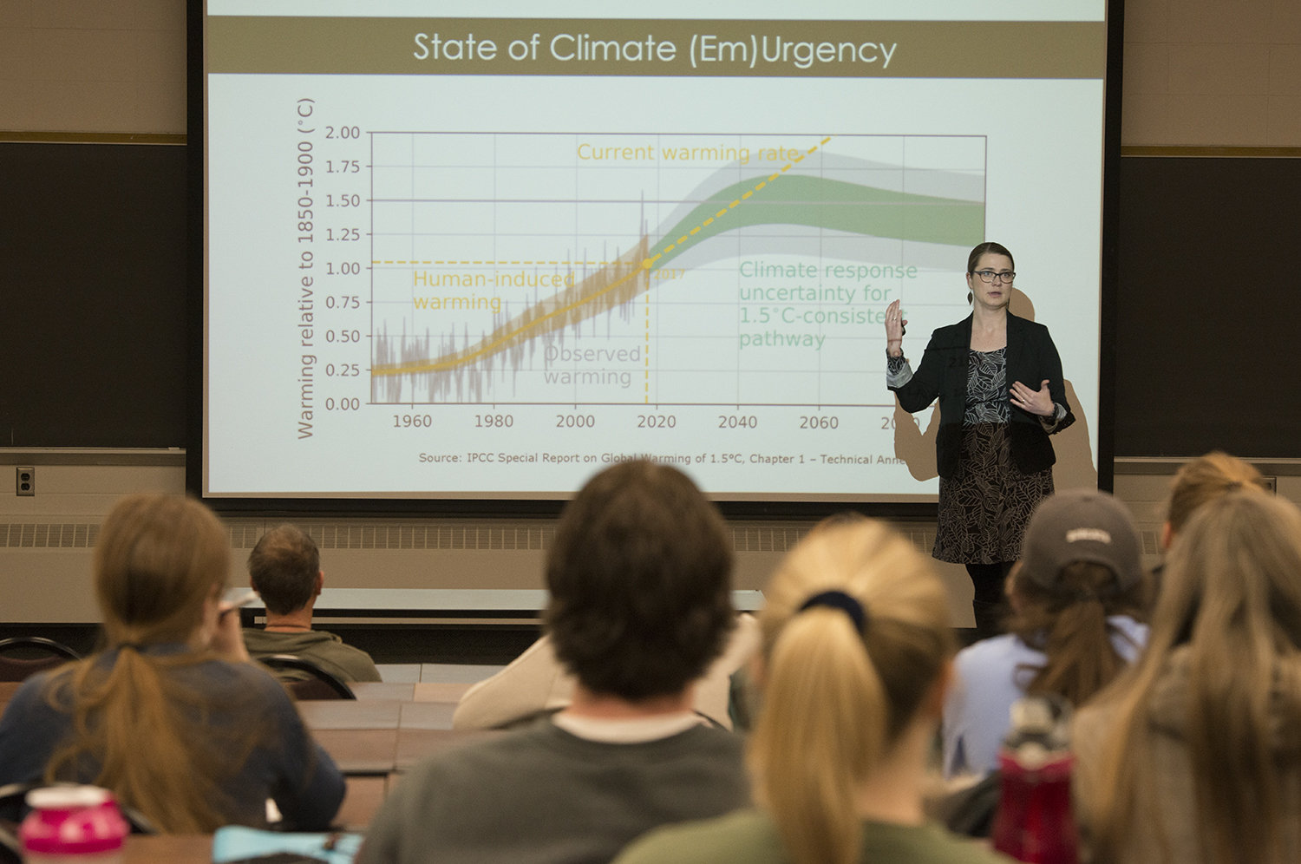
[[IMAGE REF 0000]] Image reference -- not directly editable; the original page reference is preserved automatically. Source: https://www.bemidjistate.edu/academics/css/environmental-studies/wp-content/uploads/sites/68/2022/03/19HL_Carlson_Ueland_0235.jpg
We all need a healthy environment to live and thrive. Students pursuing the Environmental Communication B.S. will gain an in-depth understanding of the complex environmental issues facing society. Students will understand, learn how to interpret and communicate scientific research. Students will also learn how to effectively use the mass communication component of story telling to effectively engage diverse audiences and communicate across different platforms. Graduates of this program will be well prepared to enter jobs within business, media, non-profit organizations, government and tribal entities.
Effective environmental communication relies on understanding from a variety of disciplines, and as such, it cannot be accomplished under just one department of study. Science, communication, interpersonal communication, political science, social and cultural understanding, are some of the areas covered in this degree.
For more information on the courses in this program, visit the course catalog.

