Title | Fraud Examination
Meta Description
— Page content begins below. Please do not edit the table above. —
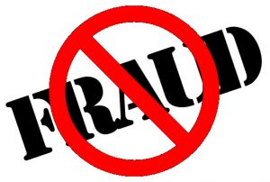
[[IMAGE REF 0000]] Image reference -- not directly editable; the original page reference is preserved automatically. Source: https://www.bemidjistate.edu/academics/accounting/wp-content/uploads/sites/45/2022/02/Fraud-2-300x202-1.jpg
Available to any major, this minor offers an interdisciplinary field of study in Accounting, Business Administration and Criminal Justice. You will gain the skills needed to detect, investigate and prevent fraud and embezzlement, criminal and financial transactions, money laundering and other types of illegal activity. Upon graduation, students may sit for the Certified Fraud Examination. The job prospects for Forensic Accountants are plentiful. The FBI is currently recruiting more Forensic Accountants than Field Agents.
For more information on the courses in this program, visit the course catalog.

