Title | German
Meta Description
— Page content begins below. Please do not edit the table above. —
With between 90-95 million speakers, German is the most widely spoken native language in the European Union. It is an official language in Germany, Austria, Switzerland, Luxembourg and Liechtenstein. After English, it is one of the most widely used languages for business because of the robust German economy.
BSU offers two years of sequenced classes in German. The goal of these enrichment classes is two-fold:
- To build proficiency in the four language skills of reading, writing, listening and speaking; and
- To introduce and deepen the knowledge of the culture, history and literature of German-speaking countries.
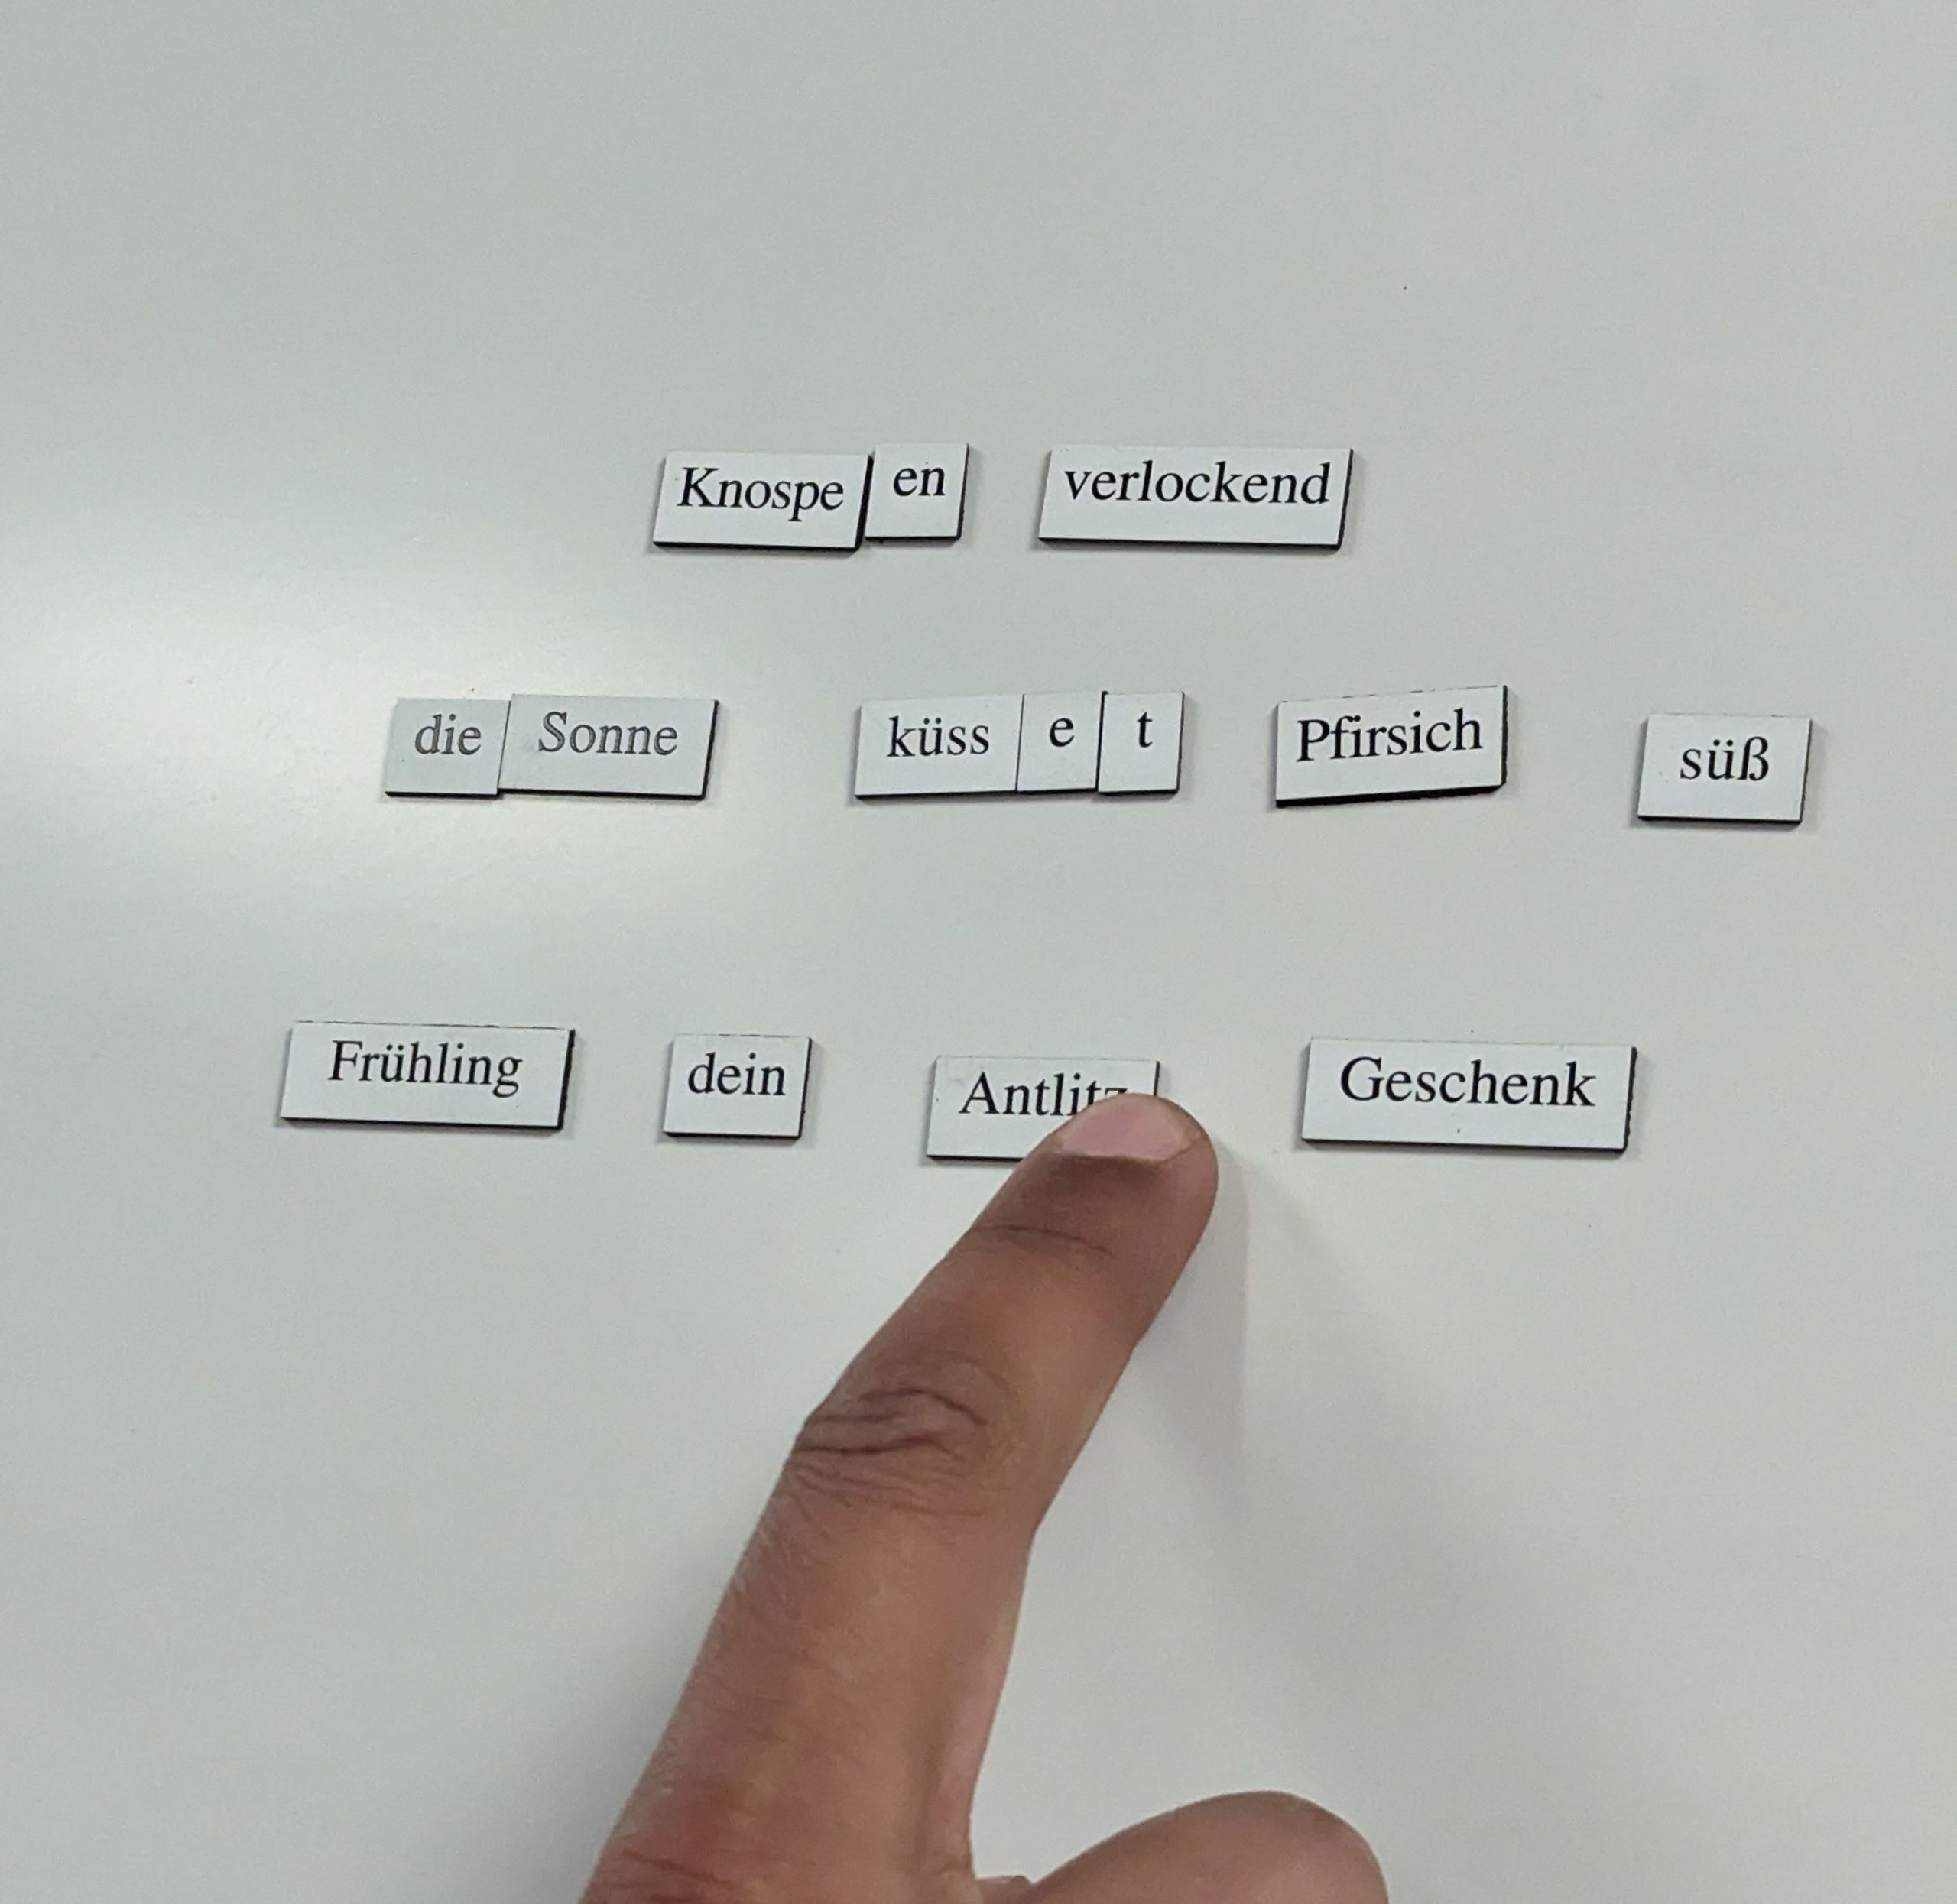
[[IMAGE REF 0000]] Image reference -- not directly editable; the original page reference is preserved automatically. Source: https://www.bemidjistate.edu/academics/languages-indigenous-studies/wp-content/uploads/sites/100/2023/04/3.Apr_.2023.2-scaled.jpg
Students taking German may combine their German studies with other areas to prepare for career opportunities in international business, government, travel or communications, where knowledge of a foreign language and of foreign cultures is essential.
For more information about the courses in this program, visit the course catalog.

