Title | Global Studies
Meta Description
— Page content begins below. Please do not edit the table above. —
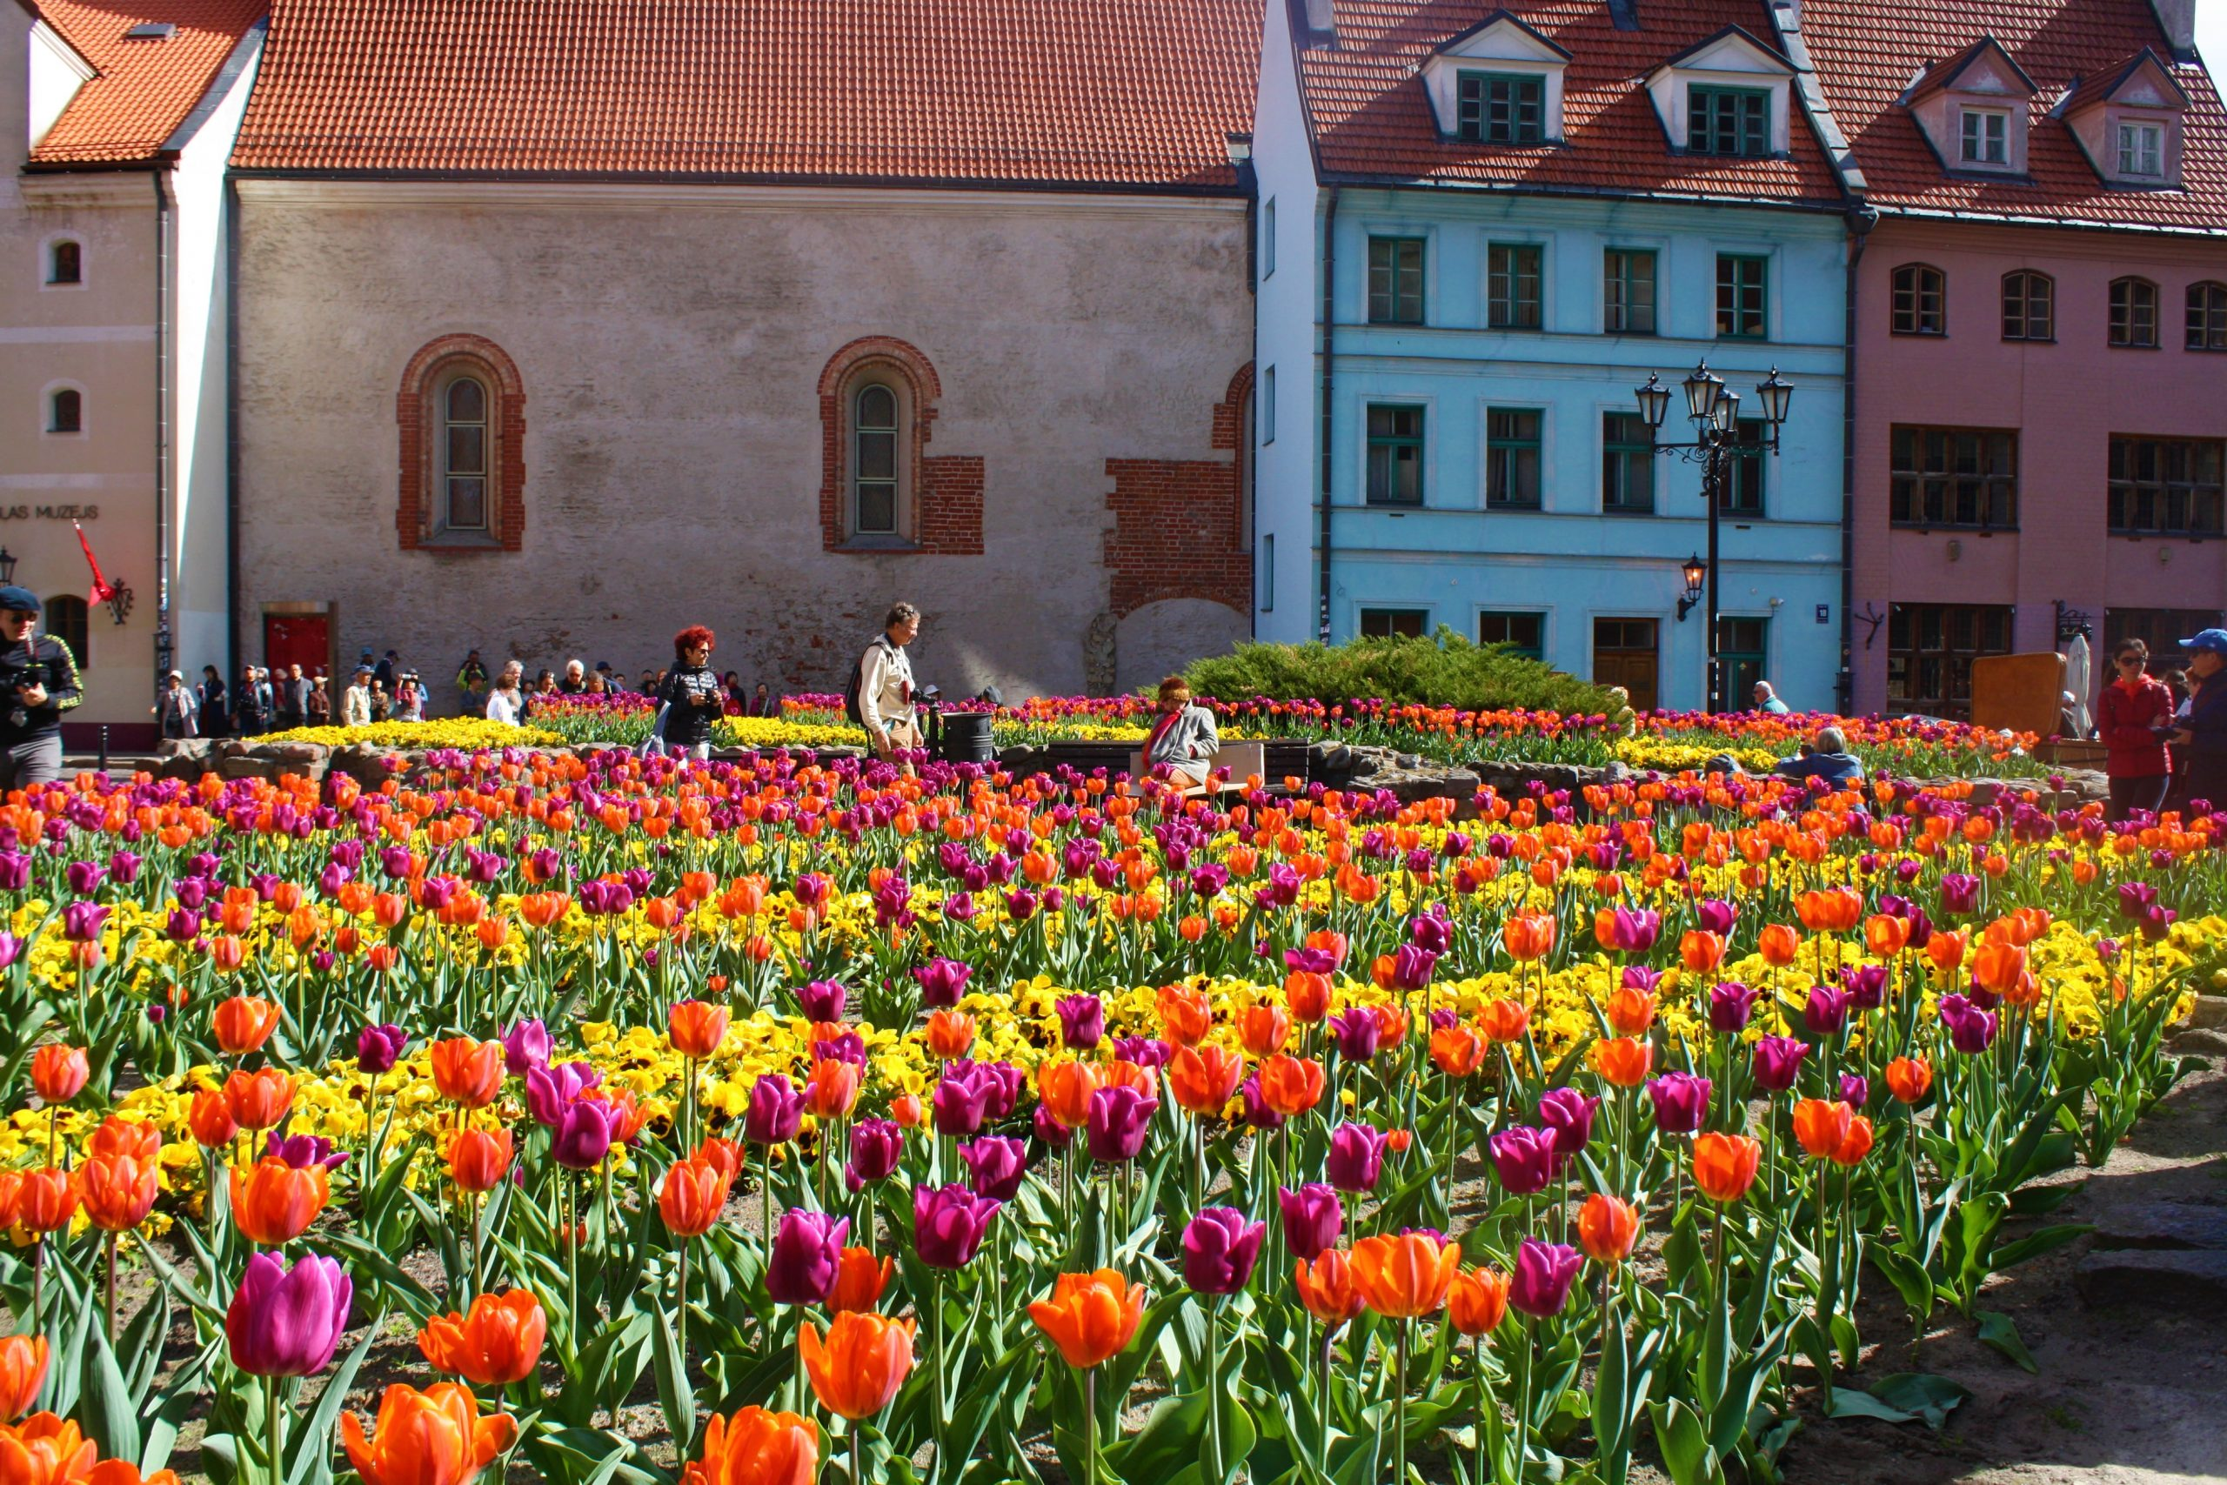
[[IMAGE REF 0000]] Image reference -- not directly editable; the original page reference is preserved automatically. Source: https://www.bemidjistate.edu/academics/geography/wp-content/uploads/sites/26/2022/02/Latvia-Riga-Tour5-scaled.jpg
The B.A. in Global Studies is an integrated, interdisciplinary global studies degree in which students can choose an area of focus through specific electives. The value of spatial awareness and analysis are critical skills for today’s world. Students of geography, no matter what path they take, explore their own place in the world, their values and responsibilities to others as well as to the health of the planet.
For more information on the courses in this program, visit the course catalog.

