Title | Human Performance
Meta Description
— Page content begins below. Please do not edit the table above. —
DAPE Primary Contact:
Dr. Sherry Holloway
(218) 755-2223
sherry.holloway@bemidjistate.edu
Developmental Adapted Physical Education (DAPE) prepares you to teach and empower people with a wide range of physical and developmental disabilities. You’ll learn how to adapt and modify physical education activities to promote movement, health and well-being. Through our fully online program, you’ll gain fundamental knowledge and hands-on experience in inclusive practice.

Why Choose DAPE
There are lots of reasons to choose DAPE at Bemidji State University, but here are our top three.

Flexibility
Bemidji State University offers an online licensure program in Developmental Adapted Physical Education (DAPE). Our comprehensive coursework takes just 5 semesters to complete — making our program the perfect choice for undergraduates and in-service professionals.
“Working in a cohort model helped connect with other professionals. Completing an online format for coursework gave me the flexibility I needed to gain the DAPE license.” — Carol, 2020 DAPE Licensure Graduate

Career Advancement
The program prepares physical education teacher candidates to complete an endorsement and qualify to add a licensure approved by the MN Professional Educator Licensing and Standards Board (PELSB). The added licensure broadens their scope of practice within the K-12 schools of Minnesota to include PreK-age 21 for students who qualify for DAPE.
“The program allowed me to work full-time and get my DAPE license. Building content knowledge of inclusive practices under the guidance of a licensed mentor with focus on real-life settings was exactly what I was looking for.” — Chris, 2021 DAPE Licensure Graduate

Hands-On Learning
Practical hours are embedded into our course curriculum. You will have many opportunities to work directly with students in the community under the guidance of a licensed mentor.
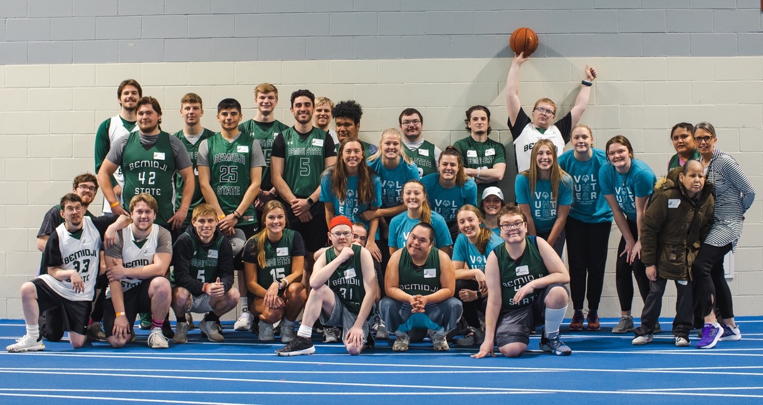
[[IMAGE REF 0002]] Image reference -- not directly editable; the original page reference is preserved automatically. Source: https://www.bemidjistate.edu/academics/human-performance-sport-health/wp-content/uploads/sites/30/2022/09/DAPE-group-photo.jpeg

DAPE Curriculum and Requirements
Our cohort model program brings you together with other DAPE learners, creating PE-focused discussions that are directly relevant to your training or your advancing career. Students will work directly with highly experienced BSU faculty to ensure program readiness and completion.
The DAPE core content standards are met through successful completion of six courses (15 credits). DAPE core content standards are completed through the following course sequence**.** (A flexible start may be allowed for qualifying candidates in the summer semester.)

Pathway to Add-on Minnesota DAPE Teacher Licensure
Candidates concurrently in an initial license in a K-12 physical education program take 4000-level courses.
Candidates with a K-12 physical education license take 5000-level courses.
5000-level courses can be transferred to complete a masters degree.

Required Physical Education Courses
Required Credits: 15
Required GPA: 2.50
Complete the following courses:
- PHED 4501.5501 Orientation to the Online DAPE Program (0 credit)
  - Offered summer-1 only
  - 0 hours of field experience
- PHED 4510.5510 DAPE Introduction to Professional Communities of Practice (3 credits)
  - Offered fall-1 only
  - Undergraduates: 15 hours of field experience
  - MNDAPE Conference attendance to fall conference is required as part of the course. Student must register on their own. However, there is an accommodation if you can’t attend. Candidates can register as a student for this conference.
- PHED 4520.5520 DAPE Foundations of Due Process, Assessment, and Evaluation (3 credits)
  - Offered spring-1 only
  - Undergraduates: 15 hours of field experience
- PHED 4530.5530 DAPE Community Transition (3 credits)
  - Offered summer-2 only
  - All candidates: 10 hours of field experience
- PHED 4540.5540 DAPE Teaching Strategies I (3 credits)
  - Offered fall-2 only
  - Graduate candidates: 40 hours of field experience
  - Undergraduate candidates: 15 hours of field experiences
- PHED 4550.5550 DAPE Teaching Strategies II (3 credits)
  - Offered Spring-2 only
  - Graduate candidates: 40 hours of field experience
  - Undergraduate candidates: 15 hours of field experiences
Note: Courses may be offered only once per academic year.
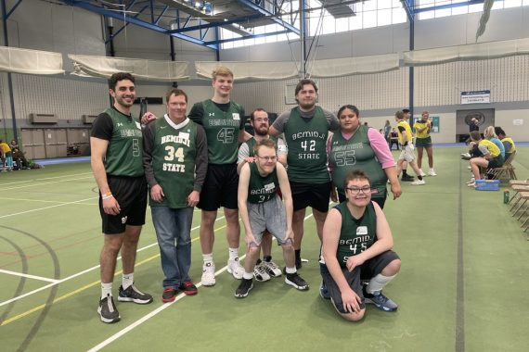
[[IMAGE REF 0000]] Image reference -- not directly editable; the original page reference is preserved automatically. Source: https://www.bemidjistate.edu/academics/human-performance-sport-health/wp-content/uploads/sites/30/2022/09/DAPE-students-instructors-570x380.jpeg
IMAGEPLACEHOLDER0001

DAPE Minor
For Bemidji State undergraduate students currently majoring in physical education, the DAPE minor prepares you for ages 3-21 DAPE licensure in Minnesota.
Consult with your PE major advisor, then add the minor using the Student Personal Data form and submit the form to the BSU Records office.
Once you have declared the DAPE minor, please email sherry.holloway@bemidjistate.edu to indicate this step has been done. You will not be able to register for DAPE courses until your file has been fully reviewed/approved.
For Minn State undergraduates, please work with your adviser for transfer information and licensing through your university.

DAPE Pathway to MN Licensure
Designed for current Minnesota licensed physical education teachers, this program leads to certification to instruct students with special needs in ways that meet their individual educational program goals in the physical education/movement setting.
You can complete the required courses at the undergraduate or graduate level. Please note: undergraduate credits will not be transferable to any future master’s degree program you may intend to complete.
For Out-of-State Licensed Physical Educators, please work with your state licensing board for standards and criteria needed for your state.

How to Apply
To add this endorsement onto your existing K-12 physical education license, apply to BSU as a non-degree seeking student in the fall semester.
If you will be taking the courses at the graduate level, complete the BSU Graduate Application and select the following options:
- Select the summer term (this program starts only in the summer term).
- Select “Graduate Certificate Student” for your educational intent, and the “part time” option.
- Click the Add Program button, and choose “Graduate Licensure – DAPE, GC.”
- Submit official transcripts from external school(s) to the School of Graduate Studies.
- Submit a copy of Minnesota K12 Physical Education License to the School of Graduate Studies.
After you submit your application, BSU Graduate Studies staff will contact you about your next steps.
Students working towards an initial K-12 Physical Education license may apply for acceptance into the Developmental Adapted Physical Education (DAPE) program after completing ED 5100, ED 5110, ED 5350, ED 5140 and ED 5780 as well as significant experience in PhyEd methods courses (focusing on content and pedagogy in dance and rhythm, elementary physical education, team and individual sports and fitness activities).
Admission to the DAPE program will be made by the Department of Human Performance, Sport & Health.

Contact Information
Dr. Sherry Holloway
Coordinator for DAPE Program
Location: Physical Education Complex 208
Phone: (218) 755-2223
Box #: 29
Email: sherry.holloway@bemidjistate.edu

