Title | Indigenous Studies
Meta Description
— Page content begins below. Please do not edit the table above. —
Bemidji Sate University’s Indigenous Studies Program and all of our course offerings are open to all students. Our students come from a wide variety of backgrounds and our program provides the depth and flexibility to inform every academic interest.
As a multidisciplinary program, we connect and collaborate across many disciplines and fields of study. At the heart of our program, we embrace Indigenous methodologies and epistemologies — or Indigenous ways of doing and knowing — as methods to examine all aspects of Indigenous Peoples worldviews, cultural values, experiences and perspectives.
We are located in the heart of Anishinaabe Aki or Land of the Anishinaabeg. We are situated between the Ojibwe Anishinaabe communities of Leech Lake, Red Lake and White Earth. We provide a broad overview of the diversity and many histories as well as commonalities of the Indigenous Peoples of Turtle Island and the world. Our close proximity to Leech Lake, Red Lake and White Earth provides our students with many opportunities to learn from, collaborate and work with these communities. Our program focuses specifically on the culture, history and perspectives of the Anishinaabeg.
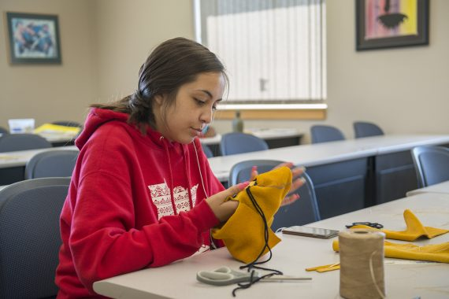
[[IMAGE REF 0000]] Image reference -- not directly editable; the original page reference is preserved automatically. Source: https://www.bemidjistate.edu/academics/languages-indigenous-studies/wp-content/uploads/sites/100/2023/04/19-OjibweCamp_0045-570x380.jpg
IMAGEPLACEHOLDER0001

Indigenous Studies Programs
The Indigenous Studies major, minor and certificate, as well as the Indigenous Sustainability Studies major and minor, are designed to provide students with critical thinking skills and a firm foundation in Indigenous knowledge to better navigate and engage the complex multicultural world in which we live. Our program emphasizes Indigenous ways of knowing as a means to examine areas of study relating to culture, history, sovereignty, tribal government, education, arts, philosophy and the environment.
The Indigenous Studies program is housed in the American Indian Resource Center (AIRC). The AIRC provides a warm and welcoming intellectual, social, cultural and spiritual space for all of our students. Join us in learning more about Indigenous approaches, culture and knowledge. For more information on the Indigenous Studies programs, visit the course catalog.

Majors
- Indigenous Studies B.A.
- Indigenous Sustainability Studies B.S.

Minors
- Indigenous Studies Minor
- Indigenous Sustainability Studies Minor
- Ojibwe Minor

Certificates
- Indigenous Studies Certificate
- Ojibwe Language Instruction Certificate

Emphases and Related Programs
- Criminal Justice B.S. with Tribal Justice Emphasis
- Business Administration B.S. with Indigenous Nations Marketing Emphasis
- Niganawenimaanaanig Indigenous Nursing Program

Summer Courses
We offer two summer courses in Indigenous studies.

INST 1107 Introduction to Turtle Island
Course dates: May 28 – June 28
3 credits
This course is designed to provide students with an introduction to the study of American Indians from a cultural and academic perspective. The academic overview will include considerations of breadth, method of research, terminology and principles of various disciplines that include American Indians in their fields of study. Liberal Education Goal Areas 5 & 7.
Register for Introduction to Turtle Island.

INST 3170 Indigenous Education
Course dates: July 8 – August 2
3 credits
Inquiry and analysis of the complexities of multiple standards of education in the U. S. including race class, gender, ethnicity, disability, age, nationality and religion, how they shape and are shaped by social and cultural tribal and non-tribal life in the United States will be examined. The course emphasizes the development of indigenous knowledge, critical thinking, analytical skills and interpersonal and inter group interactions necessary for living and working in a society characterized by tribal and western mainstream diversity. Through the mindful study of small, rural schools and traditional education practices students will find a greater understanding of (tribal) others, develop self-understanding of education in the U.S. and develop understanding in relation to others- in order to promote ethical behaviors and values in education that support a diverse world. Liberal Education Goal Areas 5 & 7.
Register for Indigenous Education.
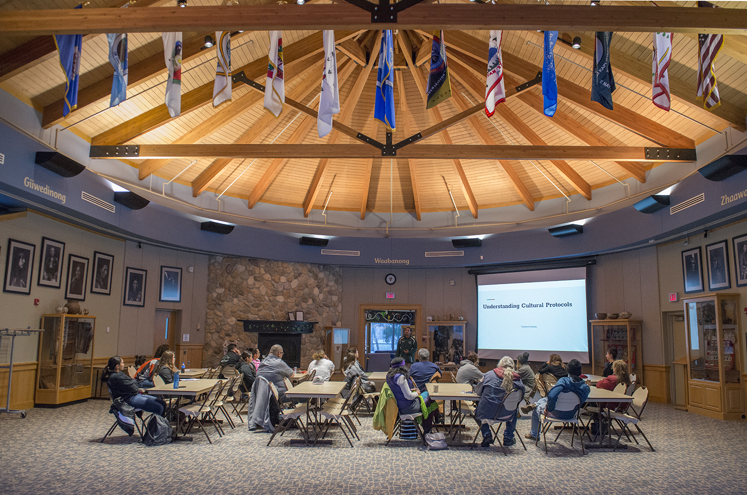
[[IMAGE REF 0002]] Image reference -- not directly editable; the original page reference is preserved automatically. Source: https://www.bemidjistate.edu/academics/languages-indigenous-studies/wp-content/uploads/sites/100/2022/03/AIRC_Vincent_Staples_Graves_0047.jpg

