Title | Master of Music Education
Meta Description
— Page content begins below. Please do not edit the table above. —
Designed for K-12 music educators, the new master of music education at Bemidji State University combines intensive in-residence instruction with the flexibility of a 4-week low-residency summer program.

Program Overview
Three consecutive summer residencies will bring you and your cohort to Bemidji State — situated on stunning Lake Bemidji in Minnesota’s North Woods — where you’ll study, perform and develop advanced musicianship skills.
Students can expect to complete 33 credit hours.
In addition to earning the master of music education (MME), students who complete the program will be awarded the national Kodály certification endorsed by the Organization of Kodály Educators (OAKE). This is a prestigious accomplishment in the field of music education — one that will distinguish you among your fellow educators.
A leader among music education programs, Bemidji State offers one of the few dual MME/Kodály Certifications in the country.
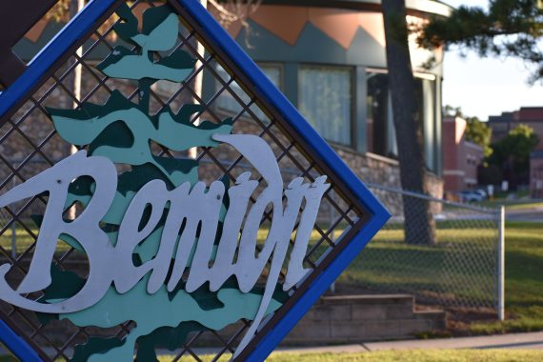
[[IMAGE REF 0000]] Image reference -- not directly editable; the original page reference is preserved automatically. Source: https://www.bemidjistate.edu/academics/music/wp-content/uploads/sites/58/2022/10/maggie_0400-570x380.jpg
IMAGEPLACEHOLDER0001

Timeline
Master of music education students will:
- Arrive in July for a 3-week residency in Bemidji. You’ll live in Linden Hall with your cohort or commute to campus if you reside nearby. Much of your coursework will be hands-on — demonstration lessons, conducting, audiation exercises, group work — designed to improve your skills as a highly prepared practitioner.
- Between your second and third summer session, you’ll enroll in two private lesson courses with your faculty adviser to cover topics such as instrumental, vocal, arranging, conducting or composition.
- In your third and final year, those who are completing capstone projects will share final projects, theses or recitals with the community.

Our Curriculum
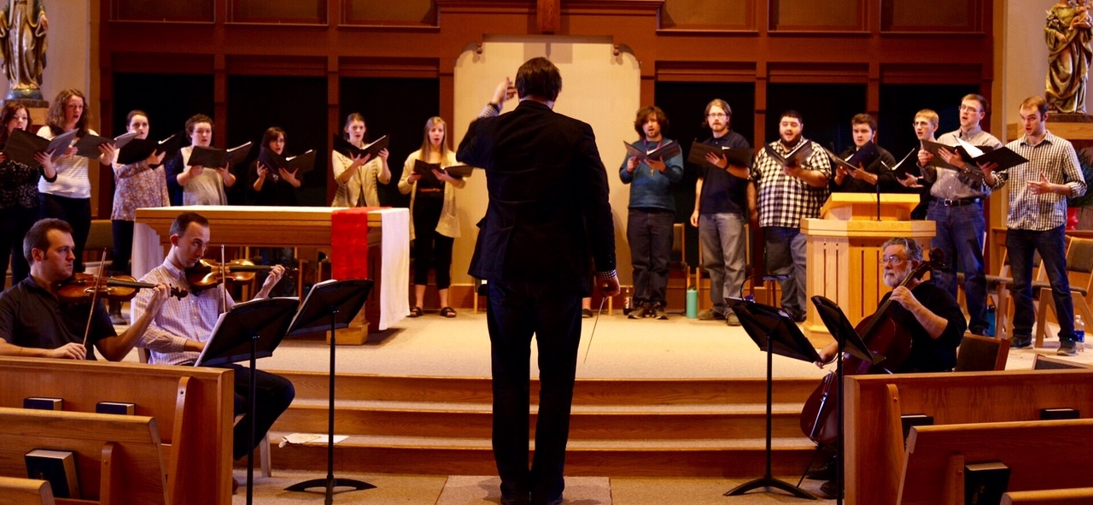
[[IMAGE REF 0002]] Image reference -- not directly editable; the original page reference is preserved automatically. Source: https://www.bemidjistate.edu/academics/music/wp-content/uploads/sites/58/2021/05/IMG_5732-copy.jpg
Our comprehensive Kodály-inspired curriculum unites faculty mentoring with specializations in choral, instrumental and general music. Topic courses provide instruction in areas such as Orff-Schulwerk, special education, classroom instruments and movement.
What You’ll Study

Our Campus
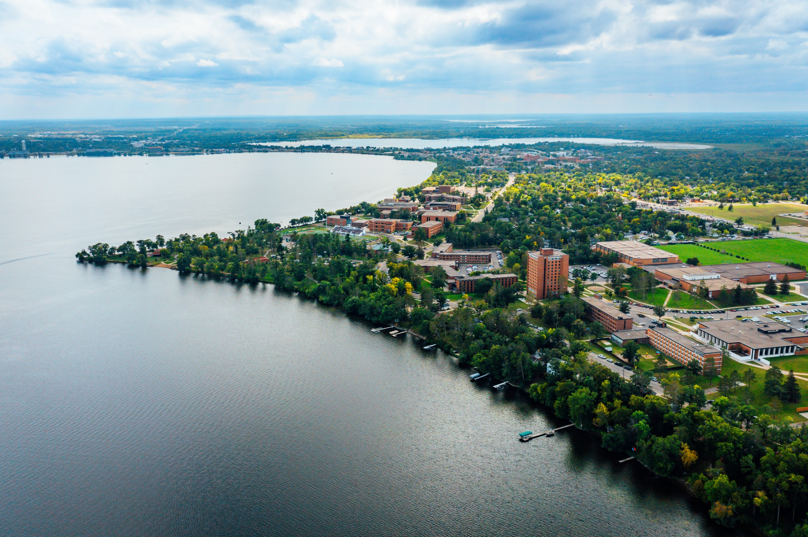
[[IMAGE REF 0003]] Image reference -- not directly editable; the original page reference is preserved automatically. Source: https://www.bemidjistate.edu/academics/music/wp-content/uploads/sites/58/2022/10/BSU-Drone-30.jpg
Each day, you’ll take hands-on courses in the Bangsberg Fine Arts Complex, overlooking stunning Lake Bemidji. Each evening, you’ll practice, write lesson plans and connect with your cohort in Linden Hall.
Surrounded by 90 acres of headspace, Bemidji State is just a minute’s walk from the charming City of Bemidji. Inspiration is everywhere on our campus.
See What Makes Us Special

Our Faculty
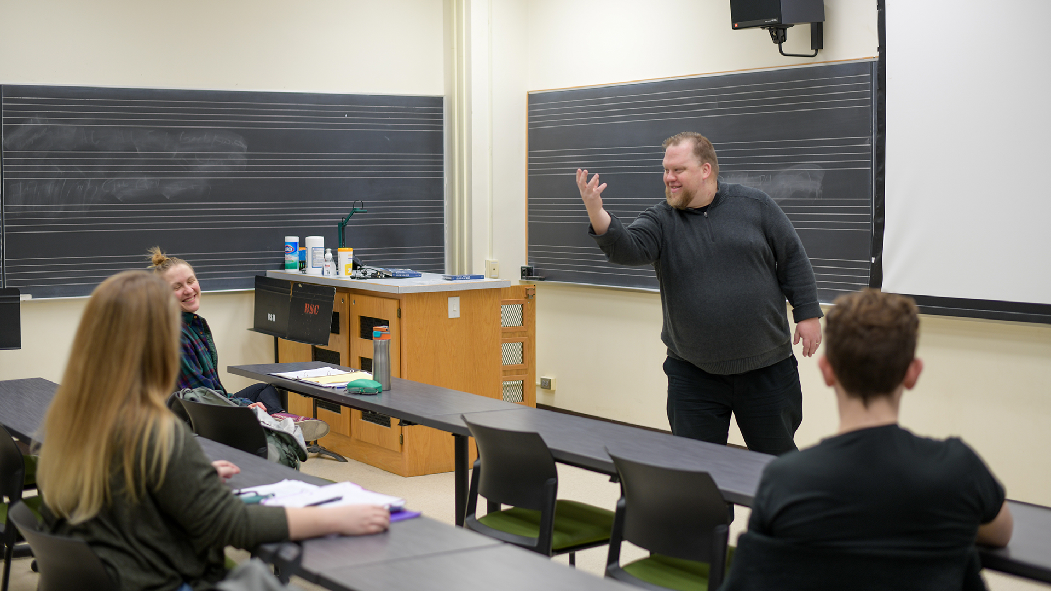
[[IMAGE REF 0004]] Image reference -- not directly editable; the original page reference is preserved automatically. Source: https://www.bemidjistate.edu/academics/music/wp-content/uploads/sites/58/2022/02/DSC_9328.jpg
The faculty of the Department of Music are committed to the intellectual, musical and social growth of all the musicians who attend Bemidji State University.
Read About Our Faculty

Admission and Requirements
The program launched its first cohort in Summer 2023. Complete the inquiry form to indicate your interest in applying or learning more about our program.
All interested applicants should have a bachelor’s degree in music or education, graduate level musicianship skills and proficiency in at least one instrument or voice part.
Visit our tuition and fees page for more information on costs.

Contact
Contact Dr. Eric Olson with any questions at eric.olson.2@bemidjistate.edu.

