Title | Mathematics
Meta Description
— Page content begins below. Please do not edit the table above. —
The study of mathematics is grounded in problem solving and includes the ability to think in a certain, organized way. It is fundamental to a number of disciplines and careers, including computer technology, business and the social sciences.

Actuarial Emphasis
This emphasis prepares students to successfully complete a series of exams required to become an actuary. Successful graduates are highly sought by large public and private companies, particularly in banking, credit and insurance industries. Courses in this program are listed in the Society of Actuaries directory of VEE courses.
For more information on the courses in this program, visit the course catalog.

Applied Emphasis
The applied emphasis focuses on mathematics and statistics in connection with sciences, technology, industry and business. This emphasis is an excellent choice for students pursuing a double major or planning to pursue graduate studies in applied mathematics or statistics.
For more information on the courses in this program, visit the course catalog.

General Emphasis
The general emphasis provides a balance of statistics and theoretical and applied mathematics for students interested in pursuing graduate studies or a career in mathematical research, college teaching, work in industry or government.
For more information on the courses in this program, visit the course catalog.

Degrees in Action
Mathemathics majors from Bemidji State go on to do some incredible things with their degrees.

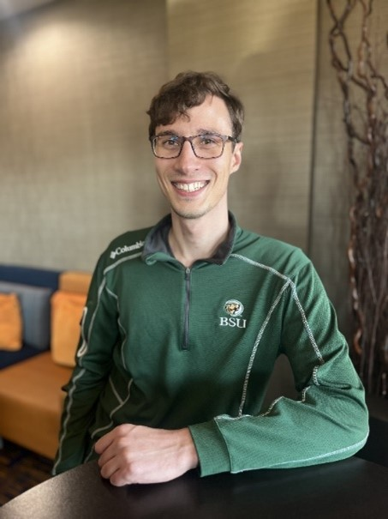
[[IMAGE REF 0000]] Image reference -- not directly editable; the original page reference is preserved automatically. Source: https://www.bemidjistate.edu/academics/mathematics-computer-science/wp-content/uploads/sites/36/2024/01/russell-dahlke.jpg
“I’m Russell Dahlke. I graduated from BSU in 2014 as a double major in math and economics. Following that, I attended Maastricht University, NL for a graduate program in econometrics and operations research. After returning to the US, I spent 5 years working at BSU in Enrollment Management and Institutional Research (IR), most recently as interim Assistant Director of IR where I helped start the “We are Listening” student surveys.
Currently, I’m a research associate for the Minnesota State college and university system focusing primarily on the state’s career and technical education programs. At present, I’m helping develop the state performance metrics and methodologies for our upcoming 4 year state plan which involves extensive use of descriptive and inferential statistics. The post-Covid period has brought unique challenges to this, such as how to best make upwards forecasts on time series that are trending downwards in order to meet legislative requirements.
Lastly, I want to thank all the outstanding faculty at BSU, many of whom I credit to helping me achieve my career and life goals. I’m extremely grateful for their mentorship and the opportunity to work with them while I was working at BSU.”
—Russell Dahlke, Mathematics and Economics Major,Research Associate – Minnesota State College and University System

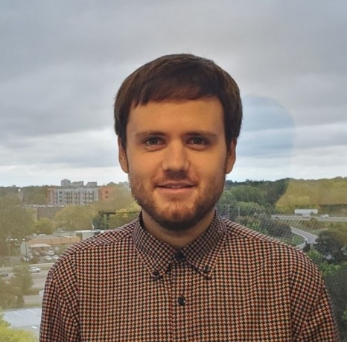
[[IMAGE REF 0001]] Image reference -- not directly editable; the original page reference is preserved automatically. Source: https://www.bemidjistate.edu/academics/mathematics-computer-science/wp-content/uploads/sites/36/2024/01/hanson.jpg
“After an Actuarial internship at Travelers Insurance, I instead started at Intact Insurance Specialty Solutions (previously OneBeacon Insurance Group) in the Statistical Reporting group within Finance shortly after graduating, and later moved into Actuarial a year and a half later, and have happily been here ever since! I spent 3 years on the pricing Actuarial team working with Commercial Auto coverage, and for the last year I’ve been on the reserving Actuarial team, where I help with International Financial Reporting Standards (IFRS) reporting (due to being part of an international company!), and reserving for a number of our business units, including our Entertainment unit, who has insured a lot of big name movies, musical artists, and celebrities you may have heard of!
As a mathematics and accounting graduate, being an actuary is the perfect career for me; it’s a perfect way to use mathematical skills and thinking in a business context, as many of the techniques we use to project historical data to price & reserve for insurance are rooted in probability & statistics. Depending on your role, there can also be a decent amount of coding involved in a number of different programming languages such as SQL, VBA & R, so it’s great for people interested in computer science and data science! It’s also great for those who value continual learning and professional development, as the professional actuarial exams continue to develop your knowledge past college while also boosting your career, and beyond the exams, insurance is an ever-changing field with new risks to understand and account for.”
—Brent Hanson Mathematics and Accounting Major Actuarial Supervisor – Intact Insurance Specialty Solutions

There is tons of math and mathematical thinking in my work. Given the datasets I am working with, I utilize various statistical methods to build models related to performance and/or injury risk, draw from physics principles to determine how the body is moving, and use plenty of calculus and linear algebra to calculate the various metrics we analyze on a daily basis.”
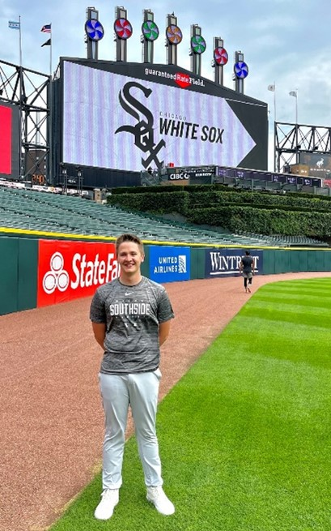
[[IMAGE REF 0002]] Image reference -- not directly editable; the original page reference is preserved automatically. Source: https://www.bemidjistate.edu/academics/mathematics-computer-science/wp-content/uploads/sites/36/2024/01/aron-trunt.jpg
“I am Aaron Trunt, a 2017 graduate from BSU with a double major in Exercise Science and Applied Mathematics. After my undergraduate degree at Bemidji I went on to the University of South Dakota where I graduated with my PhD in Biomedical Engineering in 2022. During my time at USD, my research focus was on sports biomechanics, the study of human movement and how it pertains to injury mechanisms and performance of athletes, specifically in golf and baseball pitching populations. In February of 2023, I was hired by the Chicago White Sox as a Biomechanist. With the White Sox I primarily use biomechanics data from our motion capture labs as well as in-game data to identify biomechanical trends related to injury risk as well as ways to improve performance on the field for both our pitchers and hitters. I work closely with the coaches, performance staff, and players to communicate findings and develop long-term plans for success on the field.
—Aron Trunt, Applied Mathematics and Exercise Science Major, Biomechanist – Chicago White Sox

In the fall of 2017, I interviewed and was offered a job on the Optum Insight Finance team starting in May of 2018. Optum Insight is a healthcare technology company, underneath the United HealthGroup umbrella. We focus on providing data and analytics, research and consulting, technology, and managed services solutions to the healthcare industry. Focusing on payers, providers, governments, and life science companies.
Through my 5 years, I worked my way up to becoming a Finance Manager. My latest role, focuses on providing operational leaders with financial data and analytics around their workforce to help drive operational efficiencies and help them make informed decisions.
On a day by day basis, I am most often applying mathematical modeling, problem solving, and applying logic. Working primarily in Microsoft Excel, logic is the basis for creating good modeling to do scenario testing. Additionally, problem solving is almost always embedded in my work.”

[[IMAGE REF 0003]] Image reference -- not directly editable; the original page reference is preserved automatically. Source: https://www.bemidjistate.edu/academics/mathematics-computer-science/wp-content/uploads/sites/36/2024/01/Ryan-Kurtz-Mathematics-and-Finance-Major.png
“I graduated in the spring of 2018 with a double major in mathematics and finance.
—Ryan Kurtz, Mathematics and Finance Major, Finance Manager – Optum Insight Finance team (United HealthGroup)

