Title | Music
Meta Description
— Page content begins below. Please do not edit the table above. —
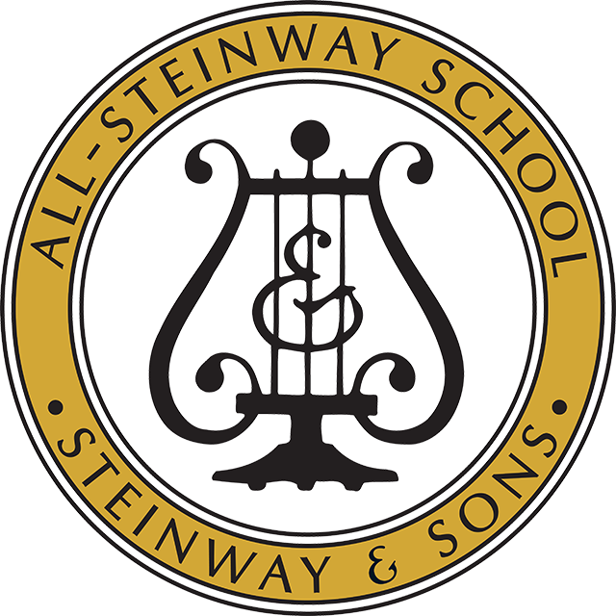
[[IMAGE REF 0000]] Image reference -- not directly editable; the original page reference is preserved automatically. Source: https://www.bemidjistate.edu/academics/music/wp-content/uploads/sites/58/2021/12/SeekPng.com_troy-university-logo-png_6360965.png
Practice, perform and master your craft by the beautiful forests, rivers and lakes of northern Minnesota. With over 80 years of tradition, the Bemidji State School of Music can help you realize your musical goals.
Bemidji State University is fully accredited by the National Association of Schools of Music and the School of Music is recognized as an All-Steinway School.
National Association of Schools of Music
11250 Rober Bacon Drive, Suite 21
Reston, VA 20190-5248

