Title | Ojibwe
Meta Description
— Page content begins below. Please do not edit the table above. —
At Bemidji State University, our commitment to celebrating and preserving indigenous cultures extends to the rich linguistic heritage of the Ojibwe people. Our Ojibwe Language Programs aim to promote the understanding, acquisition and revitalization of Ojibwe, which holds a unique and vital place in the cultural fabric of our region.

Ojibwe Language Programs
Designed for students from diverse backgrounds and expertise levels, our programs provide immersive experiences that combine rigorous academic study with engaging cultural exploration.
Whether you are an Ojibwe community member seeking to reconnect with your roots, a language enthusiast excited to discover new linguistic landscapes or an educator looking to expand your skillset, our Ojibwe programs offer a comprehensive and enriching experience in this indigenous language.
- Ojibwe Minor
- Certificate in Instruction of Ojibwe
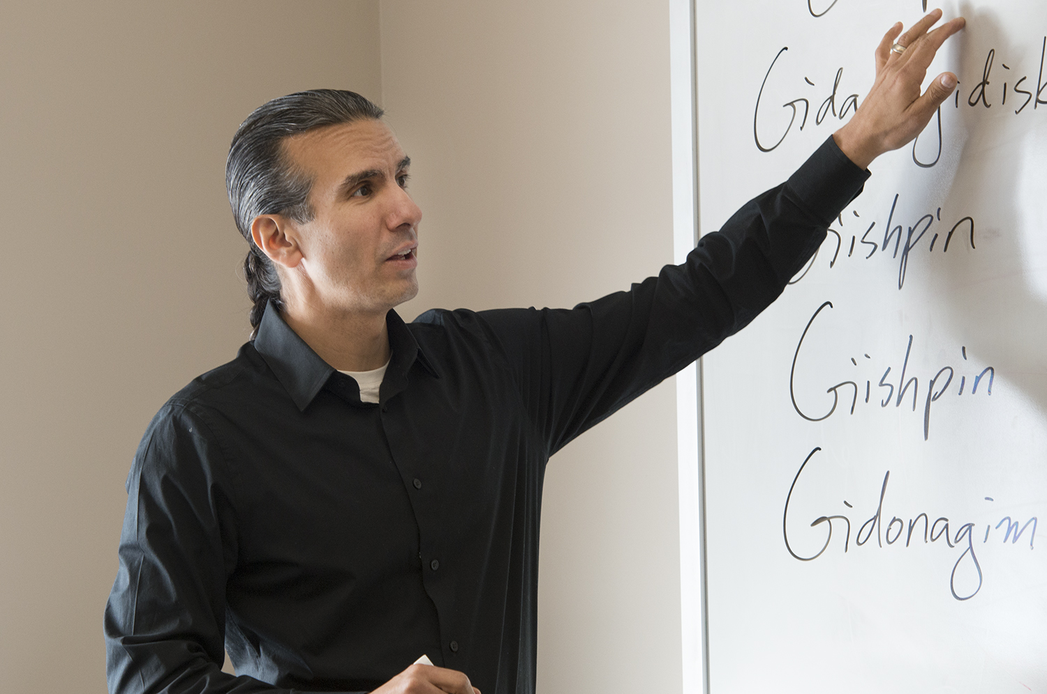
[[IMAGE REF 0004]] Image reference -- not directly editable; the original page reference is preserved automatically. Source: https://www.bemidjistate.edu/academics/languages-indigenous-studies/wp-content/uploads/sites/100/2022/03/Adv_Ojibwe_Treuer_0030.jpg

Ezhichigeyaang Bemijigamaag Gabe-gikendaasoowigamig Endazhi-gikenjigaadeg Anishinaabemowin
What we do in the Bemidji State University Ojibwe language program

Gikinoo’amaagewin – Teaching
Bemidji State University is home to the first collegiate Ojibwe language program in the United States, starting with adjunct classes in 1969 and a full three-year sequence of language courses starting in 1971. Additional current course offerings include Ojibwe Culture, Ojibwe Oral Literature and Instruction of Ojibwe.
Students can obtain a minor in Ojibwe at BSU. BSU Ojibwe program students include co-founders of Niigaane Ojibwe Immersion School and Wadookodaading Ojibwe Immersion Charter School, the highest performing Ojibwe immersion schools in the world, as well as many other language activists, scholars and cultural carriers.
There are currently over 250 Indian students at BSU and most are involved with the Ojibwe language program in some capacity. The Ojibwe teaching staff at BSU has garnered numerous awards for excellence in instruction.

Endazhi-gikinoo’amawindwaa Gekinoo’amaagejig – Teacher Training
BSU offers a Certificate in Instruction of Ojibwe. With the advent of tribal schools and Ojibwe immersion programs in Reserve (Wisconsin), Bena (Minnesota), Red Lake (Minnesota) and Ponemah (Minnesota), BSU seeks to train a new generation of fluent speakers who have training and credentials necessary to accelerate this critical dimension of the Ojibwe language revitalization movement.
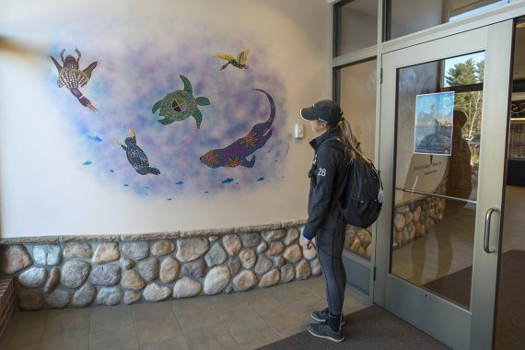
[[IMAGE REF 0000]] Image reference -- not directly editable; the original page reference is preserved automatically. Source: https://www.bemidjistate.edu/academics/languages-indigenous-studies/wp-content/uploads/sites/100/2023/04/AIRC_EntryMural_0053-570x380.jpg
IMAGEPLACEHOLDER0001

Endazhi-wiidookawindwaa Gikinoo’amaaganag – Student Enrichment
BSU staff assist in facilitating area language tables, coordinate activities with the campus language club and the Council of Indian Students and special events and activities for students that typically include trips to local Ojibwe ceremonies and language conferences. BSU’s Ojibwe program also participates in and often hosts a collegiate quiz bowl for Anishinaabemowin.

Endaawaad Anishinaabeg – Indian Communities
BSU is located in the heart of northern Minnesota right between the three largest reservations in the state and a short distance from all other Ojibwe communities in Minnesota. The relationship between the Ojibwe language program, the tribes and the communities they serve is deep and symbiotic. Fluent tribal elders regularly come to campus and the staff and students at BSU frequently go into the native communities for ceremonies, powwows, social and cultural events.
BSU staff has assisted the White Earth Reservation in presenting the preamble for their new constitution in the language and helping Red Lake Tribal Court to develop rulings and supporting material in the language. Tribal language and sovereignty go hand-in-hand. You are in Ojibwe country at BSU.
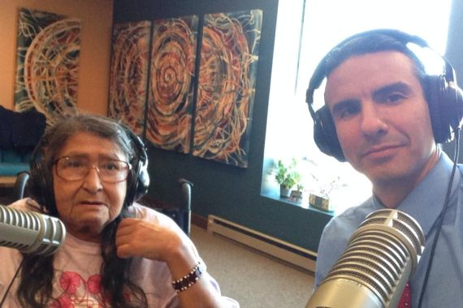
[[IMAGE REF 0002]] Image reference -- not directly editable; the original page reference is preserved automatically. Source: https://www.bemidjistate.edu/academics/languages-indigenous-studies/wp-content/uploads/sites/100/2023/03/4-AST-AG-Radio21-570x380.jpg
IMAGEPLACEHOLDER0003

Ozhibii’igewin – Scholarship
The academic record of the Ojibwe language program is truly distinguished. BSU Ojibwe language staff have published numerous books, ranging from the premier Ojibwe dictionary, A Concise Dictionary of Minnesota Ojibwe, to award-winning Ojibwe in Minnesota and a host of other languages, culture and history books, such as The Assassination of Hole in the Day, Aaniin Ekidong: Ojibwe Vocabulary Project and the first-ever monolingual young reader series for Ojibwe, Awesiinyensag: Dibaajimowinan Ji-gikinoo’amaageng.
BSU also publishes the only academic journal of the Ojibwe language, the Oshkaabewis Native Journal, in print since 1979 and now producing hundreds of pages of text and several audio CDs every year.
For more information about the courses in this program, visit the course catalog.

