Title | Physical Education
Meta Description
— Page content begins below. Please do not edit the table above. —
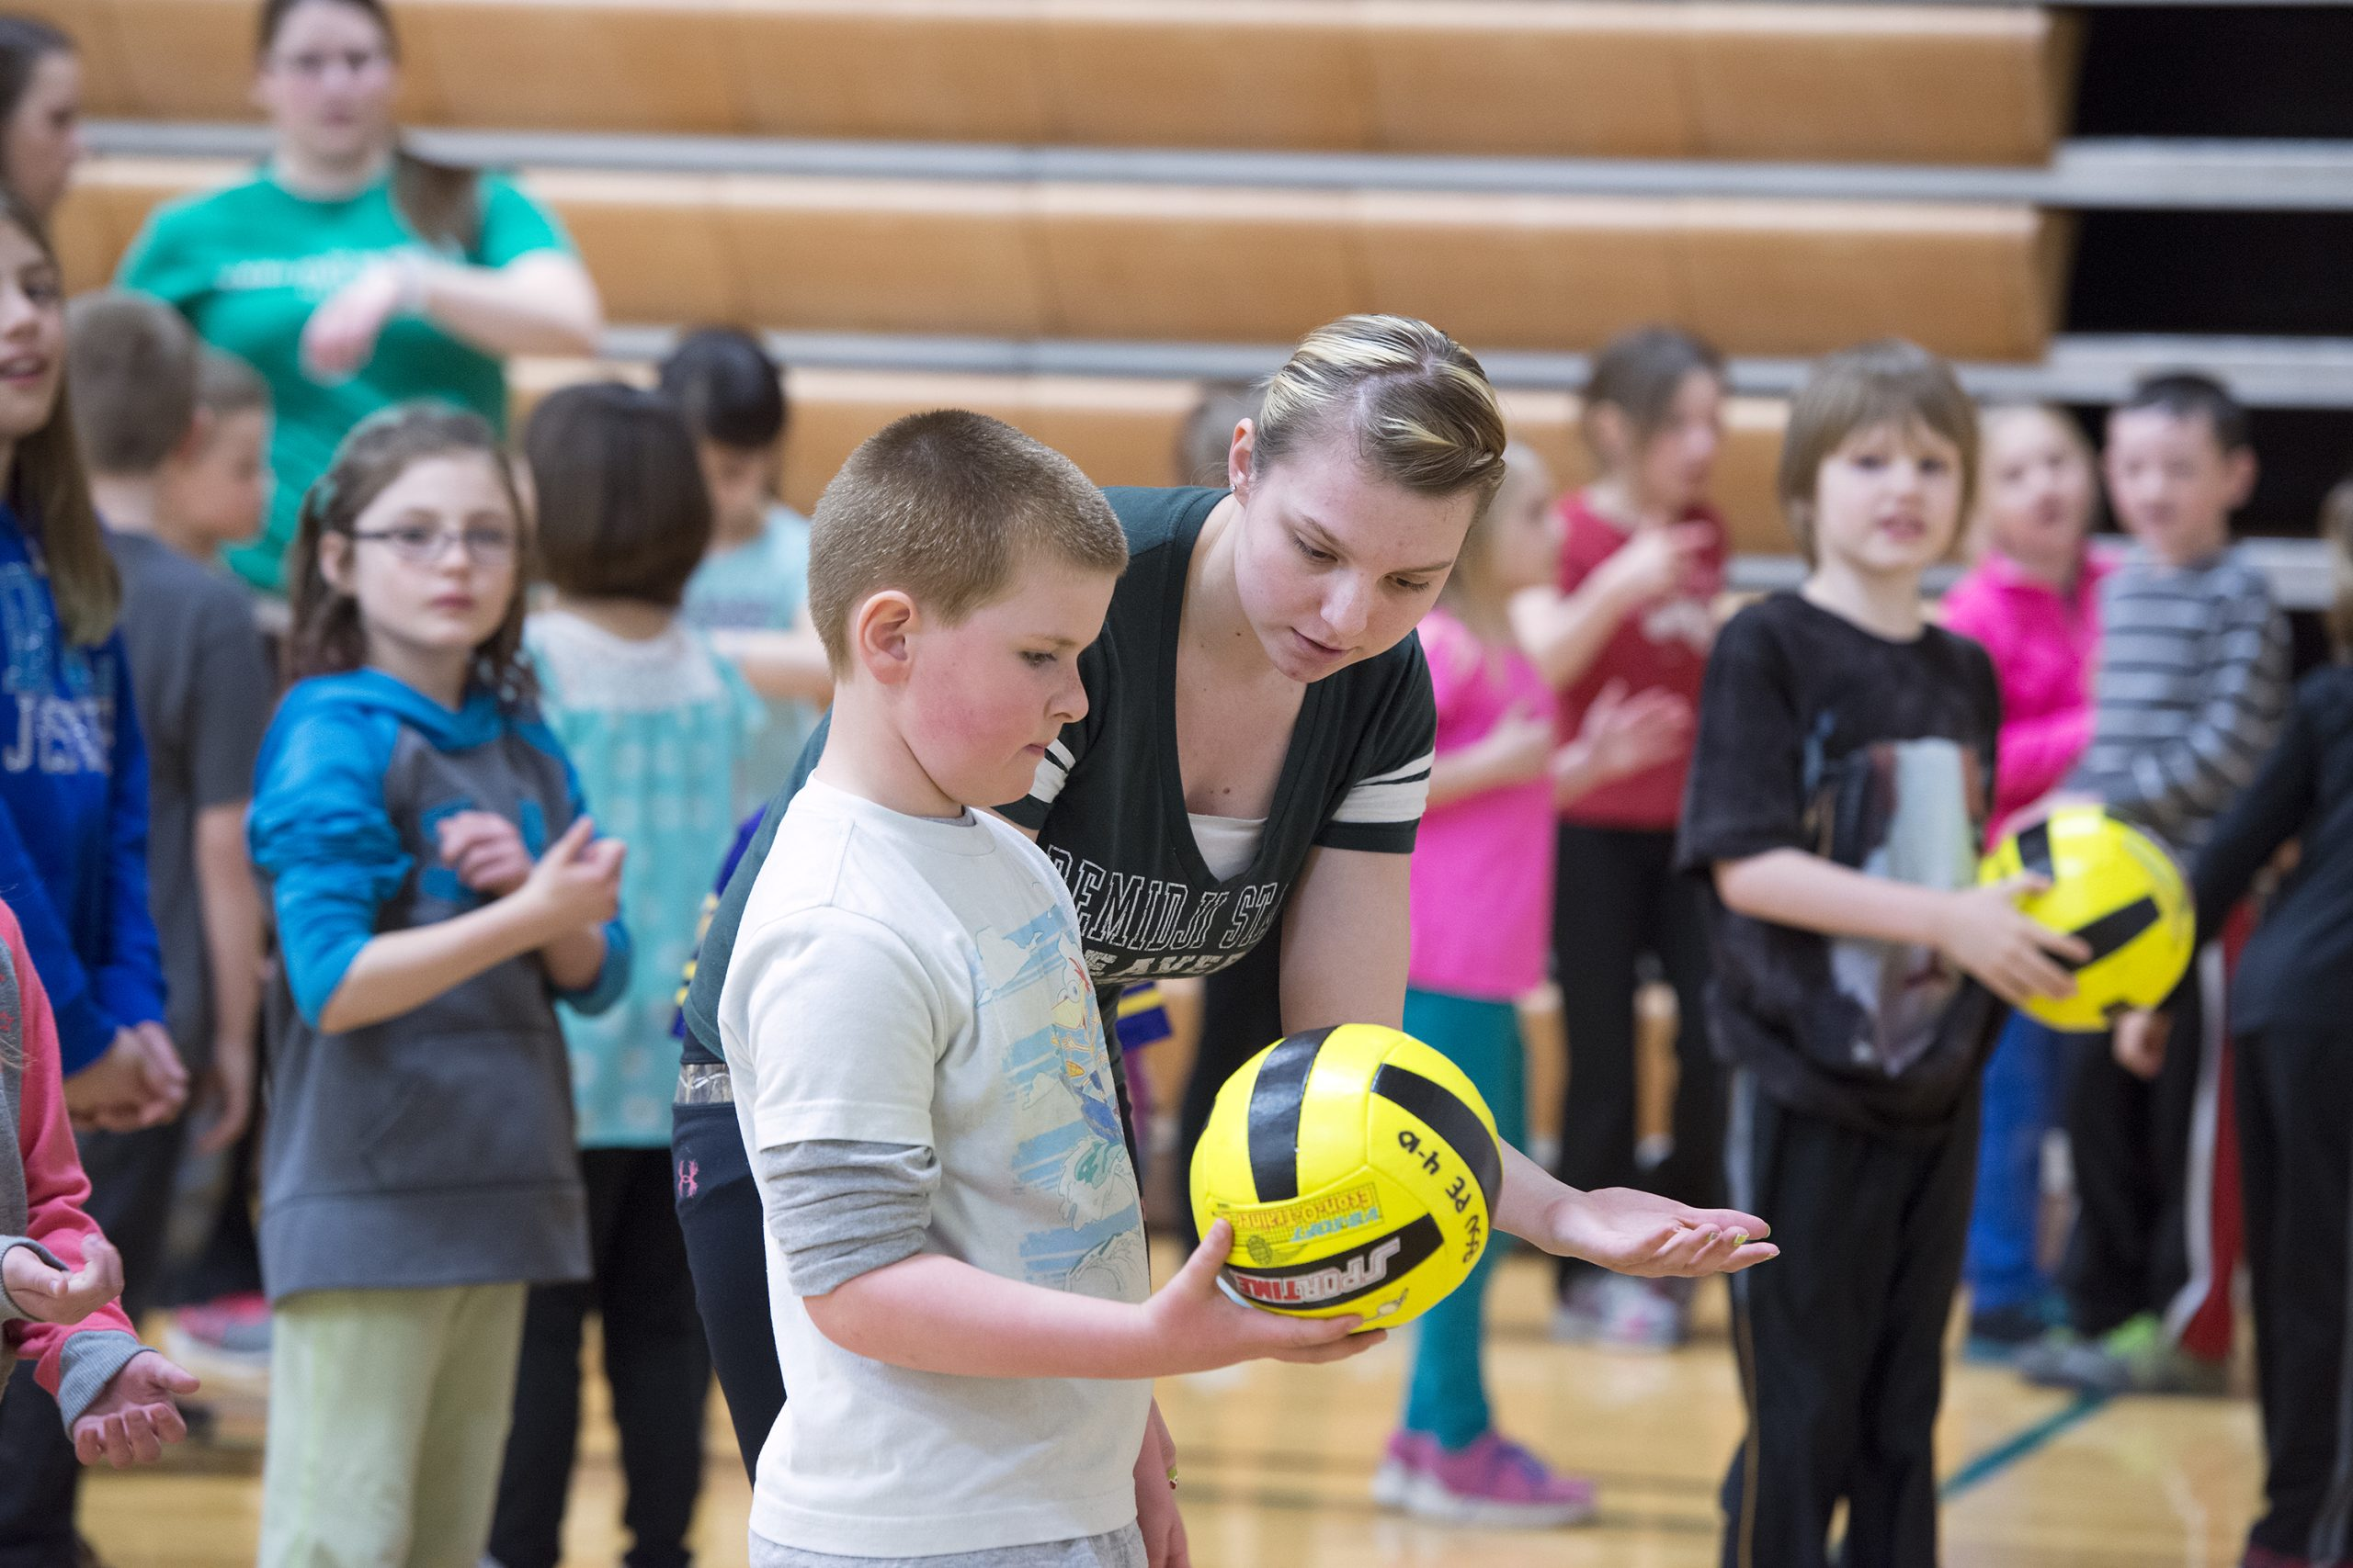
[[IMAGE REF 0000]] Image reference -- not directly editable; the original page reference is preserved automatically. Source: https://www.bemidjistate.edu/offices/teacher-education/wp-content/uploads/sites/148/2022/09/15Beaver_Fitness_Day_0037-scaled.jpg
The Physical Education B.S. program is for students who wish to be licensed physical education teachers in K-12 schools.
The Physical Education Teacher Licensure Program is designed to meet the teaching licensure requirements of the Minnesota Professional Educator Licensing and Standards Board (PELSB) and is guided by the National Physical Education Standards.
Hands-on learning is at the core of your educational experience. You learn from professionals in the field and experience teaching in real-world situations. The five methods courses focus on content and pedagogy in dance and rhythm, elementary physical education, team sports, individual sports and fitness activities. You engage in multiple field experiences that include observation, tutoring and teaching. Program completion requirements include 16 weeks of student teaching. Our program provides you with a diversity of experiences and the chance to develop a varied skill set that will increase your career options.
For more information on the courses in this program, visit the course catalog.
*Pursuing a dual license in both Physical Education and Health Education will allow you a wide range of teaching options and maximize your employment potential.

Multiple Teacher Licensures
Our program provides opportunities to gain a diverse and varied set of skills, experiences and credentials. You may choose to pursue teacher licensure majors in Health Education and Physical Education to open the door to more teaching options. We also offer a certificate program in coaching. Working together with your faculty advisor, you will plan your academic career to ensure that you will have the background and experiences that best fit your career goals.

DAPE Minor/Licensure for PE majors
Pursuing a DAPE minor or in addition to an existing license provides further career options. For more information about DAPE, visit Human Performance, Sport and health.
For more information about the courses in this program, check out the course catalog.

