Title | Spanish
Meta Description
— Page content begins below. Please do not edit the table above. —
Studying Spanish at BSU means you will be able to communicate in one of the most popular languages spoken in the world and the U.S. You will become familiar with the history and culture of Spanish-speaking societies and their role in the global context. Besides that, you will get a better understanding of your own culture(s) by making connections with Hispanic and Latino cultures.
Learning Spanish at BSU is a fun and eye-opening experience. You learn by using the language: writing poems for their Valentines, sharing micro-stories on social media, discussing changing gender roles in Latina societies or role-playing short drama plays. You will have the opportunity to practice in real life by studying abroad in a Spanish-speaking country or doing an internship in a multilingual or multicultural organization.
Besides language learning, being exposed to knowledge and works by Hispanic and Latino authors will allow you to look at the world with new perspectives and develop new insights into experiences that you may face in your personal and professional life.
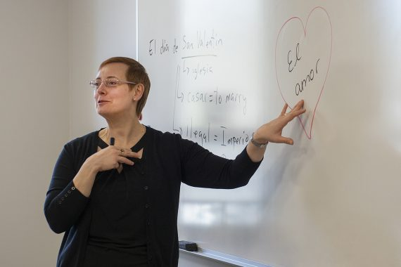
[[IMAGE REF 0000]] Image reference -- not directly editable; the original page reference is preserved automatically. Source: https://www.bemidjistate.edu/academics/languages-indigenous-studies/wp-content/uploads/sites/100/2023/04/Spanish2212_0078-570x380.jpg
IMAGEPLACEHOLDER0001

Spanish Programs
The Spanish program at Bemidji State allows students to acquire beginning- and intermediate-level Spanish-language skills with a few courses or go further and develop a level of mastery through a minor. The Spanish Minor requires 14 Spanish credits numbered 3300 or above.
Studying Spanish at BSU means that you choose the way to attend the classes that work best for you, in person or via Zoom. Your learning is recognized starting with your elementary Spanish courses and you decide the proficiency level you want to obtain in Spanish by choosing between the minor or major. A wide range of classes allows you to choose those that better suit your personal interests and professional plans.
For more information on the Spanish programs, visit the course catalog.

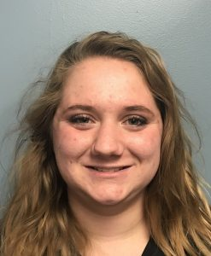
[[IMAGE REF 0002]] Image reference -- not directly editable; the original page reference is preserved automatically. Source: https://www.bemidjistate.edu/academics/languages-indigenous-studies/wp-content/uploads/sites/100/2023/04/Kortney-Carlin.jpg
“I am majoring in Spanish because I have fallen in love with the language. I love the way it sounds, and I also enjoy learning other languages. This is my eighth year studying Spanish. I started in eighth grade and continued all through high school.
My most valuable experience as a Spanish major has been perspective I have gained about the language and culture of Latin America. The professors have been very supportive. If I don’t understand something, they are very willing to take the extra time to help me.”
— Kortney Carlin
Spanish Culture and Language B.A.
Criminal Justice (Victimology emphasis) B.S.

Why study Spanish at BSU? Spanish students and graduates tell you why.

Preparing for Graduate Study in Spanish
Students majoring in Spanish may go on to graduate study in areas such as Spanish and Spanish American or Spanish literature, comparative literature or Hispanic linguistics. They may combine their Spanish studies with other areas to prepare for career opportunities in international business, government, travel or communications, where knowledge of a foreign language and of foreign cultures is essential.

Suggested Year-by-Year Plan
The list below is a suggested year-by-year plan for required language courses. It is intended to help students plan their courses in an orderly fashion. Students entering with previous high school language background may begin at the 2000 or 3000 level. See Dr. Miriam Rivera-Hokanson, department chair, for placement testing.
Spanish students are encouraged to choose liberal education courses in the following areas to enhance their language study: European and/or other appropriate History courses, Philosophy, European and/or appropriate Art History courses, folk dance, Economics or Political Science.
Year | Course
1 (Freshman) | * SPAN 1111 Elementary Spanish I (4 credits) * SPAN 1112 Elementary Spanish II (4 credits) * Second major or minor course work * Liberal Education requirements
2 (Sophomore) | * SPAN 2211 Intermediate Spanish I (3 credits) * SPAN 2212 Intermediate Spanish II (3 credits) * Second major or minor course work * Liberal Education requirements
3 (Junior) | * SPAN 3311 Composition and Conversation (3 credits) * SPAN 3312 Advanced Readings and Conversation (3 credits) * Second major or minor course work * Complete Liberal Education requirements
4 (Senior) | * SPAN 4427 Spanish Culture and Civilization (3 credits) * Spanish 3311 or above * Complete second major or minor course work

Minoring in Spanish
Bemidji State students can add a minor in Spanish by taking the 14 credits of language courses numbered 3300 or above. Doing so will ensure that they gain a high level of competence as a Spanish speaker, as well as in reading and writing the language.
These abilities will allow them to have a much richer and rewarding experience when traveling in Spanish-speaking countries, as well as living and working in U.S. communities with significant numbers of Spanish speakers.
Knowledge of Spanish can also be useful in virtually any profession that has an international, legal, health care or human services dimension.

Spanish Career Opportunities
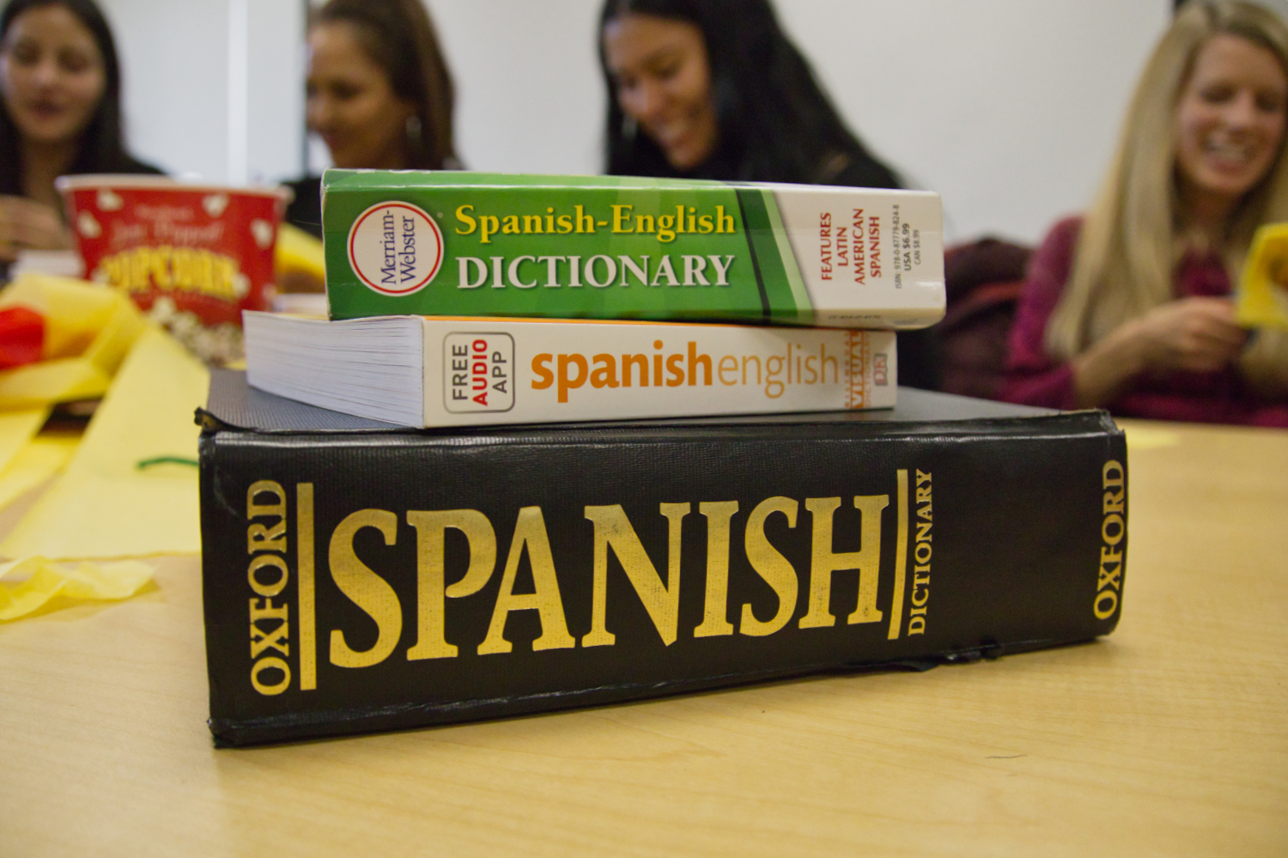
[[IMAGE REF 0003]] Image reference -- not directly editable; the original page reference is preserved automatically. Source: https://www.bemidjistate.edu/academics/languages-indigenous-studies/wp-content/uploads/sites/100/2023/03/MG_9839.jpg
Spanish-language ability is beneficial — and in some cases essential — to jobs in government, education, business, communications, health care and social and community services. Knowledge of Spanish is a preferred qualification for many positions and can lead to a higher salary, both immediately and over the long term. It also can offer an advantage for acceptance into graduate programs.

Local Connections
In addition to its well-rounded programs and curriculum and outstanding faculty, Bemidji State’s location offers another distinctive advantage — proximity to Concordia Language Villages, located 11 miles northeast of the BSU campus. Concordia, also known as CLV, is one of the world’s most respected centers for language immersion. Spanish students at BSU can enhance their learning by attending sessions in one of Concordia’s Spanish villages, all in beautiful north woods locations. They also can apply for jobs as youth camp counselors and in other staff roles.

Global Perspective
Regardless of whether you expect to use Spanish in your work, the ability to read, write and converse in the world’s third most common language will help make you a citizen of the world. Knowledge of Spanish enriches students’ appreciation of culture and the arts, expands study abroad options, increases international understanding and enables lifelong friendships with people around the world.

Contact Information
Spanish Program
Languages & Indigenous Studies
Bensen Hall 356
1500 Birchmont Drive NE #35
Bemidji, MN 56601-2699
Office: (218) 755-2810

