Title | Sustainability
Meta Description
— Page content begins below. Please do not edit the table above. —
- 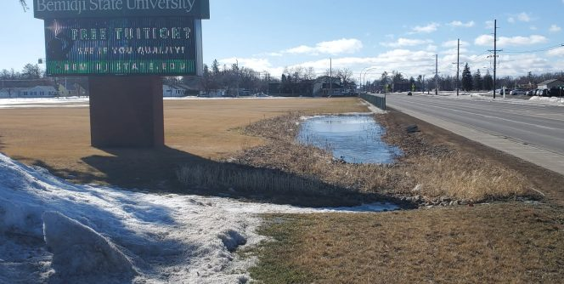
- 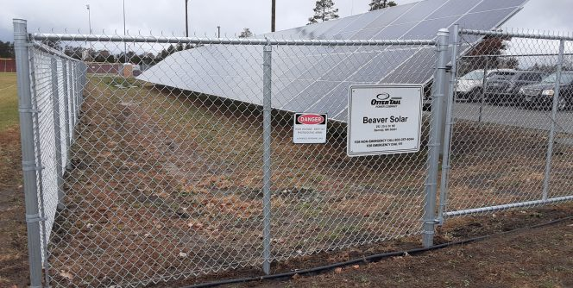
- 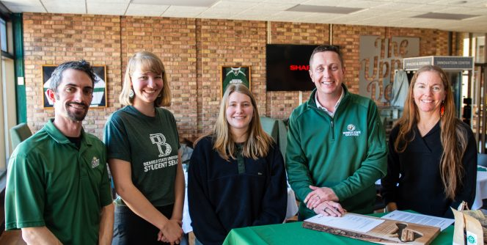
- 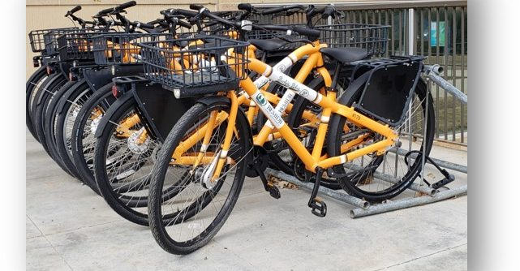
- 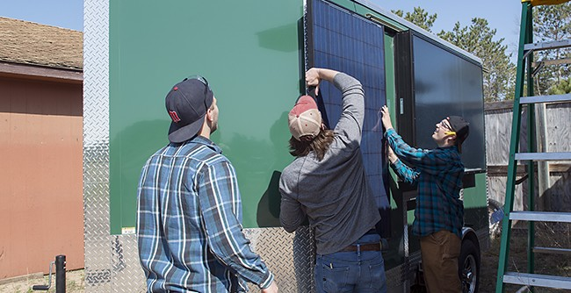
- 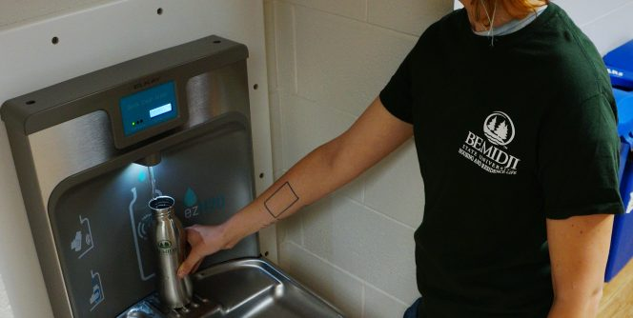
- 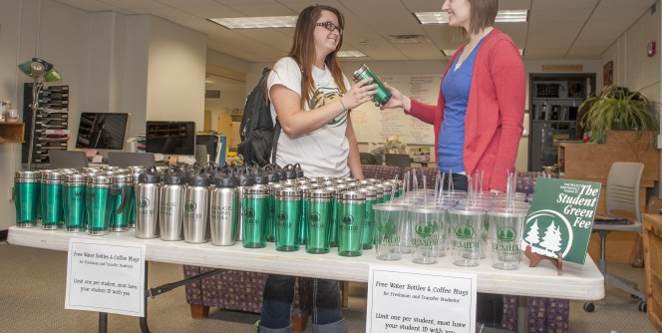
- 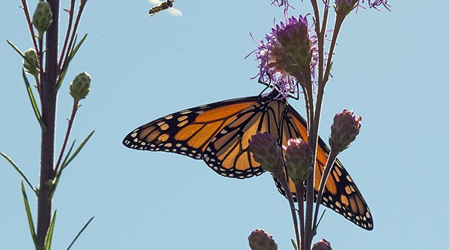

[[IMAGE REF 0000]] Image reference -- not directly editable; the original page reference is preserved automatically. Source: https://www.bemidjistate.edu/offices/sustainability/wp-content/uploads/sites/59/2025/04/2025.3.3.-EBJ-2-114x62.jpg

[[IMAGE REF 0001]] Image reference -- not directly editable; the original page reference is preserved automatically. Source: https://www.bemidjistate.edu/offices/sustainability/wp-content/uploads/sites/59/2024/11/20241104_110746-114x62.jpg

[[IMAGE REF 0002]] Image reference -- not directly editable; the original page reference is preserved automatically. Source: https://www.bemidjistate.edu/offices/sustainability/wp-content/uploads/sites/59/2024/10/2024-Climate-Committment-Signing-2-114x62.jpg

[[IMAGE REF 0003]] Image reference -- not directly editable; the original page reference is preserved automatically. Source: https://www.bemidjistate.edu/offices/sustainability/wp-content/uploads/sites/59/2020/07/Bucky-Bikes-locked-to-rack-114x62.jpg

[[IMAGE REF 0004]] Image reference -- not directly editable; the original page reference is preserved automatically. Source: https://www.bemidjistate.edu/offices/sustainability/wp-content/uploads/sites/59/2015/03/86-114x62.jpg

[[IMAGE REF 0005]] Image reference -- not directly editable; the original page reference is preserved automatically. Source: https://www.bemidjistate.edu/offices/sustainability/wp-content/uploads/sites/59/2020/07/DSC08800-114x62.jpg

[[IMAGE REF 0006]] Image reference -- not directly editable; the original page reference is preserved automatically. Source: https://www.bemidjistate.edu/offices/sustainability/wp-content/uploads/sites/59/2015/03/39-114x62.jpg

[[IMAGE REF 0007]] Image reference -- not directly editable; the original page reference is preserved automatically. Source: https://www.bemidjistate.edu/offices/sustainability/wp-content/uploads/sites/59/2015/03/11-114x62.jpg

News
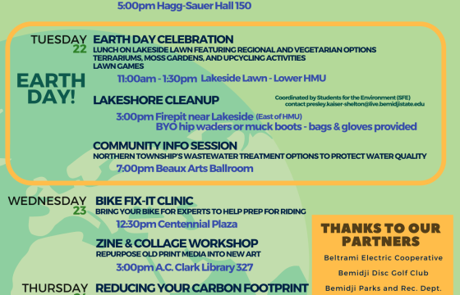
[[IMAGE REF 0008]] Image reference -- not directly editable; the original page reference is preserved automatically. Source: https://www.bemidjistate.edu/offices/sustainability/wp-content/uploads/sites/59/2025/04/Earth-Day-2025-560x360.png

BSU to host Earth Day activities through April 2025
Bemidji State University’s Sustainability Office is excited to invite the Bemidji community to observe Earth Day throughout April. This year marks the 56th annual celebration of Earth Day, a mobilization of people around the world in support of stewardship for our home. Though the international theme for Earth Day 2025 is Our Power, Our Planet, Bemidji […]
Keep reading »

[[IMAGE REF 0009]] Image reference -- not directly editable; the original page reference is preserved automatically. Source: https://www.bemidjistate.edu/offices/sustainability/wp-content/uploads/sites/59/2020/11/21BSU_Andrew_Wilson_0005-560x360.jpg

Bemidji State Hosts Minnesota GreenCorps Member to aid in Climate Resilience Planning
Bemidji State University welcomes Minnesota GreenCorps member Andrew as part of the university’s ongoing climate resilience planning efforts. Miller will assist in the process of rewriting BSU’s Climate Action Plan.
Keep reading »

Events
403 Forbidden

Forbidden
You don't have permission to access this resource.
Bemidji State University’s mission for sustainability is to promote awareness and instill passion for the Earth through our leadership in operational, academic, wellness, and community and cultural activities.

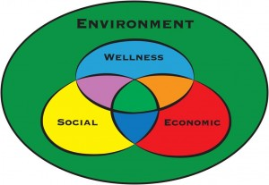
[[IMAGE REF 0010]] Image reference -- not directly editable; the original page reference is preserved automatically. Source: https://www.bemidjistate.edu/offices/sustainability/wp-content/uploads/sites/59/2015/03/Colorful-Wellness-Model-300x207.jpg
Here at BSU, we have a unique understanding of and commitment to sustainability in which we emphasize personal wellness along with social equity, economic feasibility, and environmental responsibility. Our perspective has been greatly influenced by Anishinaabe culture – we recognize we are a part of the earth and dependent on it for our survival. Click here to learn more about BSU’s wellness model for sustainability.

Quick Features
Bucky's bikes Bucky’s Bikes | BSU’s Bucky’s Bikes program provides long-term bicycle rentals to enrolled students, staff, and faculty. To rent a bike, email a completed rental waiver (Summer-2025-Rental-Agreement-Liability-Waiver) to Jordan.Lutz@bemidjistate.edu Bikes are available to rent for $25 per semester or $40 for the summer ($35 and $50, respectively, for faculty and staff). Check out this interactive map of local destinations accessible by bike!
BSU's FreeStore Free Store | The store where everything is FREE! If you’re a currently enrolled student, stop by Mon-Fri from 10:00–3:00 during the school year for school supplies, kitchen items, clothing, textbooks, etc. Have something you no longer want or need that’s still in good condition? Donate it by dropping it in the green “Donate Don’t Dumpster” bin as you enter the Free Store. Located in the Sustainability Office right across from the Bookstore.
TailWinds logo Green Power Partner | From 2009 through 2019, BSU was one of the EPA’s Green Power Partners because we purchased enough wind energy annually through Otter Tail Power’s Tailwinds program to cover 5% of campus electricity usage – about what the Student Union consumes. New program requirements prevented BSU from qualifying until it began retiring Renewable Energy Credits to offset its electricity consumption in 2024. We anticipate renewing our partnership through the program in 2025.
Beaver Solar | BSU’s first and only solar photo-voltaic array was installed in summer 2024. The 40kW array is the product of collaboration between Otter Tail Power and the Beltrami Soil & Water Conservation District. The rain garden beneath the array manages stormwater runoff from the Oak Hall parking lot and supports pollinator populations. Explore the array’s real-time energy production data.

News
[[IMAGE REF 0011]] Image reference -- not directly editable; the original page reference is preserved automatically. Source: https://www.bemidjistate.edu/offices/sustainability/wp-content/uploads/sites/59/2025/04/Earth-Day-2025-560x360.png

BSU to host Earth Day activities through April 2025
Bemidji State University’s Sustainability Office is excited to invite the Bemidji community to observe Earth Day throughout April. This year marks the 56th annual celebration of Earth Day, a mobilization of people around the world in support of stewardship for our home. Though the international theme for Earth Day 2025 is Our Power, Our Planet, Bemidji […]
Keep reading »
[[IMAGE REF 0012]] Image reference -- not directly editable; the original page reference is preserved automatically. Source: https://www.bemidjistate.edu/offices/sustainability/wp-content/uploads/sites/59/2020/11/21BSU_Andrew_Wilson_0005-560x360.jpg

Bemidji State Hosts Minnesota GreenCorps Member to aid in Climate Resilience Planning
Bemidji State University welcomes Minnesota GreenCorps member Andrew as part of the university’s ongoing climate resilience planning efforts. Miller will assist in the process of rewriting BSU’s Climate Action Plan.
Keep reading »

Events
403 Forbidden

Forbidden
You don't have permission to access this resource.

