Title | Water Science
Meta Description
— Page content begins below. Please do not edit the table above. —
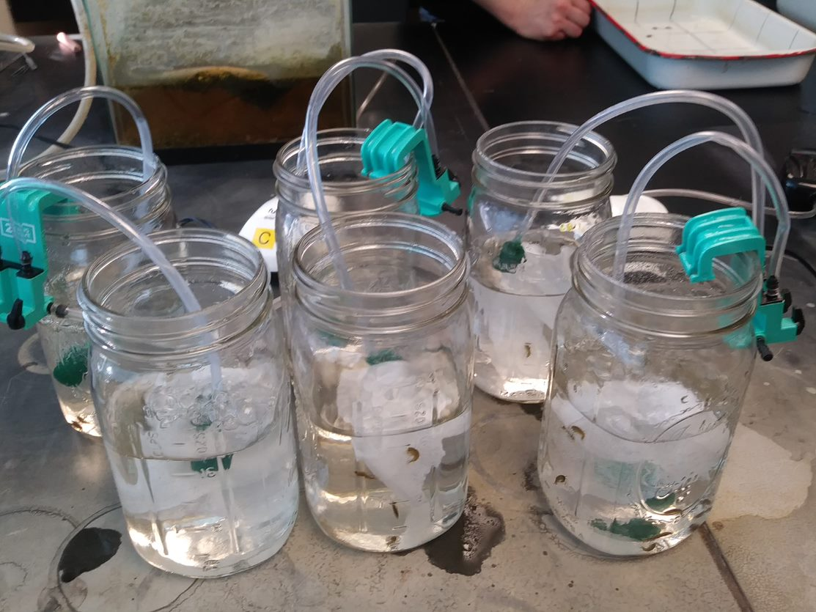
[[IMAGE REF 0000]] Image reference -- not directly editable; the original page reference is preserved automatically. Source: https://www.bemidjistate.edu/academics/css/environmental-studies/wp-content/uploads/sites/68/2022/03/Amphipod.jpg
Water drives the presence and abundance of life on Earth and human actions have greatly impacted the quantity and quality of water resources. Students pursuing the Water Science minor will gain an in-depth understanding of both water quality and water quantity management issues that our global and local communities face. By enrolling in this minor, students will complete courses that focus on the impact of human activities on the presence of nutrients and pollutants in our waters, as well as courses focusing on how water is distributed and managed across the surface and within the Earth. Ultimately, this minor will prepare students for careers with non-profit organizations, tribal, local, state and federal government agencies or private industry.
For more information on the courses in this program, visit the course catalog.

