Title | Faculty, Staff & Council Members
Meta Description
— Page content begins below. Please do not edit the table above. —
The Honors Program is governed by a Council of 12 Bemidji State University faculty members with specializations ranging from art and design, biology, computer science, criminal justice, library science, music, nursing, social work, theater and more. Each Council member is dedicated to fostering innovative cross-disciplinary thinking and guiding student research.

Our Mission
The Honors Program hosts an intellectually challenging, supportive environment featuring interdisciplinary active learning and a rigorous, dynamic curriculum. Faculty and students work together to gain new understandings and interests, engage in dialog, analyze ideas, practice creative and unconventional thinking and cultivate habits that lead to life-long learning.

Our Faculty & Staff
Dr. Miriam Webber
Interim Director of the Honors Program
Associate Professor
Bangsberg Hall 367, Memorial 312
Phone: (218) 755-3360
Email: miriam.webber@bemidjistate.edu
Field: Music
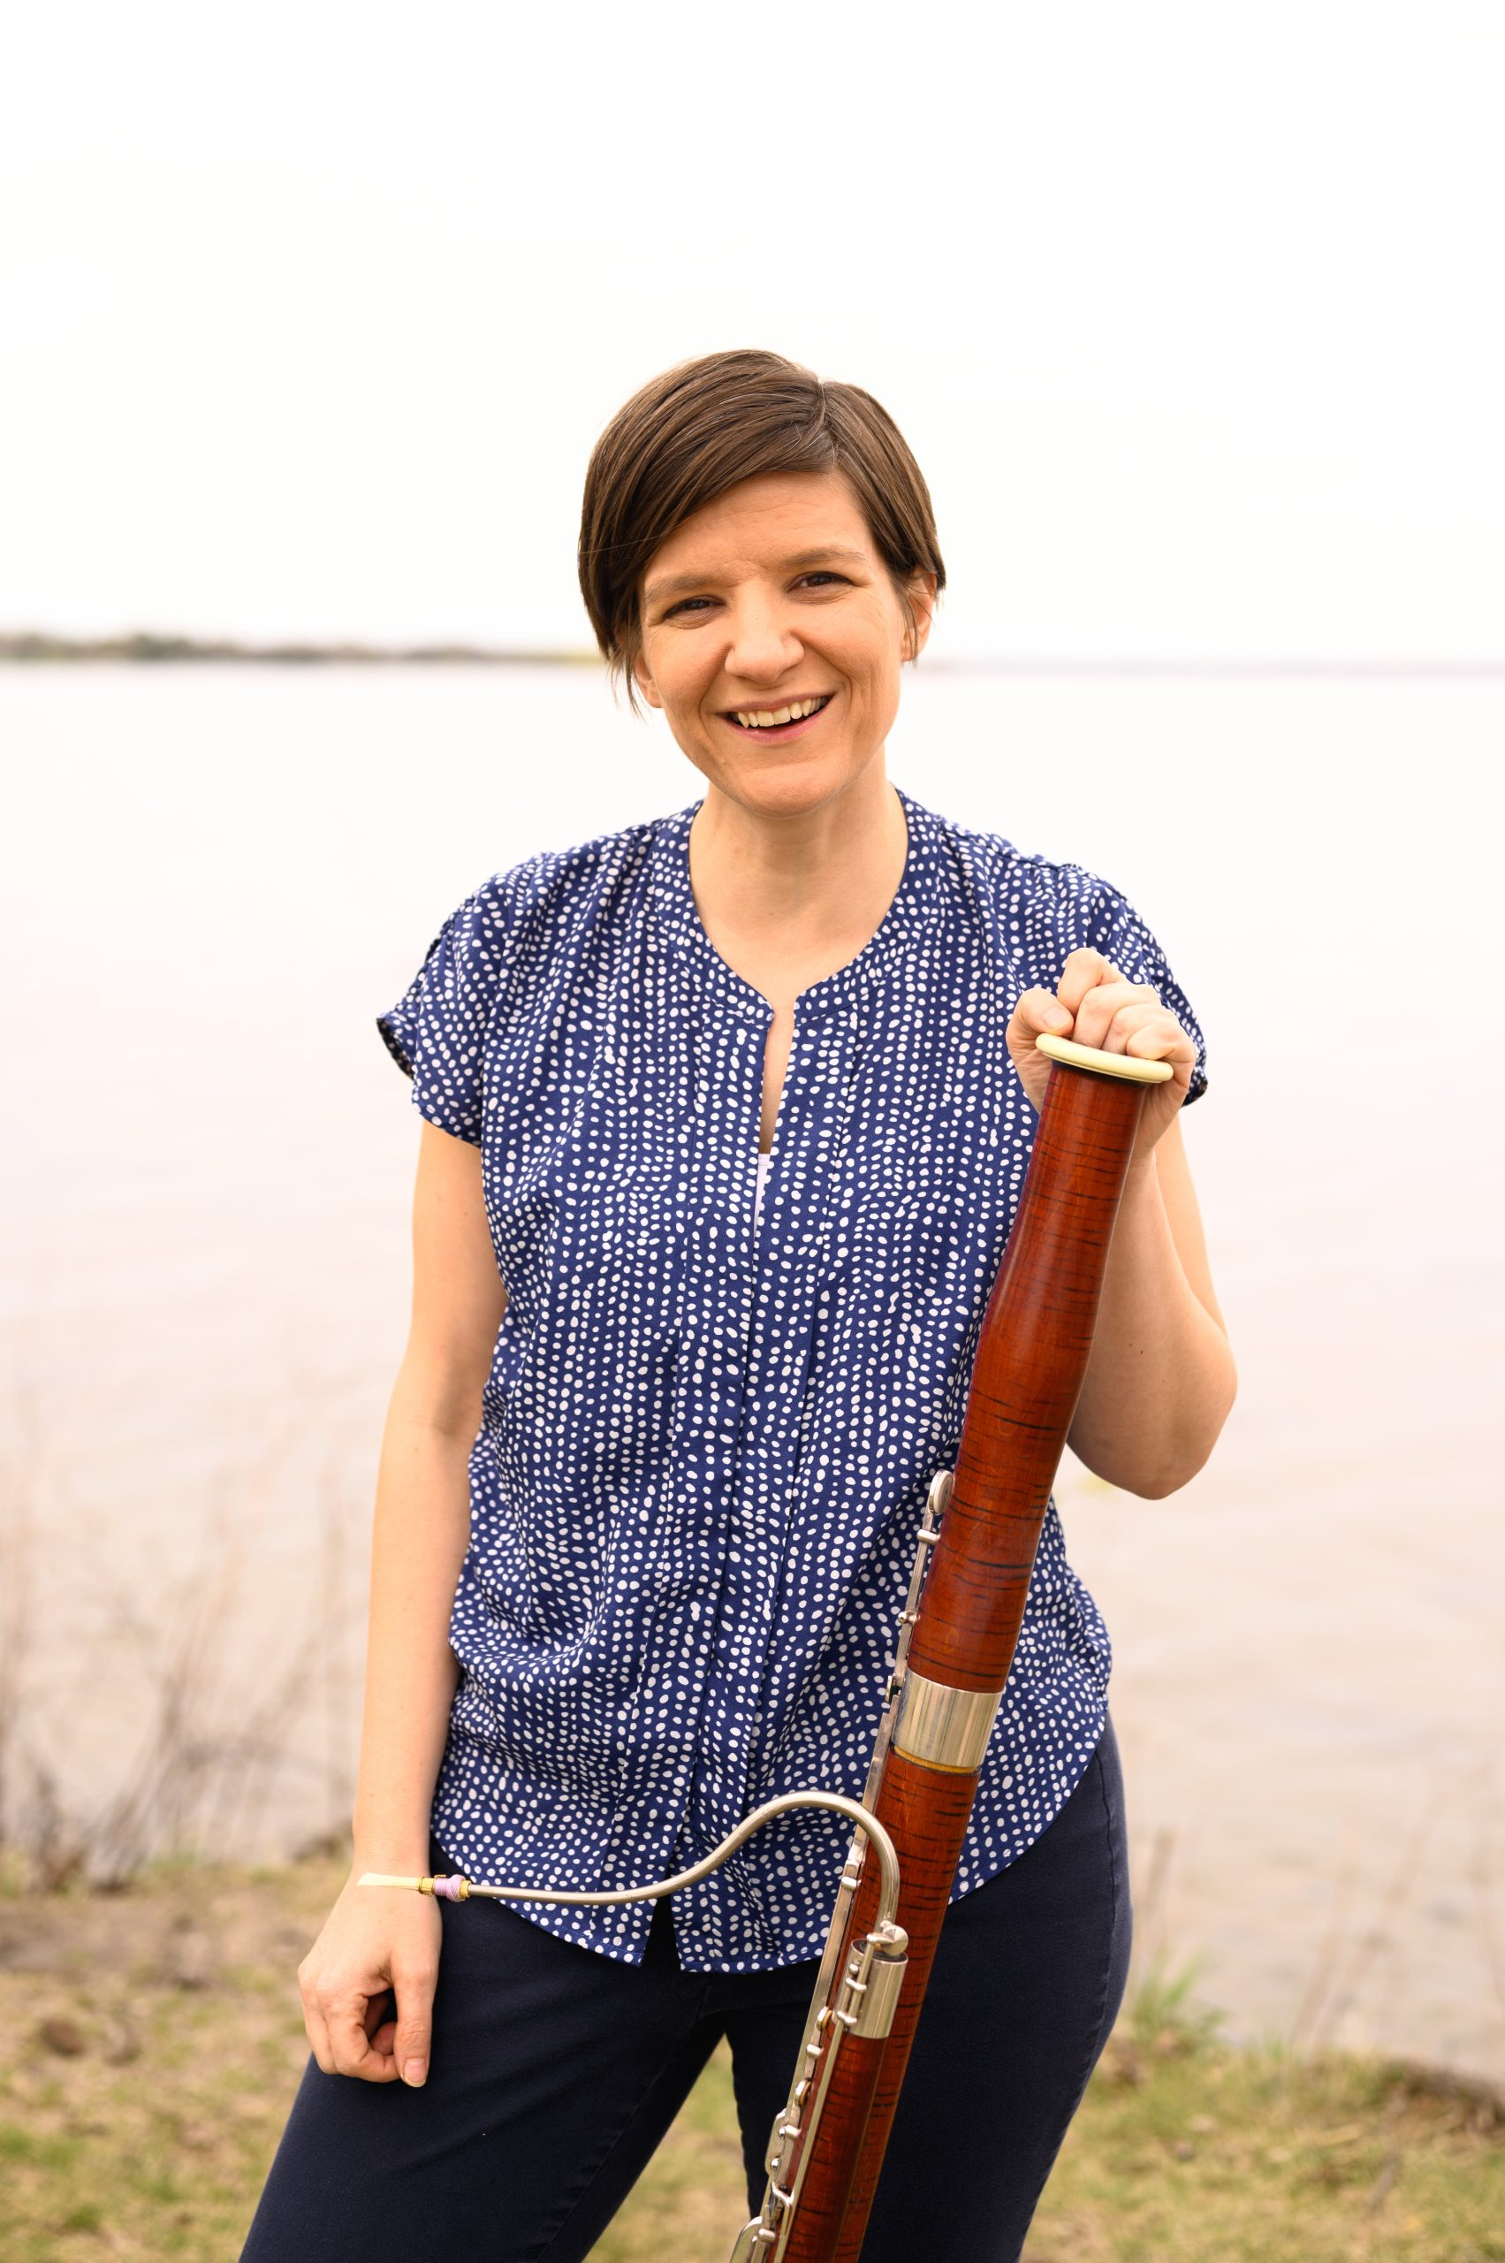
[[IMAGE REF 0000]] Image reference -- not directly editable; the original page reference is preserved automatically. Source: https://www.bemidjistate.edu/academics/honors/wp-content/uploads/sites/73/2022/12/Miriam-Webber-scaled.jpg

Seminar Professor Spotlight
Dr. Season Ellison
Associate Professor
Remote
Phone: (218)-755-3355
Email: season.ellison@bemdijistate.edu
Field: Humanities

[[IMAGE REF 0001]] Image reference -- not directly editable; the original page reference is preserved automatically. Source: https://www.bemidjistate.edu/academics/honors/wp-content/uploads/sites/73/2022/11/season_ellison-9912-Edit-595x744-1.jpg

Dr. Mark Fulton
Professor
Sattgast Hall 218E
Phone:(218) 755-2787
Email: mark.fulton@bemidjistate.edu
Field: Biology

[[IMAGE REF 0002]] Image reference -- not directly editable; the original page reference is preserved automatically. Source: https://www.bemidjistate.edu/directory/wp-content/uploads/sites/16/2023/02/mark-fulton-scaled.jpg

