Title | Study Abroad
Meta Description
— Page content begins below. Please do not edit the table above. —
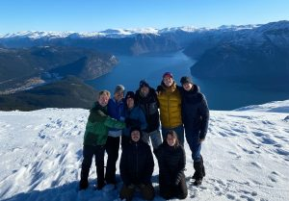
[[IMAGE REF 0000]] Image reference -- not directly editable; the original page reference is preserved automatically. Source: https://www.bemidjistate.edu/services/international/wp-content/uploads/sites/19/2025/09/Louis-e1756837722521-300x209.jpg
BSU student on HVL’s exchange program in Norway
Experience first-hand the Danish concept of hygge, an intangible sense of warmth and contentment.
An education abroad isn’t just a memorable part of your college experience. It is a chance to understand the world, your studies and yourself in a broader cultural context. Whether you travel to the East or head overseas to the Nordics, you’ll return to Bemidji State with a whole new perspective.
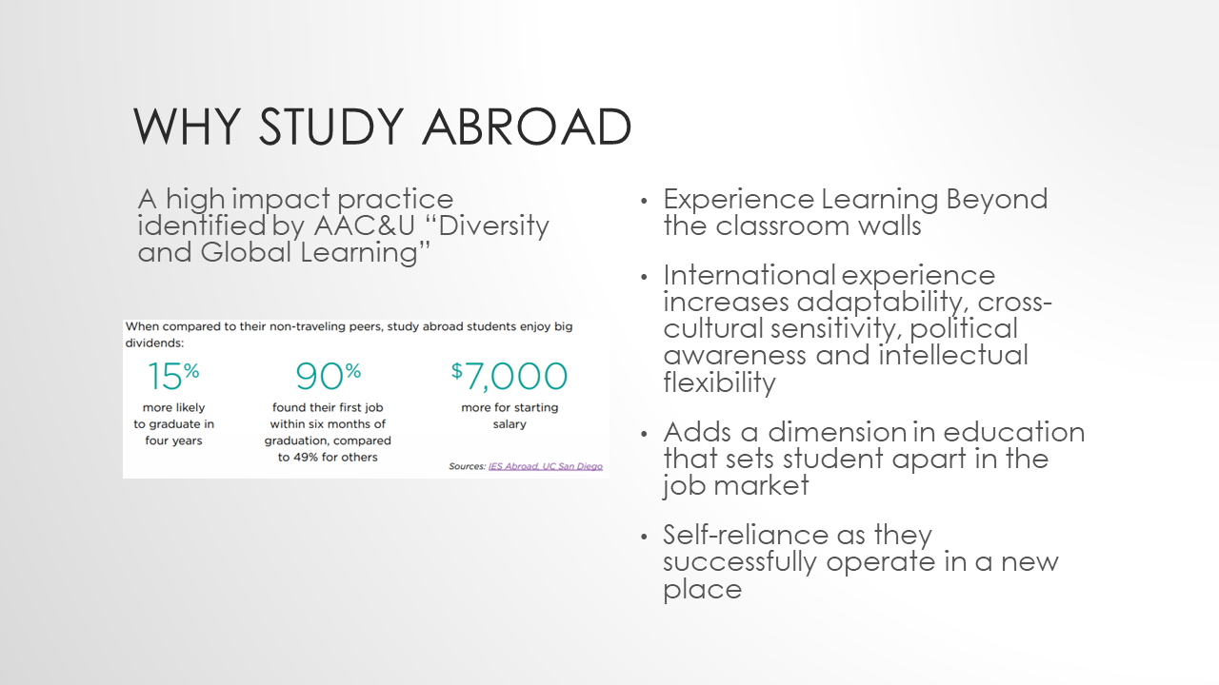
[[IMAGE REF 0001]] Image reference -- not directly editable; the original page reference is preserved automatically. Source: https://www.bemidjistate.edu/services/international/wp-content/uploads/sites/19/2023/09/Ed-abroad-presentation.png
To help you consider your options and prepare for international travel, we’ve put together a few helpful resources:
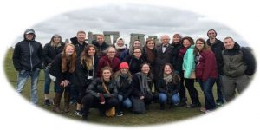
[[IMAGE REF 0002]] Image reference -- not directly editable; the original page reference is preserved automatically. Source: https://www.bemidjistate.edu/services/international/wp-content/uploads/sites/19/2014/08/Group-Photo-EuroSpring-2016-300x150.jpg

Getting Started

Application Deadlines
Please note the application deadlines (Beavers Abroad Application must be submitted by)
- For Spring Program: October 15
- For Summer Program: February 15
- For Fall program: March 7

3 Distinct Types of Study Abroad Programs at BSU:

1. Faculty Led Programs
Faculty led programs are short-term (1 to 5 weeks) study abroad programs led by BSU faculty.

2026-27 Offerings:
- Eurospring: 5 weeks in Oxford, England in Spring 2027
- International Choir: May 9 – 16, 2027 in Central Europe

Past Offerings
- SinoSummer program – 3 weeks in Nanjing, China in Spring 2026
- Social Work program – 2 weeks in Switzerland, France, The Netherlands, Canada

International Choir 2027
This program is only available to choir students. Connect with Dr. Isaac Lovedahl to inquire about the program.
Payment Deadlines
- October 15 – $1,000 Deposit Due
- December 15 – Full program fee due: (estimated to be $3,865)
The BSU Alumni Foundation and Music Department have raised funds to support student’s financial needs for this program. Talk with Dr. Isaac Lovedahl to inquire.
December 1 is the commitment deadline. No refunds available after this date.

2. Exchange Programs
Exchange programs are semester long programs where students direct enroll at our partner universities around the world. BSU students pay BSU tuition while they are abroad. Explore our exchange partner programs around the world.

3. Provider Programs
You may also participate on a BSU approved provider program. Providers offer study abroad programs and internship programs for a variety of length, including summer options, semester options, and yearlong options.

How to Study Abroad?
Step 1: Explore the different options and programs we offer, and Book an appointment with the International Program to discuss your plan.
Step 2: Start working on your Study Away Agreement Packet. If you are going on a BSU faculty-led program, skip to Step 3. The packet includes:
- Study Away Agreement
- Transfer Credit Approval Form
  - Meet with you academic advisor/department chair to determine how your study abroad credits will apply towards your degree at BSU. Fill out the Transfer Credit Form if you are going with a non-BSU program.
- Financial Aid Budget Approval Form (Meet with Financial Aid office if you will be using financial Aid to pay for the program)
**Step 3:**Pay the $150 application process fee. Fall 2026 promotion: save $100 on your application fee (only $50) if you pay and submit your application by October 1!
There are two ways to pay the fee
- Via PayMyTuition
  - Note that PayMyTuition charges a small fee
  - Select “$150 Study Abroad Application Processing Fee”
- With the Cashier’s Office
  - Make sure to keep your receipt.
  - Visit at Deputy Hall 202 or call at (218)755-2045 to make your payment.
  - The cashier’s window is open from 9am to 3pm Monday through Friday. However, since the register must be shut down by 3, please arrive at least 15 minutes prior to 3pm to allow sufficient time for processing.
  - Please inform the cashier that you are paying the Study Abroad Application Processing fee of $150. Make sure to collect the receipt for your payment so you can upload a copy to this application.)
Step 4: Fill out the Beaver Abroad Application.
- You will need to upload your completed Study Away Agreement and receipt for your application process fee while completing the application.
Step 5: Get accepted or nominated by BSU and apply with exchange partner or provider.
Step 6: As soon as you’ve been accepted to a program, start doing your work and research to prepare for international travel. Check out our Before You Travel guidefor helpful information about applying for your visa, overcoming language barriers and making foreign purchases.

Student Safety
Safety is vital for all of our students, especially those going abroad. All students going abroad are required to have insurance that covers them while away. Additionally, we are required to report all student hospitalizations and deaths during education abroad experiences. More information can be found here:
Minnesota Study Abroad Program Law
(Minnesota Statute chapter 312, article 1, section 5)
The “Minnesota Study Abroad Law” (August 2014) requires higher education institutions in Minnesota to report student hospitalizations and deaths abroad as well as ensure its study abroad programs comply with health and safety standards set by the Forum on Education Abroad. The Minnesota Office of Higher Education will then post the reported information in aggregate on its website annually, which institutions will provide a link to on its program information.
- The MN Office of Higher Education has posted data collected: http://www.ohe.state.mn.us/sPages/SAHS.cfm
[[IMAGE REF 0003]] Image reference -- not directly editable; the original page reference is preserved automatically. Source: https://www.bemidjistate.edu/services/international/wp-content/uploads/sites/19/2025/09/Louis-e1756837722521-300x209.jpg
BSU student on HVL’s exchange program in Norway

