Title | Land Acknowledgment
Meta Description | Bemidji State's land acknowledgement recognizes the Indigenous peoples who have been dispossessed from their homelands upon which an institution was built.
— Page content begins below. Please do not edit the table above. —
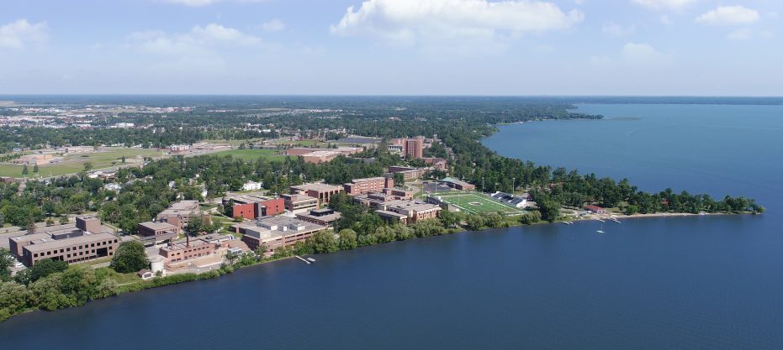
[[IMAGE REF 0000]] Image reference -- not directly editable; the original page reference is preserved automatically. Source: https://www.bemidjistate.edu/about/wp-content/uploads/sites/4/2021/04/Aerial-2018-DJI_0234_NewSky-1024x628-1-e1617815608721.jpg
We acknowledge that Bemidji State University is located on land and water that is the current and ancestral homeland of the Ojibwe and Dakota. We acknowledge the painful history of genocide, forced assimilation and efforts to alienate the Indigenous inhabitants from their territory here. We honor and respect the many diverse Indigenous peoples still connected to this land, retained tribal sovereignty, treaty rights and cultural resilience. Indigenous people are spiritual and physical caretakers of this land to which we all belong. Bemidji State University respects these sacred lands, stands with the community members from these Nations and will fight injustice in all its forms.

What is a Land Acknowledgment
An Indigenous Land or Territorial Acknowledgement is a statement that recognizes the Indigenous peoples who have been dispossessed from the homelands and territories upon which an institution was built and currently occupies and operates.
For some, an Indigenous Land or Territorial Acknowledgement might be an unfamiliar practice, but it is a common protocol within Indigenous communities in the United States and is a standard practice in both Australia and Canada. The terms “land” and “territorial” are not necessarily interchangeable, and the decision as to their use should be specific and local, pertaining to those Indigenous people who are being acknowledged as well as to those legacies and responsibilities of an institution that are also being acknowledged.
Within cultural institutions, these statements can be adopted in various ways. However, it is vital that they be spoken as a verbal statement given at the beginning of programs or events.

Indigenous Land Acknowledgements
In this video Dr. Anton Treuer, professor of Ojibwe in the Department of Languages and Indigenous Studies, shares additional information about Indigenous Land Acknowledgements —what they are, why they are important, what a good land acknowledgement will include and avoid and how to develop a sound process for developing one for your organization or institution.

Links & resources
March 4, 2021 news release — Bemidji State University Honors the Indigenous Land Where Campus Rests

