Title | News
Meta Description
— Page content begins below. Please do not edit the table above. —
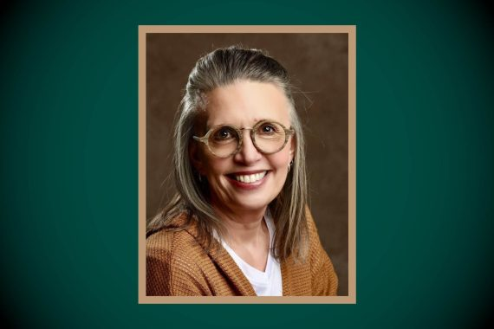
## BSU Creates New Opportunities for Inclusive, Accessible Higher Education
State grant helps BSU build first-of-its-kind program supporting students with intellectual, developmental disabilities.
Read more: BSU Creates New Opportunities for Inclusive, Accessible Higher Education

## Stories, Science and the Healing Power of Horses
Psychology professor Dr. Angela Fournier and partner Liz Letson seek science behind stories in horse-assisted services.
Read more: Stories, Science and the Healing Power of Horses

## “Disclosing Disclosure Day”: Music Faculty Member Explores Blockbuster Score
Ryan Webber examined the work of legendary composer John Williams for the July 2026 edition of "Film Score Monthly."
Read more: “Disclosing Disclosure Day”: Music Faculty Member Explores Blockbuster Score
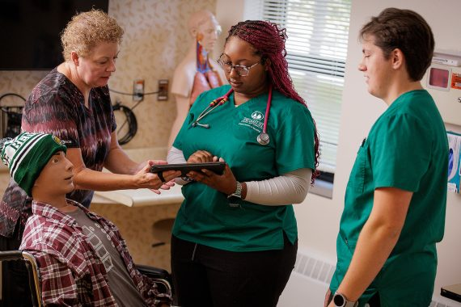
## Bemidji State Nursing Grads Lead Minnesota in Success on National Licensing Exam
All 26 spring grads who have taken the NCLEX exam passed on their first attempt; 1 of 2 MN schools with 100% success
Read more: Bemidji State Nursing Grads Lead Minnesota in Success on National Licensing Exam

## New and Reimagined Programs at BSU Support Student and Regional Workforce Needs
Changes include new data science and Ojibwe teacher training majors, revised computer science and design programs.
Read more: New and Reimagined Programs at BSU Support Student and Regional Workforce Needs
All Posts

