Title | Emergency Phones
Meta Description
— Page content begins below. Please do not edit the table above. —
There are several emergency blue light telephones installed throughout the University campus. These telephones are identified by a blue light and provide a direct line to the Public Safety Dispatcher.
- All elevators on campus have an emergency phone located within them that provides a direct line to the Public Safety Dispatcher.
- All Residence Hall entrances have an emergency phone located within them that provides a direct line to the Public Safety Dispatcher.
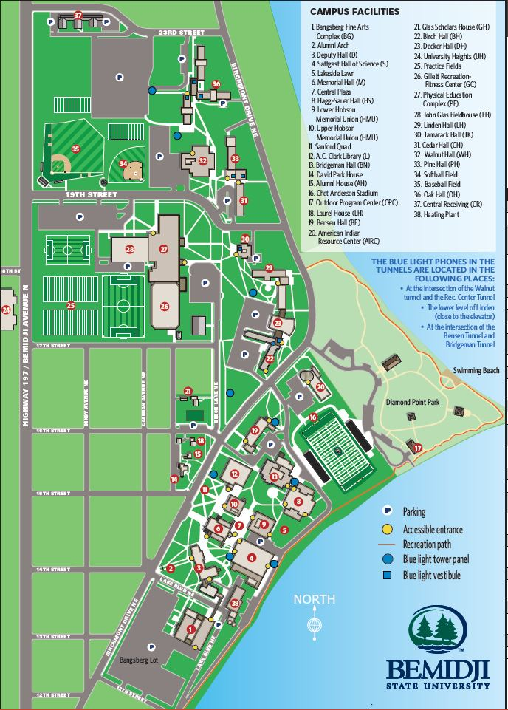
[[IMAGE REF 0000]] Image reference -- not directly editable; the original page reference is preserved automatically. Source: https://www.bemidjistate.edu/services/public-safety/wp-content/uploads/sites/92/2022/10/Blue-Light-Map-2022.jpg

