Title | Emergency Preparedness
Meta Description
— Page content begins below. Please do not edit the table above. —
BSU Emergency Management is an office in the Department of Public Safety. BSUEM is responsible for the comprehensive “all-hazards” emergency and disaster management planning efforts for the university.
With input from university stakeholders, we facilitate the development and implementation of emergency operations plans, department-based plans, continuity of operations plans and university preparedness plans. We encourage individual preparedness plans and promote programs and projects that facilitate institution-wide disaster resilience.
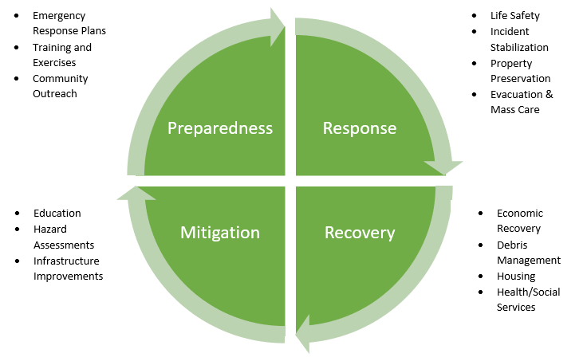
[[IMAGE REF 0000]] Image reference -- not directly editable; the original page reference is preserved automatically. Source: https://www.bemidjistate.edu/services/public-safety/wp-content/uploads/sites/92/2022/10/EM-Circle-Pic..png

