Title | Career Outlook
Meta Description
— Page content begins below. Please do not edit the table above. —

Discovering the path to your future career begins the day you enter college. Every experience you have at BSU shapes the professional you’ll become. The Career Advancement Office is here to guide and support you, helping you explore options, build skills, and design a career path that prepares you to leave BSU career-ready

We can help you begin your academic journey by helping you choose your major

What Will Your Path to Success Be
Many roads lead to successful outcomes — but the journey you take will be unique to you. Over the next few years, we’ll provide you with the resources and support you need to get to where you want to go.

I’m Just Getting Started

[[IMAGE REF 0000]] Image reference -- not directly editable; the original page reference is preserved automatically. Source: https://www.bemidjistate.edu/services/career/wp-content/uploads/sites/97/2022/10/Fall-Road-2021.jpg
We all start somewhere! Maybe you just graduated from high school and think that two or three majors sound interesting. (Okay, maybe four or five…) Or you might have completed some of your requirements and want to know, “What next?” We’re here to help you follow your passions and make informed choices about what you need to do to succeed after BSU.
Choose Your Major

Halfway There
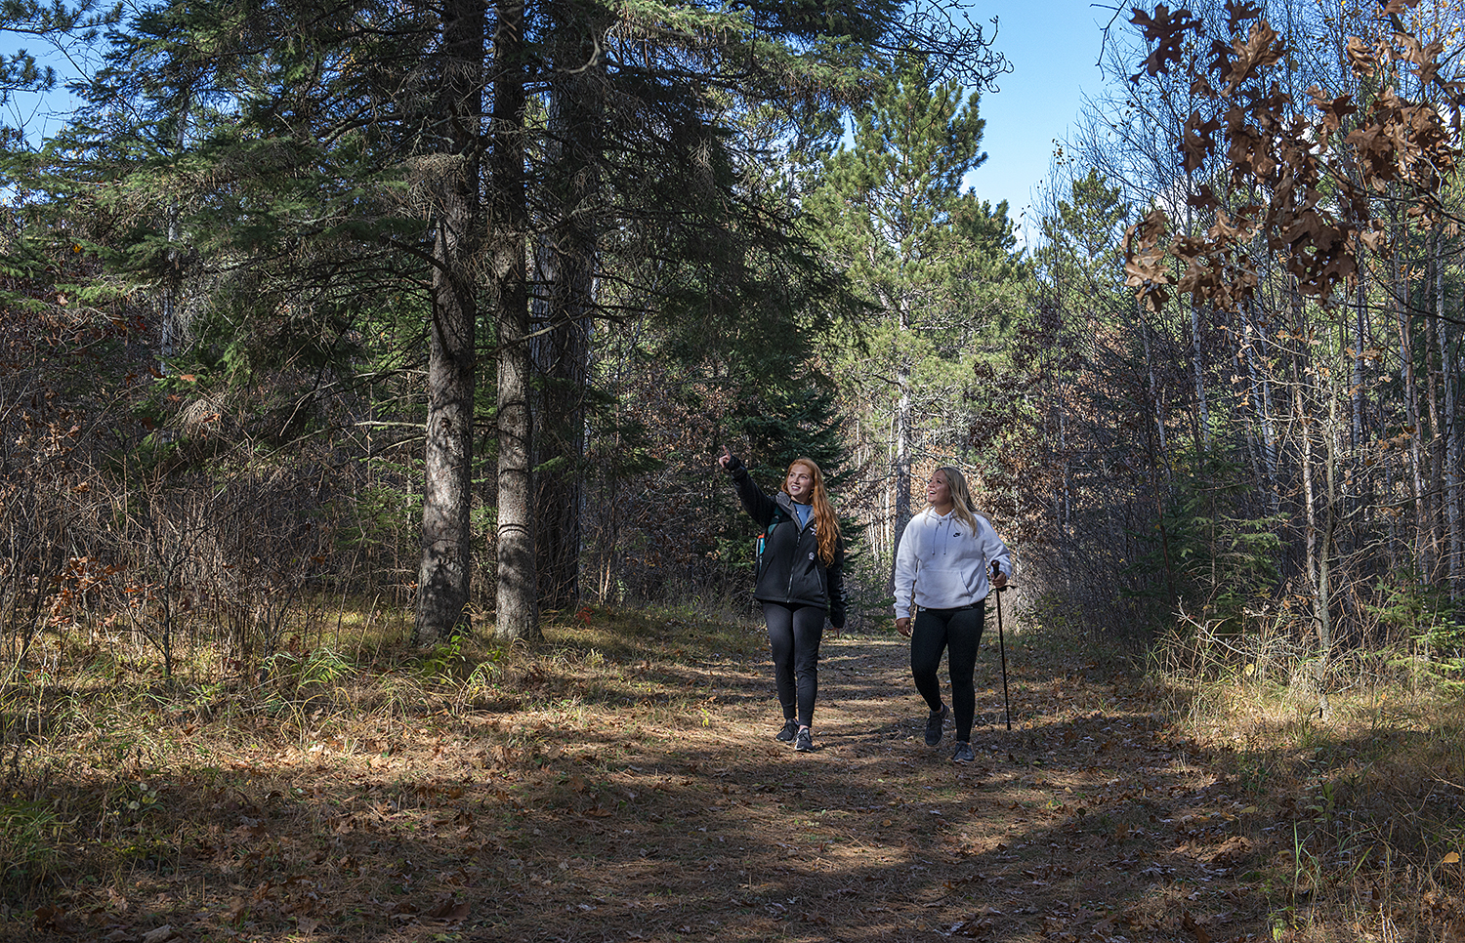
[[IMAGE REF 0001]] Image reference -- not directly editable; the original page reference is preserved automatically. Source: https://www.bemidjistate.edu/services/career/wp-content/uploads/sites/97/2022/10/Hobson-Forest-Girls.jpg
You’re a sophomore or junior. (Or a really eager first-year.) You’ve created a degree plan with your academic adviser, but you’re curious about getting real world experience. How do you get an internship? What kinds of skills do you need to be career ready?
Attend Our Fairs, Events and Webinars (and Meet Some Employers, Too)

Career, Here I Come

[[IMAGE REF 0002]] Image reference -- not directly editable; the original page reference is preserved automatically. Source: https://www.bemidjistate.edu/services/career/wp-content/uploads/sites/97/2022/10/Guys-Walking-Diamond-Point.jpeg
Your schedule is packed with capstones and projects and advanced seminars. You have a resume (but it could use a bit of work.) You have some experience — maybe most of it is academic, with an internship or some work study peppered in. How do you translate all the skills and knowledge you’ve earned into a 300-word cover letter? How do you apply for a job? And where do you find one, anyway?
Explore Job Search Resources

Get in Touch
Let the Career Advancement staff help point you in the right career direction!
Call our office at (218) 755-2405 or schedule an appointment through Handshake.
Questions? Our email is career@bemidjistate.edu.
Coming by in person? We are located in the Sauer House.
Meet our staff

