Title | Choosing a Major
Meta Description
— Page content begins below. Please do not edit the table above. —

Make the Most of Your Unique Qualities
Your college major is your specialized field of study, encompassing the courses and experiences that lead to your degree. In addition to fulfilling general college requirements, you’ll complete courses in a chosen subject area, such as Nursing, Business Administration, or Social Work.
With more than 70 majors available to undergraduates at Bemidji State University, the thought of narrowing your selection to a single field may seem overwhelming. Your major should be a field of study that you find interesting, that you believe you can be successful in, and that will help prepare you for a rewarding career in which you can continue to grow.
No one expects you to automatically have this figured out. In fact, way more than half of U.S. college students change their major at least once.
Enrolling in a First-Year Experience (FYE) Seminar and selecting liberal education courses that let you sample a variety of fields are two important first steps.
Then, by learning about your inherent strengths and motivations, using sophisticated assessment tools and talking with lots of people, you will discover how your passions and potential can align for an outstanding career and a rewarding life.
Once you’ve chosen a major, you can be sure you’re moving you toward your goal. Along with your coursework, you can join career-related clubs and seek other experiences that increase your learning.

What to Consider
Here are our top three things to consider when choosing your major.

Career Prep

[[IMAGE REF 0000]] Image reference -- not directly editable; the original page reference is preserved automatically. Source: https://www.bemidjistate.edu/services/career/wp-content/uploads/sites/97/2022/10/Academic-Advising-Nursing-2022.jpg
Your major is the educational path that will prepare you for a specific career field or advanced study.
Before you declare a major, be sure to take a class or two in that area and talk to students who have chosen it. Make sure you understand the expectations and are ready to succeed.
Make an appointment with a Career Coach

Earning Potential
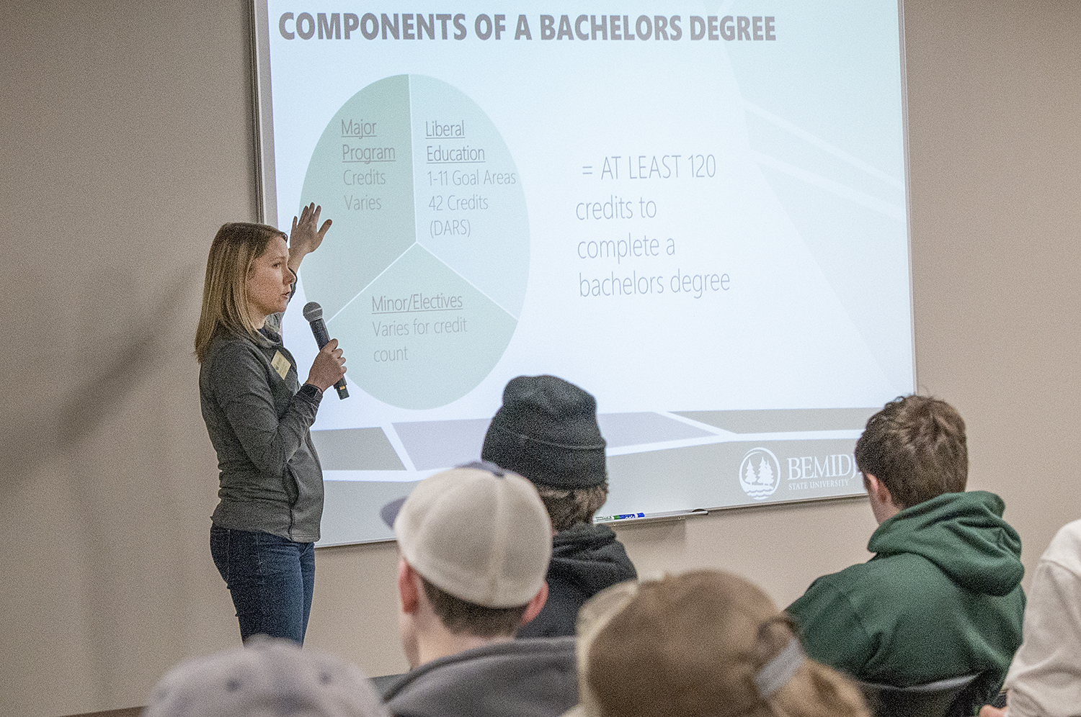
[[IMAGE REF 0001]] Image reference -- not directly editable; the original page reference is preserved automatically. Source: https://www.bemidjistate.edu/services/career/wp-content/uploads/sites/97/2022/10/Academic-Advising-Degree-Info-2022.jpg
The money you will earn in a given career, both in your early years and over the long run, is definitely a factor to consider.
Do your best to pick a field that will give you financial security and allow you to achieve your personal goals.
But a big salary won’t make you happy if you’re miserable in your work.

Subjects You Love

[[IMAGE REF 0002]] Image reference -- not directly editable; the original page reference is preserved automatically. Source: https://www.bemidjistate.edu/services/career/wp-content/uploads/sites/97/2022/10/TAD-Faculty-Show-2019.jpg
If you enjoy what you’re learning, you’re more likely to do your best work and get the most out of your courses and overall experience.
Your interest and enthusiasm will not only make you a more successful student, but you will be a much more attractive job candidate as well.
Learn Where You’ll Thrive

We’re Here to Help You
If you have specific questions about choosing a major, are unsure where to start or are considering a change in major, call or email the Career Advancement office. We’ll schedule an appointment to meet with one of our professional staff or peer advisers, who can answer your questions or point you in the right direction.
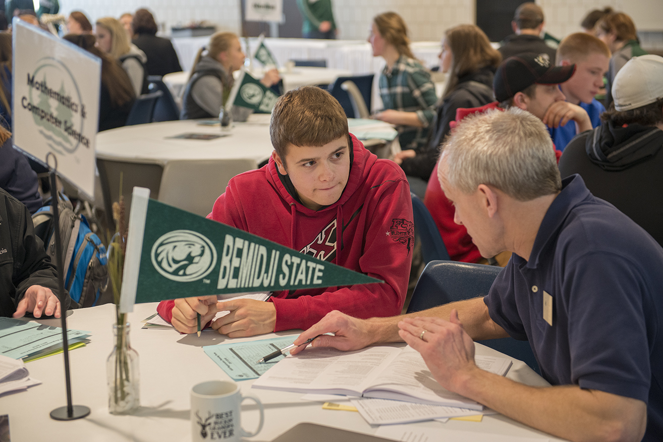
[[IMAGE REF 0003]] Image reference -- not directly editable; the original page reference is preserved automatically. Source: https://www.bemidjistate.edu/services/career/wp-content/uploads/sites/97/2022/10/Academic-Advising-1-2022.jpg
Also, check out the Career Advancement Calendar for upcoming programs and workshops, including some specifically related to choosing a major. The main University Calendar is also a great resource for lectures, events and other special activities that can help you decide.
BSU’s Student Success Center is another important resource — especially if you need help to stay on track for your major or determine whether it’s even the right fit.

