Title | Graduate School Resources
Meta Description
— Page content begins below. Please do not edit the table above. —

How to Know if You Should Go to Graduate School
Choosing to enter graduate school is an important decision that we can help with. Some career paths require or would highly benefit from obtaining a master’s or doctorate. We host graduate schools and informational sessions on graduate school to better inform and prepare those considering or entering graduate studies.
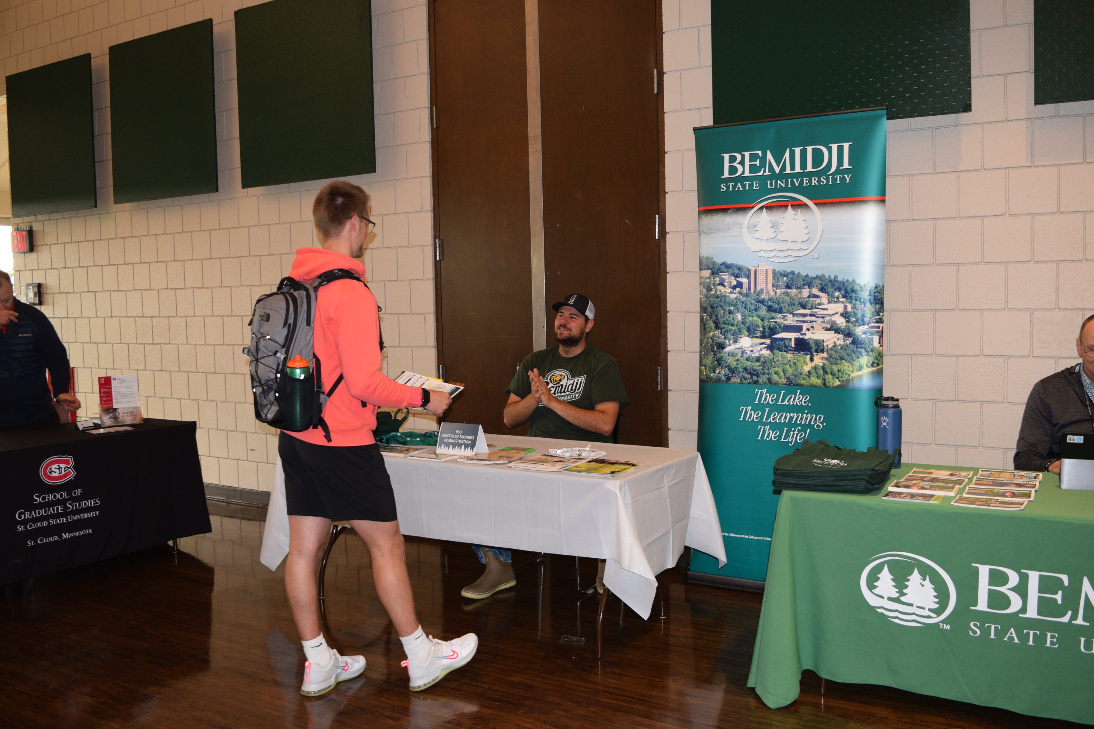
[[IMAGE REF 0000]] Image reference -- not directly editable; the original page reference is preserved automatically. Source: https://www.bemidjistate.edu/services/career/wp-content/uploads/sites/97/2022/09/DSC_1052-scaled.jpg

The Difference Between a CV and a Resume
A Curriculum Vitae is a detailed and comprehensive description of your academic credentials and achievements. A CV differs from a resume in that it includes extensive information on your academic background, including detailed descriptions of your academic experiences, degrees, any type of research, awards, publications, presentations, conferences and other achievements. CVs are thus lengthier than resumes, and include more information, particularly details related to one’s academic and research background.
- Emphasis on academic accomplishments
- Used when applying for positions in academia, fellowships and grants
- Length varies greatly, and will depend upon experiences. Will include a complete list of publications, posters, presentations and abstracts.
- Always begins with education and can include name of advisor and dissertation title or summary (see examples). Also used for merit/tenure review and sabbatical leave
Sample CV 1
Sample CV 2

Resume
- Emphasis on skills
- Used when applying for a position in industry, non-profit and public sector
- No longer than 2 pages. Additional materials submitted if highly relevant to the job
- After 1 year of industry experience, lead with work experience and place education section at the or near the end, depending upon qualifications.

Personal Statements
Information on how to write a personal statement or CV (curriculum vitae) can be found here:
- English Owl
- Preparing Personal Statements

Graduate School Links
- College Affordability Guide
- Gograd.org
- Gradschools.com: the most comprehensive online source of graduate school information
- Graduate School Guide
- LSAC– Law School Admission Council
- Mastersinaccounting.info
- Kaplan Test Preparers: details on Kaplan services, plus info on education programs, admissions, financial aid and more.
- Teacherdegrees.com
- The Princeton Review: contains data and statistics on law, medical, business and graduate programs and other grad school info.
- Thomson Peterson’s: Information on test preparation, applying for colleges, financial aid and links to other helpful sites.
If you’re graduate school-bound**,** you will need to complete the application process and take needed entrance exams.

