Title | Hire a Beaver (Employers)
Meta Description
— Page content begins below. Please do not edit the table above. —

Connecting You With the Best and the Brightest
Partnering with BSU Career Advancement for your college engagement and recruitment needs gives you access to one of northern Minnesota’s largest and most well-prepared talent pools.
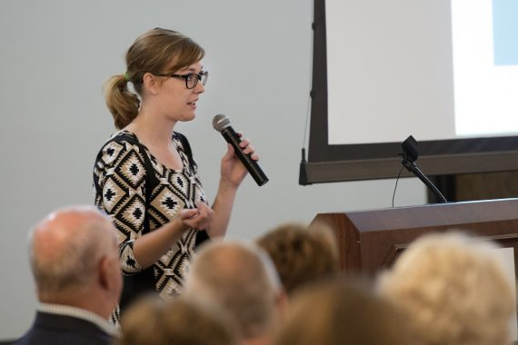
[[IMAGE REF 0000]] Image reference -- not directly editable; the original page reference is preserved automatically. Source: https://www.bemidjistate.edu/services/career/wp-content/uploads/sites/97/2022/02/16PresidentsBfast_0013_Kaylee-570x380.jpg
IMAGEPLACEHOLDER0001
Minnesota State Rep. John Persell answers questions in a meeting with Political Science students.
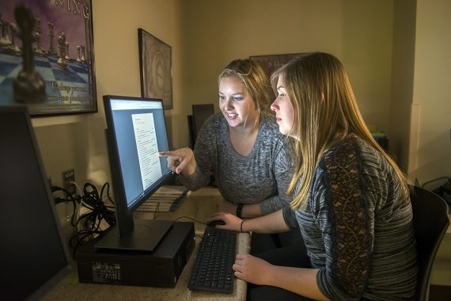
[[IMAGE REF 0002]] Image reference -- not directly editable; the original page reference is preserved automatically. Source: https://www.bemidjistate.edu/services/career/wp-content/uploads/sites/97/2022/02/Career_Services_0049-570x380.jpg
IMAGEPLACEHOLDER0003IMAGEPLACEHOLDER0004IMAGEPLACEHOLDER0005

Connect with BSU talent
Partner with BSU Career Advancement for your college engagement and recruiting needs.
- Using our career services platform, Handshake, employers can register for events and expos, advertise company events, post internship and job opportunities, and more!

Attend our Career Fair
- Hosted in late-winter/early-spring, BSU’s Career Fair provides employers seeking to hire students for full-time jobs, internships, part-time jobs and summer projects the opportunity to meet with prospective applicants. This event is open to all BSU students and employers. Check the Calendar for upcoming dates.

Participate in Other Career Advancement Events
- Throughout the year, Career Advancement offers special events for students where employer assistance or participation is often necessary. Like, Practice Interview Days. Contact us if you are interested in learning more.

Provide On-Campus Interviews
- Career Advancement can help coordinate an interview schedule and assist with recruitment! We have designated space for interview/recruiter rooms and can also assist in coordinating a Zoom interview schedule.

Organize a Day to Table in the Student Union
- For marketing your company and/or positions you may be recruiting for, we will be happy to sponsor a table for you in our lively student union. Best times are 11a.m. – 1p.m. Contact us to set up a date.

Meet with a Student Club or Organization
- Some of the best conversations have taken place in a focused group. At Bemidji State, we have over 90 Clubs and Organizations that you may be interested in connecting with. Contact the Club President or Club Advisor to coordinate a date and time that works for both parties.

