Title | Finding an Internship
Meta Description
— Page content begins below. Please do not edit the table above. —
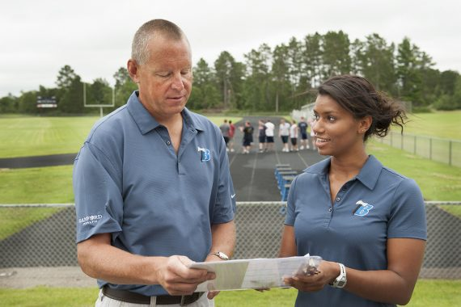
[[IMAGE REF 0000]] Image reference -- not directly editable; the original page reference is preserved automatically. Source: https://www.bemidjistate.edu/services/career/wp-content/uploads/sites/97/2022/02/NeilsonIntern_Kendra_Cobb_0026-570x380.jpg
Sanford Health & Performance providing instruction to an intern

[[IMAGE REF 0001]] Image reference -- not directly editable; the original page reference is preserved automatically. Source: https://www.bemidjistate.edu/services/career/wp-content/uploads/sites/97/2022/02/neilsonintern_KatrinaBroten_0345-570x380.jpg
An intern at Design Angler is obtaining experience from their internship

[[IMAGE REF 0002]] Image reference -- not directly editable; the original page reference is preserved automatically. Source: https://www.bemidjistate.edu/services/career/wp-content/uploads/sites/97/2022/02/Jamie_Team_0039wc-570x380.jpg
Student completes their accounting internship at TEAM Industries
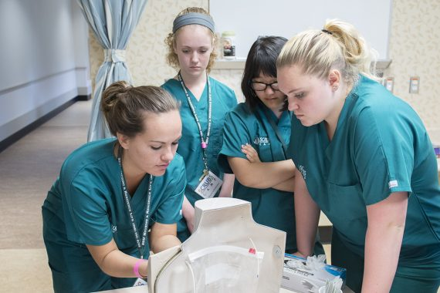
[[IMAGE REF 0003]] Image reference -- not directly editable; the original page reference is preserved automatically. Source: https://www.bemidjistate.edu/services/career/wp-content/uploads/sites/97/2022/02/16ScubsCamp_0059-1-570x380.jpg
IMAGEPLACEHOLDER0004IMAGEPLACEHOLDER0005
Valvoline Instant Oil Change providing an internship opportunity

Your Path to Professional Experience Starts Here
Doing an internship as a student can be your path to the professional world in your field of study. You’ll gain real world experience, learn about the latest trends, build a stronger resume and develop confidence as a professional. You’ll also be establishing a network that you can tap into later to find a job.

Finding An Internship
You want to do an internship. Great! Now what? We will walk you through the process from helping you identify the type of internship you are interested in and where to find employers to the interview process and follow up. Here is a quick step by step checklist from preparation to implementation.
- Prepare
  - Research where, what (type of work/organization) & what you want to gain
  - Complete your profile in Handshake
  - Prepare your resume be sure to have Career Advancement critique it by utilizing Resumes on the Run
  - Consider an informational interview
- Locate
  - Check with your Advisor, and then the Departmental Internship Coordinator
  - Search within Handshake
  - Attend career fairs & on-campus recruiting (most effective according to employers)
  - Career Advancement resources – links to off-site resources
  - Consider reaching out to an employer and expressing an interest in their company. You may do so by writing a letter of interest or a prospecting letter.
- Apply
  - Prepare a cover letter specific for the internship—show you have researched the company
  - Send cover letter and resume along with reference list
  - When emailing, always send a cover letter with the resume as one attachment
- Handshake
- Internship Agreement Form
- Washington DC Internships (WISH)
- Internship Resources
- BSU Internship Memo of Understanding

