Title | Forms & Resources
Meta Description
— Page content begins below. Please do not edit the table above. —
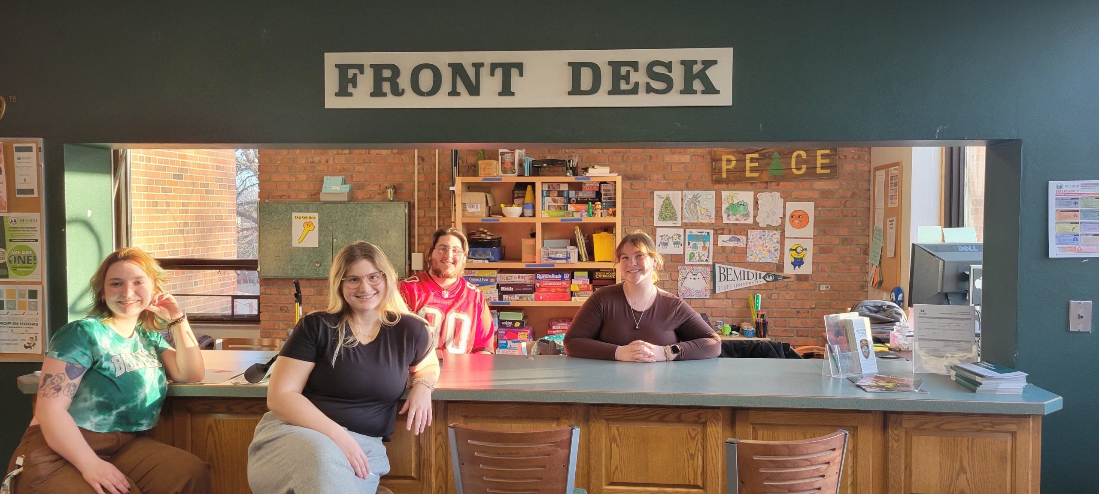
[[IMAGE REF 0000]] Image reference -- not directly editable; the original page reference is preserved automatically. Source: https://www.bemidjistate.edu/services/reslife/wp-content/uploads/sites/20/2024/03/20240226_171823-scaled.jpg
Our residents thrive at BSU because they can access the support and services they need to focus on their studies and make positive contributions to our campus community.
We’ve created a number of programs, policies and guides to help students transition from high school to college to the real world. Check out our Move-in Guide to plan your arrival to campus, brush up on our student policies and procedures, learn where to store your bike or practice the clarinet and find the forms you need to apply for housing and meal plans.

Campus Resources

Peer Academic Assistant (PAA) Support & Tutoring
PAAs can be found in the Academic Resource Centers (ARCs) in Oak and Tamarack Halls, as well as on individual floors and in study rooms. Check out the PAA schedule and areas of specialty posted on PAA room doors and in the ARC.

Academic Resource Center
Located in Oak and Tamarack Halls and staffed by PAAs, Academic Resource Centers contain literature on academic skills and unique programs and resources for all academic needs. Individual study rooms also available in the Oak ARC. All ARC’s feature:
- Group study in the ARC
- Study Sessions or “Tables” for individual courses
- Individual or group tutoring through the PAAs

Internet – Campus Network
The residence halls are all connected to the campus network, allowing residents to share information and access external resources at high speeds. Wireless internet is also available in all residence halls.
More information is available from Information Technology Services:
- Computer Requirements
- Connecting to the Network
- Printing in the Residence Halls

Community Resources
Learn more about what there is to do, see and explore in Bemidji:
- Visit Bemidji: Info on all the area’s attractions, including lodging, churches, shopping and entertainment.
- Bemidji Area Chamber of Commerce: Listing of businesses in Bemidji, so you can find out where to shop and eat in the city. There is also Employment information and an Events Calendar of member businesses.
- Bemidji Pioneer: Bemidji’s local newspaper with info on local happenings.

