Title | International Student Organization
Meta Description
— Page content begins below. Please do not edit the table above. —

[[IMAGE REF 0007]] Image reference -- not directly editable; the original page reference is preserved automatically. Source: https://www.bemidjistate.edu/services/international/wp-content/uploads/sites/19/2019/03/DSC0090-664x334.jpg
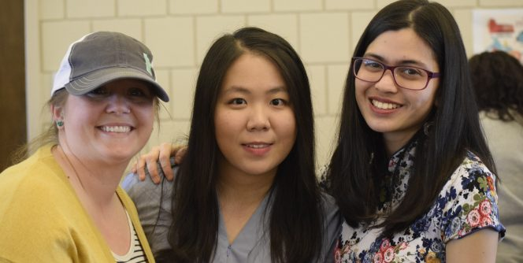
[[IMAGE REF 0008]] Image reference -- not directly editable; the original page reference is preserved automatically. Source: https://www.bemidjistate.edu/services/international/wp-content/uploads/sites/19/2019/03/DSC0310-664x334.jpg
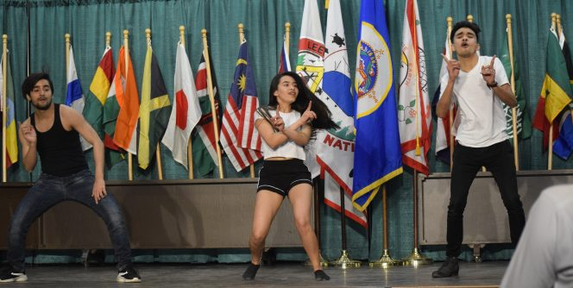
[[IMAGE REF 0009]] Image reference -- not directly editable; the original page reference is preserved automatically. Source: https://www.bemidjistate.edu/services/international/wp-content/uploads/sites/19/2019/03/DSC0268-664x334.jpg
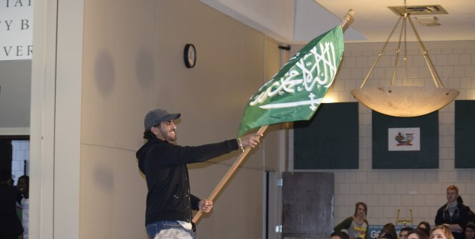
[[IMAGE REF 0010]] Image reference -- not directly editable; the original page reference is preserved automatically. Source: https://www.bemidjistate.edu/services/international/wp-content/uploads/sites/19/2019/03/DSC0038-664x334.jpg
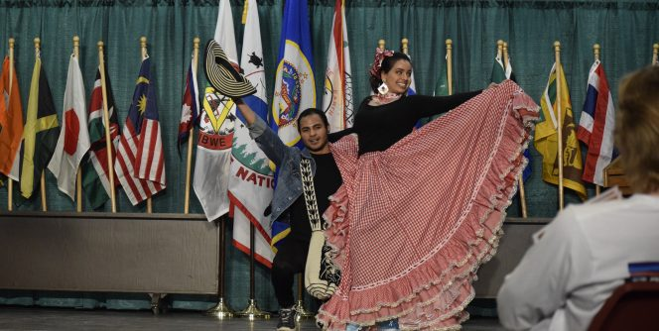
[[IMAGE REF 0011]] Image reference -- not directly editable; the original page reference is preserved automatically. Source: https://www.bemidjistate.edu/services/international/wp-content/uploads/sites/19/2019/03/DSC0150-664x334.jpg

[[IMAGE REF 0012]] Image reference -- not directly editable; the original page reference is preserved automatically. Source: https://www.bemidjistate.edu/services/international/wp-content/uploads/sites/19/2019/03/DSC0374-e1553617676637-664x334.jpg
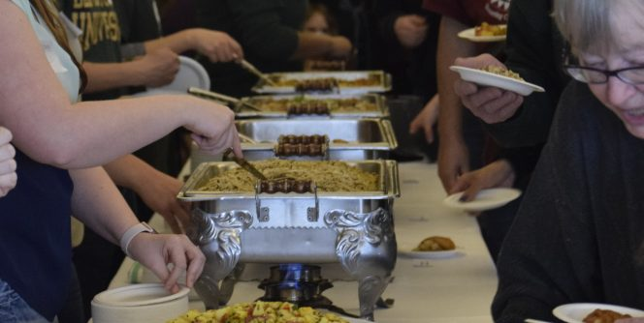
[[IMAGE REF 0013]] Image reference -- not directly editable; the original page reference is preserved automatically. Source: https://www.bemidjistate.edu/services/international/wp-content/uploads/sites/19/2019/03/DSC0348-e1553617474385-664x334.jpg

[[IMAGE REF 0000]] Image reference -- not directly editable; the original page reference is preserved automatically. Source: https://www.bemidjistate.edu/services/international/wp-content/uploads/sites/19/2019/03/DSC0090-114x62.jpg

[[IMAGE REF 0001]] Image reference -- not directly editable; the original page reference is preserved automatically. Source: https://www.bemidjistate.edu/services/international/wp-content/uploads/sites/19/2019/03/DSC0310-114x62.jpg

[[IMAGE REF 0002]] Image reference -- not directly editable; the original page reference is preserved automatically. Source: https://www.bemidjistate.edu/services/international/wp-content/uploads/sites/19/2019/03/DSC0268-114x62.jpg

[[IMAGE REF 0003]] Image reference -- not directly editable; the original page reference is preserved automatically. Source: https://www.bemidjistate.edu/services/international/wp-content/uploads/sites/19/2019/03/DSC0038-114x62.jpg

[[IMAGE REF 0004]] Image reference -- not directly editable; the original page reference is preserved automatically. Source: https://www.bemidjistate.edu/services/international/wp-content/uploads/sites/19/2019/03/DSC0150-114x62.jpg

[[IMAGE REF 0005]] Image reference -- not directly editable; the original page reference is preserved automatically. Source: https://www.bemidjistate.edu/services/international/wp-content/uploads/sites/19/2019/03/DSC0374-e1553617676637-114x62.jpg

[[IMAGE REF 0006]] Image reference -- not directly editable; the original page reference is preserved automatically. Source: https://www.bemidjistate.edu/services/international/wp-content/uploads/sites/19/2019/03/DSC0348-e1553617474385-114x62.jpg
The Bemidji State University International Student Organization (ISO) has a membership of international students from over 30 countries. The mission is to provide support to international students from international students.
International students experience life in Bemidji, Minnesota and share their culture through many ISO activities and events. Activities both on and off campus help students get the full BSU experience and make the most of their time in northern Minnesota.
Members of the ISO have rock climbed at BSU’s Recreational Fitness Center, traveled to Itasca State Park to visit the Headwaters of the Mississippi River and learned to ice skate or cross-country ski. The biggest cultural event at BSU, the Festival of Nations, is held annually each spring. The Festival of Nations is a celebration of the global community at BSU. Students and community members share food, stories, dances and songs from around the world.

