Title | Costs & Program Elements
Meta Description
— Page content begins below. Please do not edit the table above. —
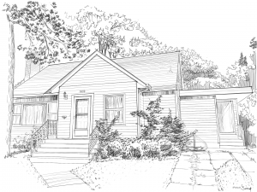
[[IMAGE REF 0007]] Image reference -- not directly editable; the original page reference is preserved automatically. Source: https://www.bemidjistate.edu/services/international/wp-content/uploads/sites/19/2020/02/glas-exterior-sketch-300x225.png
IMAGEPLACEHOLDER0008IMAGEPLACEHOLDER0009
With a single program fee, Bemidji State University will accommodate a NorthStar visiting scholar for 6 months or an entire calendar year and provide the following:
- A fully furnished double bedroom apartment, all utilities, basic kitchen supplies included
- Office space upon request, research facilities, internet and campus intranet access
- Seminars on the U.S. Education System, Culture and History
- Local cultural, social and outdoor activities on campus and within the community
- Access to resources on campus, including the library. Wireless internet connection, and other campus facilities
- A Bemidji State University faculty member as a mentor and facilitator
- Sightseeing and field trips in Minnesota
- Campus Super Fee per semester (access to Student Health Center and Gillett Wellness Center)
UPDATE: For winter semester, we recently adjusted the program start date to Mid*February (after Lunar Chinese New Year). Please contact us for questions regarding program dates and duration.*
The following costs are not included in the program fee:
- Round-trip travel costs to Bemidji
- Visa fees where applicable
- Personal expenses and food
- Health insurance (required; approximately $3,000/year)
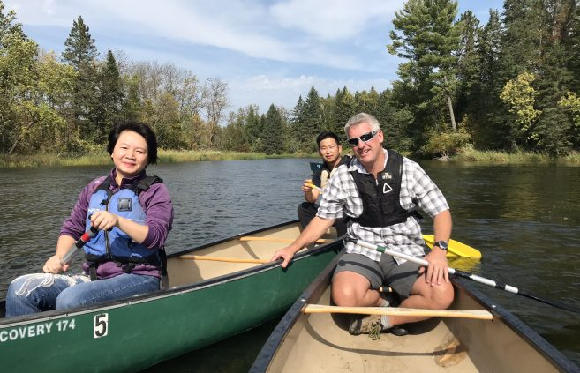
[[IMAGE REF 0000]] Image reference -- not directly editable; the original page reference is preserved automatically. Source: https://www.bemidjistate.edu/services/international/wp-content/uploads/sites/19/2020/01/paddling-657x423.jpeg
- Canoeing the Mississipi
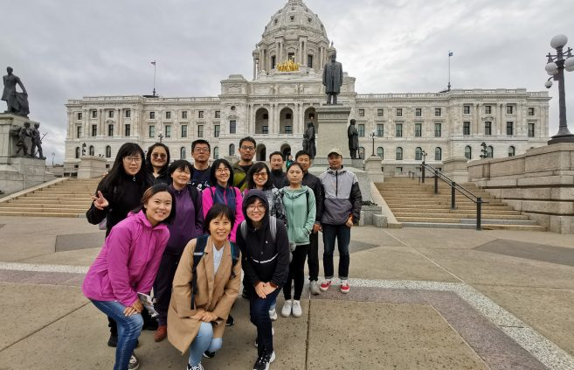
[[IMAGE REF 0001]] Image reference -- not directly editable; the original page reference is preserved automatically. Source: https://www.bemidjistate.edu/services/international/wp-content/uploads/sites/19/2020/01/in-front-of-state-capital-657x423.jpg
- State Capital
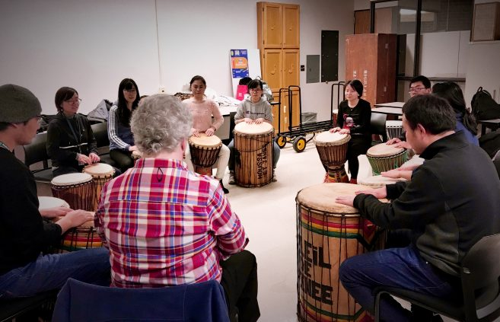
[[IMAGE REF 0002]] Image reference -- not directly editable; the original page reference is preserved automatically. Source: https://www.bemidjistate.edu/services/international/wp-content/uploads/sites/19/2020/01/drumming-657x423.jpg
- Playing African Drums
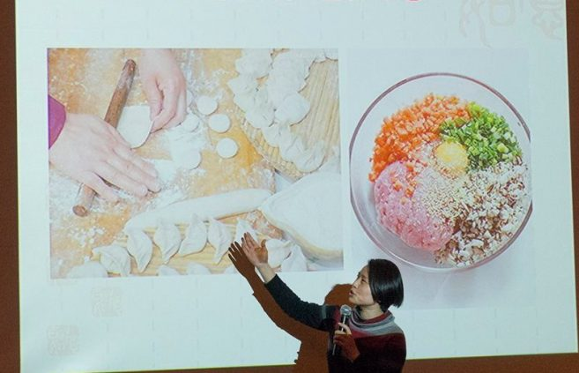
[[IMAGE REF 0003]] Image reference -- not directly editable; the original page reference is preserved automatically. Source: https://www.bemidjistate.edu/services/international/wp-content/uploads/sites/19/2019/02/Chinese-Scholar-2-e1549916471932-657x423.jpg
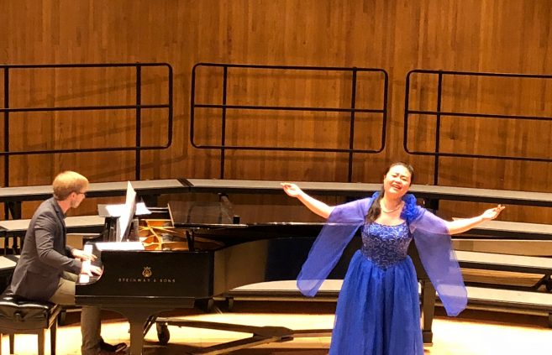
[[IMAGE REF 0004]] Image reference -- not directly editable; the original page reference is preserved automatically. Source: https://www.bemidjistate.edu/services/international/wp-content/uploads/sites/19/2019/02/QI-2-657x423.jpg
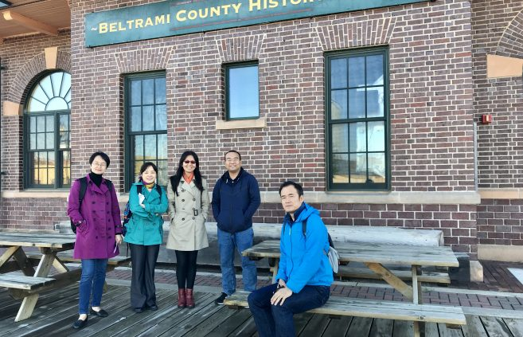
[[IMAGE REF 0005]] Image reference -- not directly editable; the original page reference is preserved automatically. Source: https://www.bemidjistate.edu/services/international/wp-content/uploads/sites/19/2019/01/BCHC-657x423.jpg
- Beltrami County History Center
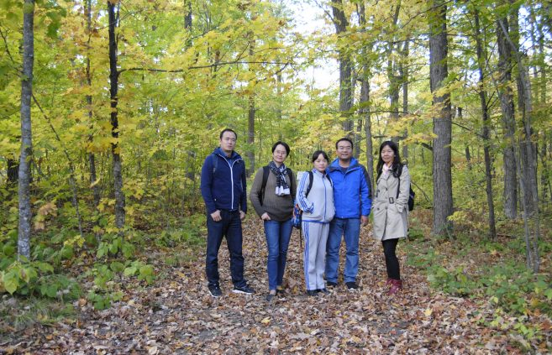
[[IMAGE REF 0006]] Image reference -- not directly editable; the original page reference is preserved automatically. Source: https://www.bemidjistate.edu/services/international/wp-content/uploads/sites/19/2019/01/2017-09-30-17.11.04-657x423.jpg
- Fall color at Itasca State Park
[[IMAGE REF 0010]] Image reference -- not directly editable; the original page reference is preserved automatically. Source: https://www.bemidjistate.edu/services/international/wp-content/uploads/sites/19/2020/02/glas-exterior-sketch-300x225.png
IMAGEPLACEHOLDER0011IMAGEPLACEHOLDER0012

