Title | North Star Visiting Scholars
Meta Description
— Page content begins below. Please do not edit the table above. —
The NorthStar Visiting Scholar Academy at Bemidji State University promotes understanding and cooperation between American and international university scholars through a unique experience of mutual enrichment.

伯米吉州立大学中文介绍
Click here to download the PDF program flyer
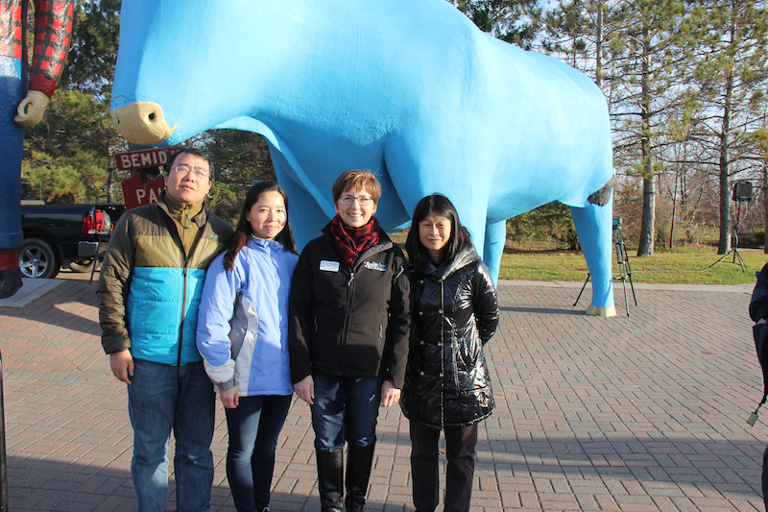
[[IMAGE REF 0001]] Image reference -- not directly editable; the original page reference is preserved automatically. Source: https://www.bemidjistate.edu/services/international/wp-content/uploads/sites/19/2019/01/PandB.jpg
With Mayor Rita in front of Paul and Bebe

Program Overview
Northstar Visiting Scholars Academy is the destination program for our visitors, including visiting faculty, scholars and student ambassadors.
NorthStar Scholars are immersed in the culture and daily life of the Bemidji State campus and the city of Bemidji, in the heart of Minnesota’s beautiful north woods.
For our visiting faculty, the program is usually one year in length. A designated program manager designed a curriculum comprised of weekly seminars, experiential activities, field trips, and tours to provide scholars a comprehensive understanding of the difference between the higher educational systems, American as well as our regional cultures, history, social fabric and the natural environment. They could observe classes, engage in class discussions, and guest lecture. Visiting scholars could participate in any of BSU campus activities, and utilize library resources and recreational facilities. In addition, they will visit historical sites, parks, businesses, American Indian reservations, schools and other places of interest. Each visiting scholar is assigned a professor at Bemidji State University as a mentor who helps them get the most out of their experience. Ideally, this professor belongs to the same discipline as the visitor, allowing the exchange visitor to observe their classes and guest lecture in them. Visiting Faculty live in fully furnished apartments or house with individual bedrooms. Bemidji State University will issue DS-2019 form required for obtaining the J visas for our admitted scholars. BSU also awards completion certificates to visiting faculty who have successfully completed the program. For more details, please see Visiting Faculty Program Elements and Costs.
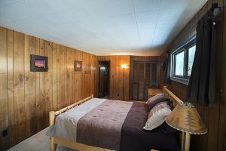
[[IMAGE REF 0000]] Image reference -- not directly editable; the original page reference is preserved automatically. Source: https://www.bemidjistate.edu/services/international/wp-content/uploads/sites/19/2019/01/VisitingScholars_rooms-300x200.jpg
Fully furnished bedroom
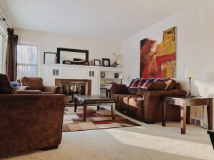
[[IMAGE REF 0002]] Image reference -- not directly editable; the original page reference is preserved automatically. Source: https://www.bemidjistate.edu/services/international/wp-content/uploads/sites/19/2022/02/glas-living-room-300x225.jpg
Glas House Living Room
For our visiting students ambassadors, BSU invites students from all of our partner institutions to join us in a varieties of summer programs, including the language and culture immersion camp. For more details, please see Summer.

Other Resources
Click here to view Exchange Visitor Welcome Brochure from U.S. Department of State.

项目简介
北极星访问者学院是伯米吉州立大学专门为所有来短期访问的老师, 学者、大学生使者所设立的学院。
访问学者项目一般为一学年。学院负责人专为访问学者安排了研修课程，通过每周的嘉宾讲座，校外实践，出访参观，郊游等各种活动让访问学者充分全面地了解中美高等教育系统的差异、美国及本地区的文化、历史、社会和环境。访问学者可以旁听伯米吉州立大学的大部分课程，和学生老师开展交流。学者们可以参与学校所有的校内活动，以及专为访问学者安排的以历史，自然，商务，教育等为主题的出访活动。例如参观博物馆，圣保罗大教堂，社会服务机构，州政府，密西西比河源头等。学院为访学老师提供专业对口的导师，辅助访问学者在校开展学习和研究。学校所有的资源和设施都对访问学者开放。访问学者居住在拎包入住的校内公寓或是房子，每一位学者有自己单独的卧室，厨房和卫生间有可能会和同性别的其他访问学者公用。伯米吉州立大学给本学院录取的老师和学者签发J-1签证所需要的DS-2019 表，为成功完成访学项目的老师颁发证书。项目详情请访问访问学者项目内容及费用。如有疑问，请邮件至jo.li@bemidjistate.edu
同样欢迎我们来访的学生大使，BSU邀请所有合作院校的学生参与我们的寒暑假语言文化浸没体验营。详情请见寒暑假语言文化浸没体验营。
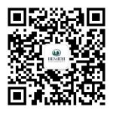
[[IMAGE REF 0003]] Image reference -- not directly editable; the original page reference is preserved automatically. Source: https://www.bemidjistate.edu/services/international/wp-content/uploads/sites/19/2022/02/微信公众号二维码-150x150.jpg
关注我们的微信公众号获取最新信息和活动更新。
好消息！我们的语言中心正在努力准备为来访的老师提供免费的英语学习机会。只要访学老师数量超过6位，就会免费开设每周一次的语言课，另有当地学生的英语角。

