Title | Annual Observances
Meta Description
— Page content begins below. Please do not edit the table above. —

Pride Month and the 2SLGBTQIA+ Movement
The first Pride Month — then called “Gay and Lesbian Pride Month” — was declared in 1999 by President Bill Clinton to recognize the Stonewall Riots on June 28, 1969. During the riots, patrons of New York City’s Stonewall Inn resisted police violence targeted towards the queer community and sparked the 2SLGBTQIA+ movement.
2SLGBTQIA+ stands for two-spirit, lesbian, gay, bisexual, transgender, queer/questioning, intersex, asexual, plus. The term “queer” throughout this narrative signifies queer-sexual and queer-gender identities, as well as those who are part of the 2SLGBTQIA+ community.

#ProudAllYear
While June is nationally recognized as Pride Month, Bemidji State University has long supported and welcomed all students regardless of gender identity or sexual orientation. To celebrate and boost Pride across campus, BSU’s community-centered opportunities for students, faculty and staff are ever-expanding.
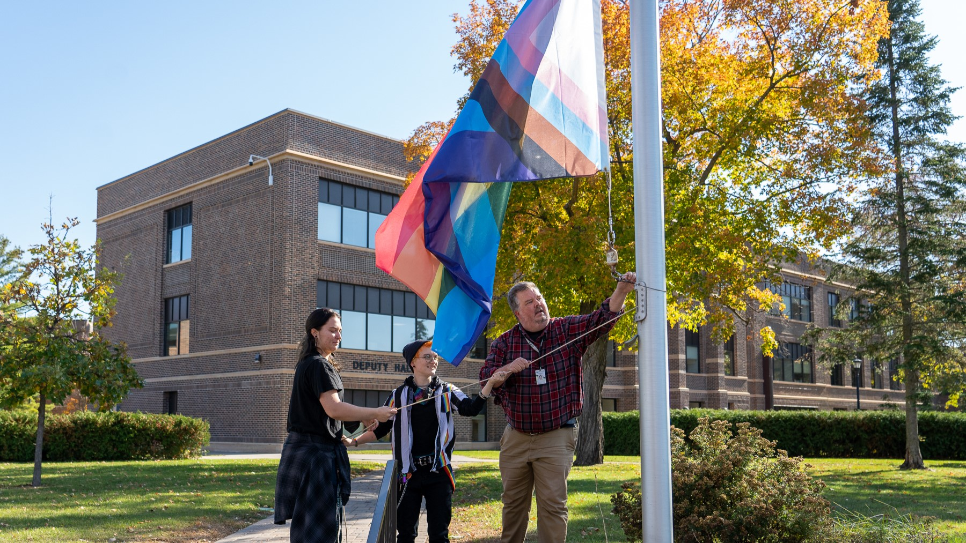
[[IMAGE REF 0000]] Image reference -- not directly editable; the original page reference is preserved automatically. Source: https://www.bemidjistate.edu/offices/diversity-equity-inclusion/wp-content/uploads/sites/49/2023/10/PrideFlagRaising10-11-22-42.jpg

Pronouns Save Lives
Utilization of appropriate pronouns is an act of humanization and inclusion. This act of intentionality can be challenging across languages, cultural and learned behavior. We are here to help with your investment in yourself and others. Remember, using the correct pronouns can save a life.

Black History and Heritage Experience
Black History and Heritage is celebrated year round with a variety of panels, podcasts, workshops and events. These various platforms allow you to engage in conversations with each other and to grow from those experiential learning opportunities with the theme of this year as “Black Health and Wellness.” Many of these events are held by the Black Student Union as well as the Center for Diversity, Equity and Inclusion.
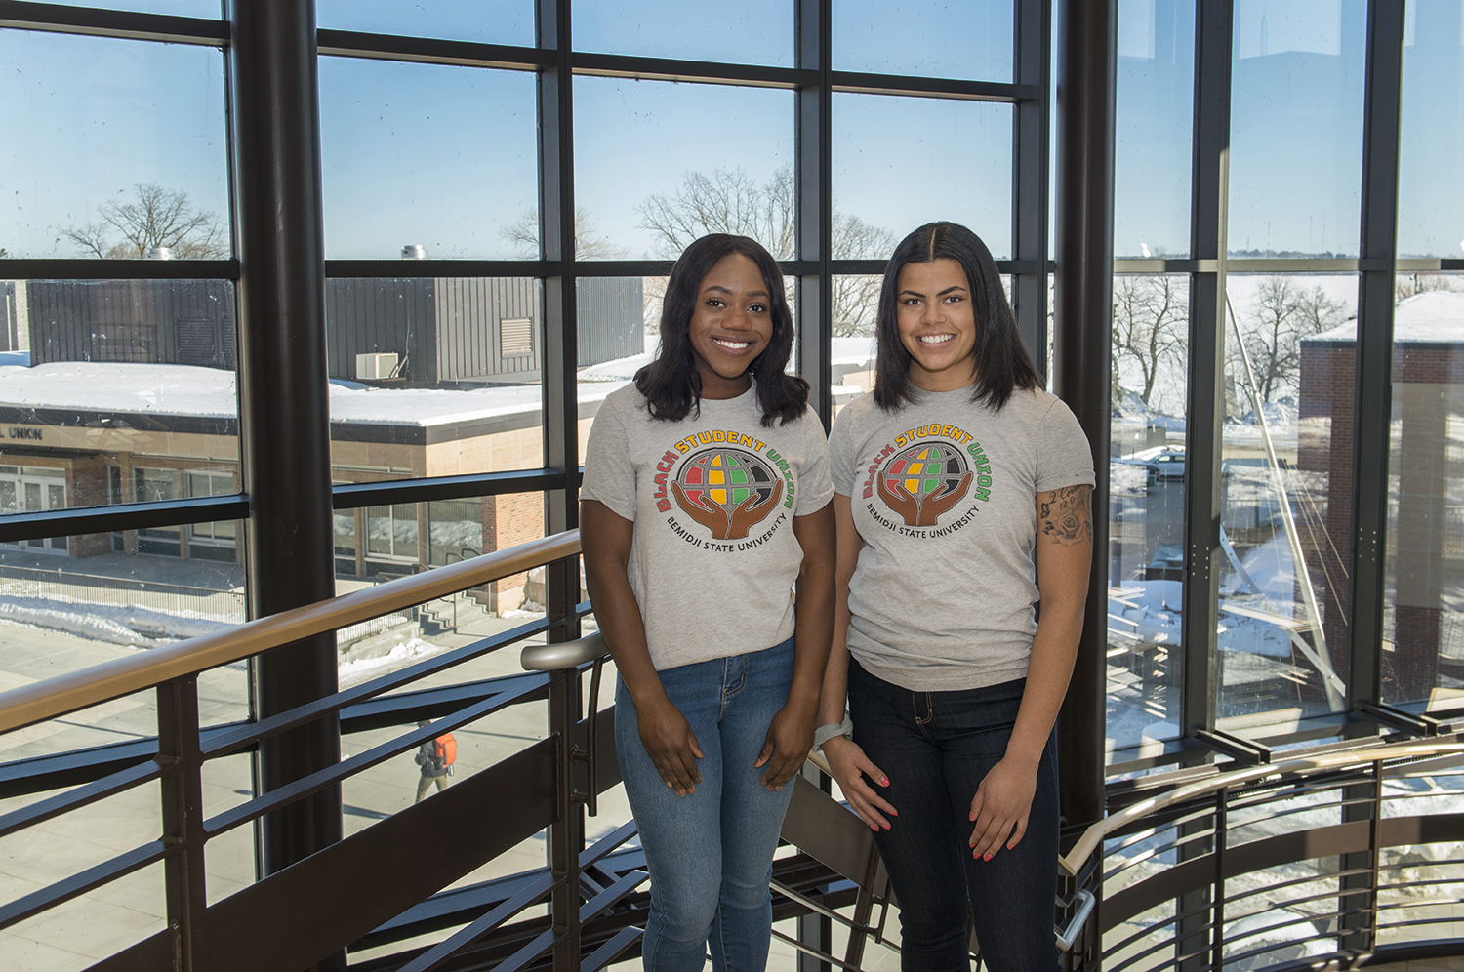
[[IMAGE REF 0001]] Image reference -- not directly editable; the original page reference is preserved automatically. Source: https://www.bemidjistate.edu/offices/diversity-equity-inclusion/wp-content/uploads/sites/49/2023/10/BlackStudentUnion_0009.jpg

Chinese New Year Celebration
On February 9th, which is also the 9th day of the first month in the traditional Chinese lunisolar calendar (年初九), the Center partners with International Partnership to bring you a Chinese New Year Cultural Demonstration.
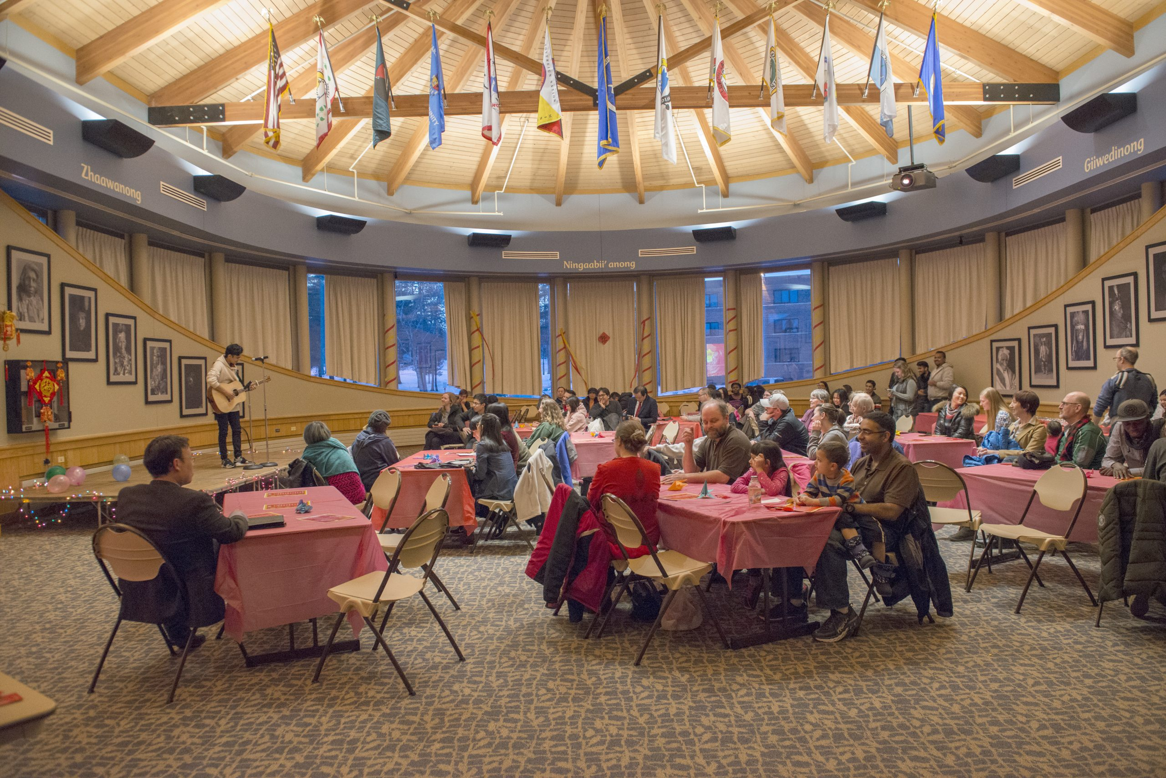
[[IMAGE REF 0002]] Image reference -- not directly editable; the original page reference is preserved automatically. Source: https://www.bemidjistate.edu/offices/diversity-equity-inclusion/wp-content/uploads/sites/49/2023/10/18LunarNewYearFestival_0089-scaled.jpg

Women’s History and Heritage Experience
Bemidji State University honors womanhood and celebrating the history, culture and experience of women worldwide. Each year, the Center for Diversity, Equity and Inclusion organizes and coordinates various educational events for the campus community involving women’s history and celebrating Women’s History Month.
- At the Heart of Women’s Excellence Season 1 — Carola Thorson
- At the Heart of Women’s Excellence Season 2 — Michele Brielmaire
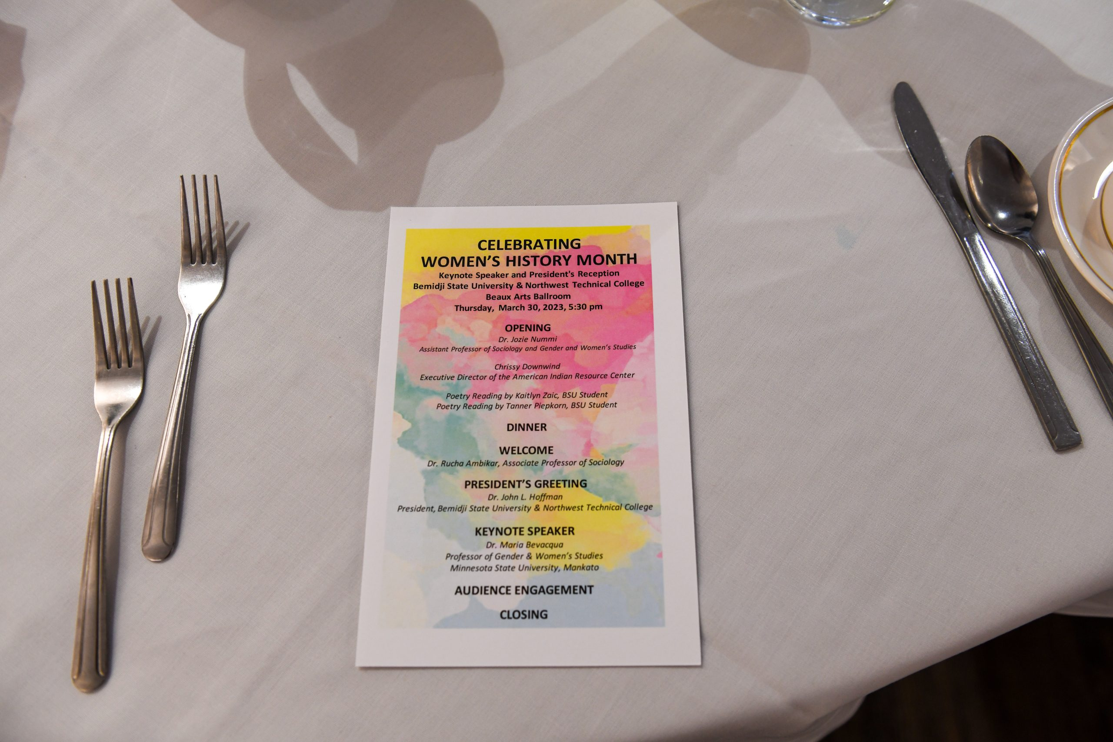
[[IMAGE REF 0003]] Image reference -- not directly editable; the original page reference is preserved automatically. Source: https://www.bemidjistate.edu/offices/diversity-equity-inclusion/wp-content/uploads/sites/49/2023/10/WHM12-scaled.jpg

Asian and Pacific Islander Heritage Experience
Bemidji State University is celebrating the Asian American and Pacific Islander experience and heritage throughout the month of April. Led by the Center for Diversity, Equity and Inclusion, the university will host several events to recognize and celebrate AAPI student identities. It is imperative to engage our campus community with experiential learning opportunities, to understand, support and advocate for the Asian, Asian American and Pacific Islander communities. It takes everyone to enhance awareness, eliminate bias, provide support and promote love and hope.

[[IMAGE REF 0004]] Image reference -- not directly editable; the original page reference is preserved automatically. Source: https://www.bemidjistate.edu/offices/diversity-equity-inclusion/wp-content/uploads/sites/49/2023/10/22TunnelofOppression_0015.jpg

Juneteenth
The United States has officially recognized Juneteenth as a pivotal moment for the country. Juneteenth National Independence Day Act is now a federal holiday as of June 18, 2021. This holiday is recognized annually on the June 19. On June 19, 1865, enslaved persons in Galveston, Texas were notified of their freedom from chattel slavery. This marked a seminal social and racial justice moment in time. Bemidji State University proudly celebrates and recognizes Juneteenth Day of Observance. The fight for social and racial justice is at our core. We take pride in being a catalyst for affirmative and equitable change.
- A Proclamation on Juneteenth Day of Observance, 2021
- Juneteenth, Black Texans and the Case for Reparations
- The Significance of Juneteenth
- The History Behind Juneteenth and Why it Resonates Today
- Juneteenth: Freedom At Last

[[IMAGE REF 0005]] Image reference -- not directly editable; the original page reference is preserved automatically. Source: https://www.bemidjistate.edu/offices/diversity-equity-inclusion/wp-content/uploads/sites/49/2023/10/22BSU_Steven_Parker_0010.jpg

Native American Heritage Experience
November is nationally recognized as Native American History Month. The month-long observance creates opportunities to increase awareness and knowledge of the challenges Native people have faced both historically and in the present. Throughout the year, the university’s American Indian Resource Center offers support and programming for its American Indian and Indigenous students. Bemidji State is home to American Indian students from across Minnesota and its neighboring states as well as from New York, North Carolina, Pennsylvania, Idaho, Canada and more. The month-long celebration is a time to recognize the rich and diverse cultures, traditions and histories of Native American people and to acknowledge the important contributions they have made and continue to make in our current world. National Native American Heritage Month serves as an opportunity to educate others about the distinct political status of tribal nations, increase general awareness about the historical and ongoing challenges faced by Native American people and highlight their resilience in overcoming these obstacles.
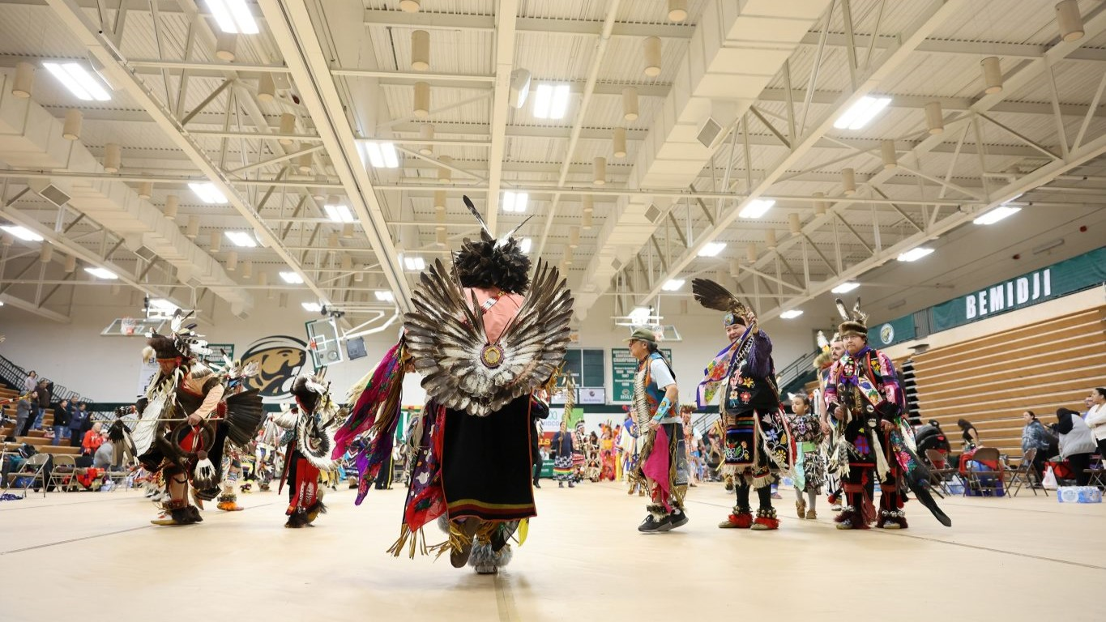
[[IMAGE REF 0006]] Image reference -- not directly editable; the original page reference is preserved automatically. Source: https://www.bemidjistate.edu/offices/diversity-equity-inclusion/wp-content/uploads/sites/49/2023/10/American-Indian-History-Month.jpg

