Title | Free Store
Meta Description
— Page content begins below. Please do not edit the table above. —
The FreeStore, located in the Sustainability Office across from the campus bookstore, is a place to donate and find.
Supported through the Green Fee, the FreeStore is open to currently enrolled students between 10:00 am and 3:00 pm or when the lights are on, Monday through Friday during the academic year. If you are in need of school supplies, office supplies, books, clothing, outdoor wear, shoes, kitchen items, or non-perishable foods, visit the FreeStore before making a trip to and spending money at another store.
We ask two things of those who use the FreeStore:
First, please help us maintain a clean and orderly space. Our staff spends numerous hours over the summer months sorting donations into the Free Store to provide a welcoming and enjoyable experience. Your help keeping it this way is appreciated.
Second, if you find anything to take home, please write the date and a short description of the items (ie. “two 3-ring binders, one shirt, and six pencils”). Doing so helps us maintain a rough sense for the number and types of items moving through the Free Store. For instance, since 2010 over 1,650 binders, 1,715 books, 3,650 kitchen items, 1,625 pairs of pants, 365 professional suits, and 460 winter clothing items have moved through the Free Store. Not only has this saved students the expense of buying new products, it has prevented these items from ending up in a landfill.
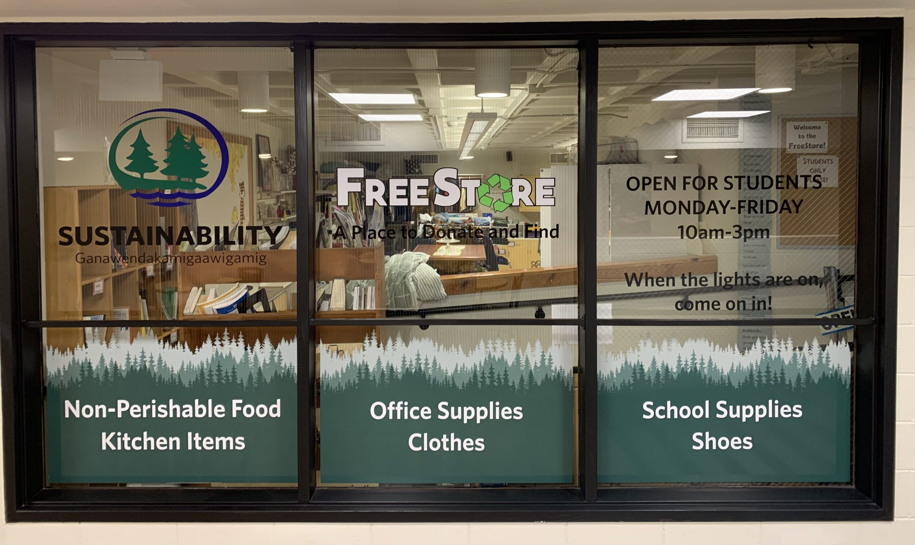
[[IMAGE REF 0000]] Image reference -- not directly editable; the original page reference is preserved automatically. Source: https://www.bemidjistate.edu/offices/sustainability/wp-content/uploads/sites/59/2024/03/2024-3-1-1-scaled-e1709322427796.jpg
The FreeStore functions in partnership with the Donate Don’t Dumpster program, which encourages students to donate their no longer needed or wanted items at the end of each semester. Instead of sending items that are still usable to the landfill, please consider donating them to the FreeStore.
If you have clean, functional items ready to be enjoyed by someone else, please consider bringing them to the FreeStore. Items accepted include:
- Notebooks (please tear out any used pages)
- Notepads / Post-Its
- Pens / Pencils / Erasers
- Books (novels, textbooks, etc.)
- Folders / Binders
- Electronics (in working condition, with necessary accessories)
- Printers (in working condition, with necessary accessories)
- Extension Cords / Power Strips
- Ethernet Cords / HDMI Cords
- Winter Apparel (clean & in good condition)
- Clothing (clean & in good condition)
- Shoes (clean & in good condition)
- Plates / Cups / Bowls / Utensils (clean)
- Pots / Pans / Baking & Cookware (clean)
- Small Kitchen Appliances (clean and functional)
- Non-perishable food *(unopened, regardless of date label)*

[[IMAGE REF 0001]] Image reference -- not directly editable; the original page reference is preserved automatically. Source: https://www.bemidjistate.edu/offices/sustainability/wp-content/uploads/sites/59/2019/07/Donate-Dont-Dumpster-300x194.jpg
Please only donate clean, functional items ready to be enjoyed by someone else – thank you!

