Title | RISE Coaching
Meta Description
— Page content begins below. Please do not edit the table above. —
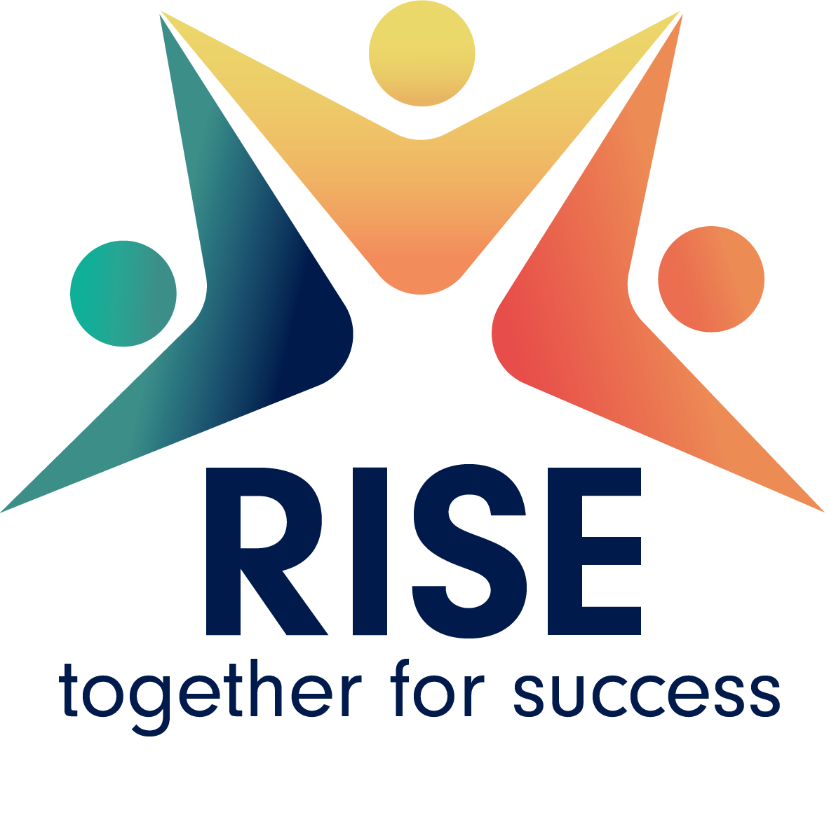
[[IMAGE REF 0001]] Image reference -- not directly editable; the original page reference is preserved automatically. Source: https://www.bemidjistate.edu/services/student-success-center/wp-content/uploads/sites/62/2024/12/RISE-1.png
College can be challenging for many reasons, and having the right support and resources can help students succeed.

RISE Program Overview
Bemidji State’s RISE (Roberge Inspiring Student Excellence) program pairs students with a coach/advisor to help them succeed, earn a college degree and advance on their career path. The program was built based on a nationwide study designed to test whether providing students with access to coaching and other resources can improve their ability to reach their goals and graduate on time. RISE gives students access to resources and support throughout their first few semesters of college for up to two years. This model has proven that students in the program have a higher than national average retention rate and those who stay in the program consistently improve their GPA.
Bemidji State University’s 2024 Distinguished Minnesotan and BSU alumnus Mike Roberge has made this program possible through a generous multi-year donation. Thank you, Mike!

Eligibility
RISE eligibility requires students to be degree-seeking with 60 or fewer earned college-level credits and meet at least one of the following criteria:
- Pell grant-eligible (based on FAFSA)
- Student of color
- First generation (neither parent completed a four-year degree)
- Conditionally admitted to BSU
If you meet the criteria above and want to learn more about the RISE program, schedule an appointment with a RISE coach.

Program Benefits
- Access to a RISE coach all year who will help you navigate college and provide personal and academic coaching.
- Guidance on the steps you can take to be a successful student.
- Access to a RISE peer mentor for day-to-day check-ins on how things are going.
- Financial incentives to help cover some of your daily expenses for up to two years.
- Support in registering for classes each semester, campus resources, referrals and career planning.
- Invitation to fun and engaging events and socials each semester.

Student Testimonial
“As someone who has been in the SUCCESS program for almost two years now, I can vouch that it has been a real game changer for me. The personalized advisement and guidance I have received from my coach has helped me set clear academic goals, and the resources they provide have helped me achieve successful habits both inside and outside the classroom. All in all, I am extremely grateful to have such an experience here at BSU.” Aleks G., Bemidji, MN

Contact
- Please send questions to success@bemidjistate.edu
- Karen Stish, RISE program coordinator, coach and advisor
- Justin Walters, RISE coach and advisor
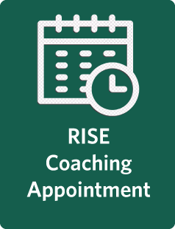
[[IMAGE REF 0000]] Image reference -- not directly editable; the original page reference is preserved automatically. Source: https://www.bemidjistate.edu/services/student-success-center/wp-content/uploads/sites/62/2024/12/request_RISE_appt_button.png

