Title | TRIO
Meta Description
— Page content begins below. Please do not edit the table above. —
Are you looking for a program that can help you succeed in college and prepare for a professional career? Bemidji State is proud to offer TRIO Student Support Services (SSS)! This federally-funded program, offered by the US Department of Education, is available to eligible students free of charge.

Academic and Personal Support
- First generation college students

[[IMAGE REF 0000]] Image reference -- not directly editable; the original page reference is preserved automatically. Source: https://www.bemidjistate.edu/services/triosss/wp-content/uploads/sites/80/2022/05/TrioLogo2020-small-300x111-1.png
- Students who qualify for financial aid
- Students who have documented disabilities

Apply for TRIO
Request a Tutor
Become a Tutor

TRIO Student Support Services Benefits
With TRIO SSS, you’ll have access to a wide range of resources and support, including:
- Courses specifically designed to help you succeed in college
- Individualized academic, personal and financial advising
- Tutoring to help you master difficult subjects
- Mentoring to guide you through the college experience
- Connections with other students who share similar backgrounds
- Cultural and social events to help you get involved on campus
- Leadership opportunities to help you develop valuable skills and experience
If you’re interested in taking advantage of these great benefits, be sure to apply. Participation is based on eligibility, selection and enrollment in credit-earning courses that count toward graduation.
Learn more about eligibility requirements and application procedures, or stop by and see us. Our offices are located in Decker Hall, Suite 240.

Contact Us
Decker Hall 240
Phone: (218) 755-2614
Fax: (218) 755-2598
Email: TRIO_SSS@bemidjistate.edu
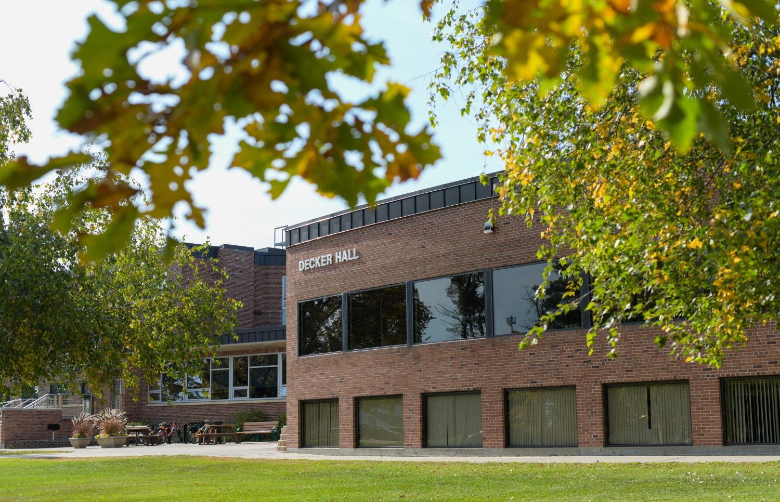
[[IMAGE REF 0001]] Image reference -- not directly editable; the original page reference is preserved automatically. Source: https://www.bemidjistate.edu/services/triosss/wp-content/uploads/sites/80/2022/10/Decker-Hall-Fall-2022.jpeg

