Title | Home
Meta Description | Bucks County Community College offers associate degree and certificate programs at a fraction of the cost of a traditional four-year college. Bucks has campuses in Newtown, Perkasie, Bristol and offers Online Learning. Programs can be earned fully online, in person, or a combination of both. A variety of non-credit certificates, trainings and courses are available through our division of Continuing Education, Workforce Development & Public Safety.
— Page content begins below. Please do not edit the table above. —
[Image preview unavailable (MissingSchema) -- original reference preserved automatically below.]
[[IMAGE REF 0001]] Image reference -- not directly editable; the original page reference is preserved automatically. Source: /open-house-home.jpg

Open House
Discover all that Bucks has to offer. Join us for an Open House!
→ October 21: Culinary & Hospitality
→ October 24: Newtown Campus
Visit an Open House

[[IMAGE REF 0002]] Image reference -- not directly editable; the original page reference is preserved automatically. Source: https://www.bucks.edu/media/bcccmedialibrary/marketing/assets/graduation-cap-icon.png

90+
Transfer and Career-Ready Majors
Find A Program
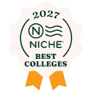
[[IMAGE REF 0000]] Image reference -- not directly editable; the original page reference is preserved automatically. Source: https://www.bucks.edu/media/bcccmedialibrary/marketing/assets/niche-icon.png

#1
Best Community College in the Region
The Value is Clear

[[IMAGE REF 0003]] Image reference -- not directly editable; the original page reference is preserved automatically. Source: https://www.bucks.edu/media/bcccmedialibrary/marketing/assets/user-group-icon.png

14:1
Student-to-Faculty Ratio
Explore Academics

Save Up To 68% On Your Bachelor's Degree
Completing your first two years at Bucks means big savings with our 2+2 dual admission transfer partners.
Save at Bucks
[

[[IMAGE REF 0004]] Image reference -- not directly editable; the original page reference is preserved automatically. Source: https://www.bucks.edu/GettyImages-661410282.jpg
Workforce Development](https://www.bucks.edu/workforce/)
[

[[IMAGE REF 0005]] Image reference -- not directly editable; the original page reference is preserved automatically. Source: https://www.bucks.edu/GettyImages-619749258.jpg
Career + Professional Development](https://www.bucks.edu/career-professional-development/)

Student Services
Admissions
Registration
Financial Aid
Tuition & Payment
Academic Advising
Academic Success Center
Student Counseling
Workday Student
Continuing Education
[# Personal Enrichment

Exercise your mind, invigorate your body, develop your personal hobbies, and build friendships.](https://www.bucks.edu/enrichment/)
[# Professional Development

Advance your career by learning a new skill, maintaining your credentials, or obtaining new ones.](https://www.bucks.edu/career-professional-development/)
[# Information Technology

Training for industry-standard technology certification programs and courses to advance your tech career.](https://www.bucks.edu/career-professional-development/it/)
[# Healthcare

Start or advance your career in healthcare with our programs taught by highly-skilled, experienced instructors](https://www.bucks.edu/healthcare/)
Free Career Training
[# Metalwork

Learn a new trade alongside industry experts in as little as 12-weeks.](https://www.bucks.edu/workforce/metalwork/)
[# Healthcare Pre-Apprentice

Turn your passion for helping others into a healthcare career.](https://www.bucks.edu/healthcare/pre-apprenticeship/)
[# Industrial Maintenance

Gain the fundamentals needed to maintain and repair machinery using cutting-edge technology.](https://www.bucks.edu/workforce/industrial-maintenance/)
[# All Programs

Our free and accelerated training programs put you on the fast-track to a rewarding new career.](https://www.bucks.edu/workforce/)

Graduate Spotlight
Shining a spotlight on the graduating Class of 2026.
Graduate Spotlight

In the News
All recent news
[
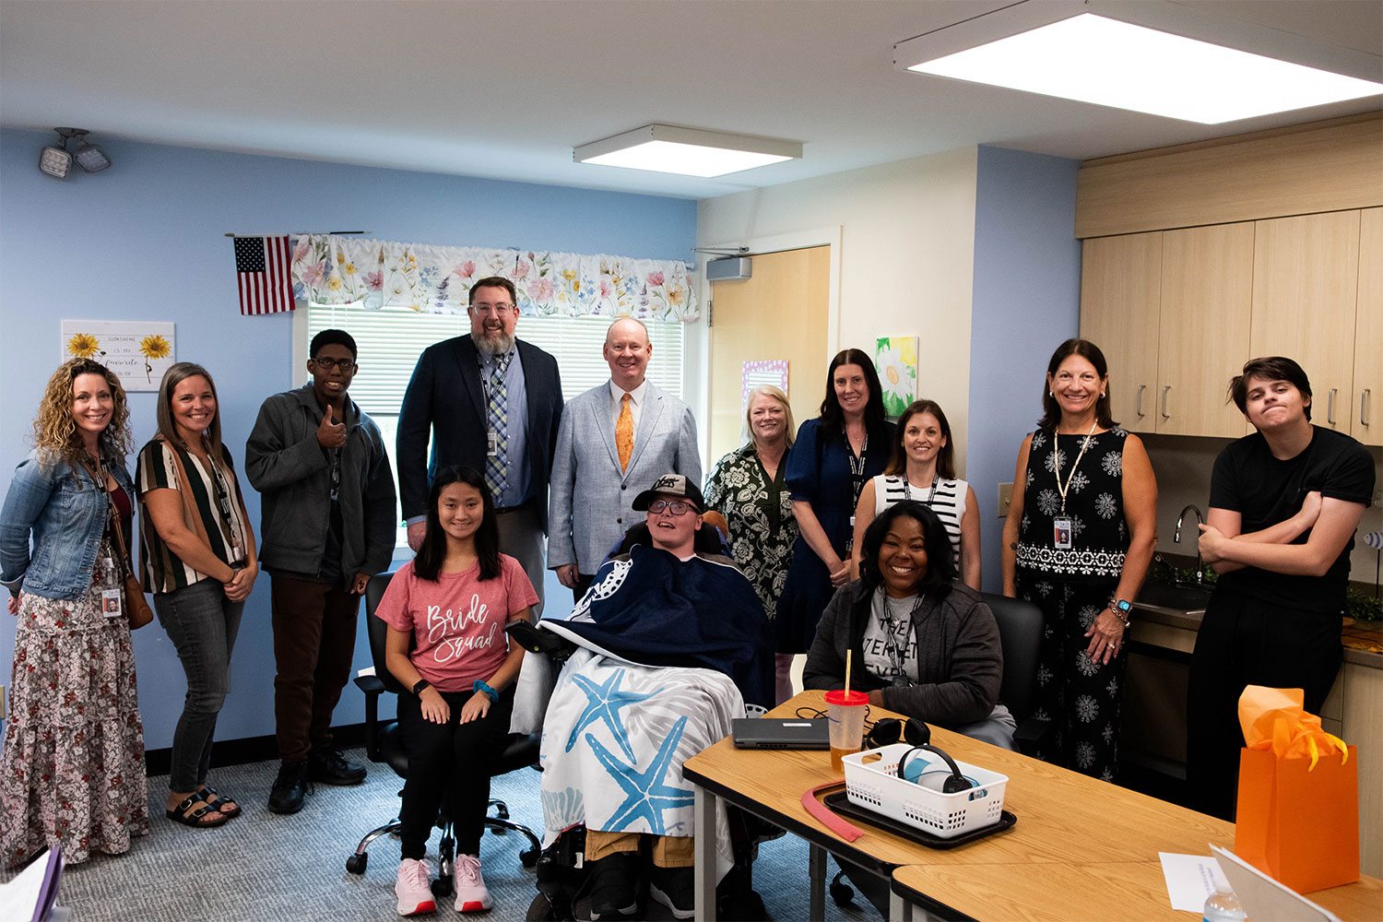
[[IMAGE REF 0006]] Image reference -- not directly editable; the original page reference is preserved automatically. Source: https://www.bucks.edu/media/bcccmedialibrary/marketing/news/bucks-iu.jpg

Bucks County Community College and the Bucks IU Expand Partnership
The Bucks County Intermediate Unit (Bucks IU) and Bucks County Community College (BCCC) have announced an expansion of their long-standing partnership to add an adult services hub – the IU’s first – on the College’s Newtown Campus to better serve IU clients over age 22. “At Bucks County Community College, partnerships with key community organizations are crucial to our success,” said President and CEO Patrick M. Jones, Ph.D. “Strategic partnerships allow us to combine resources to extend the reach and impact of both organizations. This evolution of our relationship with the Bucks IU is just one of the latest examples of such partnerships, with more on the horizon.” Jones added that the expanded partnership benefits each organization. The space will serve as the home of an Adult Community Hub, connecting participants to the educational, social, vocational, and wellness opportunities available on campus and throughout the community. Individuals will build practical life skills, explore employment opportunities, develop relationships, and participate in meaningful experiences that support independence and community inclusion. “The Adult Community Hub reflects our commitment to creating meaningful opportunities for individuals with disabilities beyond their K-12 years,” said Mark Hoffman, Ed.D., the Bucks IU’s executive director. “This partnership recognizes a simple truth: adulthood should bring new opportunities, not fewer. Through our collaboration with Bucks County Community College, participants will have access to authentic learning, social, and vocational experiences that foster independence, connection, and personal growth. Together, we are creating a pathway that helps more individuals build fulfilling lives as active members of their community.” The two organizations already collaborate in many ways. Bucks County Community College provides Bucks IU with classroom space to serve preschool age students, which gives the College’s Pre K-4 early education students the chance to work with special needs children directly on campus. This has been a fixture on the Newtown Campus for many years and now has a new home in the specially designed Early Learning Center. The IU also uses classroom space at the Upper Bucks Campus in Perkasie and the Gene and Marlene Epstein Campus in Bristol to serve students ages 18 - 22. Bucks County Community College students enrolled in the Associate of Science in Nursing program also complete a community clinical rotation at Bucks IU’s Lower Southampton Early Learning Center. BCCC and Bucks IU also collaborate on a unique registered apprenticeship program to help address the critical shortage of special education teachers. The program — the first of its kind in Pennsylvania — is a three-way collaboration between the College, the Bucks IU, and Gwynedd Mercy University. Students earn an associate degree at Bucks and a bachelor’s degree from Gwynedd Mercy while completing apprenticeships at the BCIU.](https://www.bucks.edu/calendarnews/news/news/bucks-county-community-college-and-the-bucks-iu-expand-partnership.html)
[
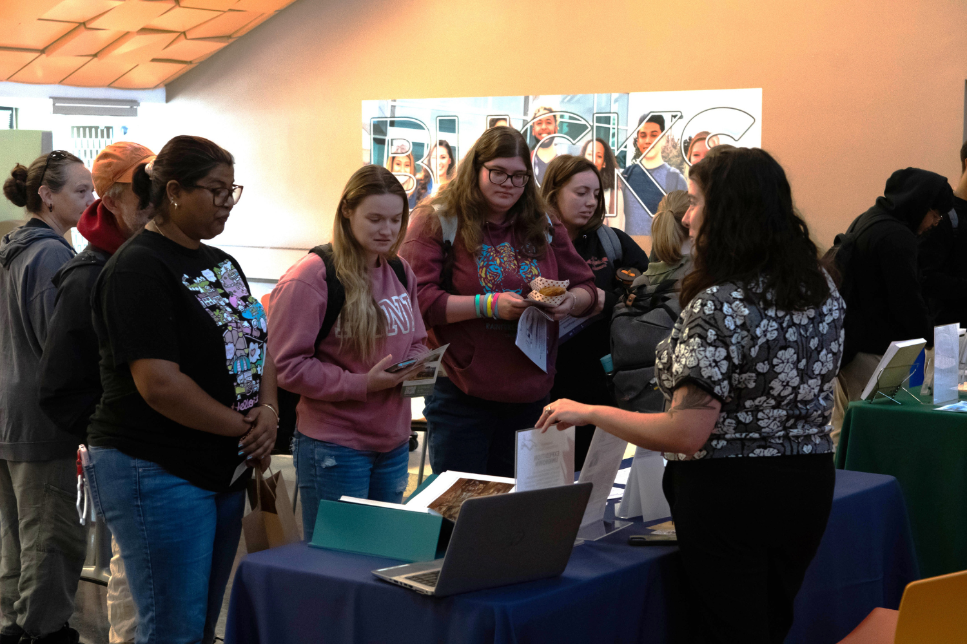
[[IMAGE REF 0007]] Image reference -- not directly editable; the original page reference is preserved automatically. Source: https://www.bucks.edu/media/bcccmedialibrary/marketing/images/bccc_family_history_month_web.png

Get Help Finding Your Roots at Family History Month Meet & Greet
In celebration of Family History Month, Bucks County Community College’s Library will host a free Family History Event Meet & Greet on Thursday, October 15, from noon to 2 p.m. on the Newtown Campus. The event aims to connect community members with the vast array of local resources available to aid them in their personal family history searches while highlighting the county's rich cultural heritage. Attendees will have the opportunity to meet representatives from local genealogical societies, historical associations, and museums spanning Bucks County, according to Kelly Deeny, the Library’s community outreach technician who organized the event for the third year in a row. “Each year’s event has been so well received that we’ve expanded the number of organizations taking part,” said Deeny. “And so, whether you’re an avid genealogy enthusiast or just starting out, we have plenty of resources to help you in your family history journey.” Participating organizations scheduled to attend include: Bolton Mansion Bucks County Free Library Bucks County Genealogical Society Bucks County Historical Society/Mercer Museum & Fonthill Castle Bucks County Register of Wills & Clerk of Orphans’ Court Doylestown Historical Society Gather Place Museum Genealogical Society of Pennsylvania Grundy Museum & Archives Historic Fallsington Pennsbury Manor Plumstead Historical Society Solebury Township Historical Society Washington Crossing Historic Park Yardley Historical Association The event, which is free and open to the public, takes place in the Gallagher Room of the Rollins Center. The campus is located at 275 Swamp Rd., Newtown, PA, where there is ample free parking. For a campus map and directions, visit our Newtown Campus web page](https://www.bucks.edu/calendarnews/news/news/get-help-finding-your-roots-at-family-history-month-meet--greet-.html)
[
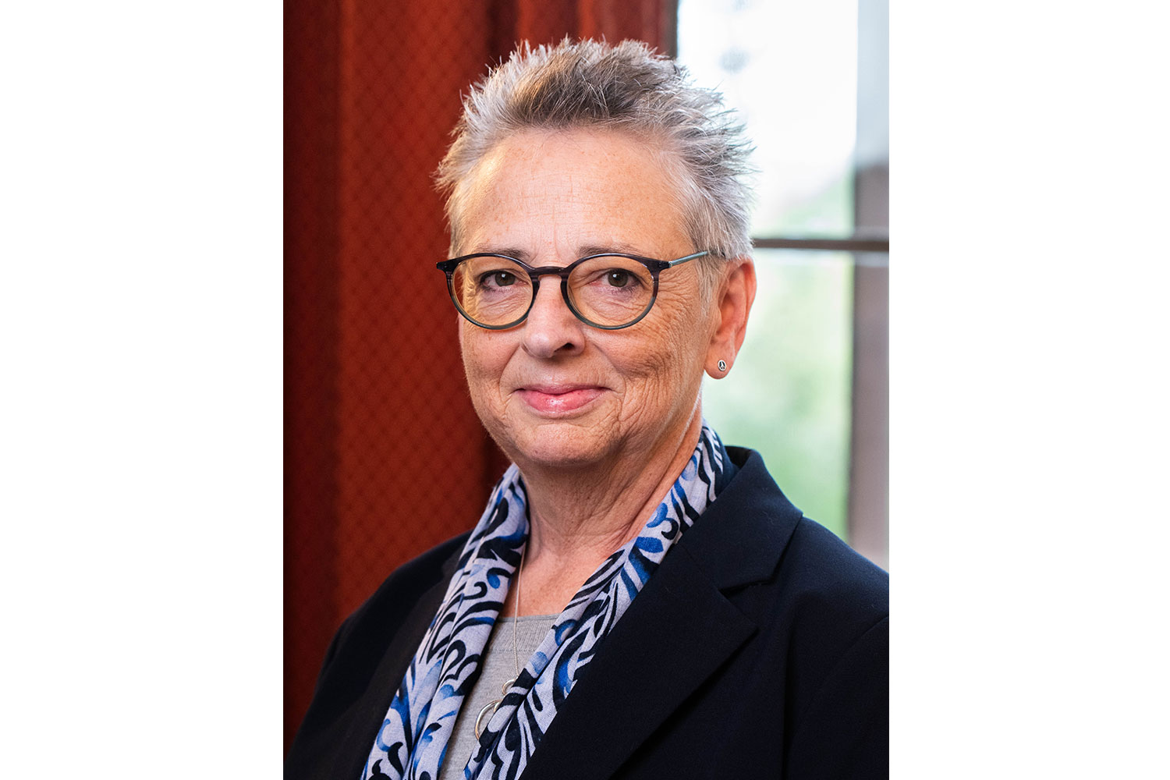
[[IMAGE REF 0008]] Image reference -- not directly editable; the original page reference is preserved automatically. Source: https://www.bucks.edu/media/bcccmedialibrary/marketing/news/darmstrong.jpg

Bucks County Community College Hires VP for Advancement & Alumni Relations
Bucks County Community College officials have announced that Deborah Armstrong has joined the College as Vice President for Advancement & Alumni Relations. In this role, Armstrong is responsible for increasing philanthropy by engaging alumni, friends, foundations, and corporations to advance the College’s mission of changing lives through accessible and affordable high-quality education and workforce development. She leads a team of advancement and alumni professionals who work with individual donors, non-profit foundations, corporations, and government grant awarding agencies, and facilitate the work of dedicated volunteers on the Alumni Council, the BCCC Foundation board, and various college advisory groups. She leads development strategies, major gift cultivation, and donor stewardship. President & CEO Patrick M. Jones said, “Deborah is a proven fundraiser and strategic leader. Her data-driven approach to aligning strategy, systems, resources, and metrics to institutional priorities will serve the College well.” Armstrong’s 20+ years of advancement experience in higher education includes positions at University of Denver, Syracuse University, and SUNY Oswego. In addition, her non-profit experience includes Bicycle Colorado, a statewide advocacy organization with 10,000+ members; Girl Scouts, Illinois Crossroads Council; and Big Brothers Big Sisters, Fox Valley Region. “As a community college graduate and an East Coast native, being back in higher education at Bucks County Community College already feels like home. I am looking forward to working with prospective and current donors, community partners, friends of the College, and my colleagues, to change students’ lives.” Armstrong attended SUNY Morrisville, earned the bachelor’s degree in Sociology from SUNY Oswego and the master’s degree in Philanthropy & Development from Saint Mary’s University of Minnesota. She is studying for an Executive Master of Public Administration degree from Syracuse University, where she previously earned a certificate in conflict resolution. She is also a Masters swim coach, a USA Triathlon Coach Level 1, and a certified Ironman Coach.](https://www.bucks.edu/calendarnews/news/news/bucks-county-community-college-hires-vp-for-advancement--alumni-relations.html)

