BUSINESS INTELLIGENCE ASSIGNMENT

Online Retail Sales, Customers & Returns

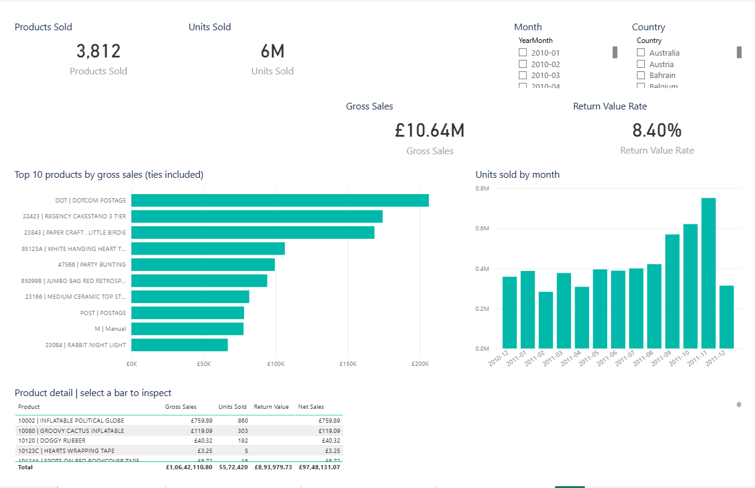

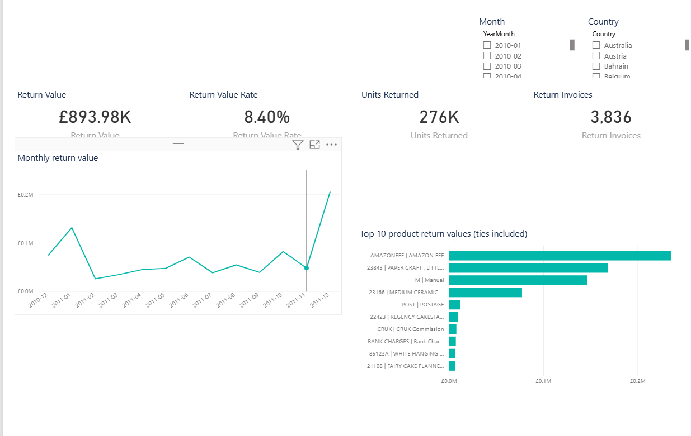

Aim and business questions
To transform retail invoice lines into an interactive Power BI report that explains sales performance, product demand, customer activity, geographical concentration and observed returns.
The report answers: How much was sold? Which months and markets contributed most? Which product codes and identified customers generated the largest sales? How much value was credited or returned? How does source quality affect these answers?

Dataset and scope
The submitted Online Retail.xlsx contains 541,909 transaction lines and 8 columns. Observed dates span 1 December 2010 at 08:26 through 9 December 2011 at 12:50. The matching UCI documentation describes a UK online retailer and prices in sterling. All monetary values here are GBP. The uploaded file, rather than website summary statistics, is authoritative for row counts and missingness.
Original column Meaning / treatment
InvoiceNo Invoice identifier; leading C indicates cancellation. Stored as text.

StockCode Product or transaction code. Stored as text; codes may include non-merchandise charges.
Description Product label; a canonical label is selected per code. Quantity Signed item quantity: positive sale, negative return/credit.
InvoiceDate Transaction timestamp; a separate date key supports the calendar. UnitPrice Price per unit, in GBP. Only positive prices are included.

CustomerID Customer identifier. Missing IDs become Unknown; not counted as a known customer.

Country Country label attached to each transaction. Original labels are retained.

Scope boundaries
This is descriptive analysis of one historical dataset. It does not estimate profit, margin, inventory, acquisition cost or customer lifetime value because costs and supporting inputs are absent. No forecast or full year-over-year growth claim is made.

Data preparation and audit

Step | Rows
Original invoice lines | 541,909
Remove exact duplicates across all 8 original fields | -5,268
Exclude zero quantity, non-positive price, invalid date, or positive-quantity cancellation | -2,512
Retained transaction lines | 534,129
Of retained: positive-quantity sales | 524,878
Of retained: negative-quantity returns/credits | 9,251

Cleaning decisions
Exact duplicate removal is an explicit assignment assumption: repeated identical lines are treated as duplicated records. This may remove legitimate identical invoice lines; the original workbook is retained for audit. Duplicate detection occurs before filling missing values or normalizing text. Exclusion counts are sequential and do not double count overlapping conditions.
Missing customer IDs occur on 135,080 raw rows. They become a shared Unknown key, retaining their sales while excluding them from known-customer and repeat-customer counts. The raw file has 1,454 missing descriptions. Remaining missing labels become Unknown product. Where a code has multiple descriptions, select the most frequent cleaned description; alphabetical order breaks ties.
LineAmount = Quantity x UnitPrice, rounded to two decimal places. Negative quantities retain their sign. Gross Sales includes positive lines. Return Value is the absolute amount of negative lines. Net Sales = Gross Sales - Return Value. Returns are observed credits and are not matched to their original sale dates.
Unusual large transactions and positive-priced manual/postage codes are retained. Therefore Products Sold counts stock codes, not a verified physical-product catalogue. December 2011 is incomplete and must not be treated as a full month.

Refresh and reproducibility
The prepared CSV files are the active Power BI source. Their data types are assigned in Power Query. Scripts/prepare_data.py reproduces these tables from the retained workbook using pandas and openpyxl. If the workbook changes, regenerate all CSVs before refreshing Power BI. Simply changing the workbook does not update the prepared source. The fixed quality text and this PDF describe the original supplied snapshot.

Semantic model and measures
The star model has one invoice-line fact table and four dimensions. All relationships are active, many-to-one from fact to dimension, with single-direction filtering from the dimension to the fact. Dimension keys are unique and every retained fact key has a corresponding dimension row.
Dimension key (one) Fact key (many)
DimDate[Date] FactTransactions[TransactionDate]

DimProduct[StockCode] FactTransactions[StockCode]

DimCustomer[CustomerID] FactTransactions[CustomerID]

DimCountry[Country] FactTransactions[Country]

The calendar covers every date in 2010 and 2011. YearMonth is sorted by YearMonthSort, Month by MonthNumber, and DayOfWeek by DayOfWeekNumber. Use the date-only key for relationships; use InvoiceDate only when timestamp detail is needed.
Measure Definition
Gross Sales Sum of LineAmount for Sale lines.

Return Value / Net Sales Absolute return amount / gross sales less returns.

Sales Orders / Average Order Value
Distinct sale invoice numbers / gross sales divided by sales orders.

Known Customers Distinct sale customer IDs, excluding Unknown.

Repeat Customer Rate Known customers with more than one sale invoice divided by known
customers, within current filters.

Return Value Rate Return Value divided by Gross Sales; not an item or order return
probability.

Monthly Sales Change Current sales vs previous month, using DATEADD. Interpret only at
month grain and with complete periods.

Top 10 measures Rank within the current selection. Dense-rank ties can show more than
10 entities.

All 23 formulas and format strings are included in Scripts/Measures.dax. Measures are already in the project; do not paste duplicate copies. DIVIDE returns blank when its denominator is zero. Slicers change measure filter context; fixed audit annotations are deliberately unchanged.

Dashboard design and use
Page Visuals and purpose
  - | Sales Overview Gross/net sales, sales orders and AOV cards; monthly gross/net trend;
country sales; monthly detail and partial-month note.

  - | Product Performance Product count, units, gross sales and return rate cards; top product
sales; monthly units; product detail table.

  - | Customers & Markets Known customers, repeat rate, countries and anonymous share cards;
top identified customers; market sales and detail.

  - | Returns & Quality Return value, rate, units and invoices cards; monthly credits; top product
returns; fixed source-quality annotations.

Each page has Month and Country slicers. Click chart bars to inspect related visuals, and clear selections before verifying the whole-dataset totals. Slicers are page-specific; switching pages does not automatically copy a selection. Scroll the country charts and tables for additional rows. No map visual is needed, so the assignment does not depend on geocoding services.

Results and interpretation

Full-data KPI | Expected value
Gross Sales | GBP 10,642,110.80
Return Value | GBP 893,979.73
Net Sales | GBP 9,748,131.07
Sales Orders | 19,960
Average Order Value | GBP 533.17
Known Customers | 4,338
Units Sold | 5,572,420
Products Sold (stock codes) | 3,922
Countries Served (source labels) | 38
Return Value Rate | 8.40%
Repeat Customer Rate | 65.58%
Anonymous Sales Share | 16.49%

Findings and actions
Concentration: The UK contributes GBP 9,001,744.09, or 84.59% of gross sales. Protect performance in that market while evaluating demand in the Netherlands, EIRE, Germany and France. These country labels are preserved as provided.
Seasonality: November 2011 has the highest observed monthly gross sales at GBP 1,503,866.78. September to November rises in this snapshot. This supports investigating pre-holiday stock planning, but one observed season cannot establish a general seasonal pattern.
Data coverage: Anonymous sales total GBP 1,754,901.91. Customer-level analysis cannot explain that revenue at an individual level. Improve customer identification before making broad retention claims.
Returns: Investigate the product codes with the largest credit values and check unusually large transactions. This dataset alone cannot distinguish operational causes such as damage, invoicing mistakes or actual physical returns.

Open, refresh and submit
Requirements: Power BI Desktop on Windows, with support for Power BI Project files and the enhanced PBIR report format. If your Desktop build requires preview features, enable Power BI Project (.pbip) save and enhanced report format in File > Options and settings > Options > Preview features, then restart.
- Extract the entire ZIP to a normal folder. Keep Data, PowerBI and all other folders together.
- Before opening the project, optionally run Setup_Paths.ps1 with PowerShell to set the DataFolder parameter to the extracted Data directory. It only edits the local model file. If script execution is blocked, use the manual method below.
- Open PowerBI/OnlineRetail.pbip. This opens the report and its semantic model. There is no preloaded data cache.
- Manual path method: Home > Transform data > Edit parameters (or Manage Parameters inside Power Query). Set DataFolder to the full path of the extracted Data folder, such as D:\Assignments\Online_Retail_PowerBI_Assignment\Data. Do not add quotation marks.
- Close & Apply if needed, then click Refresh. Wait for all five tables to load.
- Verify DimDate is marked as the date table using its Date column; if not, use Table tools > Mark as date table. Confirm all four model relationships are active.
- Clear slicers, compare the overview to the expected KPI table, and inspect every page for visual errors.
- File > Save As > Power BI file (.pbix). Save as Online_Retail_Assignment.pbix. Submit that file with this report and the requested screenshots.

Troubleshooting
Symptom Action
Cannot find CSV file Correct DataFolder; use a complete local folder path and extract the
entire ZIP.

Unsupported project/report version
Use a Desktop release supporting PBIP and enhanced PBIR, and enable applicable preview options.

Blank cards immediately after open
Refresh: the project stores definitions, not an imported data cache.

Totals differ Clear filters, confirm original CSV files and check Validation/expected_results.json.

Project or visual fails to open Retain the exact error. Documentation/Manual_Build_Guide.md
provides a fallback using the same CSVs, measures and visual field mappings.

Validation limits: structural checks and source reconciliation do not replace Power BI Desktop execution. A native PBIX is not included or claimed to have been tested.

