# Q49: Connect to sql and write a query to find all patients who have a gender of 'Male' ( Attach screenshots for this question)

## **Installation of SQL Lite**



## Code in Team18_Matlib_marvels_Main80Questions.ipynb file connecting to the Sqlite and retrieving the output using the query.

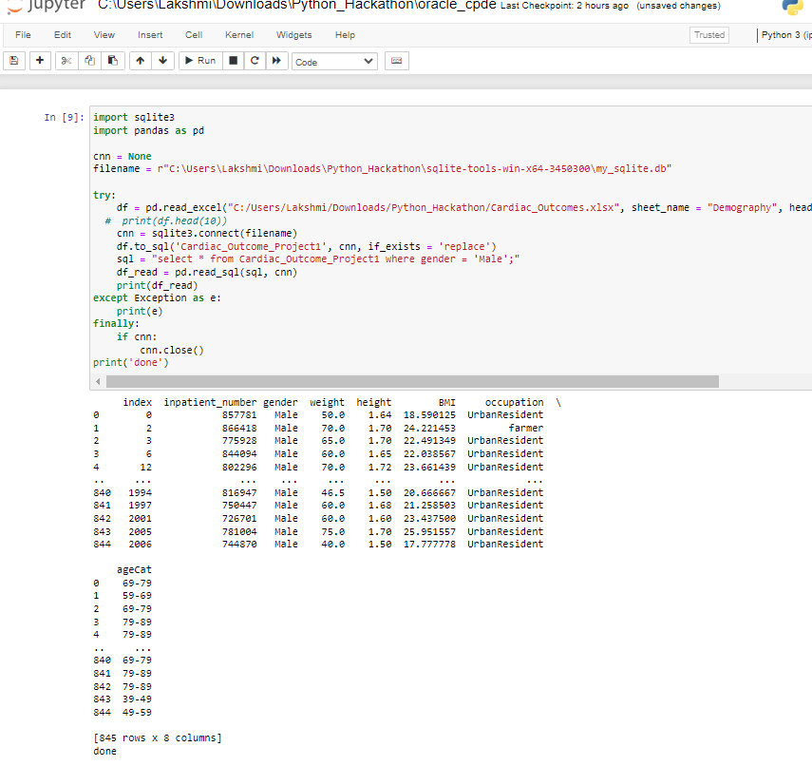

## RETRIEVING TABLE USING ORACLEDB

## I imported the Excel data as a file to SQL to Oracle SQL Developer and created a table “Demography” from the sheet. Then I used Select query to get the data.

Select * from demography where gender = ‘Male’;

Which gave me the below output.

