CLASSIFICATION(XOR):

|  |  |  |  |
| --- | --- | --- | --- |
|  | RMSE | MAD | iteration |
| Model 1 | 0.0172 | 0.1268 | 28277 |
| Model 2 | 0.0070 | 0.0808 | 27873 |
| Model 3 | 0.0059 | 0.0765 | 27481 |
| Model 4 | 0.0013 | 0.0510 | 25856 |

With input=exp(-x)

|  |  |  |  |
| --- | --- | --- | --- |
|  | RMSE | MAD | iteration |
| Model 5 | 0.0564 | 0.5260 | 172890 |
| Model 6 | 0.0023 | 0.2001 | 138937 |

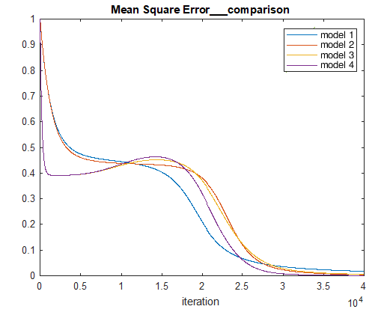

With input exp(-x)

