1- use a command to show the current working directory - list the directory contents in the short and long format (with file permissions,owner,size etc,.). Explore attributes given in long format e.g. file type, file permissions, file size, file owner etc. - list all files along with hidden files in current working directory. - list only hidden files in the directory (Hint : use pwd, ls, echo commands)

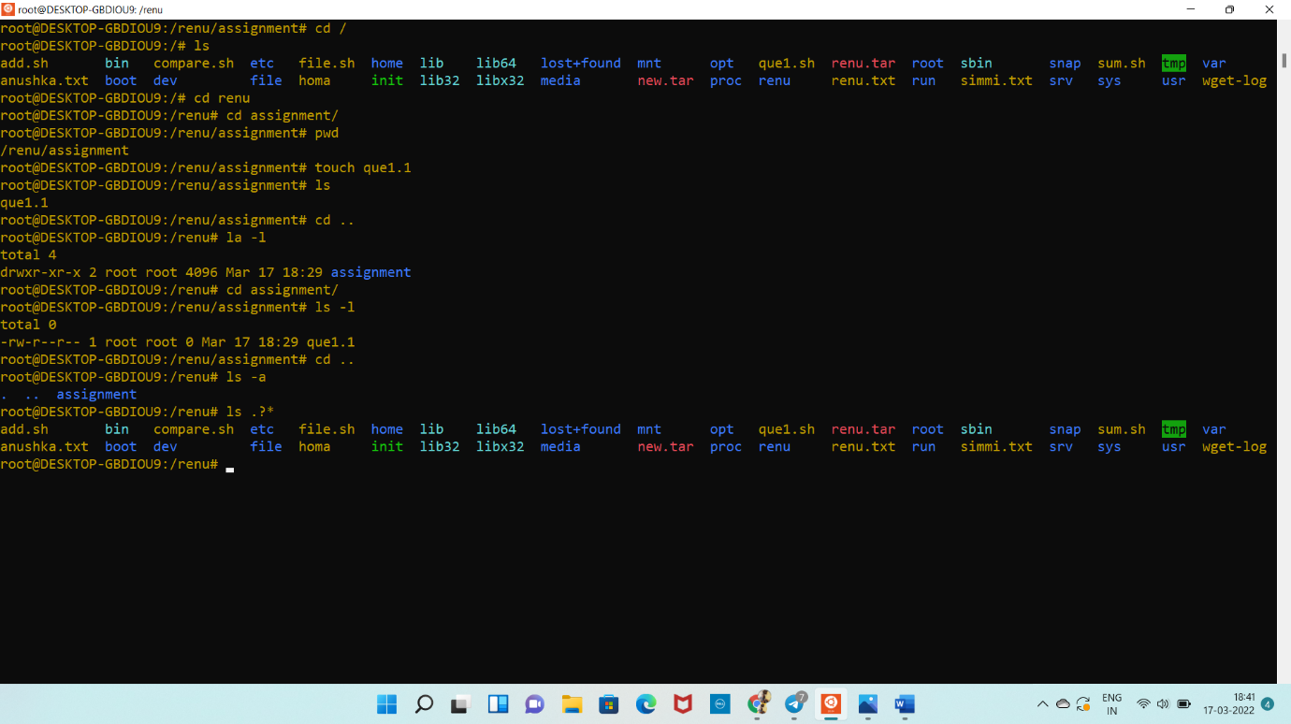

2-Make a directory and name it as cdac-dir and change the current working directory to the new directory.(Hint : use mkdir,cd commands).

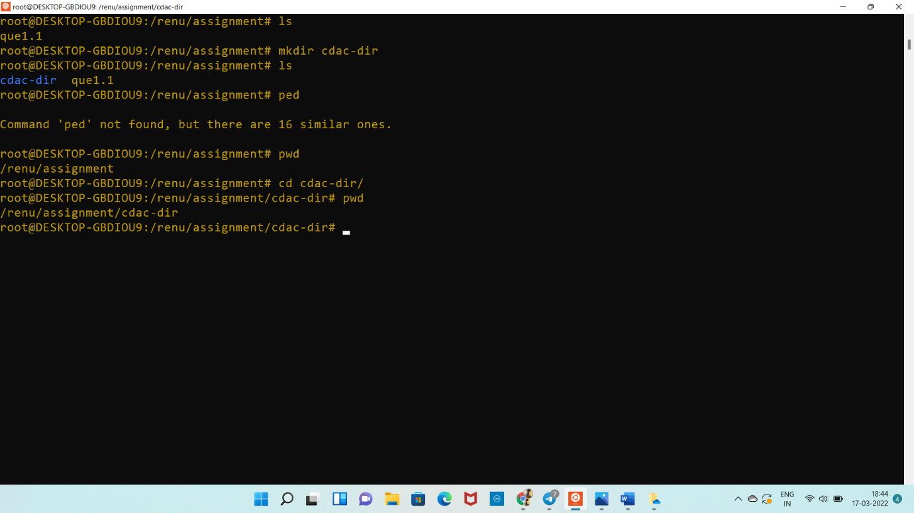

3-Create following nested directories inside current directory by invoking single command for only one time. Note : here root_dir is current directory

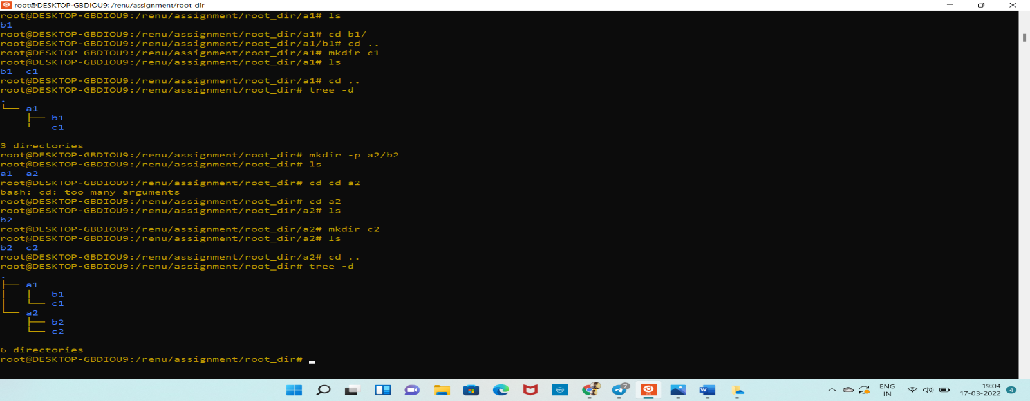

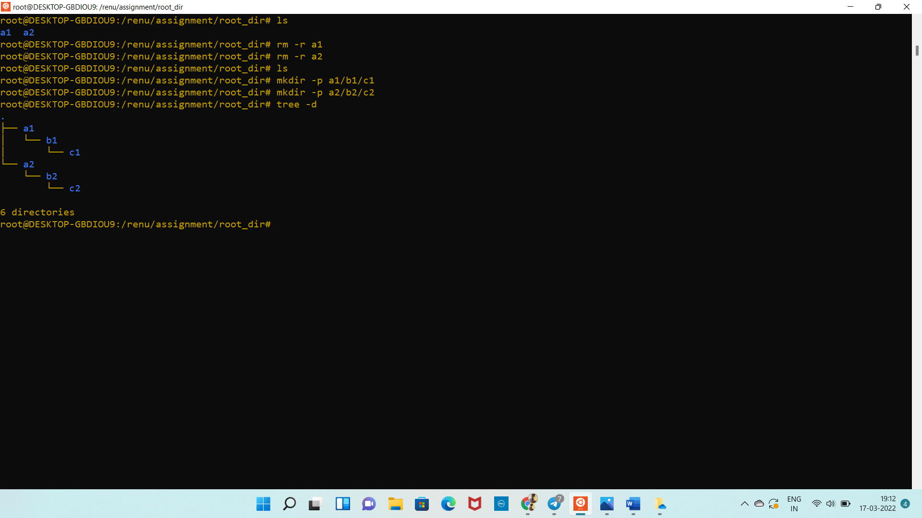

4. List the directories(folders), then remove the cdac-dir directory and list the folders again to show that it is no longer present.(Hint : use rm, ls command).

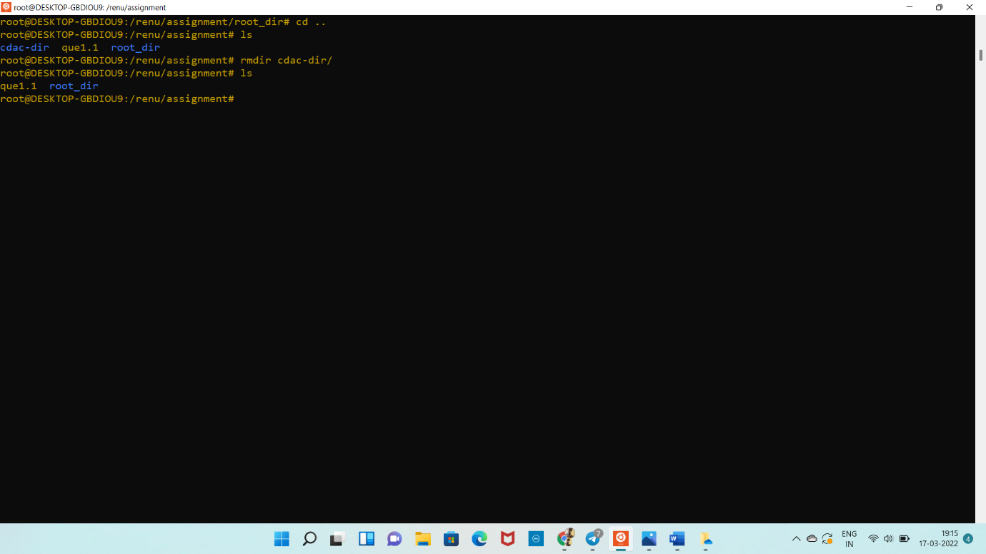

Question-2. 1. Display the man-page for ls, but redirect the output into temp.txt, then use the cat, less, and more commands to display the new file.

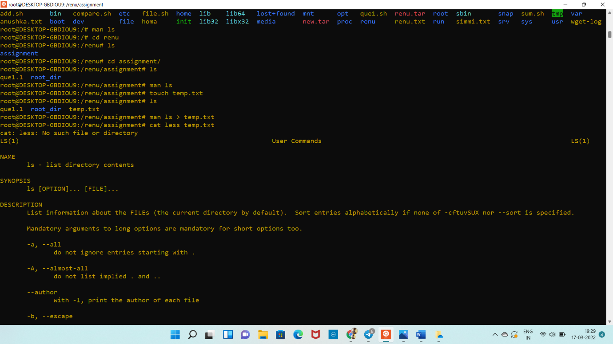

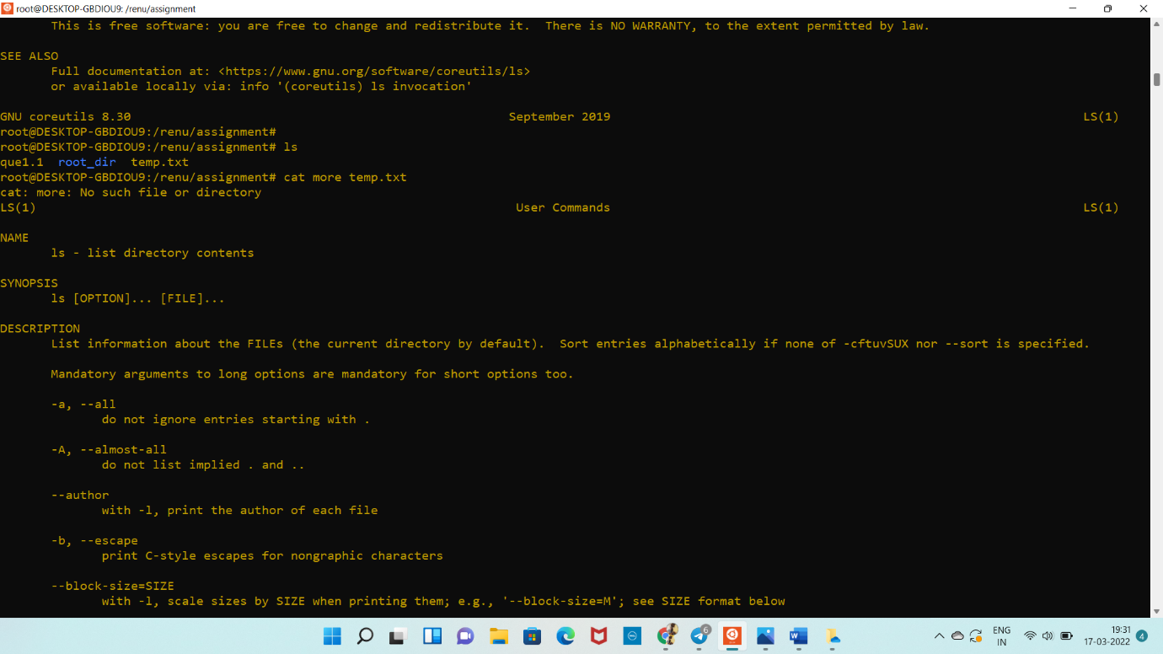

2. Display the initial 10 lines and final 5 lines of temp.txt with the obvious Linux commands.(Hint: use head and tail commands).

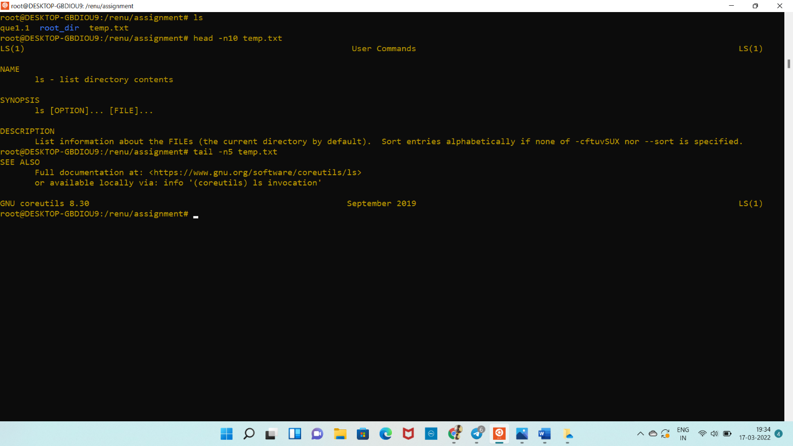

3. Copy temp.txt to another directory and rename it there. (Hint: use cp to copy and mv command to rename).

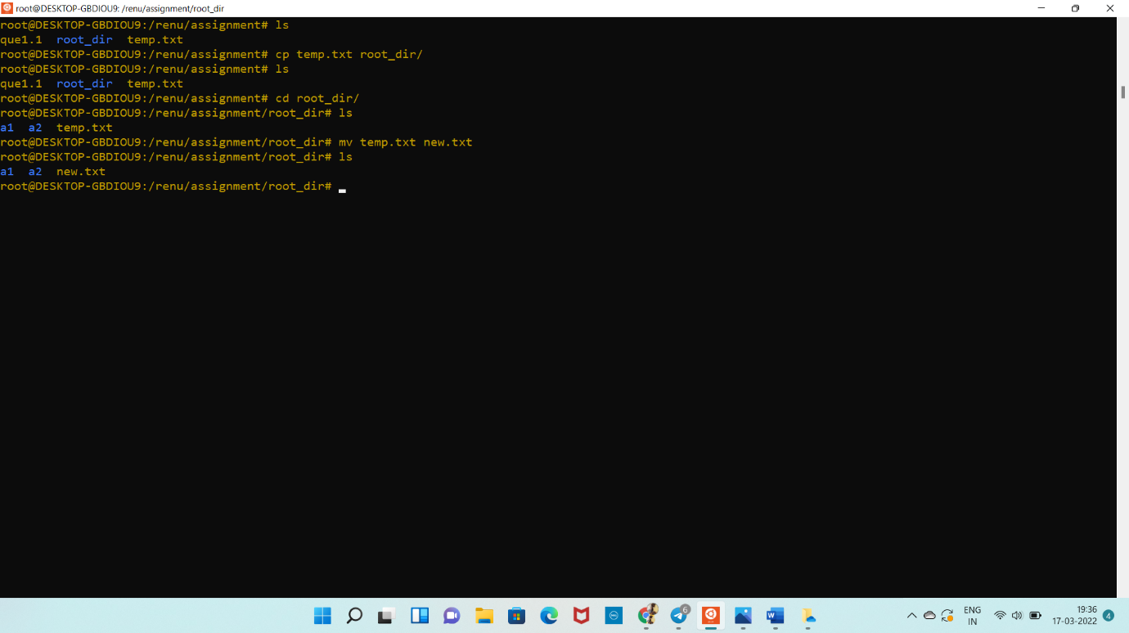

4. Display the number of lines, words and characters in file using Linux command (Hint: use wc command).5. Use history command to display last 10 commands used. (Hint: use history command).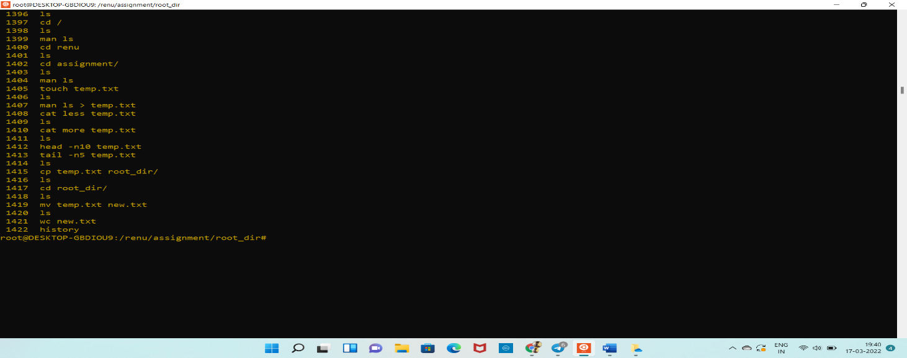

Question-3. 1. Create tar archive file of any directory present in your home directory. (Hint: use tar command) - list the contents of the archive file without extracting.

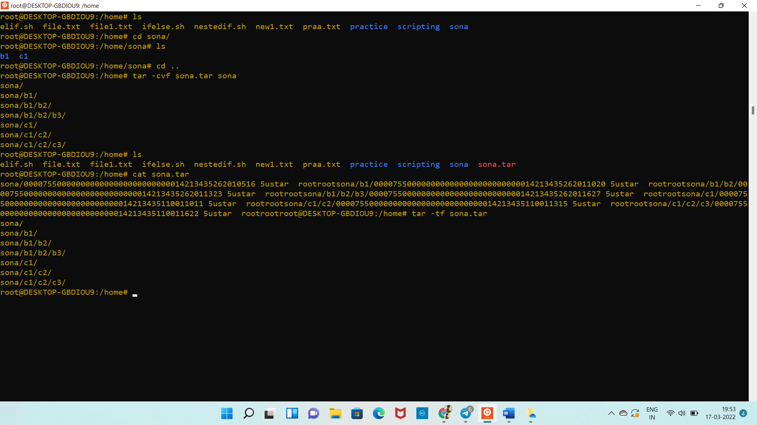

2. Create zip file of another directory. (Hint: use zip command) - list the contents of the zip file without extracting.

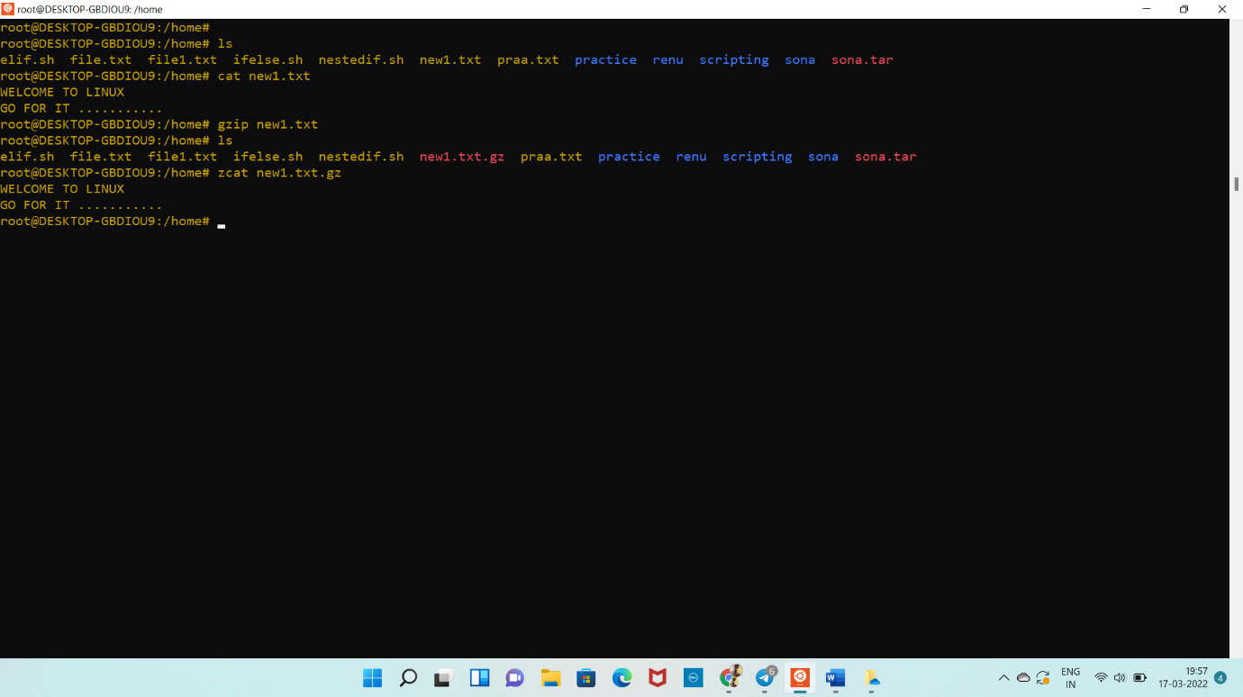

3. Give read, write & execute permissions to your file. (Hint: use chmod command)

4. Change ownership of that file.(Hint: use chown command)

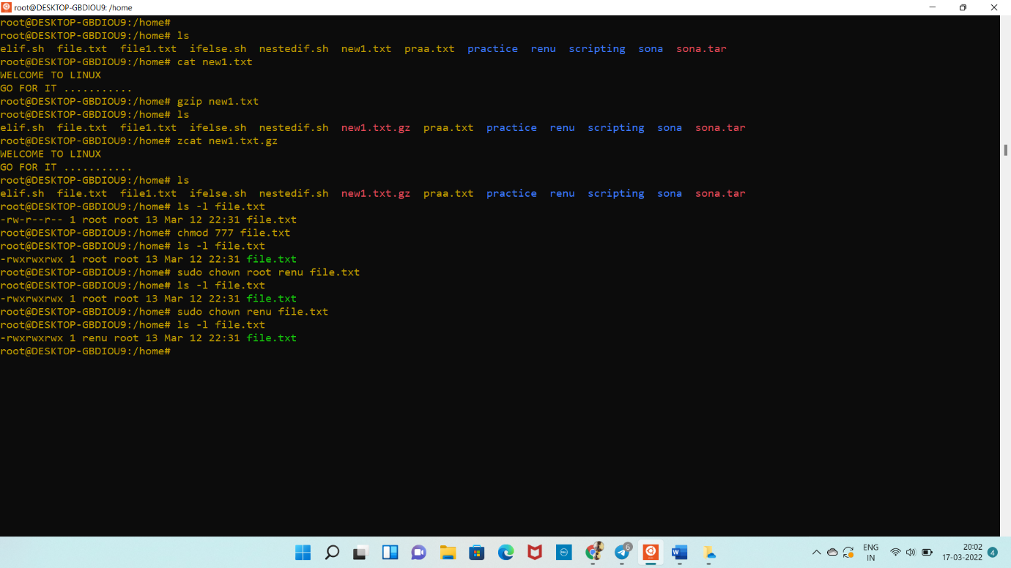

5. List processes running in shell, all running processes(Hint: use man page of ps command) and show top processes in decreasing order of their resource utilization.(Hint: use top command).

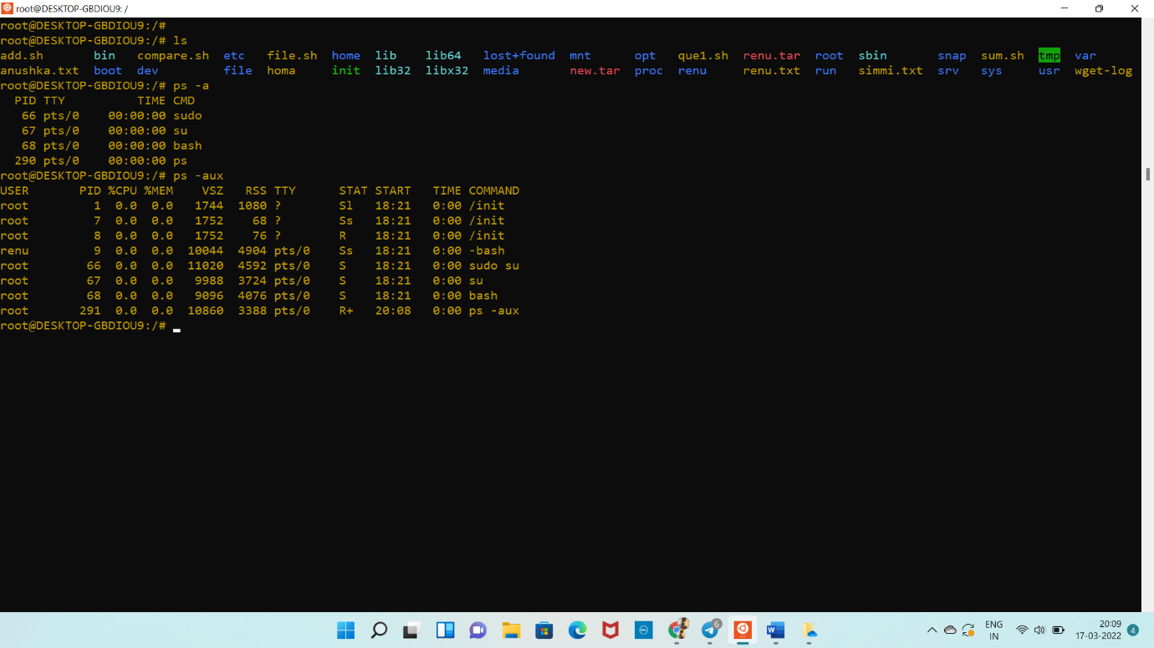

Question-4. 1. Display current time and calendar (Hint: use date, cal commands)

2. Change the current date and time of the system to following 14th March 2017, 10:10 AM

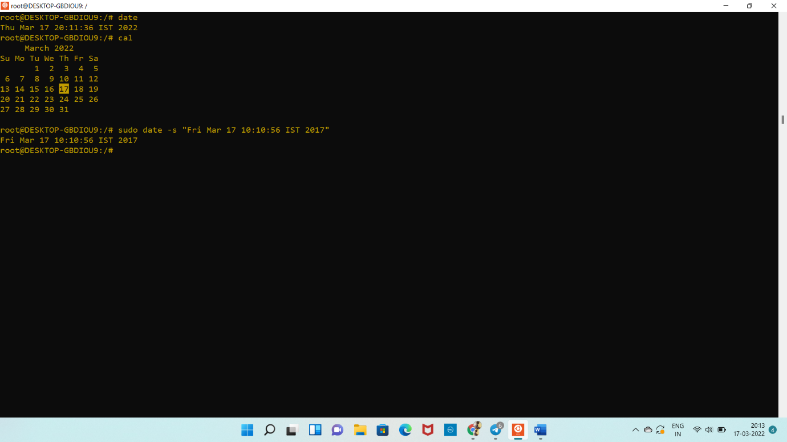

3. Explore following commands who, whoami, whatis, whereis, (Hint: use man pages).

