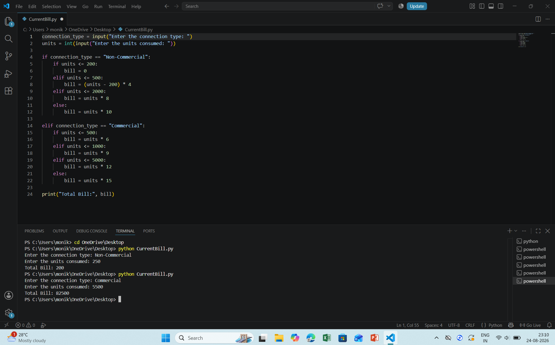

connection_type = input("Enter the connection type: ")
units = int(input("Enter the units consumed: "))
if connection_type == "Non-Commercial":
if units <= 200:
bill = 0
elif units <= 500:
bill = (units - 200) * 4
elif units <= 2000:
bill = units * 8
else:
bill = units * 10
elif connection_type == "Commercial":
if units <= 500:
bill = units * 6
elif units <= 1000:
bill = units * 9
elif units <= 5000:
bill = units * 12
else:
bill = units * 15
print("Total Bill:", bill)

