# EduTutor AI: Personalized Learning with Generative AI and LMS Integration

Project Documentation

## Team Members

1. Geethanjali  
2. Renuka Devi  
3. Subasree Lavanya  
4. Santhiya

## 1. Introduction

Education is evolving rapidly in the digital era, where students demand flexibility, interactivity, and personalized guidance in their learning journey. EduTutor AI is designed as a comprehensive solution that integrates the power of Generative Artificial Intelligence with established Learning Management Systems (LMS). The project provides learners with a tailored educational experience by dynamically adapting content to suit their pace, understanding level, and areas of improvement. Simultaneously, it empowers educators with smart teaching tools, predictive insights, and advanced analytics to support student growth. The ultimate goal of this project is to create an ecosystem where learning is not one-size-fits-all but is uniquely structured for every learner.

## 2. Project Overview

### Purpose

The purpose of EduTutor AI is to bridge the gap between conventional LMS platforms and the emerging capabilities of AI-driven personalization. Traditional systems often lack adaptability and fail to address the unique needs of students. EduTutor AI resolves this by offering:  
- Individualized support through AI tutors.  
- Smart assessment tools to evaluate learners continuously.  
- Automated content creation to save educator time.  
- Analytics that not only reflect student performance but also predict potential risks.  
  
Thus, the project addresses the critical challenge of inclusivity and engagement in digital education.

### Features

1. Conversational AI Tutor – Provides a natural language interface where students can ask questions, seek clarifications, and receive easy-to-understand responses, making learning feel more interactive.  
  
2. Adaptive Learning Paths – Recognizes individual strengths and weaknesses, tailoring each student’s educational journey through customized lesson plans and content sequencing.  
  
3. Automated Content Generation – Leverages AI to generate quizzes, practice tests, flashcards, and learning summaries instantly, ensuring students have access to fresh and relevant material.  
  
4. Real-Time Feedback – Offers immediate evaluation of learner performance, highlighting errors, suggesting corrective measures, and promoting continuous improvement.  
  
5. Seamless LMS Integration – Works with existing LMS solutions like Moodle, Canvas, and Blackboard without disrupting institutional workflows, making adoption easy and efficient.  
  
6. Analytics & Insights – Uses AI-powered predictive analytics to identify struggling students, track trends, and suggest teaching strategies that maximize learning outcomes.  
  
7. Gamification – Enhances student motivation by introducing badges, leaderboards, challenges, and rewards to transform learning into an engaging experience.  
  
8. Multimodal Input Support – Accepts various forms of learning materials such as documents, PDFs, videos, and interactive assignments, ensuring flexibility for both teachers and students.

## 3. Architecture

The EduTutor AI architecture is modular, ensuring scalability and efficiency:  
  
- Frontend (React/Streamlit): A user-friendly interface providing dashboards, AI chats, quizzes, leaderboards, and interactive visualizations.  
  
- Backend (FastAPI/Node.js): Manages APIs, data exchange, authentication, and ensures secure integration with external LMS platforms.  
  
- Generative AI Models: Core engines responsible for producing personalized learning paths, AI explanations, and generating assessments tailored to individual progress.  
  
- Database & LMS Sync: Stores student records, synchronizes learning progress, and seamlessly integrates with institutional LMS databases.  
  
- Analytics Engine: Monitors user engagement, predicts performance trends, and provides educators with actionable insights in the form of reports and dashboards.

## 4. Setup Instructions

To successfully deploy EduTutor AI, the following steps should be followed:  
  
Prerequisites:  
- Python 3.9 or above.  
- pip and virtual environment setup tools.  
- API keys for Generative AI model integration.  
- Access credentials for LMS (e.g., Moodle, Canvas).  
  
Installation:  
1. Clone the EduTutor AI repository from GitHub.  
2. Install dependencies using requirements.txt.  
3. Configure environment variables using a .env file for secure API key storage.  
4. Start the backend using FastAPI.  
5. Launch the frontend dashboard built with React/Streamlit.  
6. Connect the system to LMS for complete functionality.

## 5. Folder Structure

The project directory is organized as follows:  
- app/: Contains backend logic including services and APIs.  
- app/api/: Dedicated routes for chat, quizzes, analytics, and reporting.  
- ui/: Frontend dashboards and student interaction interfaces.  
- models/: Stores AI models used for content generation and personalization.  
- database/: Maintains student records and LMS-related integrations.  
- report_generator.py: Script for generating AI-powered reports.

## 6. Running the Application

To run EduTutor AI successfully:  
1. Start the FastAPI backend server.  
2. Execute the React/Streamlit frontend application.  
3. Log in as an educator or student with valid credentials.  
4. Navigate through available courses, interact with AI tutors, attempt quizzes.  
5. View real-time analytics, feedback, and improvement suggestions.

## 7. API Documentation

The system offers a set of RESTful APIs:  
- POST /chat/ask: AI tutor answers student queries.  
- POST /generate-quiz: Generates quizzes based on learner progress.  
- GET /progress-report: Fetches detailed analytics for a particular student.  
- POST /upload-material: Uploads learning content into the LMS.  
- GET /recommendations: Provides personalized recommendations for the next steps in learning.

## 8. Authentication

The system ensures secure access through multiple authentication techniques:  
- JWT and API Key authentication for API security.  
- OAuth2 for LMS integration.  
- Role-based access control (Admin, Educator, Learner).  
- Planned enhancements include session tracking and learner history.

## 9. User Interface

EduTutor AI provides an intuitive and interactive user interface designed for both students and educators:  
- Sidebar menu with quick navigation to courses, quizzes, and reports.  
- AI Tutor chat window for instant interaction.  
- Analytics dashboard that visualizes performance metrics.  
- Gamified leaderboard to motivate students.  
- Option to download detailed PDF progress reports.

## 10. Testing

A multi-level testing strategy is followed:  
- Unit Testing: Ensures reliability of AI prompts and quiz generation.  
- API Testing: Conducted using Swagger UI and Postman.  
- Manual Testing: Includes user acceptance testing for dashboards and progress tracking.  
- Edge Case Testing: Validates the system’s response to invalid inputs, large file uploads, and network disruptions.

## 11. Screenshots

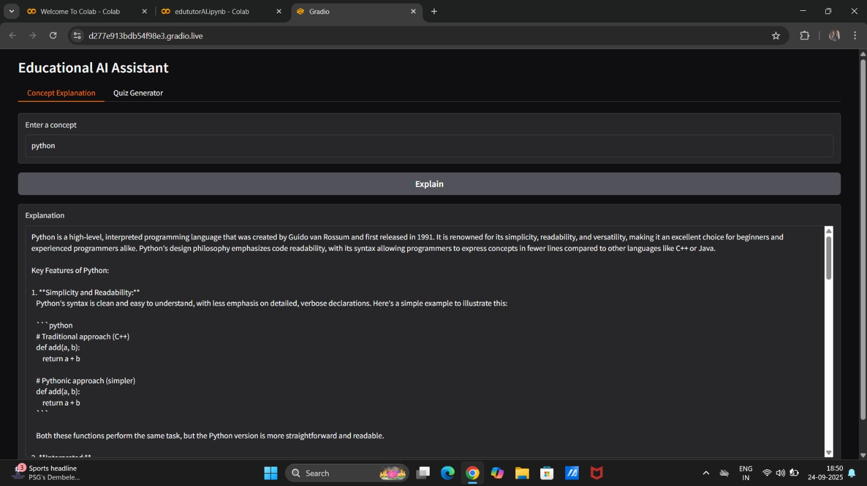

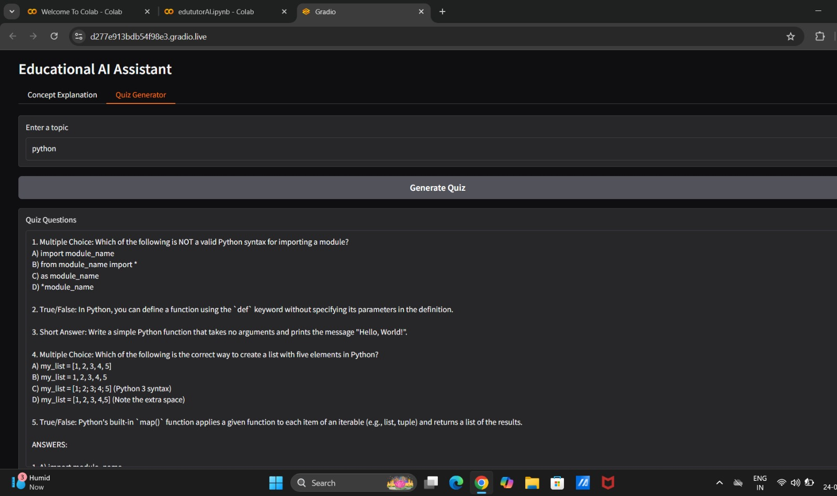

## 12. Known Issues

While EduTutor AI is a robust system, some limitations currently exist:  
- Performance degradation with extremely large student groups.  
- Limited support for non-English languages (work in progress).

## 13. Future Enhancements

To keep pace with evolving educational needs, the following features are planned:  
- Multilingual AI tutors to serve global audiences.  
- Integration of AR/VR for immersive learning.  
- AI-driven career counseling and skill recommendations.  
- Deeper industry certification linkages for professional development.