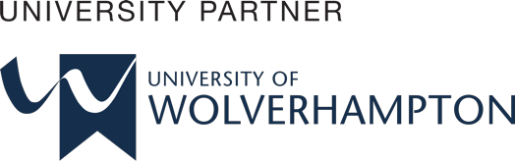 

**PROJECT PROPOSAL REPORT**

**Employee Task Management System**

University ID : 2330485

Student Name : Renuka Dhakal

Group : L6CG20

Reader : Mr.Yogesh Bikram Shah

Supervisor : Mr.Bipul Bahadur Pradhan

Award/Course : Bsc (Hons) Computer Science

Submitted on : 01/12/2024

**Abstract**

In this Final Year Project, I will be developing an "Employee Task Management System." The main purpose of this system is to make assigning, tracking, and completing tasks easier for organizations. It will allow managers to assign tasks to employees, set deadlines, and monitor their progress. Employees will be able to see their tasks, update their status, and give feedback if needed.

The system will also include features like automatic reminders, task priorities, and reports to help improve efficiency. It will use modern technology to suggest tasks, balance workloads, and analyze performance. This project aims to make task management simple and organized, helping both employees and managers work better together.

**Acknowledgement**

I would like to express my sincere gratitude to my supervisor, Mr. Bipul Bahadur Pradhan, and my reader, Mr. Yogesh Bikram Shah, for their continuous support and guidance throughout the completion of my project, the "Employee Task Management System." Their valuable feedback and encouragement have been crucial in developing this system.

I am also thankful to Herald College Kathmandu for offering this fantastic opportunity to work on such a meaningful project as part of my academic curriculum.

**Table of Content**

Table of figure: 1

1. Introduction: 1

1.1 Employee Task Management System: 1

1.2 Academic Question: 1

2. Aims and Objectives: 2

3.Problem Statements: 3

4.The Project as a Solution: 4

5. Scope and Limitations: 5

Scope: 5

Limitations: 5

6. Research Paper Review 6

Review 1: Enhancing Productivity through Task Management Systems 6

Review 2: The Impact of Task Prioritization on Organizational Outcomes 6

Review 3: Simplifying Employee Workflows with Integrated Management Systems 6

7. Artifacts: 7

8. Choosing Software Development Methodology 9

Scrum Methodology 9

9.Work Breakdown Structure (WBS) 10

Figure 1: Work Breakdown Structure (WBS) 10

10.Gantt Chart 11

Figure 2: Gantt Chart 11

11. UML Diagrams 12

11.1 Sequence Diagram 12

Figure 3: Sequence Diagram 12

11.2Activity diagram 13

Figure 4: Activity Diagram 13

11.3. Use Case Diagram 14

Figure 5: Use Case Diagram 14

12. Tools and Technologies 15

12.1 Python 15

12.2 Django Framework 15

12.3 MySQL Database 15

12.4 Frontend Development Tools 15

12.5 GitHub 15

12.6 Jira 16

12.7 Visual Studio Code (VS Code) 16

13.Reference: 16

**Table of figure:**

Figure 1: Work Breakdown Structure (WBS) 10

Figure 2: Gantt Chart 11

Figure 3: Sequence Diagram 12

Figure 4: Activity Diagram 13

Figure 5: Use Case Diagram 14

# 1. Introduction:

## 1.1 Employee Task Management System:

The Employee Task Management System is designed to help organizations manage tasks and track employee progress in a simple and efficient way. It allows employees to view, create, update, and complete tasks, while managers can assign tasks, set deadlines, and monitor progress effectively.

A key feature of the system is its task management capabilities, enabling users to organize tasks by priority, deadlines, and progress. Employees can easily track their task lists, mark tasks as completed, and view upcoming deadlines. Managers can ensure tasks are distributed effectively, track their status in real-time, and adjust priorities as needed.The system also offers reporting features, providing managers with insights into task completion rates, delays, and employee performance. This information helps optimize workload distribution, identify areas for improvement, and make informed decisions to enhance team productivity.

By offering a clear overview of tasks and responsibilities, the system improves workplace efficiency, promotes better communication between employees and managers, and supports smoother task execution. Its user-friendly interface and efficient tracking tools contribute to a more organized and effective work environment.

## 1.2 Academic Question:

* What are the benefits of using a task management system in an organization?

Ans: A task management system helps organizations improve the way tasks are handled, making work easier and more efficient. It provides several benefits that help both employees and managers. For instance, it improves organization by clearly defining and assigning tasks, which reduces confusion and ensures that deadlines are met. Communication also improves because employees and managers can easily discuss the status of tasks, updates, and any issues. Employees are able to focus better on their tasks, which leads to faster completion and better performance. Managers can also use reports from the system to analyze how tasks are being completed, identify any delays or issues, and make better decisions on resource allocation.

Moreover, the task management system helps reduce stress for employees by giving them a clear view of their responsibilities and deadlines. This helps them prioritize tasks effectively, making sure that urgent or important ones are completed first. It also encourages accountability since employees must update their progress, and managers can easily track if a task is falling behind. Overall, the system leads to a more organized and productive work environment, ensuring that tasks are completed efficiently and on time, benefiting both the employees and the organization as a whole.

1. Aims and Objectives:  
   In this project, I will be developing the Employee Task Management System, which aims to provide a efficient solution for managing tasks within an organization. This system will simplify task allocation, progress tracking, and task completion for employees, while also helping managers oversee and ensure that tasks are completed on time.

The aims and objectives of this system are as follows:

* **Simplify Task Management**: The system will allow employees to easily view, create, and update tasks. It will help them keep track of deadlines, priorities, and progress, reducing confusion and improving productivity.
* **Enhance Task Allocation**: Managers will be able to assign tasks to employees with clear deadlines and priorities, ensuring that work is distributed evenly and efficiently across the team.
* **Monitor Progress**: Managers will have the ability to track the progress of tasks in real time, ensuring that deadlines are met and identifying any delays or bottlenecks in task completion.
* **Improve Communication**: The system will allow for easy communication between employees and managers, enabling updates, feedback, and clarifications to be shared quickly and efficiently.
* **Increase Productivity**: By streamlining task management and providing a clear overview of responsibilities, the system aims to help employees stay focused and complete tasks on time, leading to improved overall productivity.
* **Support Organization Growth**: By improving task management , the system aims to help organizations scale by ensuring tasks are handled efficiently and employees are more engaged and productive.

# 3.Problem Statements:

The Employee Task Management System is designed to address several key challenges faced by organizations in managing employee tasks and ensuring smooth workflows:

**Task Mismanagement:** Without a proper system in place, employees often experience confusion about task assignments, deadlines, and priorities, leading to delays and missed tasks.

**Lack of Task Tracking:** There is no centralized way to monitor employee progress, which can result in tasks not being completed on time or overlooked.

**Overburdened Employees:** Without a clear view of team workloads, certain employees may be overloaded with tasks, while others may have too little to do, causing imbalances in productivity.

**Inefficient Communication:** Communication between managers and employees about task status, deadlines, and changes can be slow or unclear, leading to misunderstandings and delays.

**Absence of Performance Monitoring:** Managers lack an efficient way to assess individual employee performance, leading to difficulties in providing feedback or making decisions about promotions or resource allocation.

**Manual Task Updates:** Without an automated system, task updates and changes may be missed, resulting in confusion about the status of tasks and hindering workflow efficiency.

**No Task Prioritization:** Employees may not have clear guidance on which tasks are most urgent or important, leading to less focus on critical work and wasted time on lower-priority tasks.

**Limited Accountability:** Without clear tracking and deadlines, it can be difficult for employees to stay accountable for their tasks, which may affect overall team productivity.

**Lack of Transparency:** The absence of a centralized platform for managing tasks leads to difficulties in tracking overall project progress, making it harder for managers to assess team performance or provide adequate support.

These challenges result in inefficient workflows, missed deadlines, and reduced productivity, making it difficult for organizations to manage tasks effectively.

# 4.The Project as a Solution:

The Employee Task Management System is created to solve common problems organizations face in managing tasks and keeping work on track. It helps assign, monitor, and update tasks, ensuring that employees know what they need to do and when it needs to be done. This system improves the way tasks are handled, making the work process clearer and more organized.

**Clear Task Assignment:** The system will provide a structured way for managers to assign tasks to employees, ensuring that every task is tracked, prioritized, and updated in real-time. This helps eliminate confusion about task responsibilities and deadlines.

**Task Tracking and Monitoring:** Employees will be able to easily track their tasks and monitor their own progress, while managers can access up-to-date reports to track overall team performance and ensure deadlines are met. This minimizes the chances of missed tasks or delays.

**Increased Accountability:** By having clear task assignments and deadlines, employees can better manage their workload. The system’s built-in notifications and reminders ensure that employees are alerted about important updates and approaching deadlines, improving accountability.

**Efficient Resource Allocation:** Managers can use the system to assign tasks based on employee availability and workload, ensuring optimal task distribution and preventing overburdening any individual.

**Improved Communication:** The system will provide an easy-to-use interface for communication between employees and managers, allowing them to share updates, feedback, and clarifications on task status.

**User-Friendly Interface:** The system’s simple, intuitive design ensures that employees can quickly access their tasks and deadlines without facing confusion, helping to enhance productivity and ease of use.

**Performance Monitoring:** Managers can assess employee performance through progress reports, which will provide insights into task completion rates and any bottlenecks in the workflow. This enables data-driven decision-making for task prioritization and resource management.

This solution addresses the core challenges of task management, improving organization, communication, and productivity within the workplace.

# Scope and Limitations:

## Scope:

* The Employee Task Management System will provide a centralized platform for managing employee tasks and tracking progress within an organization.
* Managers can assign tasks, set deadlines, and monitor task completion to ensure projects are completed efficiently.
* Employees will have access to their task list, allowing them to view assigned tasks, update progress, and mark tasks as coAn admin dashboard will allow for user management, task categorization, and access to performance reports for better decision-making.
* A user-friendly interface will ensure employees and managers can navigate the system with ease.
* Historical task data will be stored securely for generating reports and performance evaluations.
* The system will feature notifications to alert users about task assignments, approaching deadlines, and task status updates.

## Limitations:

* Users will need to create an account to access the system and its features.
* The system’s functionality will rely on internet connectivity, so users may face issues if their connection is unstable or unavailable.
* Notifications will depend on system settings, and delays may occur in receiving alerts due to server or network issues.
* The system will not include features for resource scheduling or budget management, focusing solely on task assignments and tracking.
* Periodic updates and maintenance may be required to ensure the system remains efficient and can accommodate a growing number of users.

# 6. Research Paper Review

This section discusses various research papers and studies related to employee task management systems, task prioritization, and the use of technology to enhance organizational productivity. These studies offer valuable insights that align with the objectives of my project, helping to understand how effective task management systems can improve workplace efficiency and employee performance.

Review 1: Enhancing Productivity through Task Management Systems  
This research looks at how task management systems help organizations work better and improve performance. Tools like Jira and ClickUp make it easier for managers to assign tasks, set priorities, and track progress, reducing mistakes and missed deadlines.

These systems clearly organize tasks, helping employees focus on their responsibilities and manage their time well. Managers can also spot problems early and make adjustments. The study shows that using these tools improves teamwork, accountability, and productivity, making it easier for organizations to achieve their goals. (Taylor et al., 2020)

Review 2: The Impact of Task Prioritization on Organizational Outcomes  
This paper explores how task prioritization in management systems helps organizations work more effectively. Tools like Smartsheet and Zoho Projects allow employees to focus on urgent tasks by organizing work based on importance and deadlines. This reduces stress, prevents task duplication, and ensures timely completion of important projects.

The study concludes that task prioritization improves team organization, productivity, and efficiency, making these systems vital for achieving company goals. (Kumar et al., 2021)

Review 3: Simplifying Employee Workflows with Integrated Management Systems  
This research discusses how modern task management systems, like Notion and Basecamp, combine tools such as task tracking, reminders, and performance monitoring into one platform. These features save time, reduce manual work, and simplify tasks for employees and managers.

Automation and user-friendly designs help employees stay on track with reminders, while managers use reports to monitor progress. Feedback from small businesses shows these systems improve teamwork and ensure tasks are completed on time. The study concludes that integrated systems help organizations stay organized and handle modern work challenges efficiently. (Ali et al., 2019)

# 7. Artifacts:

The **Employee Task Management System** is a system designed to help organizations manage employee tasks, track performance, and ensure timely completion of projects. This system will be used by managers, employees, and administrators to streamline task allocation and progress monitoring. Below are the key components and features of the system:

· **Task Creation and Assignment**:

Managers can create tasks with titles, descriptions, priority, and deadlines.

Tasks are assigned to employees based on availability and skillset.

Dependencies can be set for tasks that must be completed before others.

· **Task Tracking and Progress Monitoring**:

Managers can track task statuses (completed, in progress, pending).

Time logged for tasks is monitored to identify time management issues.

Notifications alert managers of nearing deadlines and updates.

· **Task Prioritization and Deadlines**:

Tasks are assigned priorities (high, low) and deadlines to help manage work effectively.

· **Time Tracking**:

Employees log hours spent on tasks, providing insight into workloads and productivity.

· **Notifications and Alerts**:

Employees receive notifications about new tasks, approaching deadlines, and updates. Managers receive alerts about task completion and missed deadlines.

· **Task Search and Filtering**:

Users can filter tasks by deadline, priority, and status to find relevant tasks quickly.

· **Reporting and Analytics**:

Managers can generate reports on performance, task completion, and project progress to make data-driven decisions.

· **Task History and Completion Tracking**:

Task details and history (status, time spent) are recorded for review and performance analysis.

· **Role-Based Access Control**:

Different user roles (admin, manager, employee) have access to specific system parts based on their responsibilities.

· **User Profile Management**:

Managers and employees can update personal information, task history, and account settings.

· **Task Dependencies**:

Managers can define task dependencies to ensure tasks are completed in the correct order.

· **Employee Targets and Performance Calculation**:

Managers set annual targets and track employees’ progress toward meeting them.

· **Employee Leave Management**:

Employees can request leave, and managers can check availability before assigning tasks.

· **Company Holidays**:

Admins upload company holidays to avoid task assignments during holidays.

· **Task Reassignment and Deadline Change**:

Managers can reassign tasks and update deadlines if an employee is unavailable.

· **Deadline Notification System**:

Admins set deadline notifications for high and medium-priority tasks to remind employees of upcoming deadlines.

# 8. Choosing Software Development Methodology

For my Final Year Project , I have chosen the **Scrum Methodology** under the Agile framework. I became familiar with Scrum during my academic coursework, where I practiced it in collaborative development projects. This methodology is well-suited for projects where requirements can evolve, as it provides flexibility and continuous feedback.

## Scrum Methodology

#### ****Agile:****

Agile is a popular software development framework that combines **Incremental** and **Iterative** processes. It emphasizes adaptability, teamwork, and delivering value to users throughout the development cycle. Scrum operates within this Agile framework.

**Scrum:**

Scrum is widely used for managing projects due to its structured approach and flexibility. It involves breaking the project into smaller, manageable parts to ensure steady progress.

**How Scrum Applies to My Project?**

In my **Employee Task Management System**, the Scrum approach allows development to be divided into **sprints**. Each sprint focuses on specific tasks like:

* Building the employee task assignment module.
* Adding leave management and holiday scheduling features.
* Implementing performance evaluation functionalities.
* Testing and integrating the system step by step.

At the end of every sprint, I will deliver and review functional components, ensuring the system evolves efficiently and meets all requirements.

# 9.Work Breakdown Structure (WBS)

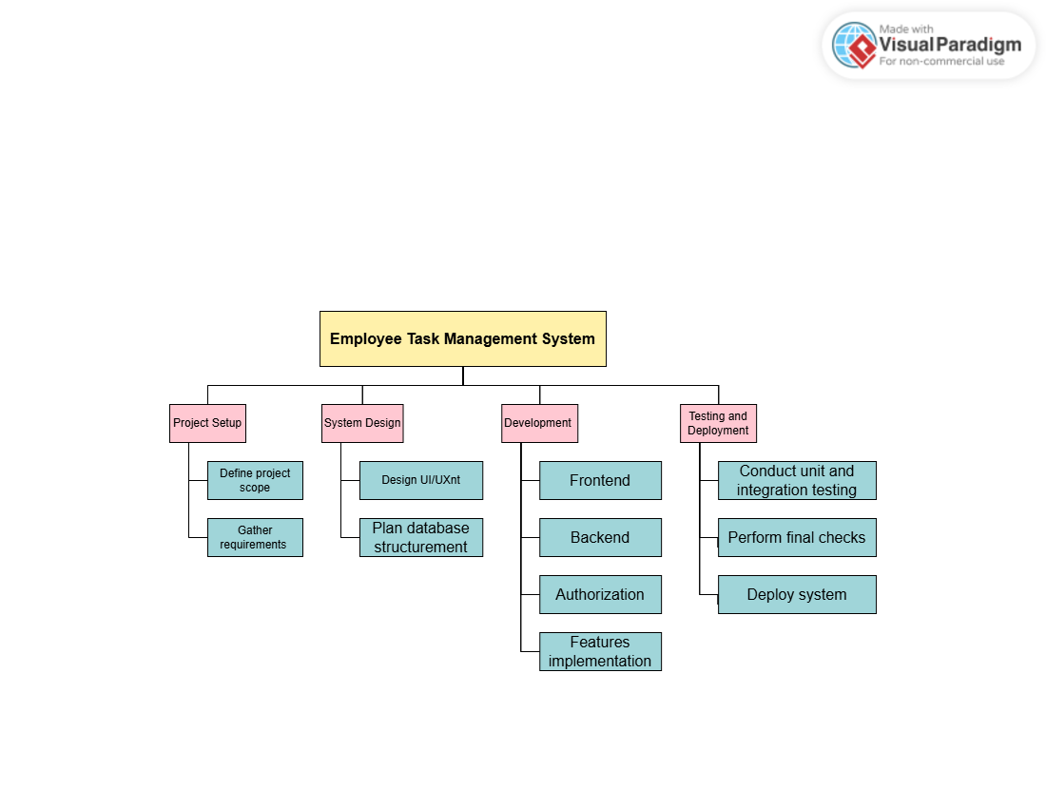

### Figure 1: Work Breakdown Structure (WBS)

This is a figure of the Work Breakdown Structure (WBS) for the **Employee Task Management System**, showing how the tasks are divided into 4 sections with specific sub-tasks. Each section outlines the steps needed to complete the project, from planning to deployment, making the process clear and organized.

# 10.Gantt Chart

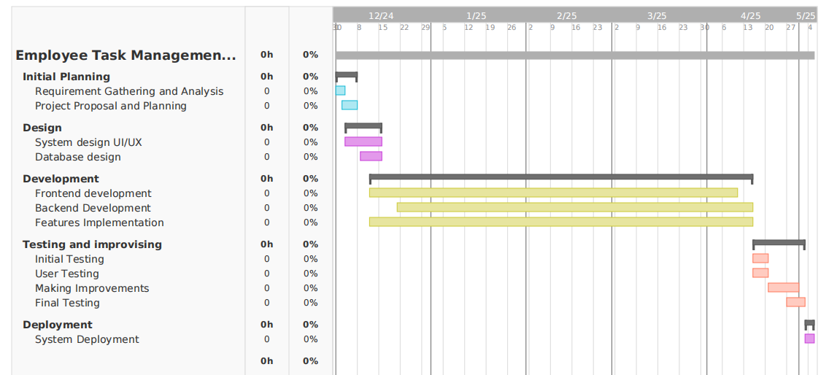

### Figure 2: Gantt Chart

This is a figure of the Gantt Chart for the Employee Task Management System, showing the timeline of tasks. It helps track when tasks start and finish, how long they take, and their order, ensuring the project stays on time.

# UML Diagrams

## 11.1 Sequence Diagram

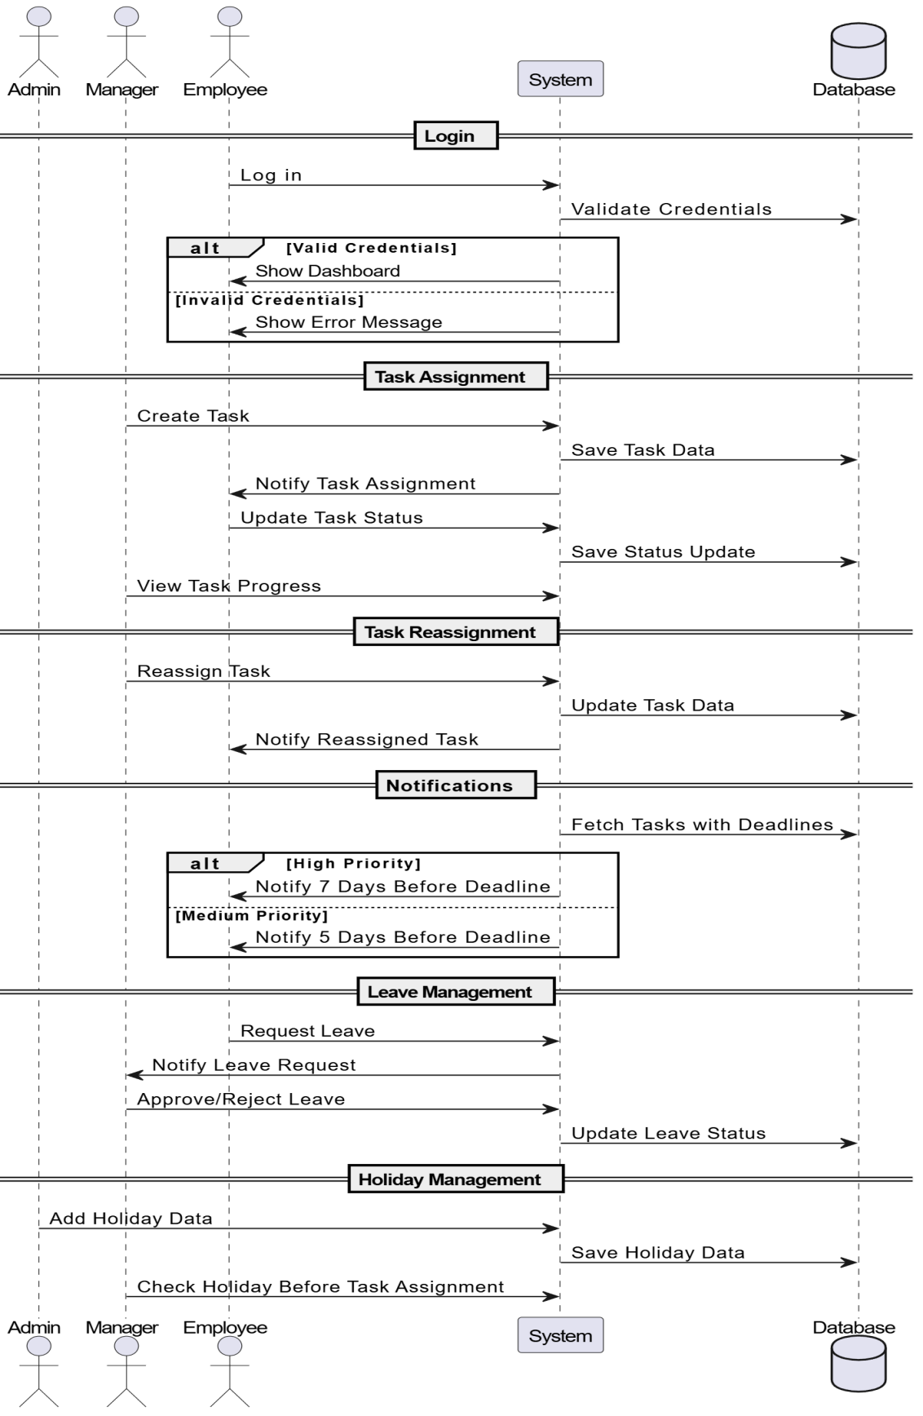

### Figure 3: Sequence Diagram

## 11.2Activity diagram

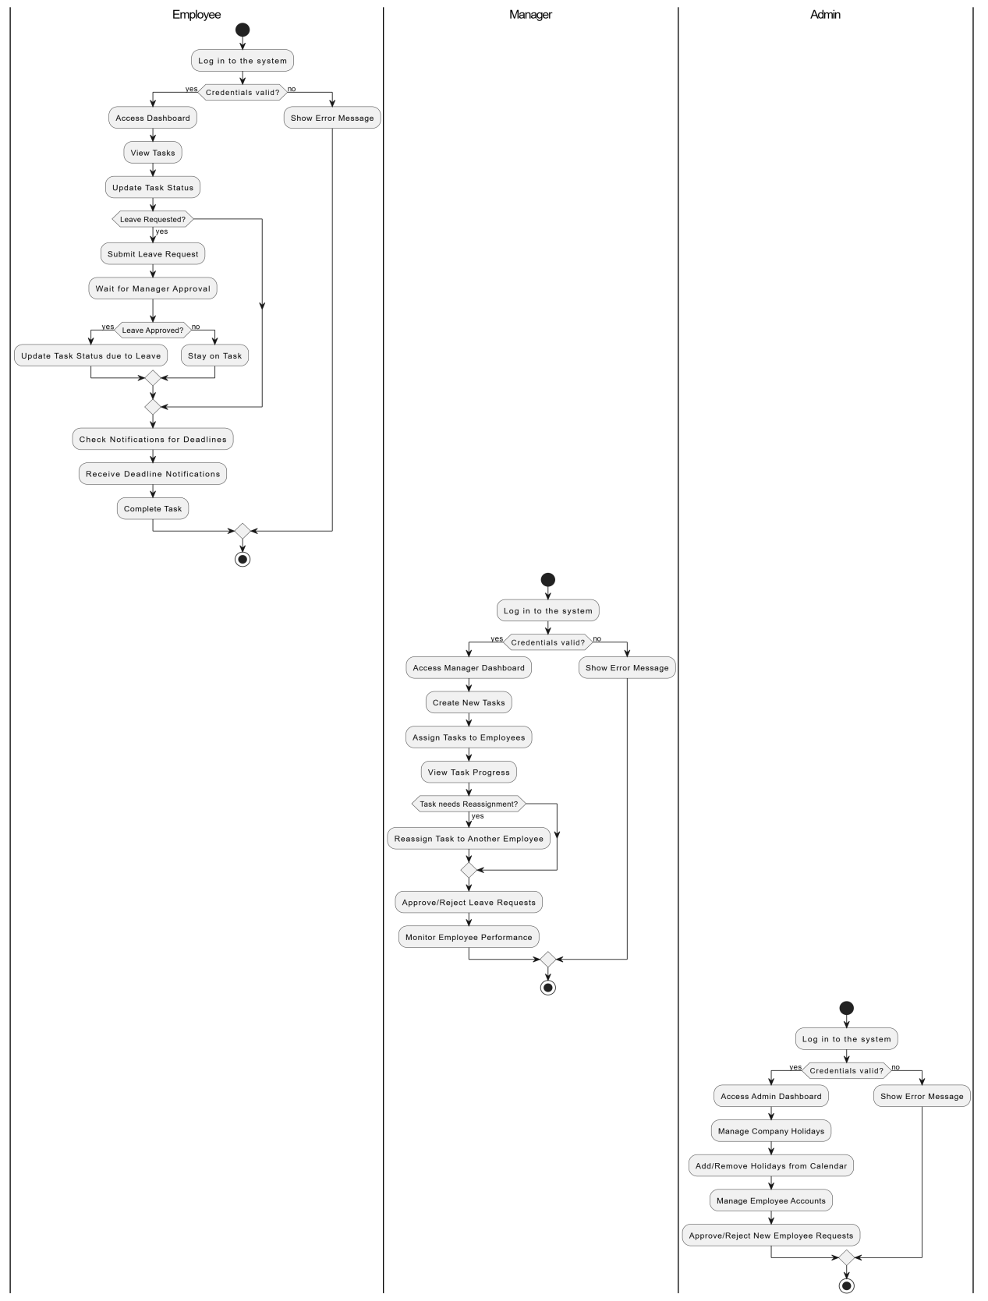

### Figure 4: Activity Diagram

## 11.3. Use Case Diagram

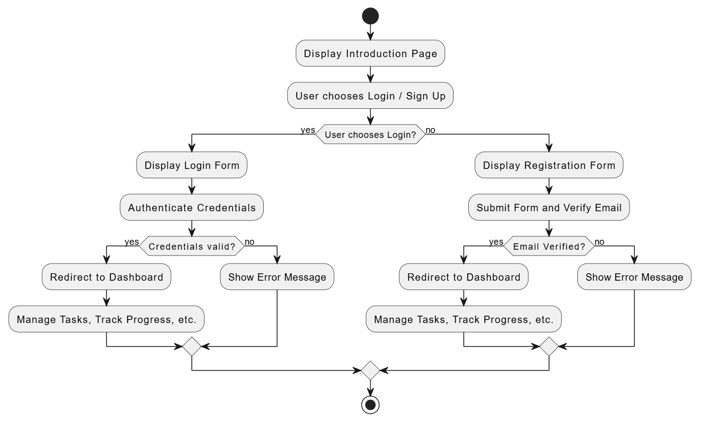

### Figure 5: Use Case Diagram

# 12. Tools and Technologies

For my **Employee Task Management System**, I will be using the following tools and technologies:

## 12.1 Python

Python will be used for the backend of the Employee Task Management System because it is simple to use, supports web development with Django, and handles tasks and databases efficiently.

12.2 Django Framework

Django is a high-level Python framework used to build the core of the system. It simplifies the development process by providing built-in features such as user authentication, form handling, and database management. Django's security features, like protection against SQL injection and cross-site scripting, will ensure that the system is secure and reliable.

## 12.3 MySQL Database

MySQL will be used to store and manage data such as user profiles, task information, deadlines, and task completion statuses. MySQL works seamlessly with Django to provide fast and efficient data retrieval. The system's data will be organized in tables and stored securely, allowing quick access for the backend to process and manage user tasks, monitor progress, and generate reports.

## 12.4 Frontend Development Tools

For the frontend, HTML, CSS, and JavaScript will be used to build an intuitive and responsive user interface. HTML will provide the structure of the pages, CSS will handle the design and layout, and JavaScript will enable interactivity such as dynamic task updates, filtering tasks, and real-time notifications. The frontend will ensure that users have a smooth and engaging experience while interacting with the system.

## 12.5 GitHub

GitHub will be used as a version control tool for the project. It will allow tracking of code changes and managing the development process effectively. GitHub will also act as a backup for the project code, ensuring data safety.

## 12.6 Jira

Jira will be used for project management, including tracking tasks, setting deadlines, and monitoring progress. It will help in managing sprints and ensuring that the development stays on track according to the Scrum methodology.

## 12.7 Visual Studio Code (VS Code)

* VS Code will be used as the primary code editor for the project. It provides features like syntax highlighting, debugging tools, and extensions that improve the development experience.

## 13.Reference:

**<https://www.researchgate.net/publication/40499451_Enhancing_Productivity_The_Role_of_Management_Practices>**

**<https://www.researchgate.net/publication/372447665_THE_IMPACT_OF_TASK_PRIORITIZATION_ON_EMPLOYEES%27_PERFORMANCE>**

**<https://www.researchgate.net/publication/286004022_Integrated_management_systems_and_workflow-based_electronic_document_management_An_empirical_study>**