ADVANCED PROJECT REPORT
Design and Implementation of an ETL Pipeline with LLM-Assisted Pipeline Generation for E-Commerce Data Analysis
M.Sc. Data Engineering — Advanced Project 1
Supervised by: Prof Atit Bashyal
Prepared by: Renuka Joshi
Constructor University Bremen
August 2026

Abstract
This project investigates the use of Large Language Models (LLMs) for generating ETL (Extract, Transform, Load) pipelines from natural-language user requirements. The developed system uses Gemini to convert a user's ETL request into a structured pipeline containing operations such as loading, cleaning, transformation, joining, storage, and validation.
The LLM-assisted approach was evaluated against manually implemented ETL pipelines using three experimental workflows based on the Olist e-commerce dataset: order items and products integration, orders and customers integration, and payments processing. The experiments measured execution time, LLM generation time, development effort, and data-quality results.
Across all three experiments, both manual and LLM-assisted pipelines successfully produced matching measured data-quality results. Rows, columns, missing values, and duplicate-record results matched at a rate of 100%. However, the LLM-assisted approach introduced additional runtime overhead because of the LLM generation process. The average LLM generation time was 10.3272 seconds, while the average additional overhead was 11.4696 seconds.
The results demonstrate that LLMs can be used to automatically generate structured ETL workflows from natural-language requirements while maintaining consistent measured data-quality outcomes in the tested scenarios. The main benefit observed is workflow generation through natural-language interaction rather than faster execution.

1. Introduction
ETL (Extract, Transform, Load) pipelines are an important part of data engineering because they prepare raw data for analysis and downstream applications. Traditional ETL development generally requires a data engineer to manually identify the required datasets, implement extraction logic, clean and transform the data, combine datasets when necessary, store the results, and perform validation.
Although this approach provides control over the data-processing process, developing ETL pipelines manually can require considerable programming effort, particularly when similar workflows need to be implemented repeatedly.
Recent advances in Large Language Models (LLMs) provide an alternative approach. Instead of manually writing every pipeline step, a user can describe the required ETL workflow using natural language. The LLM can then convert the request into a structured workflow containing operations such as loading, cleaning, transformation, joining, storing, and validation.
This project investigates an LLM-assisted approach to ETL pipeline generation. Gemini is used to interpret natural-language ETL requests and generate structured pipeline definitions. The generated pipelines are then executed by a Python-based ETL executor.
The LLM-assisted approach is compared with manually implemented ETL pipelines using three different experiments based on the Olist e-commerce datasets. The comparison focuses on execution time, LLM generation time, development effort, pipeline success, and data-quality consistency.

2. Problem Statement
Developing ETL pipelines manually requires developers to understand the structure of datasets and implement appropriate extraction, transformation, joining, storage, and validation operations.
For every new ETL requirement, similar development tasks may need to be repeated. This can increase development effort and make rapid experimentation more difficult. The problem addressed by this project is therefore:
“Can a Large Language Model generate executable ETL workflows from natural-language requirements while maintaining data-quality results comparable to manually implemented ETL pipelines?”
The project also investigates the trade-off between the additional time required for LLM-based pipeline generation and the potential reduction in manual workflow-development effort.

3. Project Objectives
- Develop an LLM-assisted ETL pipeline generation system.
- Allow users to describe ETL requirements using natural language.
- Use Gemini to convert natural-language requests into structured ETL pipeline definitions.
- Execute the generated pipeline using Python and pandas.
- Implement standard ETL operations: extract/load, cleaning, transformation, joining, storage, and validation.
- Implement equivalent manual ETL pipelines for comparison.
- Compare manual and LLM-assisted pipelines using measurable experiments.
- Evaluate data-quality consistency between the two approaches.
- Measure the runtime overhead introduced by LLM generation.
- Investigate whether LLM-assisted pipeline generation can reduce ETL workflow design effort.

4. Dataset Description
The project uses datasets from the Olist Brazilian E-Commerce dataset. The raw files are stored in the data/raw directory and represent different parts of an e-commerce transaction system, enabling both single-dataset ETL processing and multi-dataset integration.
Dataset | Raw File
Customers | olist_customers_dataset.csv
Orders | olist_orders_dataset.csv
Order Items | olist_order_items_dataset.csv
Payments | olist_order_payments_dataset.csv
Products | olist_products_dataset.csv

5. Project Structure
The project is organized into the following directories:
- data/ — data/raw/ (original datasets) and data/processed/ (cleaned and integrated outputs)
- llm_agent/ — agent.py, pipeline_generator.py, prompts.py, executor.py
- evaluation/manual_pipeline/ — manually implemented ETL baselines
- evaluation/results/ — experiment_results.csv, analysis_summary.csv, generated charts
- notebooks/ — dataset exploration, data cleaning, and ETL testing
- outputs/ — generated outputs and execution logs
- reports/ — the project report

6. System Architecture
The developed system follows a pipeline-generation and execution architecture. The user provides a natural-language request, for example:
“Load order_items, clean missing values and duplicates, join them with the products dataset using product_id, and save the final result for analysis.”
The request is passed to the Gemini agent, which generates a structured pipeline containing operations such as LOAD, CLEAN, TRANSFORM, JOIN, STORE, and VALIDATION. The generated pipeline is displayed to the user, who confirms whether it should be executed. After confirmation, the ETLExecutor interprets the generated operations and performs the corresponding data-processing tasks, then reports output dimensions and data-quality measurements.
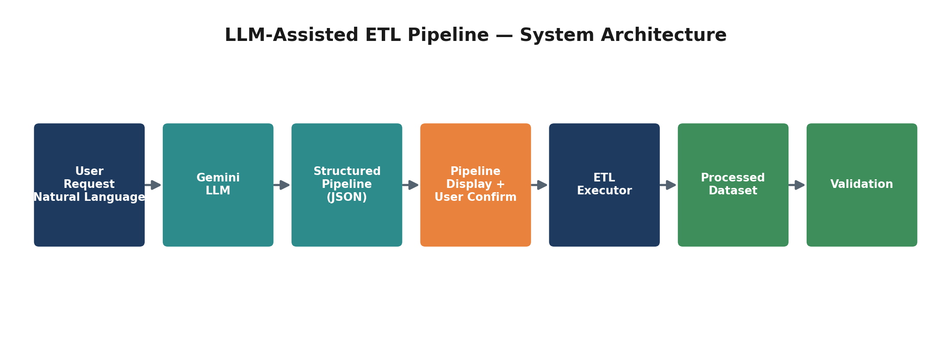
Figure A — LLM-Assisted ETL Pipeline: end-to-end system architecture.

7. LLM-Assisted ETL Pipeline
The LLM-assisted pipeline generation system is implemented in Python. The PipelineGenerator component is responsible for generating the ETL workflow through the following process:
- Receive the user's natural-language request.
- Build the pipeline-generation prompt.
- Send the prompt to Gemini.
- Receive the generated response.
- Parse the response as JSON.
- Convert the JSON into a Python dictionary.
- Display the generated pipeline.
- Ask the user for execution confirmation.
- Pass the pipeline to the ETL executor.
The prompt instructs the LLM to use only the available datasets and to produce structured ETL operations. The system also requires a final validation step in every generated pipeline.
- The generated pipeline acts as an intermediate layer between the user's natural-language request and the actual ETL execution process.
- Each generated step contains information such as the operation type, dataset, processing details, and join information when required.
- The generated pipeline is displayed to the user before execution, allowing the user to review and confirm the proposed workflow.
- The ETLExecutor processes the confirmed pipeline sequentially using Python and pandas and reports relevant execution results.
- Separating LLM-based pipeline generation from Python-based execution provides a controlled architecture and allows the generated workflow to be compared with manually implemented ETL pipelines.

8. ETL Operations
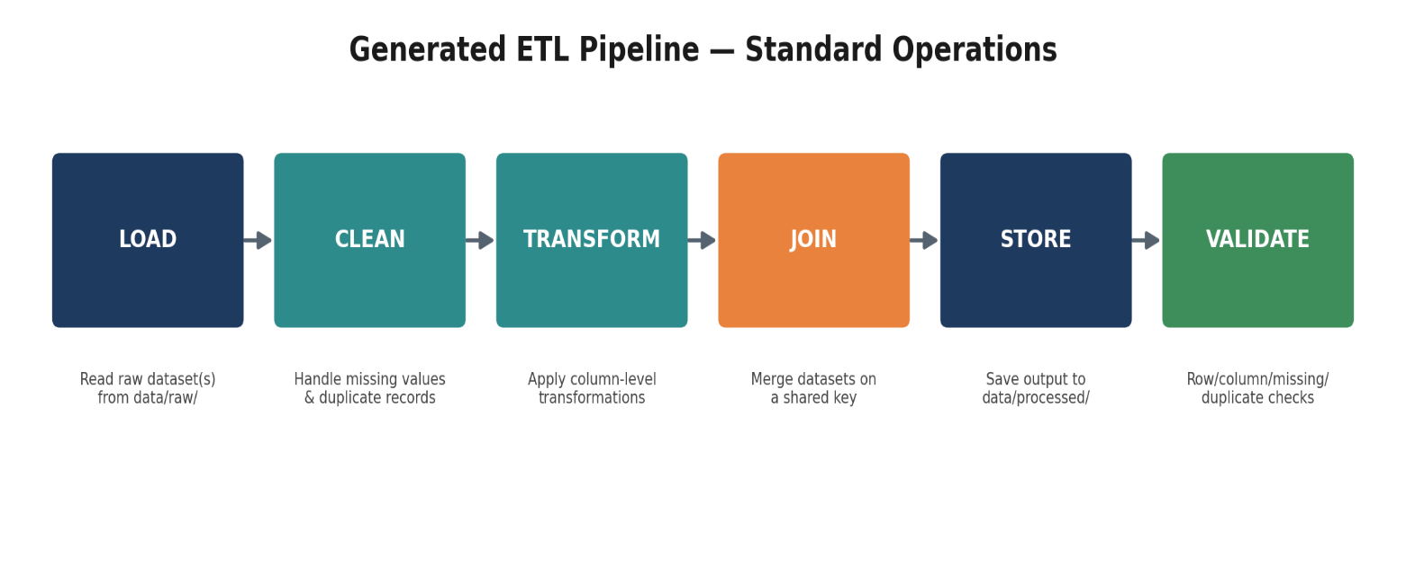
The generated pipelines use six standard ETL operations, illustrated below.

Figure B — Standard ETL operations implemented by the generated pipelines.

8.1 LOAD
The LOAD operation reads the required dataset from the raw data directory. For example, when the user requests the products dataset, the executor loads olist_products_dataset.csv, and the number of loaded rows is displayed to the user.

8.2 CLEAN
The CLEAN operation handles basic data-quality problems, measuring rows, missing values, and duplicate records both before and after cleaning. Missing values are handled during the cleaning stage and duplicate records are removed where applicable.

8.3 TRANSFORM
The TRANSFORM operation applies additional data transformations requested by the generated pipeline — for example, converting relevant numeric columns to appropriate numeric types in the payments experiment, and transforming relevant identifiers and numeric fields in the products experiment.

8.4 JOIN
The JOIN operation combines datasets using a specified key. Two multi-dataset experiments were conducted: Order Items + Products (joined on product_id) and Orders + Customers (joined on customer_id). The resulting number of rows and columns is reported after the join.

8.5 STORE
The STORE operation saves the final processed dataset as a CSV file in data/processed/, e.g. order_items_products.csv, orders_customers.csv, and payments.csv.

8.6 VALIDATION
Validation is the final stage of the generated pipelines, reporting final row count, final column count, total missing values, duplicate rows, missing values by column, and successful completion.

9. Manual ETL Approach
A manual ETL implementation was developed to provide a baseline for comparison with the LLM-assisted approach. The manual pipelines perform the same general operations as the generated workflows. For example, the order_items + products experiment performs:
- Extract order items.
- Extract products.
- Clean order items.
- Clean products.
- Join both datasets using product_id.
- Store the result.
- Validate the result.
Similarly, the orders + customers experiment uses customer_id as the join key. The manual pipelines provide a reference implementation against which the generated workflows can be evaluated.

10. Experimental Methodology
Three experiments were conducted, selected to represent different types of ETL workflows:
Experiment | Workflow | Datasets
1 | Order Items + Products | 2
2 | Orders + Customers | 2
3 | Payments | 1

For each experiment, both approaches (manual ETL and LLM-assisted ETL) were evaluated, collecting: manual execution time, LLM generation time, LLM ETL execution time, total LLM-assisted time, development effort, final rows/columns, missing values, duplicate rows, and pipeline success. Results were stored in evaluation/results/experiment_results.csv, with additional analysis in evaluation/results/analysis_summary.csv.
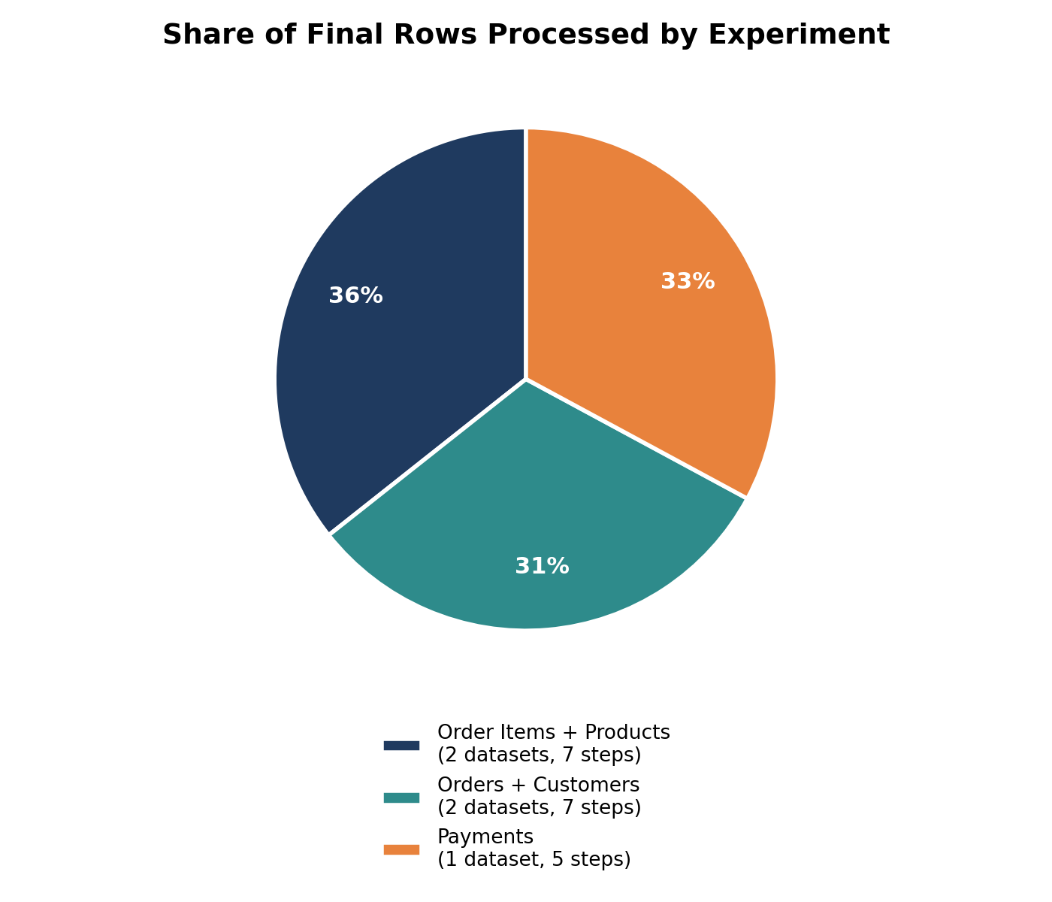
Figure C — Share of final processed rows contributed by each experiment.

11. Experiment 1 — Order Items + Products
The first experiment integrated the order_items and products datasets. The natural-language request was to clean both datasets, join them using product_id, and save the final result.
Metric | Manual ETL | LLM-Assisted ETL
Code lines / Pipeline steps | 173 | 7
Execution / Generation time | 1.9394 s | 7.6831 s (generation)
ETL execution time | — | 2.6945 s
Total time | 1.9394 s | 10.3776 s
Final rows | 112,650 | 112,650
Final columns | 15 | 15
Missing values | 0 | 0
Duplicate rows | 0 | 0
Status | SUCCESS | SUCCESS

The manual and LLM-assisted approaches produced matching measured data-quality results.

12. Experiment 2 — Orders + Customers
The second experiment integrated the orders and customers datasets, joined using customer_id.
Metric | Manual ETL | LLM-Assisted ETL
Code lines / Pipeline steps | 181 | 7
Execution / Generation time | 2.1229 s | 9.9843 s (generation)
ETL execution time | — | 4.5018 s
Total time | 2.1229 s | 14.4861 s
Final rows | 99,441 | 99,441
Final columns | 12 | 12
Missing values | 0 | 0
Duplicate rows | 0 | 0
Status | SUCCESS | SUCCESS

Again, all measured data-quality results matched between the two approaches.

13. Experiment 3 — Payments
The third experiment processed the payments dataset independently. The pipeline cleaned the dataset and transformed relevant payment-related columns.
Metric | Manual ETL | LLM-Assisted ETL
Code lines / Pipeline steps | 152 | 5
Execution / Generation time | 0.4619 s | 13.3143 s (generation)
ETL execution time | — | 0.7549 s
Total time | 0.4619 s | 14.0692 s
Final rows | 103,886 | 103,886
Final columns | 5 | 5
Missing values | 0 | 0
Duplicate rows | 0 | 0
Status | SUCCESS | SUCCESS

The final measured data-quality results again matched the manual implementation.

14. Performance Comparison
The three experiments demonstrate that the LLM-assisted approach introduces additional time because the pipeline must first be generated by Gemini.
Metric | Average
Manual ETL execution | 1.5081 s
LLM generation | 10.3272 s
LLM ETL execution | 2.6504 s
LLM total time | 12.9776 s
Additional LLM overhead | 11.4696 s

The results show that manual ETL execution was faster in the tested experiments. However, the LLM-assisted approach includes an additional pipeline-generation stage not present in the manual implementation. Therefore, the LLM approach should not be considered faster based on these experiments — its potential advantage is the ability to generate a structured workflow from a natural-language requirement.
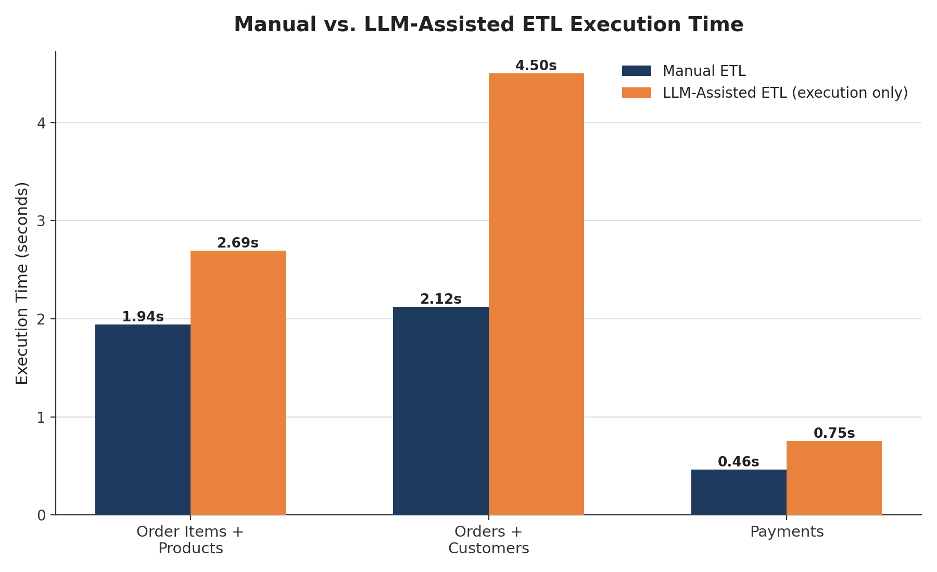
Figure 1 — Execution Time Comparison (manual vs. LLM ETL execution only).
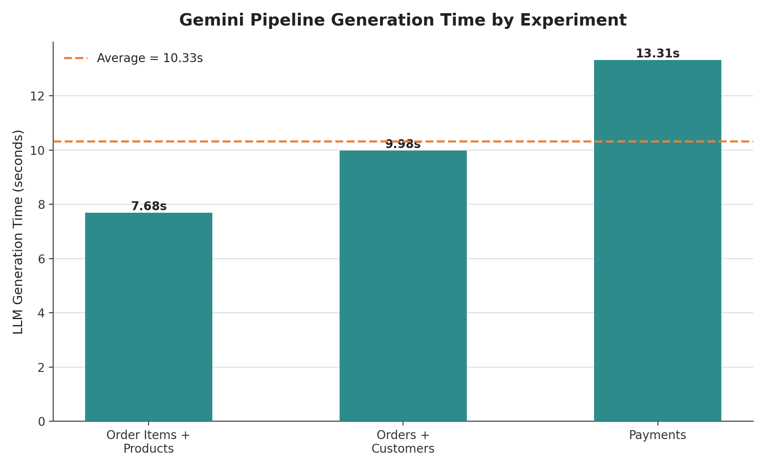
Figure 2 — LLM Generation Time per experiment.
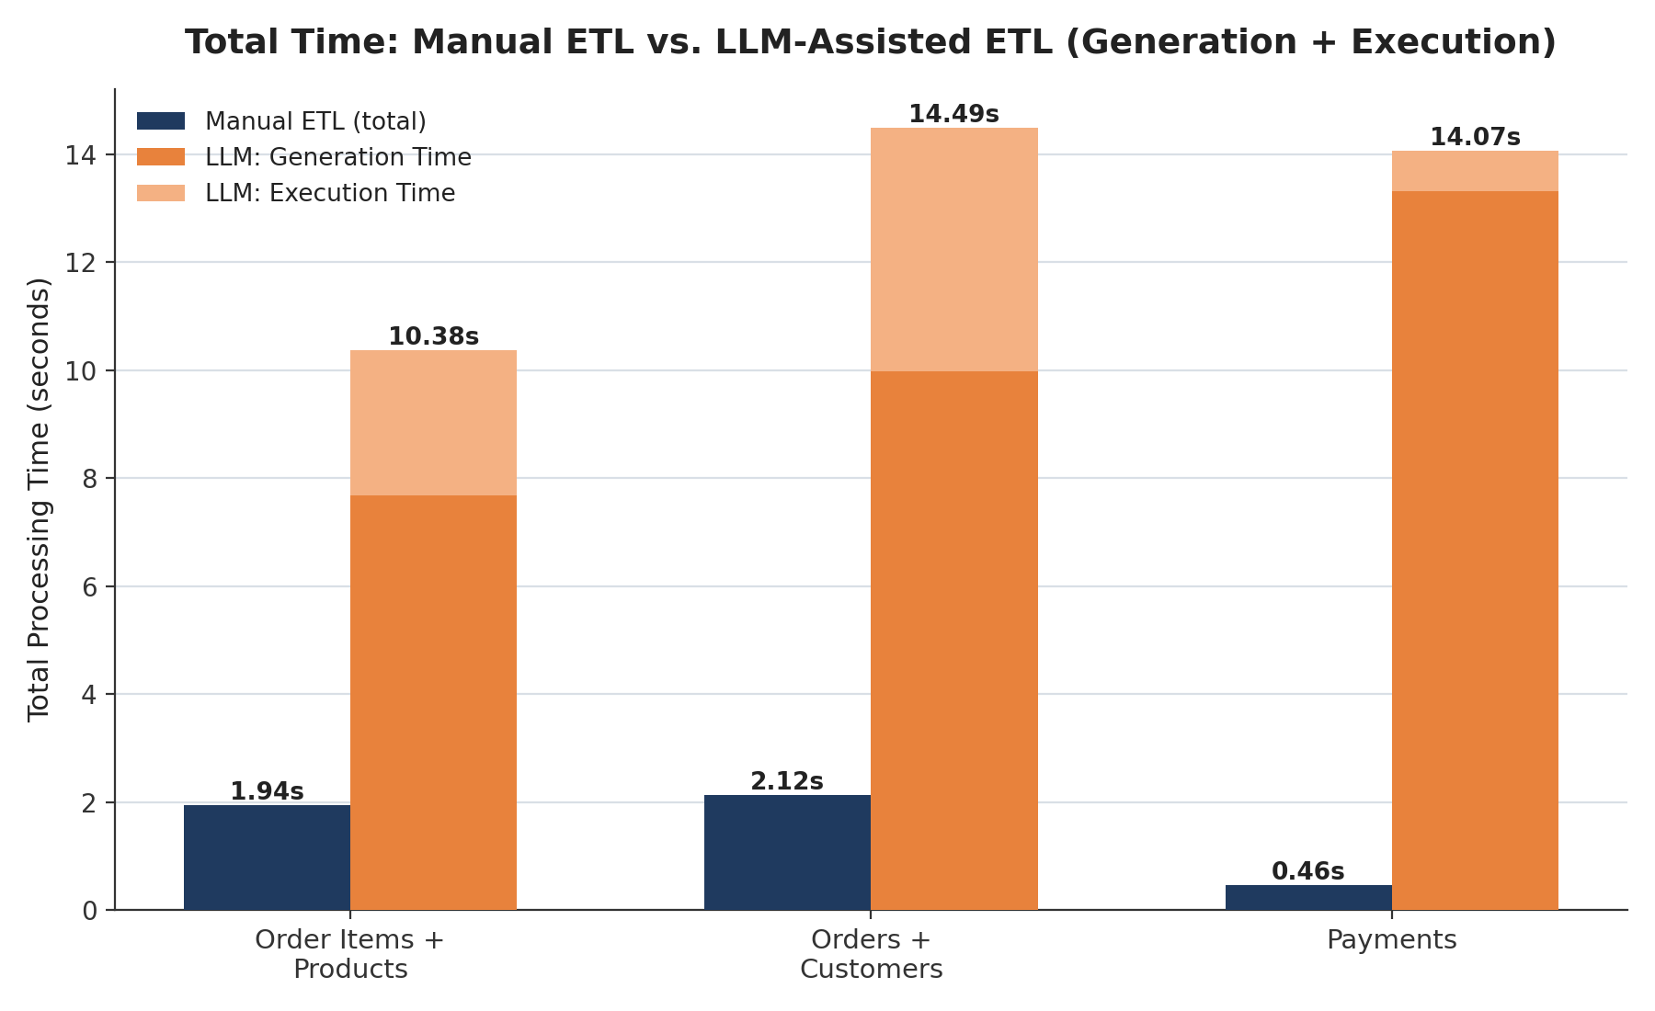
Figure 3 — Total Time Comparison (manual total vs. LLM generation + execution).

15. Development Effort Comparison
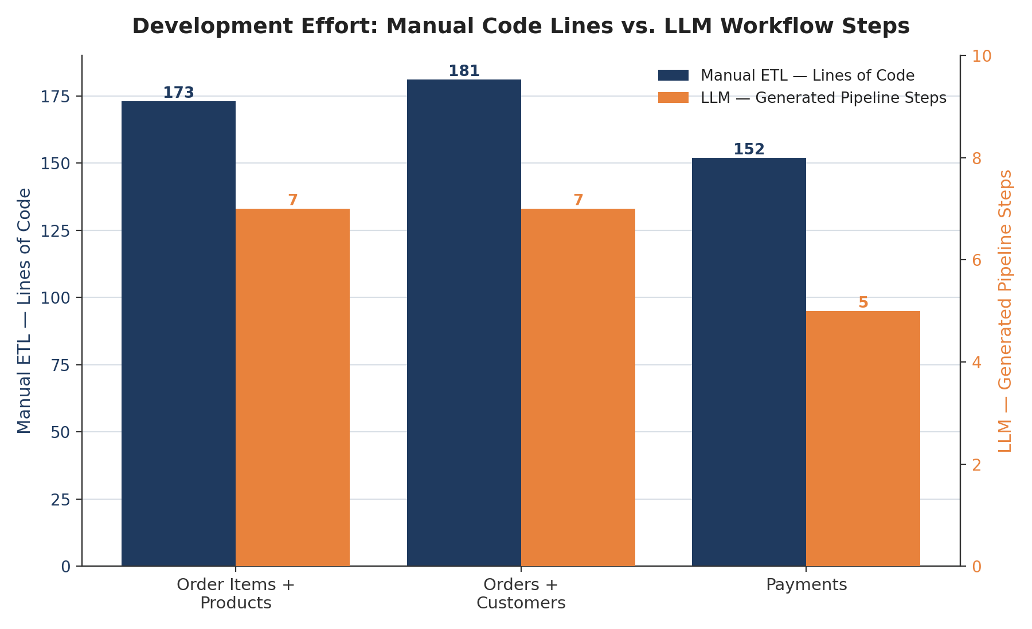
Development effort was evaluated using the number of lines in the manual implementations and the number of workflow steps generated by the LLM. The average manual implementation size was 168.67 lines, and the average number of generated LLM workflow steps was 6.33. These measurements represent different aspects of development effort and should not be treated as directly equivalent — a line of Python code and an ETL workflow step are different units. The comparison nevertheless illustrates that the LLM can express a complete ETL workflow using a relatively small structured representation.

Figure 4 — Development Effort Comparison: manual code lines vs. LLM workflow steps.

16. Data Quality Comparison
Data quality was evaluated using four measurements: row count, column count, missing values, and duplicate rows. Across all three experiments, all four metrics matched at a rate of 100% between the manual and LLM-assisted pipelines, and both approaches achieved a 100% pipeline success rate.
Data Quality Metric | Match Rate
Rows | 100%
Columns | 100%
Missing values | 100%
Duplicate rows | 100%

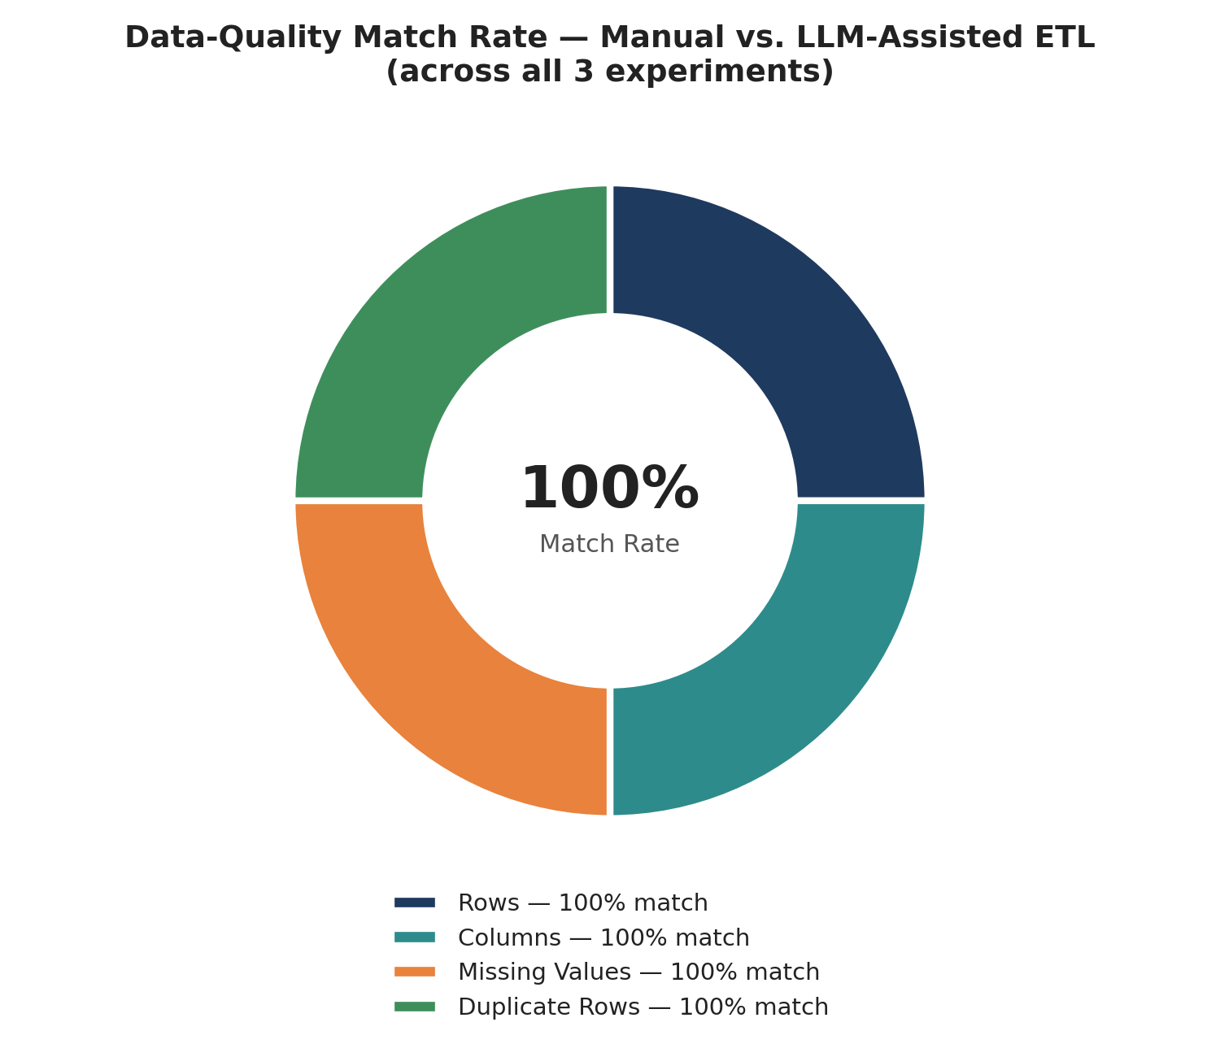
Figure 5 — Data-Quality Match Rate across all three experiments.
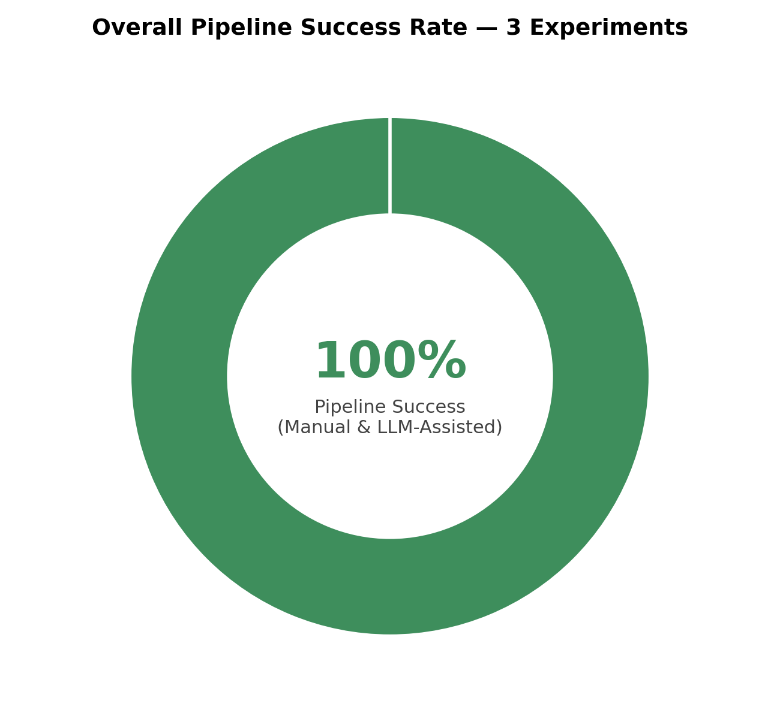
Figure D — Overall pipeline success rate (manual and LLM-assisted).
Therefore, within the scope of the three experiments, the LLM-generated pipelines produced matching measured data-quality results compared with the manual implementations.

17. Results and Discussion
The experimental results provide two important observations. First, the LLM-assisted pipelines successfully generated and executed ETL workflows for all three tested scenarios; the measured row counts, column counts, missing values, and duplicate counts matched the manual implementations. Second, the LLM-assisted approach required additional runtime because the system needs to communicate with Gemini before executing the ETL workflow — the average LLM generation time was 10.3272 seconds, while the average additional overhead was 11.4696 seconds.
Therefore, the experiments do not demonstrate a runtime-performance advantage for the LLM-assisted approach. Instead, the primary potential benefit is the ability to translate natural-language requirements into structured ETL workflows. This can potentially simplify the initial pipeline-design process and make ETL workflows more accessible to users who can describe their requirements but may not want to manually implement every operation.
The results also demonstrate that LLM assistance does not necessarily replace the need for validation. The generated pipelines still require execution and data-quality checks to ensure that the resulting dataset meets expectations.

18. Visualization of Results
The project generated a set of charts to visualize the experimental results, stored in evaluation/results/charts/. These visualizations (reproduced above in professional format in Sections 6, 8, 10, 14, and 16) provide graphical comparisons of execution time, LLM generation time, total processing time, development effort, and data-quality consistency.
Figure | Description | File
Figure 1 | Execution Time Comparison | execution_time_comparison.png
Figure 2 | LLM Generation Time | llm_generation_time.png
Figure 3 | Total Time Comparison | total_time_comparison.png
Figure 4 | Development Effort Comparison | development_effort_comparison.png
Figure 5 | Data Quality Match Rate | data_quality_match_rate.png

19. Limitations
- Only three ETL experiments were conducted; the results may not represent all possible ETL workloads.
- The experiments were performed using a specific collection of e-commerce datasets — different datasets, data volumes, or structures may produce different results.
- LLM generation time depends on the response time of the Gemini service and may vary between executions.
- The development-effort comparison uses manual code lines and generated workflow steps as separate, non-equivalent measurements.
- Validation in this project focuses primarily on row counts, column counts, missing values, duplicate rows, and successful completion. More advanced validation could include schema validation, referential integrity, business rules, value-range checks, and statistical data-quality tests.

20. Conclusion
This project developed and evaluated an LLM-assisted ETL pipeline generation system using Gemini. The system allows users to describe ETL requirements using natural language; Gemini converts these requirements into structured ETL workflows, which are then executed using a Python-based ETL executor.
Three experiments were conducted using the Olist e-commerce datasets: order_items + products, orders + customers, and payments. All three LLM-assisted pipelines completed successfully, and the experiments produced a 100% match rate for rows, columns, missing values, and duplicate rows compared with the corresponding manual ETL results.
However, the LLM-assisted approach introduced additional runtime overhead. The average LLM generation time was 10.3272 seconds, and the average total LLM-assisted processing time was 12.9776 seconds, compared with an average manual ETL execution time of 1.5081 seconds.
Therefore, the main value demonstrated by the project is not faster execution. Instead, the results indicate that LLMs can be used to generate structured ETL workflows from natural-language requirements while maintaining matching measured data-quality results in the tested scenarios. The project demonstrates the potential of combining LLMs with traditional Python-based data engineering systems.

21. Future Work

21.1 More ETL Experiments
Additional experiments could be performed using different combinations of the available datasets, including more complex multi-table pipelines.

21.2 Advanced Data Validation
- Schema validation
- Referential-integrity checks
- Data-type validation
- Range checks
- Business-rule validation
- Statistical anomaly detection

21.3 Automatic Code Generation
The current system generates a structured pipeline definition. Future work could extend this approach to generate executable Python ETL code automatically.

21.4 Pipeline Optimization
The generated pipeline could be analyzed and optimized automatically before execution.

21.5 Error Recovery
Future versions could allow the system to detect execution errors and automatically ask the LLM to correct the generated workflow.

21.6 Larger Experimental Evaluation
A larger number of experiments and datasets could provide stronger evidence about the reliability and generalizability of LLM-assisted ETL generation.

21.7 Human-in-the-Loop Validation
Future implementations could provide a more detailed interface where users review and modify generated pipeline steps before execution.

22. References
- Olist Brazilian E-Commerce Dataset. Kaggle.
- Python Software Foundation. Python Documentation.
- The pandas development team. pandas: Python Data Analysis Library.
- Google. Gemini API Documentation.
- Kimball, R. and Caserta, J. The Data Warehouse ETL Toolkit: Practical Techniques for Extracting, Cleaning, Conforming, and Delivering Data.

23. Appendix

Appendix A — Experimental Results
The complete experimental results are stored in evaluation/results/experiment_results.csv.

Appendix B — Analysis Results
The calculated performance analysis is stored in evaluation/results/analysis_summary.csv.

Appendix C — Generated Visualizations
The generated charts are stored in evaluation/results/charts/.

Appendix D — Project Source Code
The major project components are located in llm_agent/, evaluation/manual_pipeline/, evaluation/, src/, and main.py.

