SKILL – 1
ENCAPSULATION BUILDER
Wireshark Packet Capture and Header Overhead Analysis

Student Details
Name | P. Renuka Chowdary
Roll Number | 2520030176
Class / Section | 02
Date | 11-11-26

1. Aim
To capture network packets using Wireshark, examine Ethernet, IPv4 and TCP/UDP headers, calculate packet overhead, and understand how encapsulation affects network efficiency.
2. Brief Theory
Encapsulation is the process in which each network layer adds its own control information (usually a header) to data received from the layer above. Ethernet provides local-link delivery using MAC addresses; IP provides logical addressing and routing; and TCP or UDP provides transport-layer communication.
The headers increase the total packet/frame size. This additional protocol information is called overhead. Payload efficiency is the proportion of the transmitted frame that carries the payload being measured.
3. Software and Materials
Windows laptop with an active network connection.
Wireshark packet analyzer.
Web browser to generate network traffic.
Saved capture file: CN_Skill1_Capture.pcapng.
4. Procedure
Open Wireshark and select the active Wi-Fi interface (or Ethernet interface if connected by cable).
Double-click the interface to start capturing packets.
While capture is running, open websites such as Google, YouTube and Wikipedia. Wait approximately 30 seconds to generate traffic.
Return to Wireshark and click the red Stop button.
Use the display filters tcp, udp, icmp and tcp.len > 0 to inspect different packet types. Apply each filter separately.
Select a TCP packet and expand Frame, Ethernet II, Internet Protocol Version 4 and Transmission Control Protocol.
Select a UDP packet and expand Frame, Ethernet II, Internet Protocol Version 4 and User Datagram Protocol.
Record the displayed lengths and addresses. Save the capture using File → Save As and the .pcapng format.
5. Screenshot Evidence – Capture and Filters
Place the screenshots in the following order. The screenshots supplied during the practical have been inserted below as evidence.
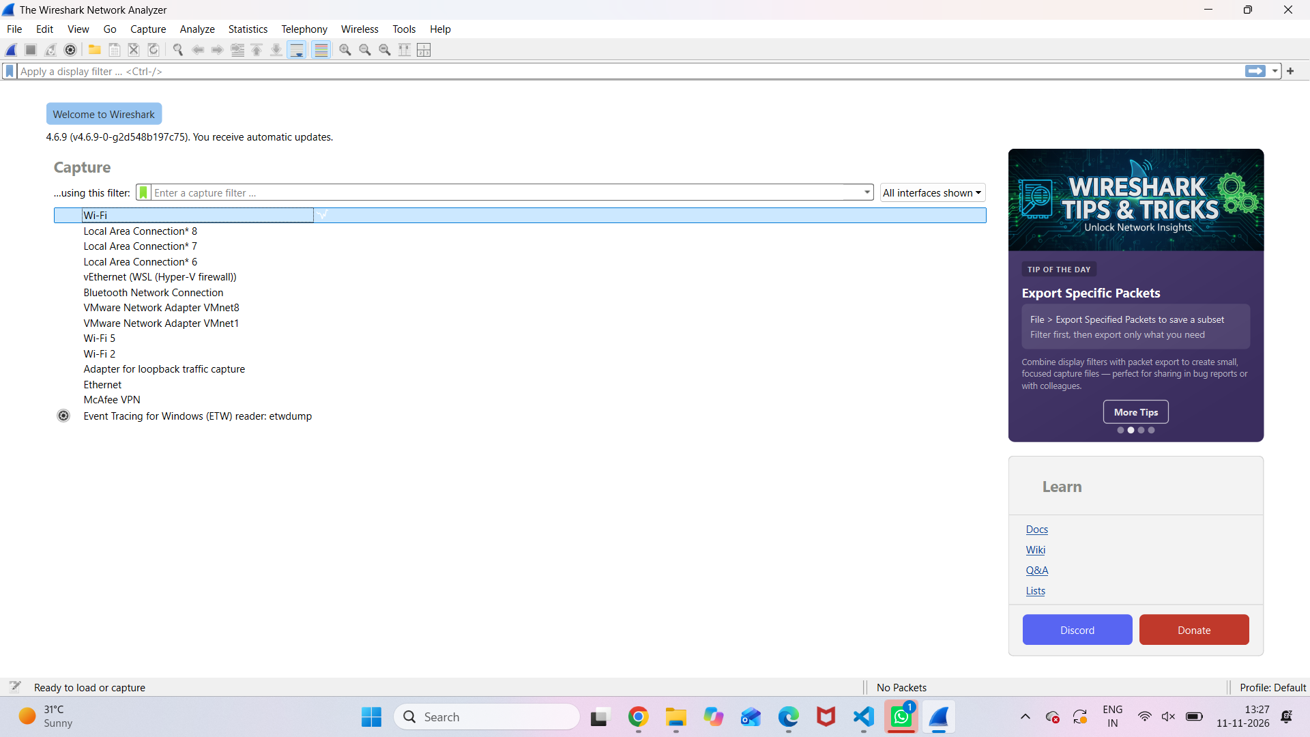
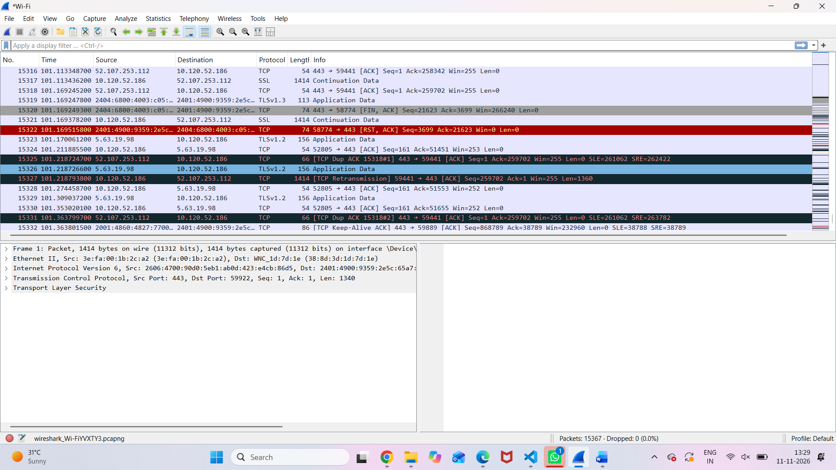
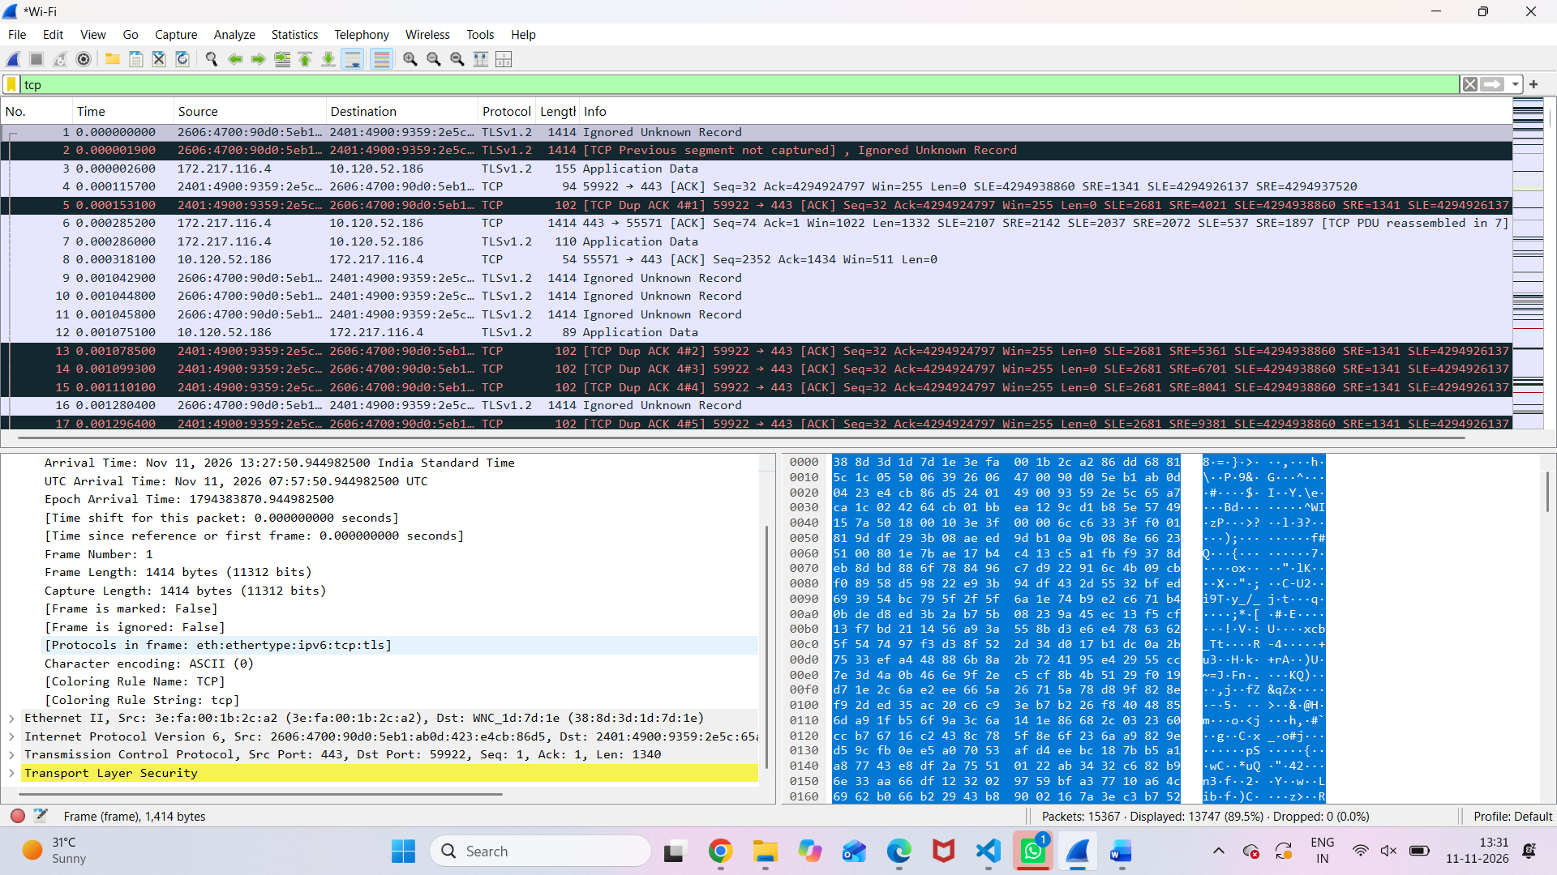\
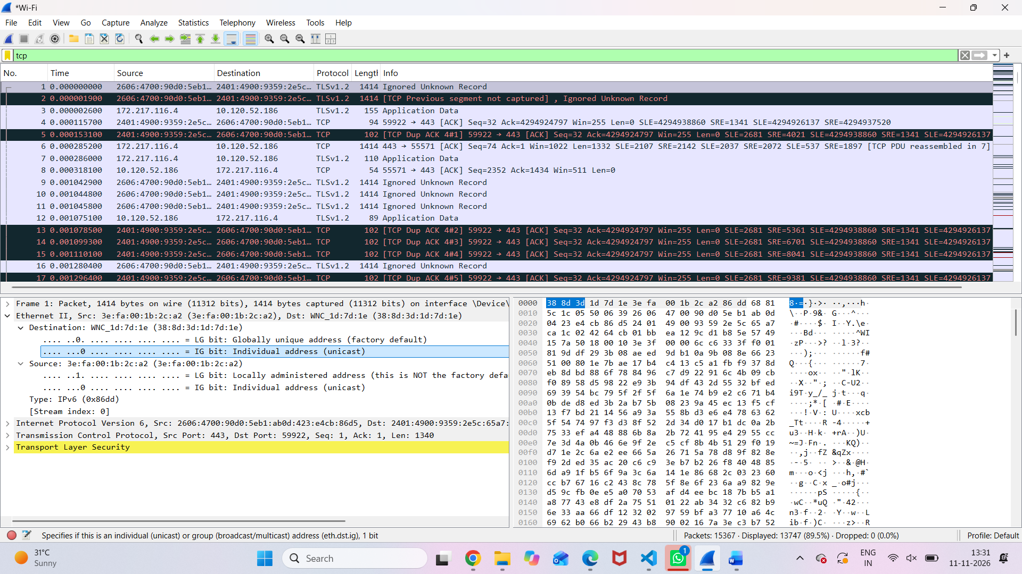
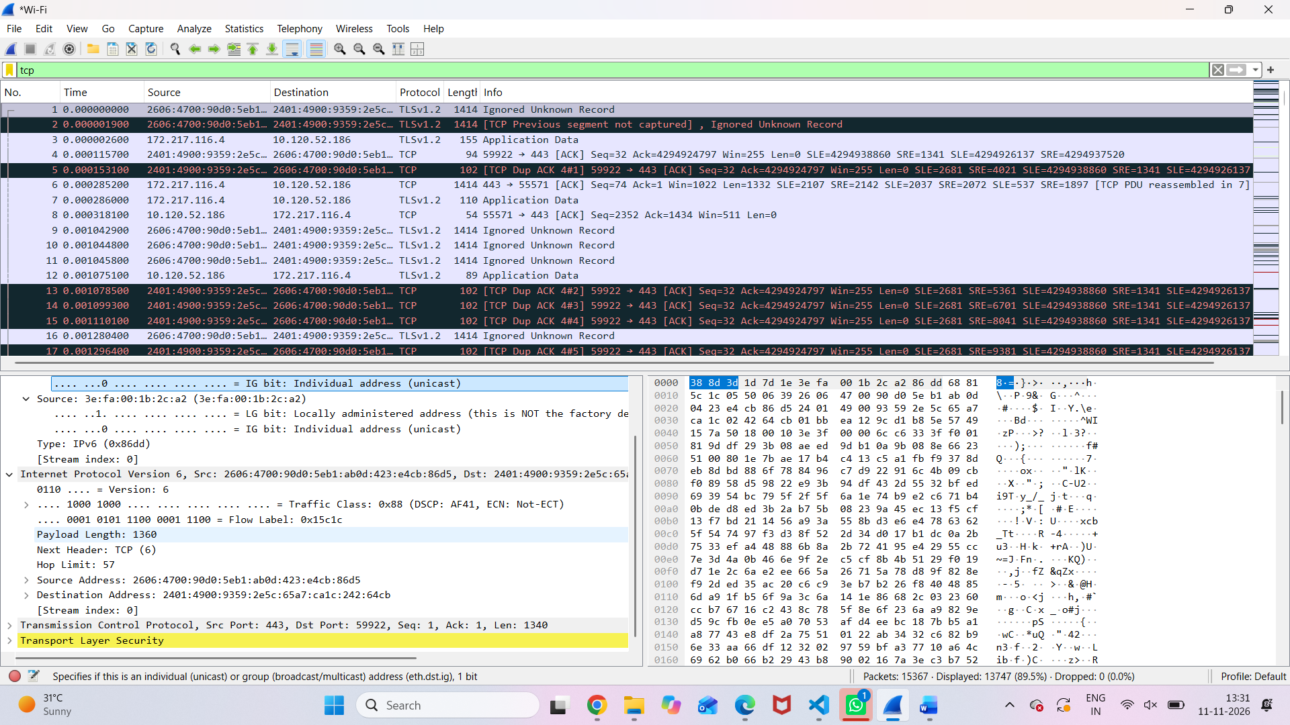
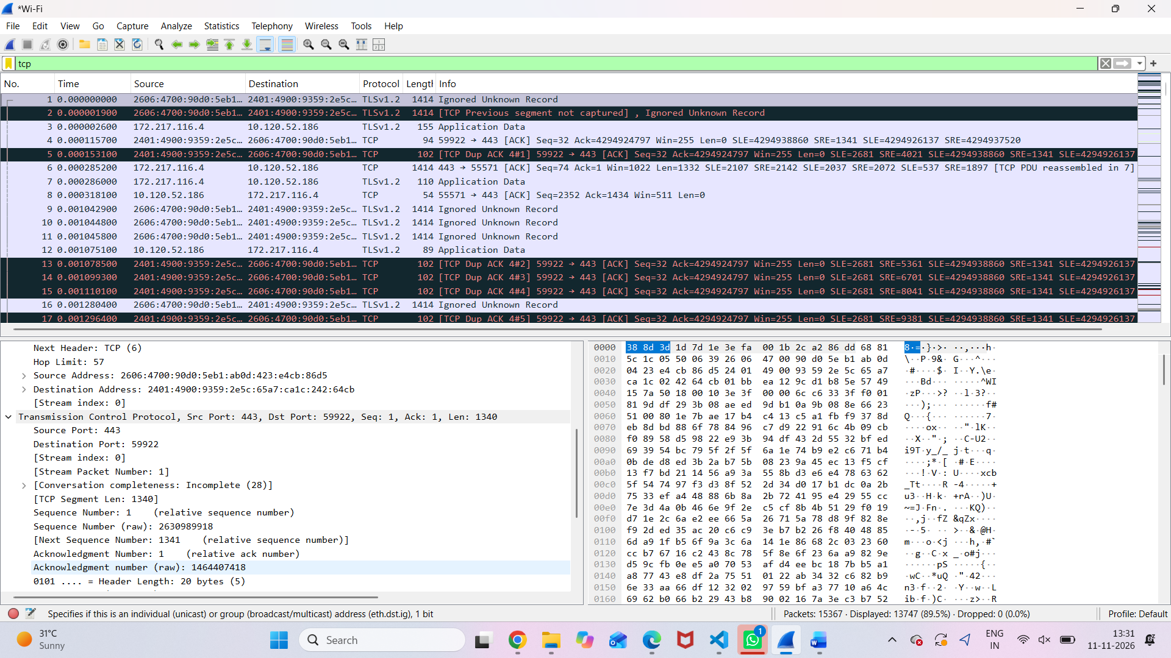
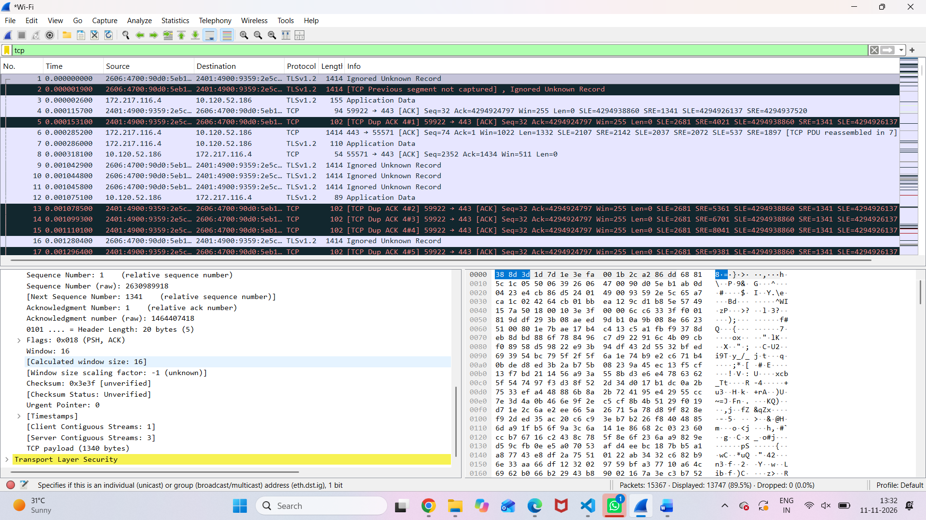
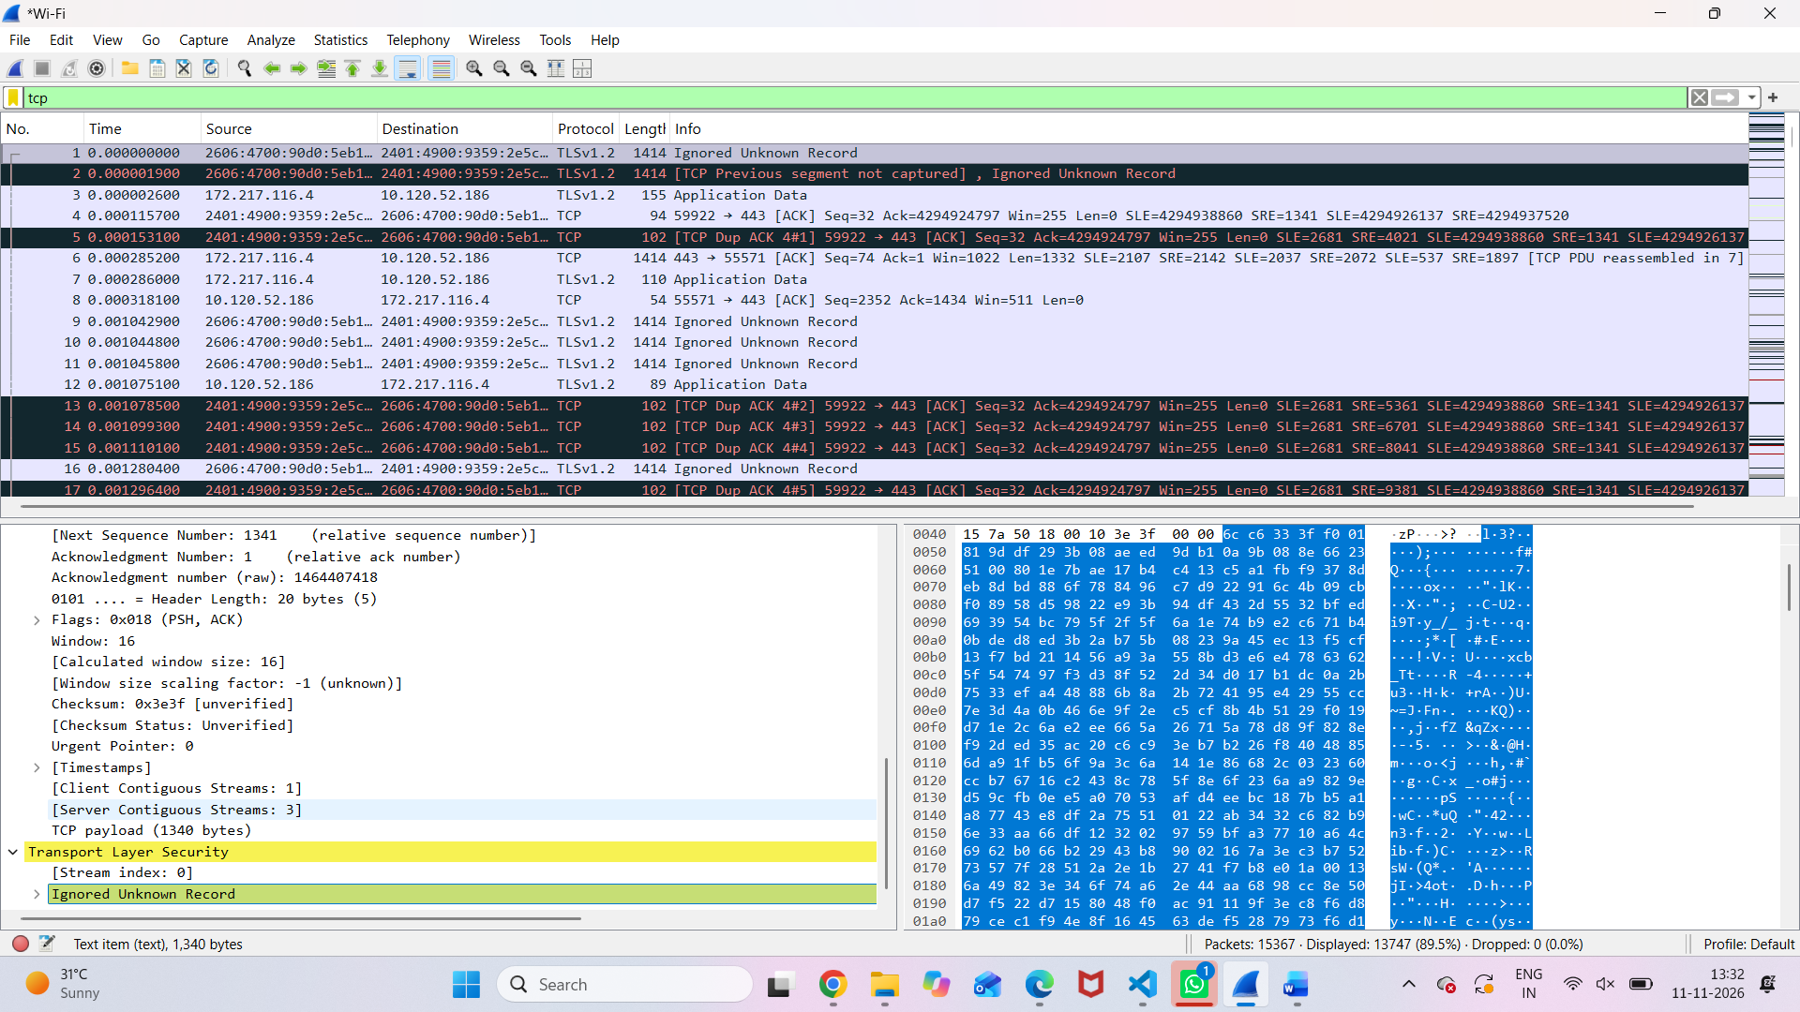
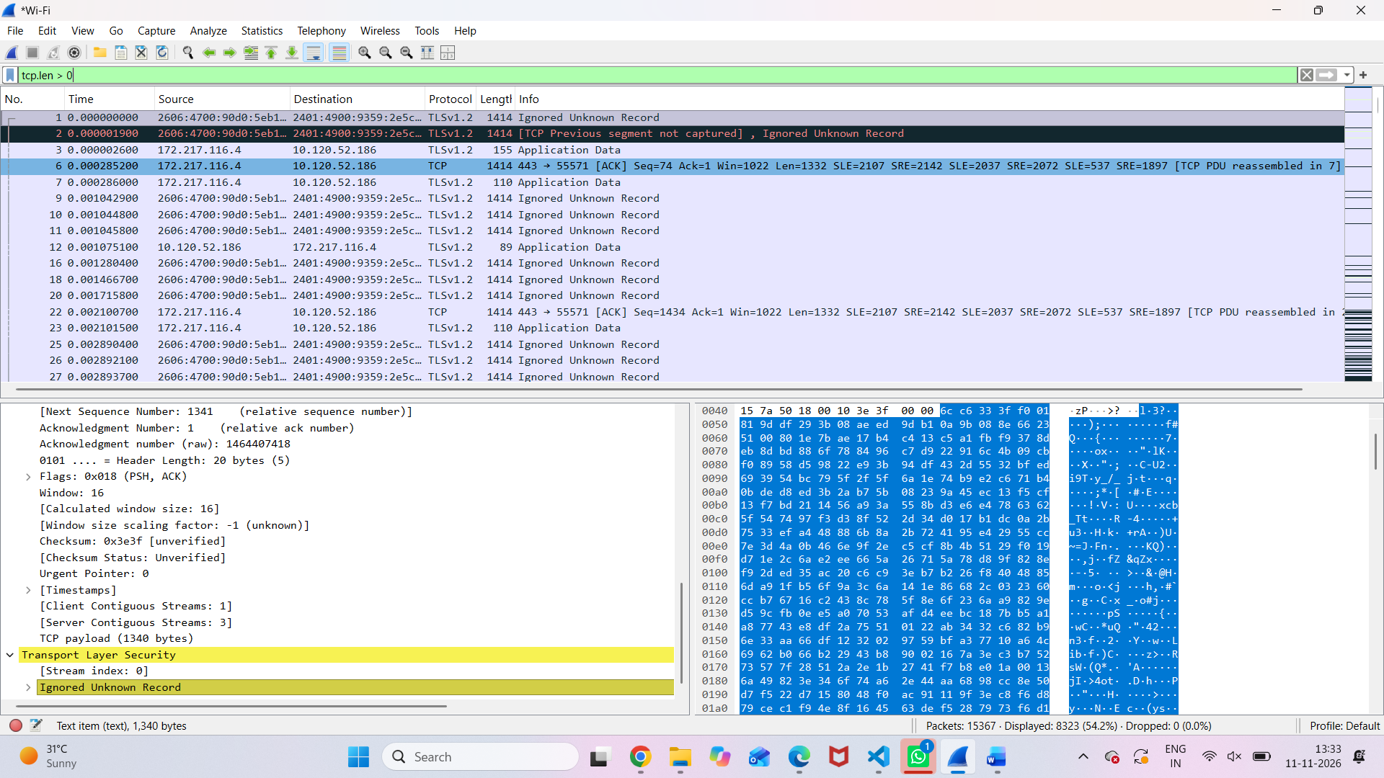
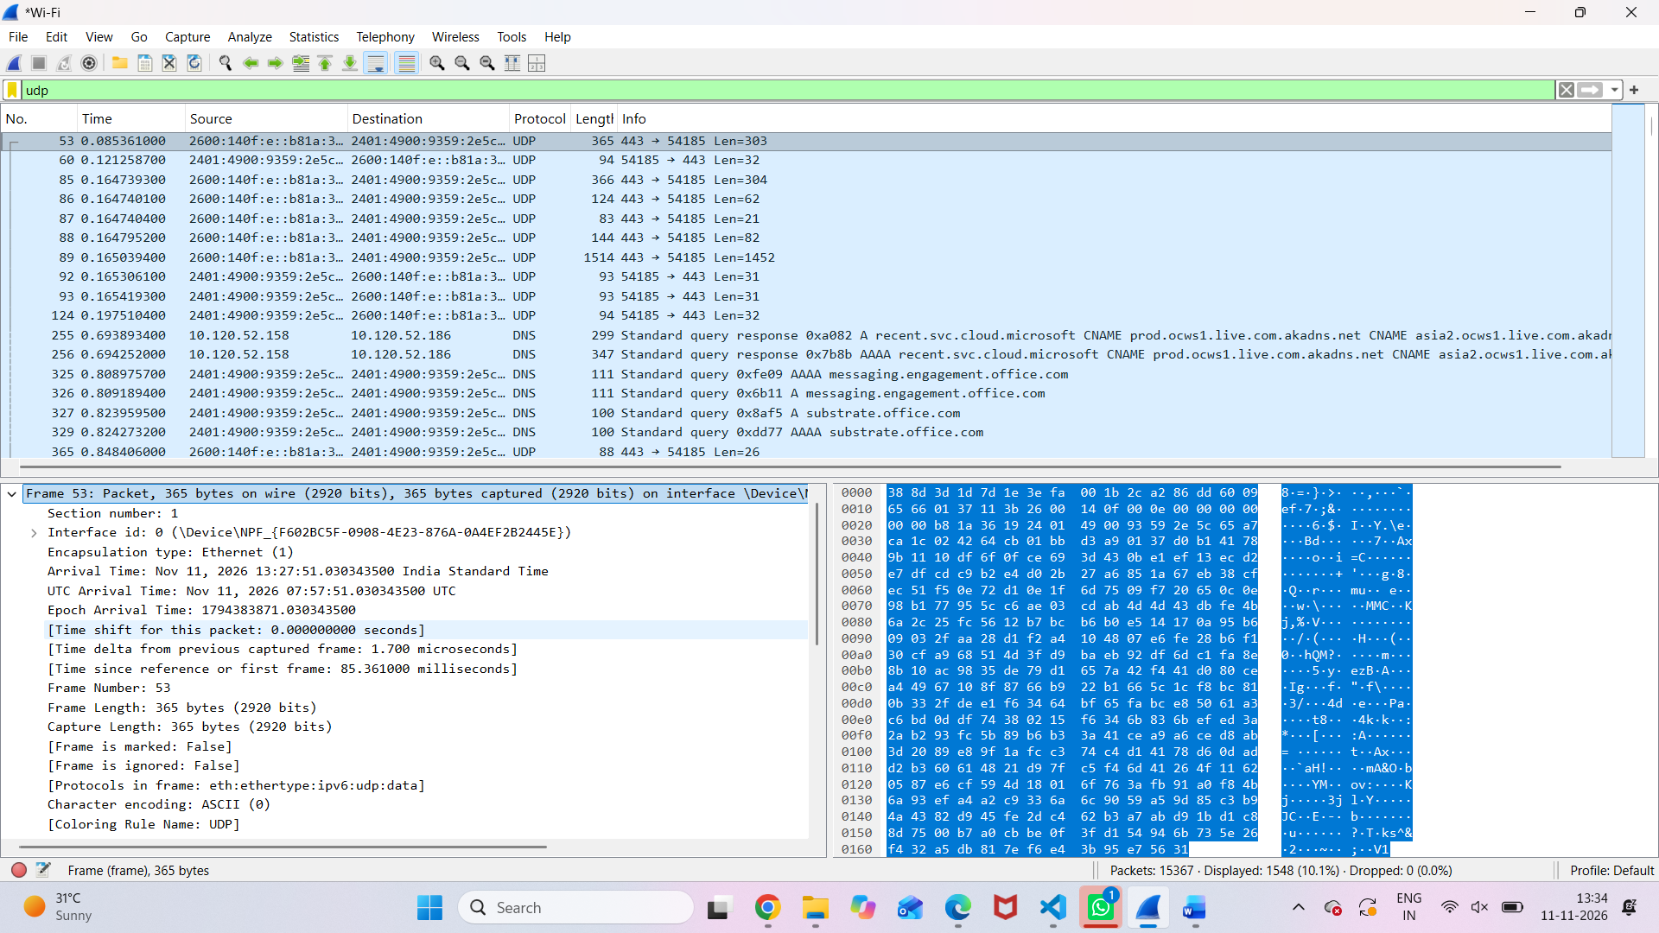
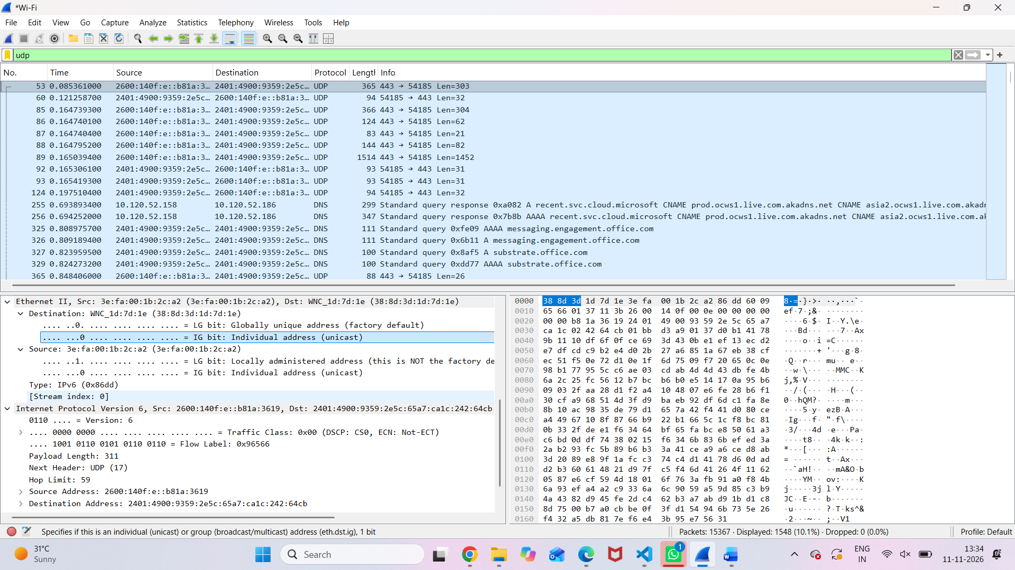
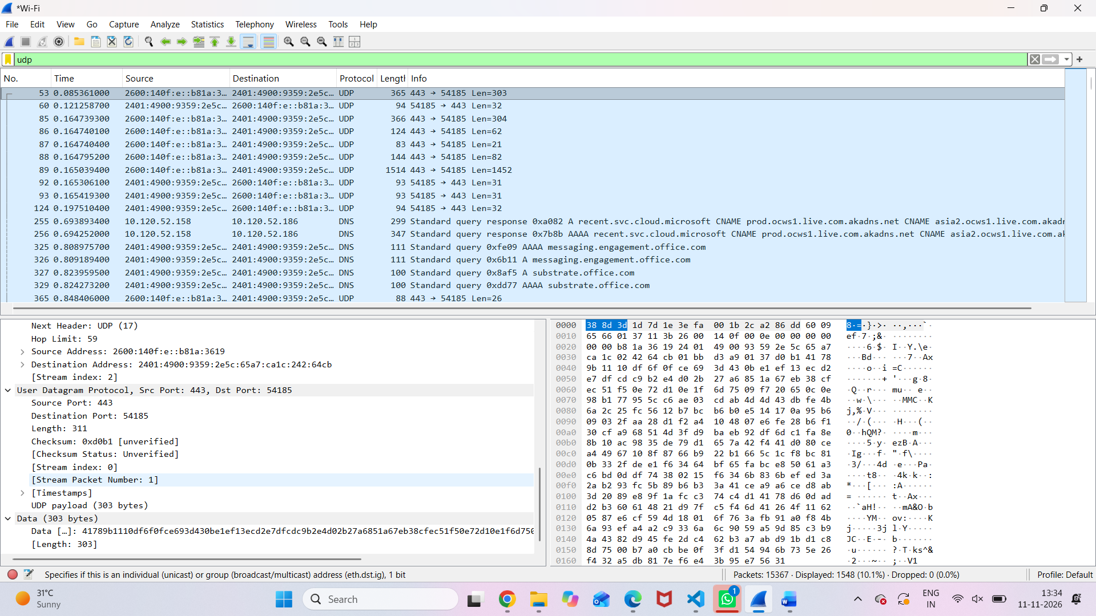

. TCP Packet Inspection
Packet No. 1
TCP Field | Captured Value
Packet Number | 1
Frame Length | 1414 bytes
Ethernet Header Length | 14 bytes
Source MAC Address | 3e:fa:00:1b:2c:a2
Destination MAC Address | 38:8d:3d:1d:7d:1e
Source IPv6 Address | 2606:4700:90d0:5eb1:ab0d:423:e4cb:86d5
Destination IPv6 Address | 2401:4900:9359:2e5c:65a7:ca1c:242:64cb
IPv6 Header Length | 40 bytes
IPv6 Payload Length | 1360 bytes
TCP Header Length | 20 bytes
TCP Payload Length | 1340 bytes
TCP Length Calculations
1. IPv6 Payload Length:
20 + 1340 = 1360 bytes
2. Total Frame Length:
14 + 40 + 1360 = 1414 bytes
UDP Packet Inspection
Packet No. 53
UDP Field | Captured Value
Packet Number | 53
Frame Length | 365 bytes
Ethernet Header Length | 14 bytes
Source MAC Address | 3e:fa:00:1b:2c:a2
Destination MAC Address | 38:8d:3d:1d:7d:1e
Source IPv6 Address | 2600:140f:e::b81a:3619
Destination IPv6 Address | 2401:4900:9359:2e5c:65a7:ca1c:242:64cb
IPv6 Header Length | 40 bytes
IPv6 Payload Length | 311 bytes
UDP Header Length | 8 bytes
UDP Length | 311 bytes
UDP Payload Length | 303 bytes
UDP Length Calculations
1. UDP Length:
8 + 303 = 311 bytes
2. IPv6 Payload Length:
311 bytes
3. Total Frame Length:
14 + 40 + 311 = 365 bytes
3. Observation Table
Parameter | TCP (Packet 1) | UDP (Packet 53)
Frame Length | 1414 bytes | 365 bytes
Ethernet Header Length | 14 bytes | 14 bytes
IP Header Length | 40 bytes (IPv6) | 40 bytes (IPv6)
Transport Header Length | 20 bytes | 8 bytes
IP Payload Length | 1360 bytes | 311 bytes
Transport Payload Length | 1340 bytes | 303 bytes

Header Overhead and Payload Efficiency
Calculation | TCP | UDP
Ethernet Header | 14 bytes | 14 bytes
IPv6 Header | 40 bytes | 40 bytes
Transport Header | 20 bytes | 8 bytes
Total Header Overhead | 74 bytes | 62 bytes
Frame Length | 1414 bytes | 365 bytes
Payload Length | 1340 bytes | 303 bytes
TCP Calculations
Total overhead:
\[ 14+40+20=\boxed{74\text{ bytes}} \]
Payload efficiency:
\[ \frac{1340}{1414}\times100 \]
\[ =\boxed{94.76\%} \]
UDP Calculations
Total overhead:
\[ 14+40+8=\boxed{62\text{ bytes}} \]
Payload efficiency:
\[ \frac{303}{365}\times100 \]
\[ =\boxed{83.01\%} \]
5. Theoretical Calculation from the Worksheet
For Ethernet + IPv4 + TCP:
Parameter | Size
Ethernet Header | 14 bytes
IPv4 Header | 20 bytes
TCP Header | 20 bytes
Application Data | 1500 bytes
FCS | 4 bytes
Total size:
\[ 14+20+20+1500+4 =\boxed{1558\text{ bytes}} \]
Total overhead:
\[ 14+20+20+4 =\boxed{58\text{ bytes}} \]
Payload efficiency:
\[ \frac{1500}{1558}\times100 =\boxed{96.28\%} \]
6. Important observation
- Your TCP screenshot shows IPv6, not IPv4.
- Your UDP screenshot also shows IPv6, not IPv4.
- Therefore, use 40 bytes as the IPv6 header length in your actual observation table.
- Do not add the 4-byte Ethernet FCS to your captured frame calculations because it is not shown in your screenshots.
These are the main final values to use in your report:
TCP overhead
74 bytes
Payload efficiency: 94.76%
UDP overhead
62 bytes
Payload efficiency: 83.01%

Experiment: Encapsulation Builder – Analyze the overhead introduced by protocol headers and determine how encapsulation affects network efficiency.

A. Answers to the Questions
1. What is encapsulation?
Encapsulation is the process in which each network layer adds its own header to the data received from the layer above it. For example, TCP adds a TCP header, IP adds an IP header, and Ethernet adds an Ethernet header.
2. What is the purpose of the Ethernet header?
The Ethernet header is used for communication within a local network. It contains the destination MAC address, source MAC address, and Type/Length field. These fields help identify the receiving device and the type of data carried in the Ethernet frame.
3. What information is stored in the IP header?
The IP header contains information such as the source IP address, destination IP address, IP version, header length, total packet length, time to live (TTL), and upper-layer protocol. This information helps routers forward packets to the correct destination.
4. What is the difference between TCP and UDP headers?
A TCP header contains source and destination ports, sequence and acknowledgment numbers, flags, and window size. It supports reliable, ordered delivery. A UDP header is smaller and contains source port, destination port, length, and checksum. UDP is connectionless and does not guarantee delivery or packet order.
5. Why does each protocol add a header?
Each protocol adds a header because it needs control information to perform its task. Headers provide addressing, routing, error checking, sequencing, and delivery information so data can travel correctly from sender to receiver.
6. What is packet overhead?
Packet overhead is the extra data added to the original application data by protocol headers and other control fields. It is needed for network communication but is not the actual application information being transferred.
7. How does header overhead affect network efficiency?
Header overhead reduces the percentage of a packet that contains useful application data. When headers take up a larger portion of each packet, fewer application bytes are carried per packet, which can reduce network efficiency.

E. Conclusion
In this activity, Wireshark was used to capture and inspect network packets. The Ethernet, IP, and TCP/UDP headers were examined to understand encapsulation at different network layers. The overhead calculation showed that protocol headers add extra bytes to each packet and reduce the proportion available for application data.

