Project Title: Position Control using Encoder
Rpm control using Encoder

INTRODUCTION:
Rotary Encoder (shaft encoder) is an electro-mechanical device that converts the angular position or motion of a shaft to analog output.
To control the position of the wheel: Output waveform of both the channels are 900 out of phase. Thus, comparing them at changing edge can identify whther the motion is in clockwise or anti-clockwise direction. Also, withe the count of the pulses exact positon (displaced angle) can be calculated.
Incremental rotary encoder to control the speed of the wheel: Initially, required speed is given to the motor (in pwm) and using encoder feedback is taken. If the rpm is greater than the required rpm, than the base pwm is decreased accordingly, i.e. using error, which is difference between the required rpm and current rpm and vice-versa.
Working of a Rotary Encoder:
A rotary encoder consists of a light source, light sensor and a disk with alternate transparent area (yellow) and opaque area (grey). Light is emitted from the light source and received by the light sensor, but due to the alternate opaque and transparent medium, the output obtained is waveform of pulses. Due to the position of two leds, the output pulse obtained is 90o out of phase.
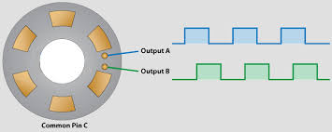

Position control:
If both the waveforms are compared at changing edges, the direction of the motion can be inferred.
Direction | Output A | Output B
Clockwise | 0 or 1 | 1 or 0
Anti-clockwise | 0 or 1 | 0 or 1
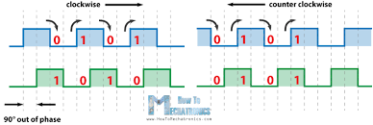
Direction of rotation specifies whether the wheel is moving clockwise or anti-clockwise. To get the exact position of the wheel, interrupt is used. When the condition for interrupt occurs, the interrupt is called. In this case, the interrupt is called at falling edge. And the counter is incremented when the interrupt is called. This count is then used to calculate the angle.
Angle = count / 600 * 3600
Here, 600 is the maximum count of the encoder.
RPM control:
Speed = Distance / Time
Using above equation, there are two ways in which rpm of the wheel (motor) can be calculated.
1. Keep count constant: One way to calculate rpm is to keep count constant and calculate the time required to get this count.
2. Keep time constant: One way to calculate rpm is to keep time constant and calculate the number of pulses.
In the first case, the count is constant, the rpm is calculated and compared with the required rpm. In the second case, the time period is constant and the speed is calculated. Here, timer interrupt is used to set the time. When the interrupt is called, the rpm is calculated as the number of count.
Their difference is calculated as error. According to the error (in proportion to the error), the pwm is given to the wheel. PID controller is used to control the rpm.

INSIGHTS:
- Relation between RPM and PWM:
There is no direct relation between the speed given and speed obtained. To get all speeds (rpm, count, pwm) in one form, map function of the arduino was used. Using this all the quantities were converted in one form(pwm).
- Constant error:
When the speed was calculated using constant count, the time required to get this speed was high. To reduce this time, the number of count was decreased to 60. this introduced a constant error in the speed, which was not solved even by adding I to the PWM.
- Tuning Encoder:
Whenever there is change in battery’s voltage, the speed obtained is not accurate. Thus, if the applied voltage is change PID should be tuned.

RESULT:
When the load increases, there is decrease in the speed of motor causing error. This error can be minimised by giving extra PWM to the motor. This extra PWM can be achieved by taking feedback from encoder and applying PID.

Renuka Bedarkar
renuka.bedarkar17@vit.edu

