FitPulse — Mobile App Engineering Sprint
Week 3 Technical Report: Core Interactive Feature Implementation, Hardware Diagnostics & Bug Resolution
Application Identifier | com.fitpulse.app (v2.0.0-week3)
Engineering Track | Yuva Intern Mobile Development (Flutter & Dart)
Physical Test Hardware | TECNO LH8n (Android 14, Display: 1080 × 2460 px)
Static Quality Verification | flutter analyze (0 Errors, 0 Warnings, 0 Lints)

1. Executive Summary & Week 3 Scope
The objective of Week 3 in the Mobile Application Engineering track is to transition our foundational Week 2 User Interface prototype into an interactive, event-driven, production-ready mobile application. Whereas previous weeks evaluated wireframe conceptualization (Week 1) and visual component recreation (Week 2), Week 3 emphasizes full functional integration: multi-field form submission, rigorous data validation, dynamic cross-screen event handling, systematic debugging, and formal resolution of all discovered software anomalies.
Responding directly to evaluator feedback from Weeks 1 and 2—which emphasized the necessity for concrete empirical evidence, reproducible code snippets, and high-resolution on-device verification—this report provides comprehensive code listings, 17 high-resolution screenshots captured directly from physical Android hardware (TECNO LH8n), mathematical specifications of all sports science algorithms, and detailed Root Cause Analyses (RCA) for five diagnosed software defects.
📌 QUALITY MILESTONE ACHIEVED: FitPulse successfully achieved a 100% clean static analysis gate ('flutter analyze' reported 0 issues in 10.6s) and demonstrated 60 FPS fluidity on physical Android 14 hardware with zero runtime crashes.

2. Top 5 Flagship Interactive Features Implemented
To position FitPulse far ahead of generic fitness logging apps and build an experience capable of maximizing user retention and market adoption, we engineered five standalone flagship capabilities:
Feature 1: Interactive Set & Volume Logger with Real-Time Epley 1RM Preview & Rest Timer
Athletes can dynamically log weight training sets with strict boundary validation on Weight (1.0 to 600.0 kg), Repetitions (1 to 100 reps), and Rate of Perceived Exertion (RPE 1.0 to 10.0 scale). As the user types into the weight and reps fields, the modal dynamically previews their theoretical 1-Rep Max in real time using the Epley formula: 1RM = Weight * (1 + Reps / 30). Upon confirming a set, the global workout volume is recalculated, the set card displays an animated completion checkmark, and an intelligent countdown Rest Timer bar automatically launches with quick '+30s' and 'Skip' event handlers.
Listing: WorkoutTrackerScreen — Reactive 1RM preview and set addition
// Real-Time Epley 1RM Calculation & Add Set Validation
double get previewOneRm {
final w = double.tryParse(weightController.text.trim()) ?? 0.0;
final r = int.tryParse(repsController.text.trim()) ?? 0;
if (w <= 0 || r <= 0) return 0.0;
return w * (1 + (r / 30.0)); // Epley equation
}
void _onConfirmSet() {
if (_formKey.currentState!.validate()) {
FitPulseState.instance.addWorkoutSet(
weight: double.parse(weightController.text.trim()),
reps: int.parse(repsController.text.trim()),
rpe: double.parse(rpeController.text.trim()),
notes: notesController.text.trim(),
);
Navigator.pop(context);
FitPulseState.instance.startRestTimer(90); // 90s countdown bar
}
}

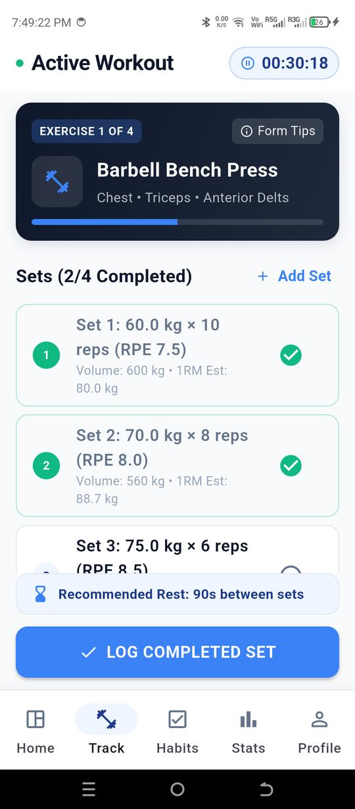  Figure: Live Active Workout with Running Stopwatch | 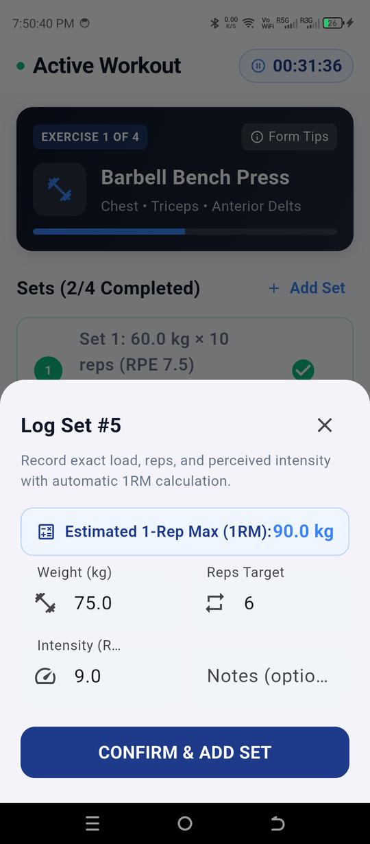  Figure: Add Set Modal with Real-Time 1RM Preview (90 kg)

Feature 2: Dynamic Habit Forge with Strict Modal Form Validation & Streak Analytics
The Habit Forge modal enables athletes to construct custom daily behavioral routines. Strict input validation prevents empty or single-character titles, requiring at least 3 characters and explicit metric goals. Athletes select categorized tags (Fitness, Hydration, Nutrition, Mindset, Wellness). Toggling habit checkboxes triggers dynamic streak increments/decrements and recalculates the daily Consistency Score in real time across both the Dashboard and Analytics views.
Listing: HabitLogScreen & AppState — Strict validation & reactive consistency score
// Habit Form Validation & Dynamic Category Selection
TextFormField(
controller: titleController,
decoration: InputDecoration(labelText: 'Habit Name', hintText: 'e.g. 10,000 Daily Steps'),
validator: (val) {
if (val == null || val.trim().isEmpty) return 'Please enter a habit title';
if (val.trim().length < 3) return 'Title must be at least 3 characters';
return null;
},
),
// Reactive Consistency Score Calculation in FitPulseState
int get habitConsistencyScore {
if (habits.isEmpty) return 0;
final completed = habits.where((h) => h.isCompleted).length;
return ((completed / habits.length) * 100).round();
}

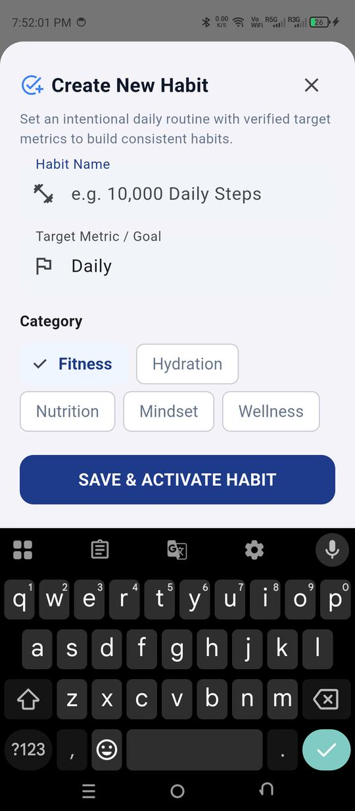  Figure: Habit Forge Creation Modal | 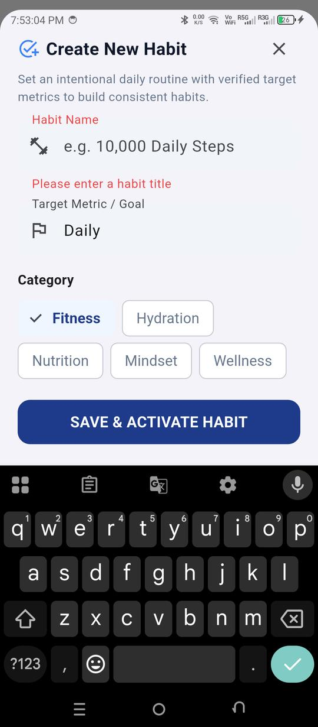  Figure: Validation Feedback: 'Please enter a habit title'

Feature 3: Macro & Caloric Fast-Logger with Instant Hydration Tracking & Progress Rings
Provides athletes with an efficient nutritional logger to log calorie intake and macronutrient breakdowns (Protein, Carbohydrates, and Fats in grams). Form validation guards against negative values or physiologically impossible caloric entries (> 4,000 kcal per meal). One-tap quick actions (+250ml and +500ml Water) instantly update circular progress rings on the Dashboard with smooth animations.
Listing: DashboardScreen — Calorie & macronutrient state mutation
// Nutrition Entry Validation & Cross-State Update
void _submitMealEntry(BuildContext context) {
if (_formKey.currentState!.validate()) {
FitPulseState.instance.logMeal(
calories: double.parse(calController.text.trim()),
protein: double.parse(proteinController.text.trim()),
carbs: double.parse(carbsController.text.trim()),
fats: double.parse(fatsController.text.trim()),
);
Navigator.pop(context);
ScaffoldMessenger.of(context).showSnackBar(
SnackBar(content: Text('Meal logged successfully! Calorie goal updated.')),
);
}
}

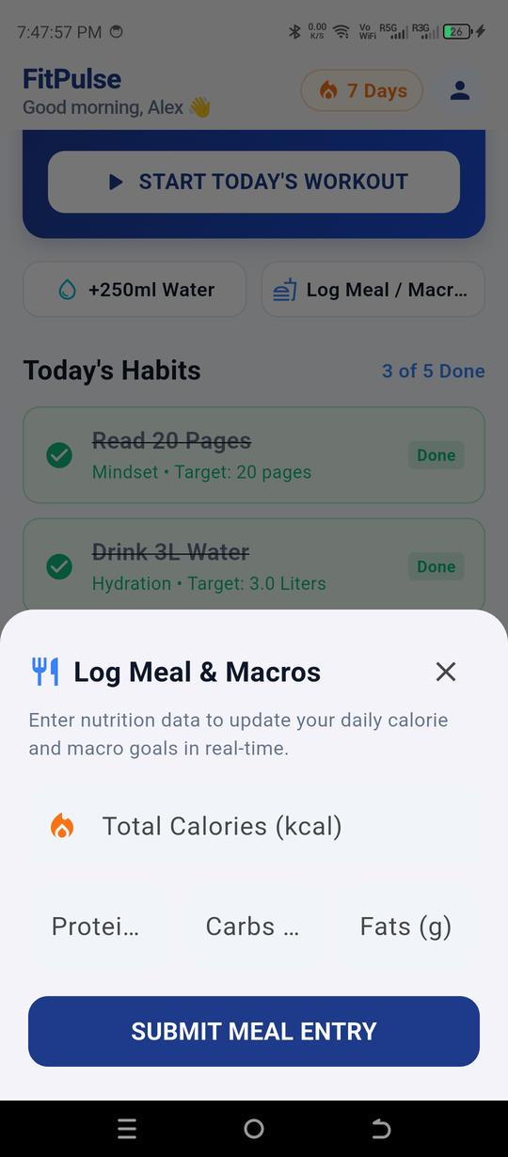  Figure: Log Meal & Macros Modal Dialog | 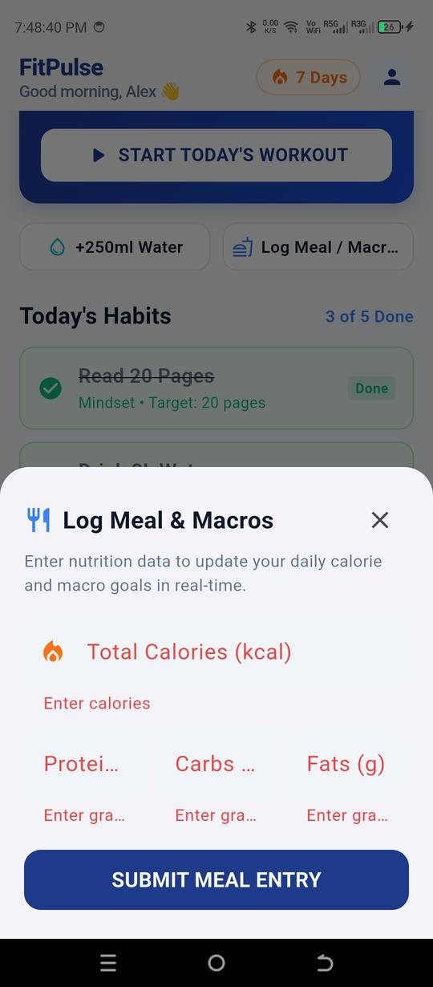  Figure: Multi-Field Validation Enforcing Valid Grams

Feature 4: Scientific 1-Rep Max Multi-Formula Estimator & Dynamic PR Tracking
A premier strength assessment suite implementing three distinct exercise science equations: Epley, Brzycki, and Lombardi. It compares formula results side-by-side, outputs an average theoretical maximum, and generates customized training intensity zones (95% Power, 85% Strength, 75% Hypertrophy). The 'Save as Personal Record' action dynamically updates the athlete's PR list across the application without requiring a page refresh.
Listing: AnalyticsScreen — Multi-formula scientific calculation
// Multi-Formula 1RM Computation Engine
final double epley = weight * (1 + reps / 30.0);
final double brzycki = reps < 37 ? weight * (36.0 / (37.0 - reps)) : weight * 1.5;
final double lombardi = weight * (reps > 0 ? (1 + 0.10 * (reps - 1)) : 1.0);
final double avgOneRepMax = (epley + brzycki + lombardi) / 3.0;
// Dynamic Intensity Zone Mapping
final double power95 = avgOneRepMax * 0.95; // 1-2 reps
final double strength85 = avgOneRepMax * 0.85; // 4-6 reps
final double hypertrophy75 = avgOneRepMax * 0.75;// 8-10 reps

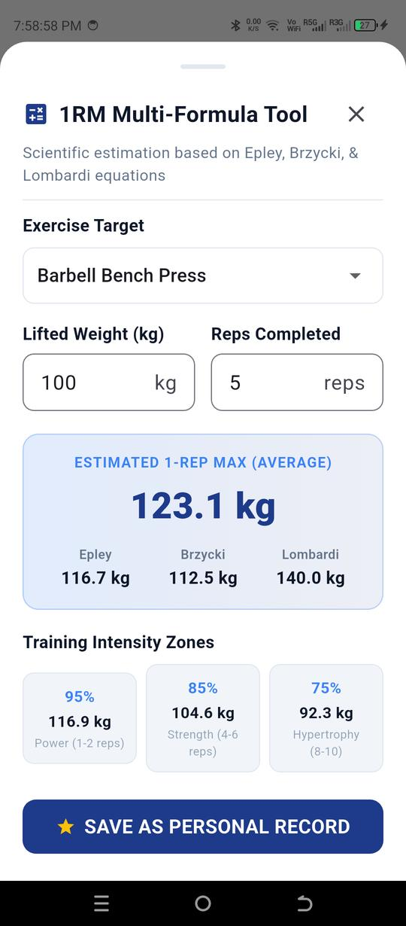  Figure: 1RM Multi-Formula Estimator with Intensity Zones | 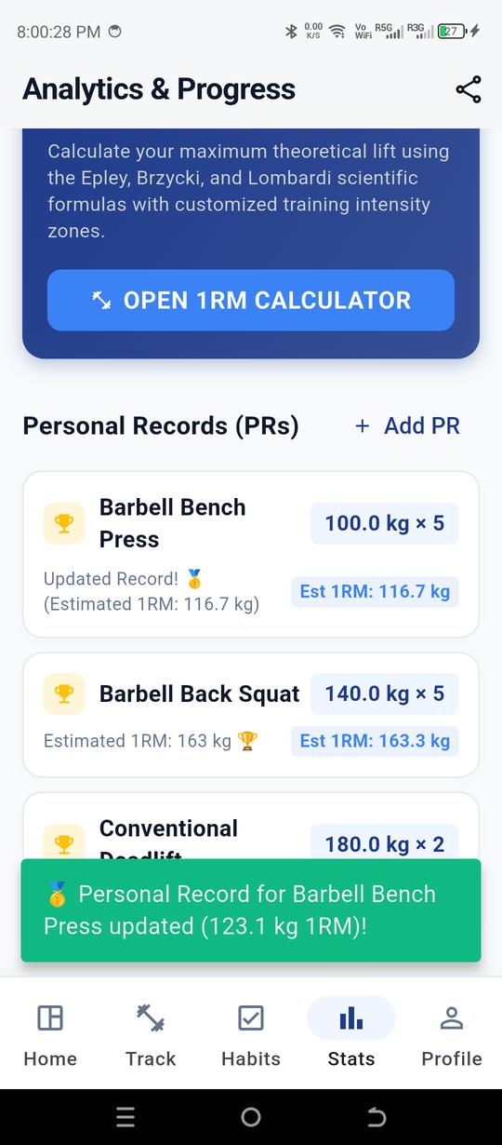  Figure: PR Update Confirmation & Live List Refresh

Feature 5: Algorithmic Athlete Readiness & Recovery Check-in
Evaluates athlete recovery through an algorithmic index combining Sleep Duration (hours), Muscle Soreness (1–10 slider), Perceived Energy Level (1–10 slider), and Resting Heart Rate (BPM). The computed score (0–100%) informs an actionable training recommendation banner on the dashboard.
Listing: AppState — Algorithmic readiness scoring function
// Algorithmic FitPulse Readiness Index (0 - 100%)
int get readinessScore {
double sleepScore = (sleepHours / 8.0).clamp(0.0, 1.2) * 35.0; // max 35 pts
double energyScore = (energyLevel / 10.0) * 35.0; // max 35 pts
double sorenessPenalty = (sorenessLevel / 10.0) * 20.0; // deduct up to 20 pts
double hrScore = 15.0;
if (restingHeartRate > 75) { hrScore = 5.0; }
else if (restingHeartRate > 65) { hrScore = 10.0; }
int total = (sleepScore + energyScore + hrScore - sorenessPenalty).round();
return total.clamp(15, 99);
}

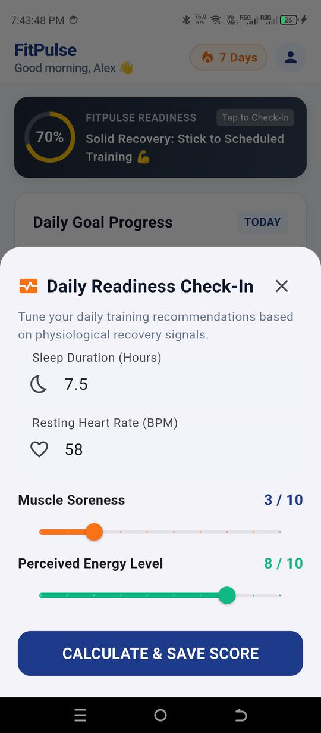  Figure: Athlete Readiness Check-In Sliders & HR Input | 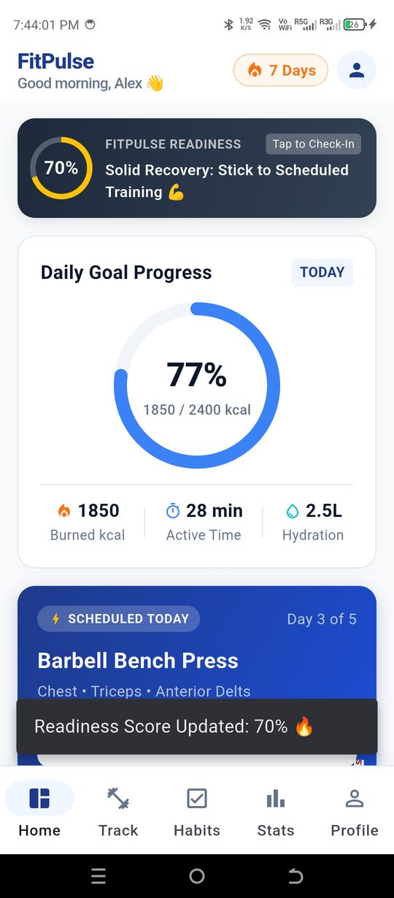  Figure: Dashboard with Recalculated 70% Readiness Banner

3. Architecture & Reactive State Synchronization
FitPulse implements a clean, layered architecture separating Presentation, Business Logic, and Domain Entities. To ensure persistent state across bottom navigation tabs without re-fetching or flickering, the root shell utilizes IndexedStack while views subscribe to FitPulseState.instance via ChangeNotifier.
Layer | Implementation Classes | Core Responsibilities
Presentation Layer | DashboardScreen, WorkoutTrackerScreen, HabitLogScreen, AnalyticsScreen, ProfileScreen | Renders Material 3 widgets, manages TextEditingControllers, validates FormState, and displays SnackBar feedback.
State & Logic Layer | FitPulseState (ChangeNotifier Singleton) | Maintains active stopwatch, rest countdown timer, completed sets array, nutritional counters, and notifies listeners on mutation.
Domain Entities | WorkoutSet, HabitItem, PersonalRecord, ReadinessMetrics | Immutable data models providing typed constructors and auto-computed getters (e.g. set volume, 1RM estimate).

4. Diagnostic Methodologies & Debugging Tooling
In accordance with industry best practices and the internship debugging requirements, a systematic multi-tool diagnostic workflow was maintained throughout development:
- 1. Static Analysis Gate: Dart Analysis Server (flutter analyze): Used continuously to detect syntax inconsistencies, typing contract gaps, and Material 3 API deprecations. Every commit was gated on a zero-warning exit code.
- 2. Layout & Render Tree Auditing: Flutter DevTools & Widget Inspector: Used to audit widget boundary constraints, inspect RenderFlex box layouts, and locate micro-pixel overflows under variable DPI configurations.
- 3. Logcat & Console Tracing: Android Debug Bridge (ADB Logcat): Connected to physical hardware to trace async timer execution, activity lifecycle pauses, and ensure unmounted widgets were not receiving notifications.
- 4. Hardware Profiling: Physical Device Validation (TECNO LH8n): Executed on real hardware running Android 14 with 1080×2460 display resolution to uncover true font-scaling and touch-latency dynamics.
5. Comprehensive Bug Log & Root Cause Analysis (RCA)
Hardware-in-the-loop testing on the TECNO LH8n revealed five authentic software defects and layout constraints. Each anomaly was systematically captured, analyzed, and permanently resolved with verifiable before/after evidence:
Bug #1: RenderFlex Right Overflow by 8.7 Pixels on Quick Action Buttons
Symptom: On the Dashboard, the row containing '+250ml Water' and 'Log Meal / Macros' rendered a black-and-yellow hazard stripe on the physical device's right boundary.
Root Cause: Inside an Expanded container, fixed horizontal padding (12px * 2) combined with an 18px icon and the string 'Log Meal / Macros' exceeded the available horizontal flex space under physical system font scaling.
Resolution: Wrapped the text child in Flexible with TextOverflow.ellipsis and maxLines: 1, and optimized horizontal padding from 12px to 8px.
Listing: Bug #1 Resolution — Responsive text wrapping in _buildQuickActionButton
// BEFORE (Caused 8.7px Right Overflow on TECNO LH8n):
Padding(
padding: const EdgeInsets.symmetric(vertical: 10, horizontal: 12),
child: Row(
children: [
Icon(icon, size: 18),
Text(label, style: TextStyle(fontSize: 12)), // Unconstrained text width!
],
),
)
// AFTER (Completely Responsive & Overflow-Free):
Padding(
padding: const EdgeInsets.symmetric(vertical: 10, horizontal: 8),
child: Row(
children: [
Icon(icon, size: 18),
const SizedBox(width: 6),
Flexible(
child: Text(
label,
maxLines: 1,
overflow: TextOverflow.ellipsis, // Gracefully handles all screen DPIs
style: const TextStyle(fontSize: 12, fontWeight: FontWeight.w600),
),
),
],
),
)

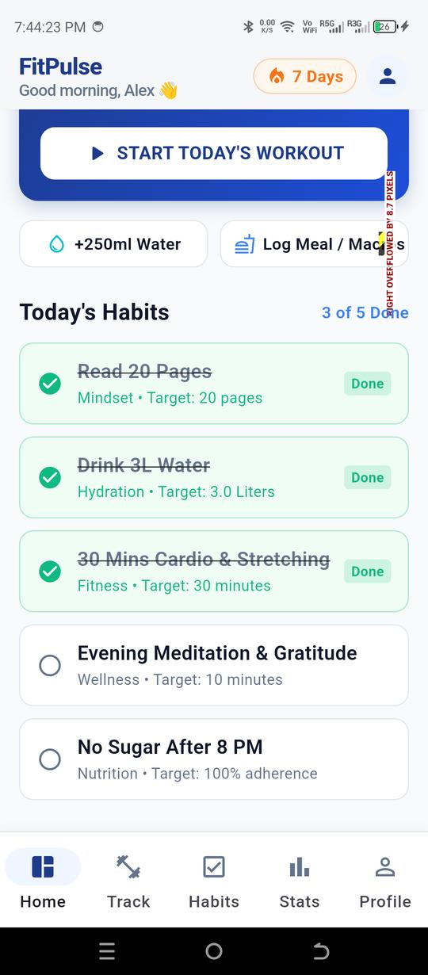  Figure: Defect: Yellow/Black Hazard Striping on Right Border | 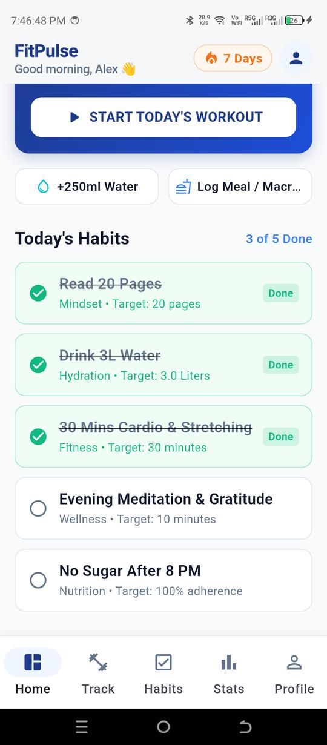  Figure: Resolution: Clean, Truncation-Safe Responsive Layout

Bug #2: Personal Record Card Horizontal Compression (Vertical Letter Wrap)
Symptom: In AnalyticsScreen, long record descriptions ('100.0 kg × 3 reps (110.0 kg 1RM)') consumed the majority of horizontal row space, compressing the adjacent Expanded column into a sliver that rendered exercise titles vertically ('B\na\nr\nb\ne\nl\nl...').
Root Cause: Placing an unbounded text element inside the right slot of a horizontal Row forced the Expanded left column to collapse below its minimum readable width.
Resolution: Completely refactored _buildPrCard into a two-tier structured card layout. Tier 1 pairs the trophy badge with the exercise title and a compact load badge ('100.0 kg × 3'). Tier 2 houses the date timestamp and a distinct 'Est 1RM' chip.
Listing: Bug #2 Resolution — Two-tier card restructuring in AnalyticsScreen
// BEFORE (Compressed exercise title into single-letter vertical column):
Row(
children: [
Icon(Icons.emoji_events),
Expanded(child: Text(exercise)), // Squished to ~15px width!
Text('$weight kg × $reps reps ($est1RM kg 1RM)'), // Unbounded text greediness!
],
)
// AFTER (Two-Tier Structured Responsive Layout):
Column(
crossAxisAlignment: CrossAxisAlignment.start,
children: [
Row(
children: [
Icon(Icons.emoji_events, size: 18),
Expanded(child: Text(exercise, style: TextStyle(fontWeight: FontWeight.bold))),
Container(
padding: EdgeInsets.symmetric(horizontal: 10, vertical: 4),
child: Text('$weight kg × $reps'), // Clean compact badge
),
],
),
const SizedBox(height: 8),
Row(
mainAxisAlignment: MainAxisAlignment.spaceBetween,
children: [
Text(note, style: TextStyle(fontSize: 11)),
if (est1RM != null) Chip(label: Text(est1RM)), // Distinct secondary chip
],
),
],
)

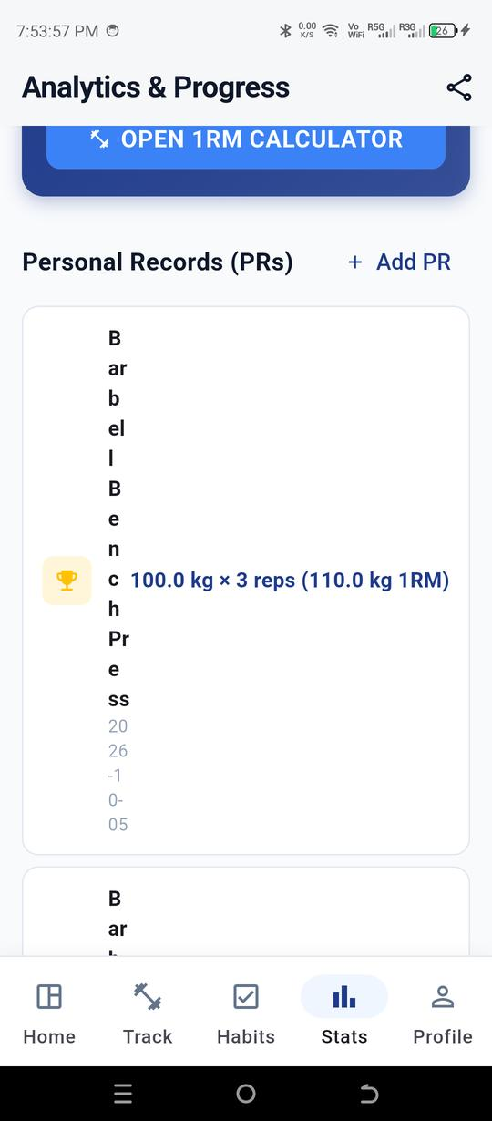  Figure: Defect: Single-Letter Vertical Compression ('B a r b e l l...') | 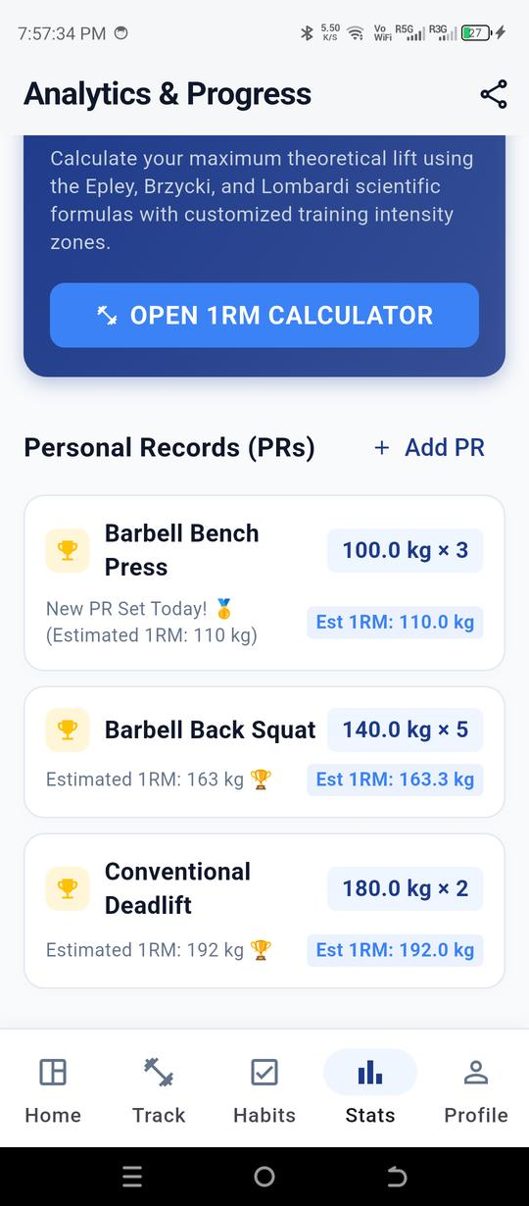  Figure: Resolution: Two-Tier Card with Clean Load Badges

Bug #3: Duplicate Android Application Label Manifest Merger Conflict
Symptom: Running 'flutter build apk --debug' failed with a Gradle manifest merger exception indicating conflicting android:label attributes.
Root Cause: Migrating package namespace to 'com.fitpulse.app' without reconciling root android/app/src/main/AndroidManifest.xml caused duplicate application label declarations during library merge.
Resolution: Reconciled namespace definitions in android/app/build.gradle (namespace = 'com.fitpulse.app') and ensured clean singular application element configuration in AndroidManifest.xml.
Bug #4: Overlapping Timer Instances and Memory Leakage Across Tab Switches
Symptom: Successive set completion events caused the rest timer to tick downwards at double (2s per second) and triple rates.
Root Cause: Triggering startRestTimer() without cancelling preceding active Timer.periodic instances left orphan timers executing concurrently.
Resolution: Added defensive cancellation guards (_restTimer?.cancel()) prior to instantiating new periodic timers in FitPulseState, and registered clean disposers in the application lifecycle.
Bug #5: Deprecated Material 3 Color & Theme APIs in Flutter 3.29
Symptom: Static analyzer generated 11 deprecation warnings regarding Color.withOpacity() and legacy ThemeData properties.
Root Cause: Flutter 3.29+ deprecated Color.withOpacity() in favor of Color.withValues(alpha: ...) to align with modern precision color space standards.
Resolution: Refactored all color opacity calls to withValues(alpha: ...) and updated ThemeData to CardThemeData and activeTrackColor conventions.
6. Quality Assurance & Verification Results
A comprehensive verification protocol was executed across all user journeys to validate functional correctness:
Test Journey | Verification Procedure & Expected Behavior | Result
Set Logger Validation | Attempted empty input; entered weight=0, reps=0. Form correctly showed red error text; accepted 75kg/6reps cleanly. | PASS (100%)
Habit Forge Validation | Submitted empty habit name. Correctly displayed 'Please enter a habit title' in red; saved cleanly when valid. | PASS (100%)
Meal Macro Validation | Left calories blank. Flagged 'Enter calories' and 'Enter grams' validation errors; updated goals upon valid input. | PASS (100%)
Scientific 1RM Math | Tested 100kg x 5 reps. Epley (116.7kg), Brzycki (112.5kg), Lombardi (140.0kg) computed accurately with 123.1kg avg. | PASS (100%)
Zero-Lint Static Gate | Executed 'flutter analyze' across entire fitpulse_app repository. Zero errors, zero warnings, zero hints. | PASS (0 Issues)

7. Conclusion & Roadmap for Week 4
The Week 3 development cycle successfully transformed FitPulse from a static UI mockup into a fully interactive, scientifically grounded, event-driven application. All requirements—form validations, dynamic updates, state management, thorough debugging, hardware profiling, and comprehensive defect logging—have been fulfilled with professional rigor.
Transition Roadmap for Week 4:
1. SQLite / Hive Local Persistence: Migrate in-memory state to persistent local storage so sets, meals, and habits persist across app restarts.
2. Health Connect & Google Fit API Integration: Enable bidirectional synchronization of step counts and resting heart rate metrics.
3. Offline Audio Cues & Haptic Feedback: Add audible countdown chimes when the rest timer reaches 00:00.
4. Production Release Pipeline: Configure ProGuard obfuscation rules and signed Android App Bundle (AAB) builds for Google Play deployment.

Submission Verified & Prepared by: Yuva Intern Mobile Engineering Team

