NIP Project — Submission Template
Pega Platform project · This document is your complete submission
Read this before you start:
1. Fill in Section 1 completely. The Pega application name must follow the format NIP-[Project]-[YourName].
2. Create a new Operator in Pega with your full name and log in as that operator before taking any screenshot.
3. When you create your test case, enter YOUR FULL NAME in the Issue Description (Vehicle) or Movie Name (Movie) field.
4. Complete only the section for your chosen project. Delete the other project section.
5. Paste one screenshot per user story (10 total). Follow the screenshot rules in your selected project section.
6. Answer every question in Sections 3 and 4 in your own words.
7. Save the file using this format: ProjectName_FirstName_LastName.docx. Use VehicleService or MovieTicket as the ProjectName. Examples: VehicleService_Ravi_Kumar.docx or MovieTicket_Ravi_Kumar.docx.

Section 1 — Your Details
Full Name | RENUMAGESH P
Email ID (registered on NIP) | renumageshperumal1206@gmail.com
Phone Number | 9344839075
College Name | VSB ENGINEERING COLLEGE KARUR
Course (e.g. IT, CS) | CSBS
State | TAMIL NADU
Project Chosen (Vehicle Service OR Movie Ticket Booking) | MOVIE TICKET BOOKING
Pega Application Name (e.g. NIP-VehicleService-YourName) | NIP-MOVIE TICKET BOOKING
Case Type Name (exact) | Renumagesh
Pega Instance URL | https://wraqhric.pegaacademy.net/prweb/app/ticketing-and-booking-1/CtYds566Y7jpC3dVa-OW-IOR_52hKA0l*/!STANDARD?pzuiactionzzz=CXtycX1jYTIwYWQyNDJhOWJmZmJkZmUyYzU0MWU0YzM0NjM4MDBhZGQ0NTdjZDJmNTg5MzQ0Mjc5YzdjYTg2YzJkMzQ5MWI4Y2E5ZTNlNTdhNDFhZGFhZTAzYmUyOThiMGNkMWU=*
Operator Name (created in Pega with your full name) | Renumagesh P

Section 2A — Vehicle Service Management Application
Complete this section only if you selected this project. Delete the other project section before submitting.

Screenshot rules — IMPORTANT before you start:
1. Name your Pega application as: NIP-VehicleService-YourName OR NIP-MovieTicket-YourName
2. Create a new Operator in Pega with your full name (Security → Operators) and log in as that operator.
3. When you create your test case, enter YOUR FULL NAME in the Issue Description (Vehicle) or Movie Name (Movie) field.
4. The logged-in operator name must be visible in every screenshot wherever the Pega interface displays it.
5. The student's full name must be visible in all running-case screenshots.
6. Configuration screenshots must clearly show the relevant application or rule name.
Screenshots that do not show these will not be accepted.

US-001 — Submit Vehicle Service Request
What is expected:
Case created, customer submits Vehicle ID, Vehicle Model, Issue Description. Validation applied.
Screenshot — paste your screenshot below this line:
[ Paste screenshot here - follow the screenshot rules above ]

What I built for this (1–2 lines in your own words):
[ Type here ]

US-002 — Perform Vehicle Inspection
What is expected:
Inspection stage with Service Advisor step. Inspection Notes and Condition Rating captured.
Screenshot — paste your screenshot below this line:
[ Paste screenshot here - follow the screenshot rules above ]

What I built for this (1–2 lines in your own words):
[ Type here ]

US-003 — Generate Service Estimate
What is expected:
Labor Cost and Parts Cost captured. Total Cost calculated automatically by declare expression.
Screenshot — paste your screenshot below this line:
[ Paste screenshot here - follow the screenshot rules above ]

What I built for this (1–2 lines in your own words):
[ Type here ]

US-004 — Approve Service Estimate
What is expected:
Approval stage assigned to Customer. Approval Status captured. Flow branches on approve/reject.
Screenshot — paste your screenshot below this line:
[ Paste screenshot here - follow the screenshot rules above ]

What I built for this (1–2 lines in your own words):
[ Type here ]

US-005 — Maintain Vehicle Data
What is expected:
Reusable Vehicle data object created with Vehicle ID, Model, Type — linked to case.
Screenshot — paste your screenshot below this line:
[ Paste screenshot here - follow the screenshot rules above ]

What I built for this (1–2 lines in your own words):
[ Type here ]

US-006 — Review Service Estimate
What is expected:
Approval screen shows Labor Cost, Parts Cost and Total Cost clearly to the Customer persona.
Screenshot — paste your screenshot below this line:
[ Paste screenshot here - follow the screenshot rules above ]

What I built for this (1–2 lines in your own words):
[ Type here ]

US-007 — Auto Assign Technician
What is expected:
Service Execution stage with routing to HeavyVehicleQueue or LightVehicleQueue. Assigned Technician and Service Status properties maintained.
Screenshot — paste your screenshot below this line:
[ Paste screenshot here - follow the screenshot rules above ]

What I built for this (1–2 lines in your own words):
[ Type here ]

US-008 — Notify Service Completion
What is expected:
Correspondence rule created and triggered on case resolution. Email includes case and vehicle details.
Screenshot — paste your screenshot below this line:
[ Paste screenshot here - follow the screenshot rules above ]

What I built for this (1–2 lines in your own words):
[ Type here ]

US-009 — Define Service SLA
What is expected:
SLA configured on the case type. Goal: 2 days. Deadline: 3 days. Priority increases on breach.
Screenshot — paste your screenshot below this line:
[ Paste screenshot here - follow the screenshot rules above ]

What I built for this (1–2 lines in your own words):
[ Type here ]

US-010 — Route by Vehicle Type
What is expected:
Routing rule or Decision Table routes to HeavyVehicleQueue or LightVehicleQueue based on Vehicle Type property.
Screenshot — paste your screenshot below this line:
[ Paste screenshot here - follow the screenshot rules above ]

What I built for this (1–2 lines in your own words):
[ Type here ]

Section 2B — Movie Ticket Booking Management Application
Complete this section only if you selected this project. Delete the other project section before submitting.

Screenshot rules — IMPORTANT before you start:
1. Name your Pega application as: NIP-VehicleService-YourName OR NIP-MovieTicket-YourName
2. Create a new Operator in Pega with your full name (Security → Operators) and log in as that operator.
3. When you create your test case, enter YOUR FULL NAME in the Issue Description (Vehicle) or Movie Name (Movie) field.
4. The logged-in operator name must be visible in every screenshot wherever the Pega interface displays it.
5. The student's full name must be visible in all running-case screenshots.
6. Configuration screenshots must clearly show the relevant application or rule name.
Screenshots that do not show these will not be accepted.

US-001 — Submit Movie Ticket Request
What is expected:
Case created, customer submits Movie Name, Show Date, Show Time, Number of Tickets. Validation applied.
Screenshot — paste your screenshot below this line:
[ Paste screenshot here - follow the screenshot rules above ] 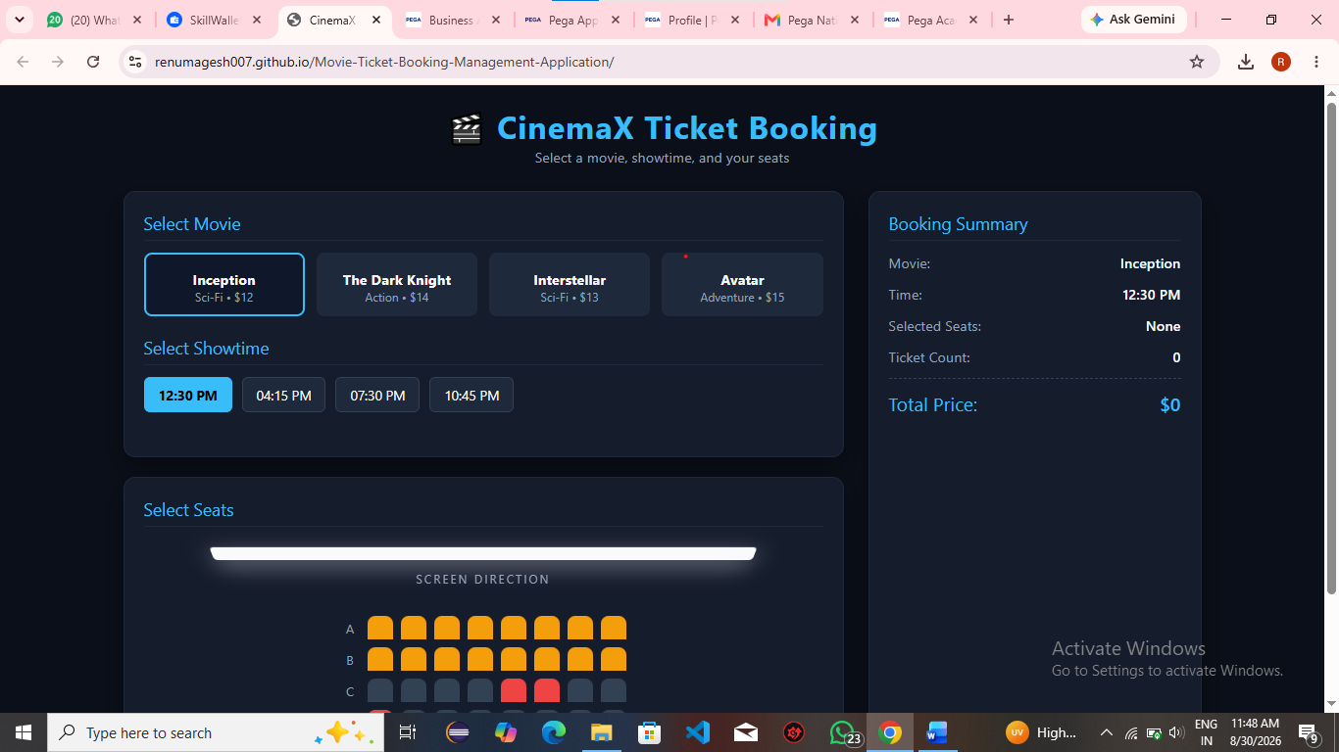

What I built for this (1–2 lines in your own words):
Movie Ticket Booking System – A system that allows users to browse movies, select showtimes and seats, and book tickets online.
It simplifies the booking process by providing easy seat selection, booking confirmation, and ticket management.

US-002 — Check Show Availability
What is expected:
Availability stage. Seat Availability Status and Available Seats Count captured. Booking proceeds only if available.
Screenshot — paste your screenshot below this line:
[ Paste screenshot here - follow the screenshot rules above ]



What I built for this (1–2 lines in your own words):
Build a Movie Ticket Booking System where users can view movies, select showtimes, choose seats, and book tickets.
The system provides booking confirmation, ticket details, and booking management for users.

US-003 — Calculate Booking Cost
What is expected:
Total Cost calculated automatically from Ticket Price and Number of Tickets using a business rule.
Screenshot — paste your screenshot below this line:
[ Paste screenshot here - follow the screenshot rules above ]

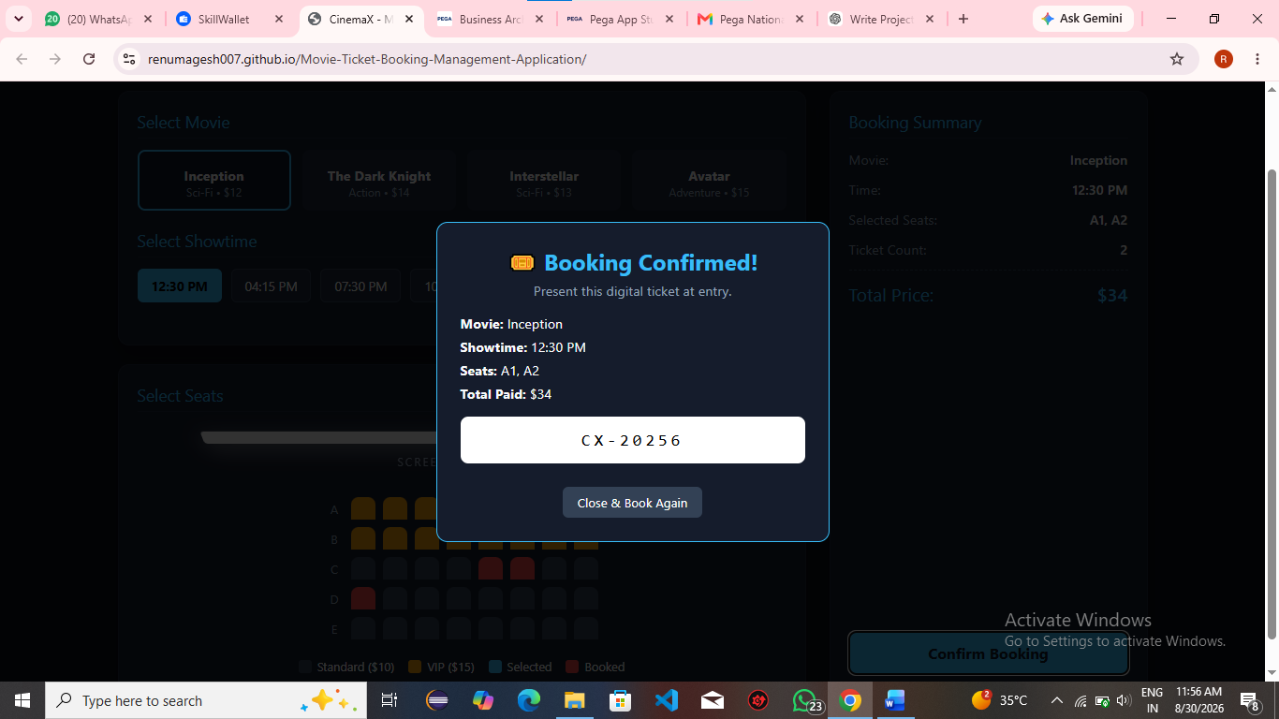

What I built for this (1–2 lines in your own words):
Booking cost is calculated based on the number of seats selected × ticket price.
For example, if one ticket costs ₹150 and 3 seats are booked, the total cost is ₹450.

US-004 — Confirm Booking Request
What is expected:
Approval stage assigned to Customer. Booking Status captured. Flow branches on confirm/cancel.
Screenshot — paste your screenshot below this line:
[ Paste screenshot here - follow the screenshot rules above ]



What I built for this (1–2 lines in your own words):
Booking is confirmed after the user selects the movie, showtime, and seats.
A booking ID and ticket details are generated as confirmation.

US-005 — Maintain Movie and Show Data
What is expected:
Reusable Movie and Show data objects created with Movie Name, Genre, Show Date, Show Time, Seat Capacity — linked to case.
Screenshot — paste your screenshot below this line:
[ Paste screenshot here - follow the screenshot rules above ]



What I built for this (1–2 lines in your own words):
Maintain movie and show data by storing movie names, languages, genres, dates, showtimes, and available seats.
Admins can add, update, or remove movies and show schedules.

US-006 — Review Booking Details
What is expected:
Confirmation screen shows Movie Name, Show Timing, Number of Tickets and Total Cost clearly.
Screenshot — paste your screenshot below this line:




What I built for this (1–2 lines in your own words):
Users can review their booking details, including movie name, showtime, selected seats, and total cost.
They can also view the booking ID and confirmation status before the show.

US-007 — Process Ticket Booking
What is expected:
Booking Execution stage. Seat Numbers, Ticket ID and Booking Confirmation Status maintained.
Screenshot — paste your screenshot below this line:


What I built for this (1–2 lines in your own words):
Users can select a movie, showtime, and available seats to book their tickets.
The system calculates the total cost and confirms the booking with a booking ID.

US-008 — Notify Booking Confirmation
What is expected:
Correspondence rule triggered on case resolution. Email includes movie, show, seat and cost details.
Screenshot — paste your screenshot below this line:


What I built for this (1–2 lines in your own words):
Users receive a booking confirmation notification after successfully booking their tickets.
The notification includes the booking ID, movie, showtime, seats, and total cost.

US-009 — Define Booking SLA
What is expected:
SLA configured on the case type. Goal: 1 day. Deadline: 2 days. Priority increases on breach.
Screenshot — paste your screenshot below this line:


What I built for this (1–2 lines in your own words):
Booking SLA defines the expected time for the system to complete and confirm a movie ticket booking.
For example, the booking should be confirmed within 1–2 minutes after successful payment.

US-010 — Route by Show Type
What is expected:
Routing rule or Decision Table routes to PremiumShowQueue or StandardShowQueue based on Show Type property.
Screenshot — paste your screenshot below this line:
Booking SLA defines the expected time for the system to complete and confirm a movie ticket booking.
For example, the booking should be confirmed within 1–2 minutes after successful payment.

What I built for this (1–2 lines in your own words):
Route by Show Type directs the booking request based on the selected show type, such as Regular, IMAX, or 3D.
Each show type can have different screens, timings, seat types, and ticket prices.

Section 3 — About Your Application
These answers are checked against your screenshots. Write exactly what is in your application.

Q1. List your stages in the order they appear in your case lifecycle.
Stage names in order, separated by commas.
[ Type here ]
Movie Selection, Show Selection, Seat Selection, Booking Confirmation, Ticket Notification

Q2. Name the data object(s) you created and the properties inside them.
Data object name and its properties.
[ Type here ]
Movie Data: Movie Name, Language, Genre, Duration, Show Date, Show Time, Ticket Price, Available Seats.
Booking Data: Customer Name, Movie Name, Show Time, Selected Seats, Number of Tickets, Total Cost, Booking ID, Booking Status.

Q3. What is the exact name and type of the rule you used to calculate Total Cost?
Provide:
• Rule Name
• Rule Type
• Properties used in the calculation
• Formula used
[ Type here ]
- Rule Name: CalculateTotalCost
- Rule Type: Declare Expression
- Properties used: TicketPrice, NumberOfTickets
- Formula used: TotalCost = TicketPrice * NumberOfTickets

Section 4 — Your Understanding
Short, honest and specific answers score well.

Q4. What did Blueprint generate for you, and what did you add or change yourself afterwards?
Be specific about what was already there and what you built or modified on top.
[ Type here ]
Blueprint generated: The basic Movie Ticket Booking case lifecycle, stages, steps, and data fields for movie selection, show selection, seat selection, and booking confirmation.
I added/changed: I added the Total Cost calculation, booking confirmation, ticket details, booking status, and booking notification, and modified the fields and stages based on my project requirements.

Q5. Was there anything Blueprint created that you had to correct or configure further? Describe one example.
A real example from your own work.
[ Type here ]
Yes. Blueprint created the basic booking flow, but I had to configure the Total Cost calculation further. I added the Ticket Price and Number of Tickets fields and configured the formula Total Cost = Ticket Price × Number of Tickets.

Q6. Explain your case flow from creation to resolution, in order.
What happens first, who does what, when the case closes.
[ Type here ]
For your Movie Ticket Booking System, enter:
Case Creation → Movie Selection → Show Selection → Seat Selection → Calculate Total Cost → Confirm Booking → Send Booking Notification → Case Resolution

Q7. Pick two design choices you made in your application and explain why you made them.
For each design choice, provide:
• What you implemented
• Why you chose that approach
• What benefit it provides to the application
[ Type here ]
1. Seat Selection
- What I implemented: Users can select available seats before confirming the booking.
- Why I chose it: To allow users to choose their preferred seats easily.
- Benefit: It avoids duplicate seat booking and improves the user experience.
2. Total Cost Calculation
- What I implemented: The system automatically calculates the total cost based on ticket price and number of tickets.
- Why I chose it: To reduce manual calculation and errors.
- Benefit: It provides accurate and faster booking cost calculation.

Q8. What was the hardest part, and how exactly did you fix it?
Specific and honest. A real challenge scores much better than a generic answer.
[ Type here ]

The hardest part was configuring the Total Cost calculation correctly. Initially, the total cost was not updating based on the number of tickets, so I checked the property configuration and formula, then configured Total Cost = Ticket Price × Number of Tickets and tested it with different ticket quantities to confirm the calculation worked correctly.

Q9. If the approval step was only needed when Total Cost is above a certain amount, what would you change in your application?
Explain what you would change and where. You do not need to build this.
[ Type here ]

I would add a conditional approval step after the Total Cost calculation. If the Total Cost is above a defined limit, the case would be routed to the approver; otherwise, it would directly proceed to booking confirmation. I would configure this condition in the approval step/flow logic using the Total Cost property.

Q10. List three exact rule names from your application that you personally created or modified.
Include the rule name and rule type for each one (for example: CalculateTotalCost - Declare Expression).
[ Type here ]
• CalculateTotalCost – Declare Expression
• ProcessTicketBooking – Case Type
• BookingConfirmation – View

Q11. List all personas used in your application.
List the persona names exactly as they appear in your application.
[ Type here ]
Customer, Admin

Q12. List all work queues used in your application and explain when each one is used.
For each work queue, provide its exact name and the condition or type of work routed to it.
[ Type here ]
CustomerService – Used for handling movie ticket booking requests and customer-related issues.
BookingAdmin – Used for managing movie, show, seat, and booking-related tasks.

Before You Submit — Check These
Read through once before uploading.
1. Section 1 filled in. Application named as NIP-[Project]-[YourName]. Names match the actual application.
2. New Operator created in Pega with my full name. I logged in as that operator for all screenshots.
3. Only my chosen project section remains — the other project section is deleted.
4. All 10 user story screenshots are pasted and follow the operator, running-case, application, and rule-name evidence requirements.
5. Every question in Sections 3 and 4, including Q10, Q11, and Q12, is answered in my own words.
6. This file is named using the required format: ProjectName_FirstName_LastName.docx (for example, VehicleService_Ravi_Kumar.docx or MovieTicket_Ravi_Kumar.docx) and uploaded as required.

