SUPPLY CHAIN
DELIVERY PERFORMANCE REPORT
End-to-End Order Fulfillment Analysis, Root-Cause Diagnostics & Predictive Modeling

Table of Contents
1. Executive Summary 3
2. Business Context & Objectives 4
3. Exploratory Data Analysis 5
3.1 Dataset Overview 5
3.2 Variable Types 5
3.3 Correlation with Late Delivery Risk (Numerical Variables) 5
3.4 Chi-Square Test of Independence (Categorical Variables) 6
3.5 Feature Engineering 6
4. Key Performance Indicators (KPIs) 7
5. Profitability Analysis 8
5.1 Profitability Distribution 8
5.2 Delay Distribution & Profit vs. Delay Days 8
6. Bottleneck Detection 10
7. Root Cause Analysis 11
8. Time-Based Delay Patterns 12
9. Machine Learning Model Results 13
9.1 Modeling Approach 13
9.2 Model Comparison 13
9.3 Final Model Selection 13
9.4 Final Model Performance — Random Forest 13
9.5 Feature Importance & Root Cause Validation 14
9.6 Model Persistence 15
10. Strategic Recommendations 16
11. Conclusion 17

1. Executive Summary
This report presents a comprehensive analysis of the delivery operations of a global e-commerce company managing end-to-end order fulfillment across multiple regions. The analysis covers 172,765 orders spanning January 2015 through January 2018, focusing on identifying root causes of chronic late deliveries, quantifying their financial impact, and establishing a data-driven framework for improvement.
The headline finding is stark: 54.71% of all orders are delivered late, costing the business $2.1M in eroded profitability on delayed orders alone. While total profit across fulfilled orders reached $7.5M, the persistent late-delivery problem represents both a significant financial drain and a major customer experience risk. Following a structured evaluation of five candidate algorithms, a Random Forest predictive model was selected as the final model, achieving 74% accuracy and an ROC-AUC of 0.82 in identifying at-risk orders before they become late.

54.71%  Overall Late Delivery Rate | 45.29%  On-Time Delivery Rate | 172,765  Total Orders Analyzed

$7.5M  Total Profit (profitable orders) | $2.1M  Profit at Risk (delayed orders) | 74%  Predictive Model Accuracy (RF)

2. Business Context & Objectives
The company operates a global e-commerce platform selling products across categories including sporting goods, fitness equipment, outdoor gear, footwear, and apparel across multiple international regions.
Core Business Problem
Actual shipping times frequently deviate from scheduled delivery windows, creating eroded customer trust, reduced order profitability, and an inability to make reliable commitments to buyers at point of purchase.
Analytical Objectives
- Understand the current state of delivery performance across all dimensions (region, mode, time, segment)
- Quantify the financial impact of delays on order profitability
- Identify the primary operational bottlenecks driving late deliveries
- Build a predictive model to flag high-risk orders before they are shipped
- Deliver actionable recommendations to improve on-time delivery and profitability

3. Exploratory Data Analysis
Before building KPIs or models, the raw dataset was profiled to understand its structure, data quality, and the statistical relationship between individual variables and the late-delivery outcome. This groundwork shaped every downstream decision, including which columns were dropped, which features were used for modeling, and which categorical factors warranted deeper root-cause investigation.

3.1 Dataset Overview
The raw dataset contained 180,519 orders across 53 columns. Thirty-two columns were removed prior to analysis — these were either fully or mostly empty (e.g., Product Description), personally identifiable customer information (e.g., Customer Email, Customer Password, Customer Street), redundant identifier columns (e.g., Order Id, Customer Id, Product Card Id), or fields with a single constant value that carried no analytical signal (e.g., Product Status). Orders with a status of "Shipping canceled" were also excluded, since cancelled orders are not meaningful for delivery-time analysis. This left a working dataset of 172,765 orders across 20 base columns, which was subsequently extended with engineered features (Section 3.4).

3.2 Variable Types
Type | Count | Variables
Numerical | 8 | Days for shipping (real), Days for shipment (scheduled), Sales, Sales per customer, Order Profit Per Order, Order Item Profit Ratio, Product Price, Late_delivery_risk (binary target)
Categorical | 10 | Type, Delivery Status, Category Name, Customer Country, Customer Segment, Department Name, Order Region, Order Status, Product Name, Shipping Mode
Date / Time | 2 | order date (DateOrders), shipping date (DateOrders)
Table 1: Variable inventory by type after initial column reduction

3.3 Correlation with Late Delivery Risk (Numerical Variables)
Pearson correlation was computed between each numerical variable and Late_delivery_risk to identify linear relationships:
Variable | Correlation with Late_delivery_risk
Days for shipping (real) | 0.4214
Days for shipment (scheduled) | -0.3896
Product Price | -0.0027
Order Item Profit Ratio | -0.0028
Sales | -0.0042
Sales per customer | -0.0045
Order Profit Per Order | -0.0046
Table 2: Pearson correlation, sorted by strength of relationship
Days for shipping (real) shows the strongest correlation (0.42) — expected, since this is the actual delivery duration used to derive the delay outcome itself, rather than an independent predictor. Because it is only known *after* an order has shipped, it was deliberately excluded from the predictive feature set in Section 9 to avoid data leakage; only Days for shipment (scheduled), which is known at order time, was retained. Profit- and price-related variables (Sales, Product Price, Order Profit Per Order) show negligible linear correlation with late delivery, indicating that delay risk is primarily an operational and logistics phenomenon rather than one tied to order value.

3.4 Chi-Square Test of Independence (Categorical Variables)
A chi-square test of independence was run between each categorical variable and Late_delivery_risk to test whether the categories of that variable are statistically associated with delay outcomes:
Variable | Chi² Statistic | p-value | Significant (α = 0.05)
Delivery Status | 172,765.00 | 0.0000 | Yes*
Shipping Mode | 40,058.67 | 0.0000 | Yes
Order Region | 76.59 | 0.0000 | Yes
Order Status | 20.55 | 0.0022 | Yes
Type | 5.20 | 0.1577 | No
Customer Segment | 2.10 | 0.3496 | No
Category Name | 46.35 | 0.5811 | No
Department Name | 6.87 | 0.7380 | No
Product Name | 105.80 | 0.7620 | No
Customer Country | 0.02 | 0.8834 | No
Table 3: Chi-square results, sorted by p-value
*Delivery Status is definitionally linked to Late_delivery_risk (it is effectively the categorical restatement of the same outcome) and is included for completeness rather than as an independent driver. Excluding that near-tautological case, Shipping Mode and Order Region emerge as the categorical variables most strongly and significantly associated with late delivery, followed by Order Status. Type, Customer Segment, Category Name, Department Name, Product Name, and Customer Country show no statistically significant individual association — though, as the Root Cause Analysis in Section 7 shows, some of these factors still matter in combination with other variables within specific regions.

3.5 Feature Engineering
To support delay measurement and time-based analysis, several columns were engineered from the raw order and shipping dates. Order Processing Time and Delay were calculated from the difference between the order date and shipping date (compared against the scheduled shipment window), and a binary Is_Delayed flag was derived from Delay. The order date was further decomposed into order_month, order_day, and order_hour to enable the seasonal and time-of-day analysis presented in Section 8.

4. Key Performance Indicators (KPIs)
The following KPIs were computed directly from the cleaned dataset to establish a performance baseline.
172,765  Total Orders | 94,523  Late Deliveries | 54.71%  Late Delivery % | 45.29%  On-Time Delivery %

Total Profit (profitable orders) | Profit at Risk (delayed orders) | 90th Percentile Delay | Avg Order Profit
$7.5M | $2.1M | 3 days | $22.03

Late Delivery Rate at 54.71%
More than half of all orders arrive late. This is not an edge-case problem, it is the default experience for the majority of customers.

$2.1M Profit at Risk
Orders that experienced delays collectively generated $2.1M in profit that is under constant pressure from further operational deterioration.

90th Percentile Delay = 3 Days
Even the most extreme cases are contained within 3 days of lateness, suggesting the problem is systemic and process-driven rather than catastrophic.

5. Profitability Analysis

5.1 Profitability Distribution
Order-level profitability was classified into three tiers based on Order Profit Per Order. While 80.7% of orders are profitable, the 18.7% loss-making share represents a meaningful drag that is disproportionately concentrated among delayed shipments.
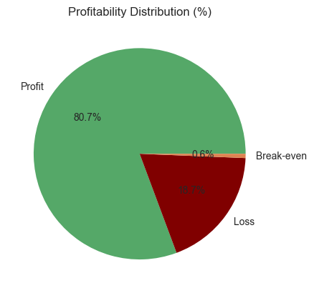
Figure 1: Profitability Distribution — 80.7% Profit | 18.7% Loss | 0.6% Break-even
Tier | Definition | Share
Profit | Order Profit Per Order > 0 | 80.7%
Loss | Order Profit Per Order < 0 | 18.7%
Break-even | Order Profit Per Order = 0 | 0.6%

5.2 Delay Distribution & Profit vs. Delay Days
The delay distribution shows that 31.0% of all orders arrive exactly 1 day late — the single largest cohort. Combined, orders delayed by 1–4 days account for 54.7% of all order volume, directly mapping to the overall late delivery rate.
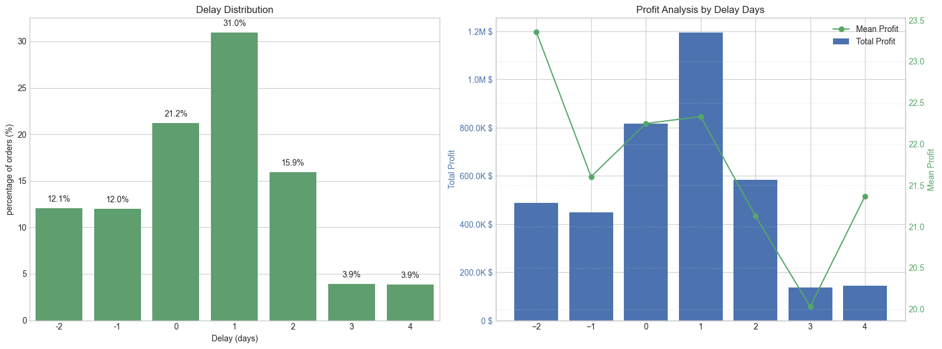
Figure 2: Delay Distribution (left) and Profit Analysis by Delay Days (right)
A critical observation: mean profit per order remains stable at approximately $20–$23 across all delay levels. The profitability problem is therefore driven by volume of delayed orders, not by individual order economics — making systemic throughput improvement the highest-leverage intervention.

6. Bottleneck Detection
Delay percentage was computed across six key operational dimensions. The charts below reveal where the fulfilment process breaks down most severely.
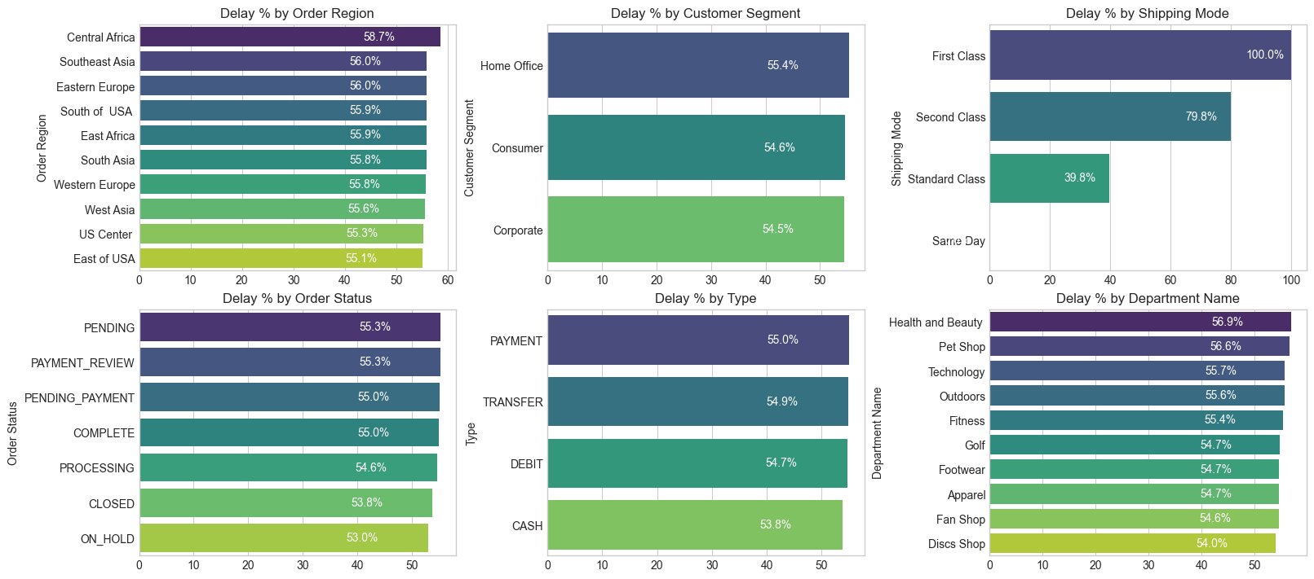
Figure 3: Delay % across six operational categories — Region, Segment, Shipping Mode, Order Status, Payment Type, Department
Shipping Mode is the #1 Lever
First Class: 100% delay rate. Second Class: 79.8%. Standard Class: 39.8%. Same Day: 0%. The mode assignment logic is the most impactful single variable to fix.

Regional Spread is Narrow (55–59%)
Central Africa leads at 58.7% but all regions cluster between 55–59%. This rules out a localised logistics failure and confirms a company-wide systemic issue.

Customer Segments Nearly Identical (54.5–55.4%)
No segment receives preferential service. Consumer, Corporate, and Home Office customers all experience the same broken delivery promise.

Health & Beauty (56.9%) and Pet Shop (56.6%) Lead by Department
These departments marginally outpace others in delay rate, warranting an inventory and carrier audit for these product categories.

7. Root Cause Analysis
Central Africa was selected for deep-dive root cause analysis as the highest-delay region (58.7%). The chart below ranks the top 10 driver factors by delay percentage within this region.
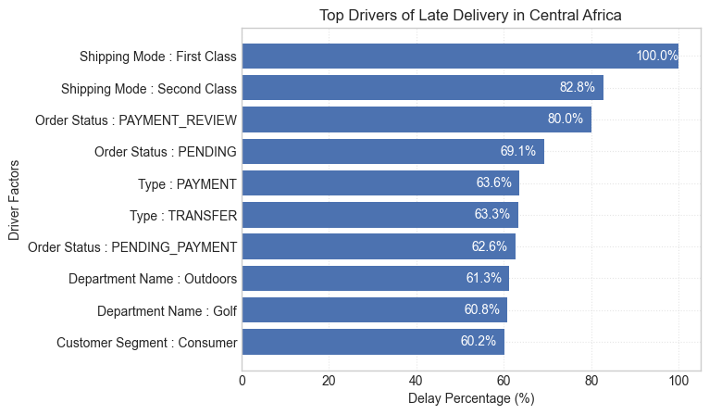
Figure 4: Top 10 Drivers of Late Delivery in Central Africa — ranked by delay percentage
Within Central Africa, Shipping Mode dominates every other factor — First Class orders in this region are delayed 100% of the time and Second Class 82.8% of the time, both well above the region's overall 58.7% average. Order Status factors (PAYMENT_REVIEW at 80.0%, PENDING at 69.1%) also stand out as secondary bottlenecks tied to payment processing friction rather than physical logistics.

8. Time-Based Delay Patterns
Three temporal dimensions were analysed: month of year, day of week, and hour of day. While delay rates are relatively stable across all dimensions (53–57%), specific peaks highlight opportunities for targeted capacity planning.
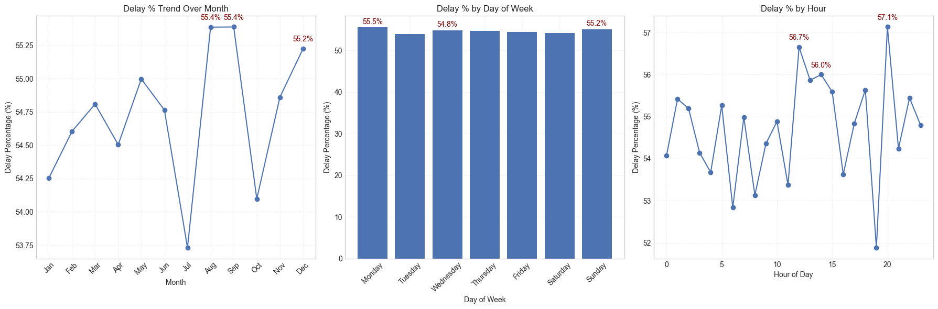
Figure 5: Delay % by Month (left), Day of Week (centre), and Hour of Day (right)
Peak Delay Months: August & September (55.4%) and December (55.2%)
These reflect mid-year promotions and Q4 holiday surge overwhelming fulfilment capacity. July represents a notable low-point (~53.75%), confirming seasonal variation is plannable.

Day-of-Week Variance is Minimal
Monday (55.5%) and Sunday (55.2%) are the peak days, but the spread across the week is less than 1 percentage point. Day-of-week is not a meaningful lever for operational intervention.

Intra-Day Peaks: Hour 21 (57.1%), Hour 11 (56.7%), Hour 12 (56.0%)
Late-evening orders (hour 21) have the highest delay rate, likely reflecting processing cutoff windows. Midday peaks suggest bottlenecks during peak-volume hours.

9. Machine Learning Model Results
A supervised classification model was built to predict whether an individual order will be delivered late (Late_delivery_risk = 1), so that at-risk orders can be flagged for intervention before they ship.

9.1 Modeling Approach
Nine features, all known at the time an order is placed, were used: Type, Days for shipment (scheduled), Category Name, Customer Segment, Department Name, Order Region, Shipping Mode, order_month, and order_hour. Notably, Days for shipping (real) — the strongest correlate identified in Section 3.3 — was deliberately excluded, since it is only known after delivery and would leak the outcome into the model.
- Categorical variables were converted using frequency encoding, fitted only on the training split and then applied to the test split, to prevent test-set information from leaking into the encoding.
- Data was split 80/20 into training and test sets with stratification on the target, preserving the late/on-time class ratio in both sets.
- The training set showed class imbalance (59,030 on-time vs. 79,182 late orders) and was rebalanced using SMOTE oversampling — applied to the training data only, never the test set.
- Five candidate algorithms were trained on the balanced training data and evaluated on the untouched, held-out test set: Logistic Regression, Decision Tree, Naive Bayes, Random Forest, and Gradient Boosting.

9.2 Model Comparison
All five models were evaluated on the same 34,553-record test set using Accuracy, Precision, Recall, F1-Score, and ROC-AUC:
Model | Accuracy | Precision | Recall | F1-Score | ROC-AUC
Logistic Regression | 0.6971 | 0.8329 | 0.5895 | 0.6904 | 0.7081
Decision Tree | 0.7183 | 0.7672 | 0.7298 | 0.7480 | 0.7276
Naive Bayes | 0.6971 | 0.8329 | 0.5895 | 0.6904 | 0.7125
Random Forest | 0.7358 | 0.7828 | 0.7457 | 0.7638 | 0.8226
Gradient Boosting | 0.7245 | 0.8934 | 0.5895 | 0.7103 | 0.7772
Table 4: Five-model comparison on the held-out test set

9.3 Final Model Selection
Random Forest was selected as the final model. Gradient Boosting achieved the highest Precision (0.8934), but its Recall was materially lower (0.5895) — meaning it misses over 40% of orders that actually end up late. Random Forest outperforms every other model on Recall (0.7457), F1-Score (0.7638), and ROC-AUC (0.8226), the metrics most relevant to this business problem: a missed late-order flag (a false negative) carries a real cost in lost intervention opportunity, directly connected to the $2.1M profit-at-risk figure established in Section 4. Decision Tree was the closest competitor on Recall but trailed Random Forest on every other metric, consistent with a single tree being more prone to overfitting than an ensemble of trees.

9.4 Final Model Performance — Random Forest
Metric | Class 0 (On-time) | Class 1 (Late) | Overall (Weighted)
Precision | 0.68 | 0.78 | 0.74
Recall | 0.72 | 0.75 | 0.74
F1-Score | 0.70 | 0.77 | 0.74
Support | 14,758 | 19,795 | 34,553
Table 5: Random Forest classification report on the test set (34,553 records)
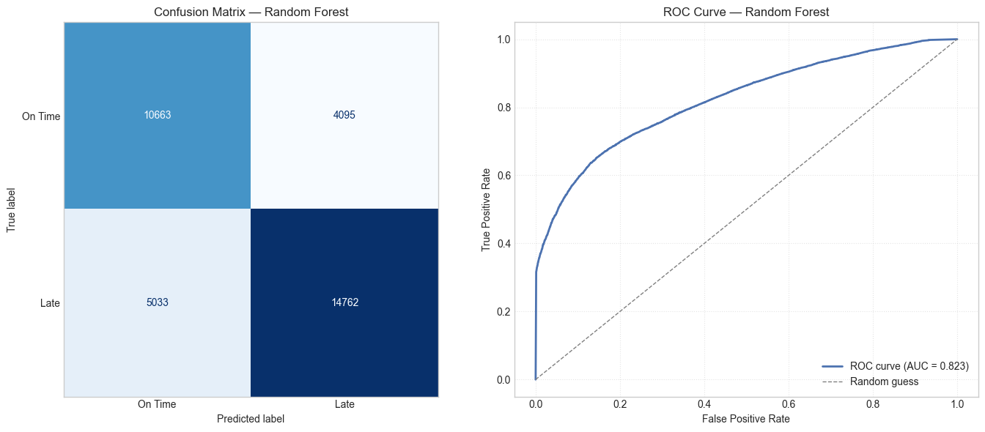
Figure 6: Confusion Matrix (left) and ROC Curve (right) — Random Forest
The confusion matrix shows the model correctly identifies 14,762 of 19,795 actual late orders (Recall = 0.75), while flagging 4,095 on-time orders incorrectly (false positives) and missing 5,033 orders that were genuinely late (false negatives). The ROC curve confirms strong discriminative ability, with an AUC of 0.823 — well above the 0.5 random-guess baseline — indicating the model reliably separates high-risk from low-risk orders across decision thresholds.

9.5 Feature Importance & Root Cause Validation
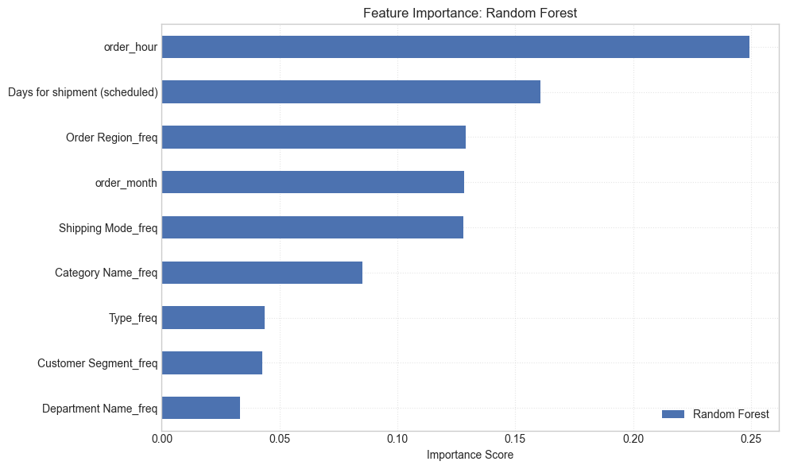
Figure 7: Feature Importance — Random Forest
Random Forest's top predictors — order_hour, Days for shipment (scheduled), Order Region, order_month, and Shipping Mode — line up closely with the EDA and Root Cause Analysis findings above. Days for shipment (scheduled) ranking highly confirms that the promised delivery window itself is a strong driver of risk, not just execution. Shipping Mode appearing in the top five matches the Bottleneck Detection finding that First and Second Class shipments carry the highest late-delivery rates. Order Region being influential is consistent with the region-level spread seen in Section 6, and order_hour / order_month being important reflects the same time-of-day and seasonal patterns visualized in Section 8. This convergence between an independently-trained model and manual EDA is a useful sanity check: the model is learning genuine operational bottlenecks rather than noise, which supports using its risk score operationally rather than relying on static category-level breakdowns alone.

9.6 Model Persistence
The final trained Random Forest model, together with the frequency-encoding maps learned from the training data, was saved (via joblib) so that new, incoming orders can be scored consistently using the same encoding logic the model was trained on — without needing to retrain or re-derive encodings from scratch. This packages the model as a reusable scoring artifact rather than a one-off notebook result, ready for integration into an order-management pipeline.

10. Strategic Recommendations
Based on the findings across all analytical dimensions, the following prioritised actions are recommended:
CRITICAL · 1. Immediately Audit First Class & Second Class Shipping Capacity
First Class shipping has a 100% delay rate and Second Class 79.8%. These modes operate in complete contradiction to their brand promise. Conduct an immediate carrier SLA audit. Until resolved, consider suspending First Class or repricing to reflect actual performance.

HIGH · 2. Deploy the Predictive Alert System
The Random Forest model (74% accuracy, 78% precision on late orders) is ready for production piloting. Integrate it into the order management system to flag high-risk orders at confirmation and trigger proactive customer communication and priority handling queues.

HIGH · 3. Resolve Payment Processing Bottlenecks
Orders in PAYMENT_REVIEW (55.3% overall; 80.0% in Central Africa) and PENDING_PAYMENT (55.0%) have significantly elevated delay rates. Introduce automated escalation for stalled payment reviews exceeding 2 hours.

MEDIUM · 4. Develop Seasonal Surge Capacity Plans
August, September (55.4%), and December (55.2%) are peak delay months. Build pre-season capacity plans including temporary logistics partnerships, inventory pre-positioning, and adjusted delivery promise windows.

MEDIUM · 5. Default to Standard Class for Eligible Orders
Standard Class achieves a 39.8% delay rate — far superior to First and Second Class. Re-evaluate shipping mode assignment logic to default eligible orders to Standard Class, particularly in regions and departments with poor premium mode performance.

MEDIUM · 6. Investigate High-Delay Departments in Central Africa
Outdoors (61.3%) and Golf (60.8%) in Central Africa show significantly elevated delay rates. Conduct a warehouse-level audit of stock availability, pick-and-pack times, and carrier assignment for these product categories.

LOW · 7. Reduce Loss-Making Order Share (18.7%)
The 18.7% loss-making order share warrants a separate pricing and discount review. Combine with delay analysis to identify whether discounted orders are disproportionately late, creating a compounded margin problem.

LOW · 8. Continuously Retrain the Predictive Model
Retrain the model quarterly. Explore adding carrier-level data, weather events, and warehouse utilisation features. Target a recall improvement to above 80% on late orders within 6 months.

11. Conclusion
This analysis has surfaced a clear and urgent picture: a global e-commerce operation where the majority of orders (54.71%) fail to meet their promised delivery windows, costing $2.1M in at-risk profit and undermining customer trust at scale.
The root causes are identifiable and addressable. Shipping mode misconfiguration (First Class at 100% late, Second Class at 79.8%) is the dominant operational failure — a finding independently confirmed by both the categorical Chi-square test in Section 3.4 and the Random Forest feature importances in Section 9.5. Payment processing friction creates a secondary bottleneck. Seasonal volume spikes are not adequately planned for. And geographic disparities, while present, are secondary to the systemic company-wide pattern.
A Random Forest predictive model — selected after a structured comparison against four other algorithms — trained on readily available, pre-shipment order features already achieves 74% accuracy and an ROC-AUC of 0.82 in identifying at-risk orders. The trained model and its supporting encoding logic have been saved as a reusable artifact: this is a deployable tool, not a future aspiration.
Priority Area | Current State | Target State
Late Delivery Rate | 54.71% | < 30% within 12 months
First Class On-Time Rate | 0% | > 80%
Second Class On-Time Rate | 20.2% | > 60%
Predictive Model Accuracy | 74% | > 82% (enhanced model)
Loss-Making Orders | 18.7% | < 12%
Profit at Risk | $2.1M | Reduce by 40%

With focused execution on the eight recommendations in this report — starting with the critical shipping mode audit and predictive alert system deployment — the business can systematically recover its delivery performance, protect its $7.5M profit base, and build the operational reliability that sustained e-commerce growth demands.

